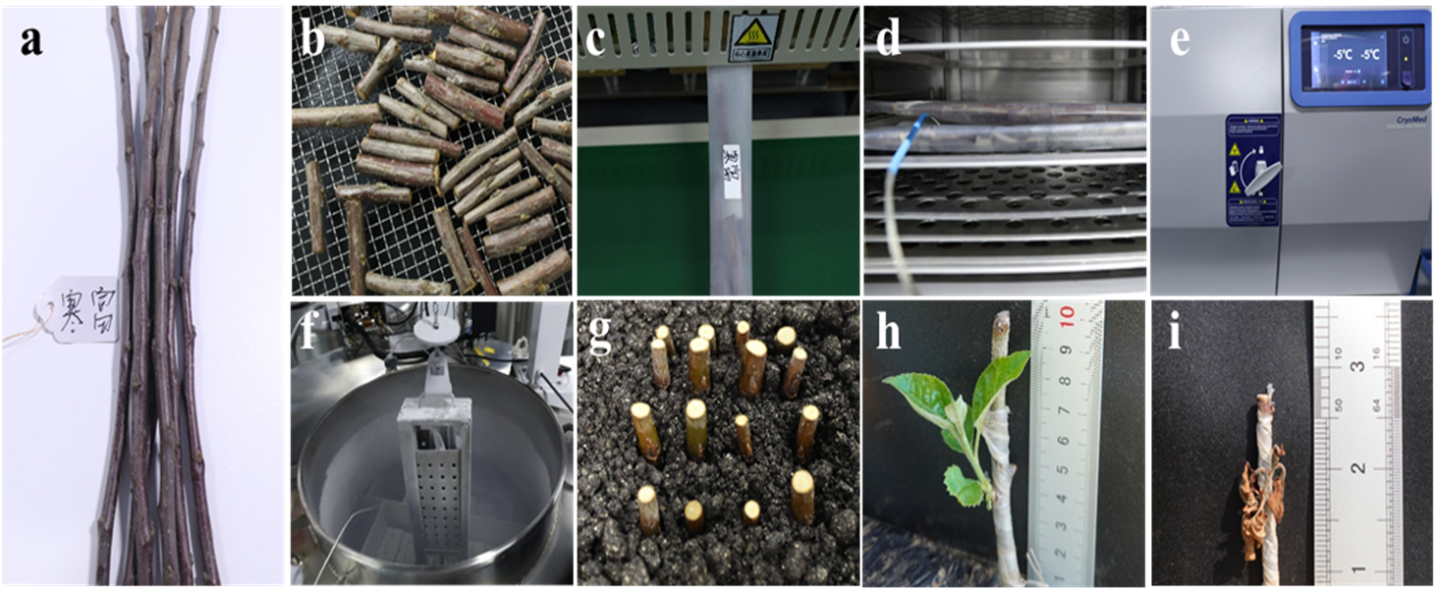
Figure S1 Cryopreservation and regrowth of apple dormant buds. a, Dormant branches. b, Drying treatment. c, Sealing in plastic tubes with labels. d, Precooling treatment. e, Controlled-cooling treatment. f, Exposure in liquid nitrogen and preservation in a cryo-tank for long-term storage. g, Rehydrating treatment. h, Regrowth of cryopreserved dormant buds. i, Dead cryopreserved after grafting.

Figure S2 TTC staining pattern in different parts of dormant buds. A-B, CT images of dormant buds in multiple planes. C–D, TTC staining indicates viable dormant buds. E-F, TTC staining showing dead dormant buds. Red staining indicates viability, and green indicates death. arrow 1 indicates the meristem. arrow 2 indicates the cambium. arrow 3 indicates the phloem. Scale bar represents 1 cm.

Figure S3 Heatmap of relative contents of FFA, SM and Cer in dormant bud during cryopreservation procedures.

Table S1. Primers used in Real-time RT-PCR experiment.
Gene name | Primer | Sequence (5'-3')
MdActin | Forward | GGATTTGCTGGTGATGATGCT
MdActin | Reverse | AGTTGCTCACTATGCCGTGC
LPCAT1 | Forward | GTGGCTCCGTCACTATGTGT
LPCAT1 | Reverse | GCCATTTTCGGACTGATCGC
LPCAT2 | Forward | GCTGTCTGGCATGGACTGTA
LPCAT2 | Reverse | AATGACACGCACATGGGACT
PDAT | Forward | ACAATGAAACGGGGCTCGAT
PDAT | Reverse | GCTTGGTCCCGAATCTCTGT
PDCT | Forward | GAGCAGACTTTCCGAGAATG
PDCT | Reverse | CACCTCCTTCAGCCATAGCC
MdDGK2 | Forward | AGAACAGAGCGAGGAAAGGC
MdDGK2 | Reverse | GGCCACAAAAGACCAGGTGA
MdDGK4 | Forward | GAAGTTTCGGATGGGGAGGTT
MdDGK4 | Reverse | GGAACCAACCCTGAGAGCAA
MdPLA1 | Forward | ATGTCCAGTCTCGTGCCAAG
MdPLA1 | Reverse | TGCCAAAGAATCTGATCCCTGA
MdPLA2 | Forward | TGCCAAAGAATCTGATCCCTGA
MdPLA2 | Reverse | CCTCAGAAATGGAGGCACTGA
MdPI-PLC2 | Forward | GCACACACACTTTGATGCGT
MdPI-PLC2 | Reverse | TTCAATGCGGAGCACAGCTA
MdPI-PLC4 | Forward | GGTGCTCAAATGGTTGCGTT
MdPI-PLC4 | Reverse | CCTGCTATGCCAACCCTAGT
MdPI-PLC6 | Forward | CCCGACTTCTACACAAAGGTCT
MdPI-PLC6 | Reverse | AAGGGGAAGTGCTGTTGTCC
MdPLD03 | Forward | GAGGAAAGTAAATGAGGTTGCA
MdPLD03 | Reverse | GCATATCAGGAATTTTGTTGGA
MdPLD05 | Forward | ACAACGATCGATTTGGGAATAG
MdPLD05 | Reverse | GGGGATGTATAAAATTCACTTTCA
MdPLD09 | Forward | ACAACTATCGACTTGGGAATTG
MdPLD09 | Reverse | AATGAAATACTTGAGGAGACGC
MdPLD10 | Forward | GTGAACCAGATTGCTGACAAA
MdPLD10 | Reverse | GTAAGGATCGGAGGAAGGTAG
MdPLD17 | Forward | GTGAACCAGATTGCTGACAAA
MdPLD17 | Reverse | GTAAGGATCGGAGGAAGGTAG

