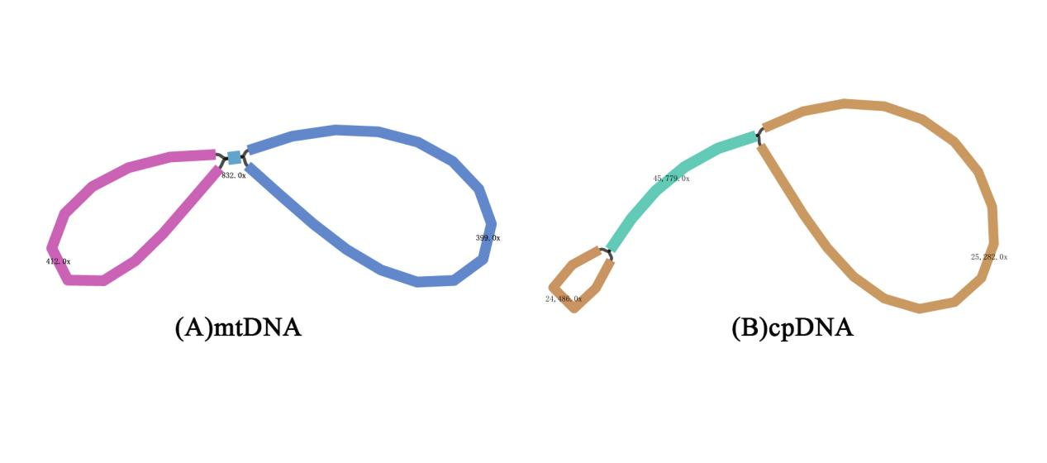

Supplementary Figure 1. Bandage visualization of the mitochondrial (A) and chloroplast (B) assembly graphs of K. arborescens.
The assembly graphs were visualized from the GFA files using Bandage. Node labels indicate sequencing depth. The mitochondrial assembly graph supports the assembled mitochondrial genome representation, while also indicating that alternative mitochondrial conformations cannot be completely excluded. The chloroplast assembly graph supports the assembled chloroplast genome sequence.

