Table S1. Perilla frutescens germplasm information used in this study.
Taxa | Name | IT No. | Taxa | Name | IT No. | Taxa | Name | IT No. | Taxa | Name | IT No.
PG1 | Daeyeop | IT217424 | PG60 | Anyu | IT229431 | PG111 | YCPL681 |  | PG160 | YCPL855
PG2 | Baekjin | IT261876 | PG61 | YCPL286-2-1 |  | PG112 | YCPL435 |  | PG161 | YCPL858
PG3 | Daeyu | IT276227 | PG62 | YCPL286-3-1 |  | PG113 | 312077 |  | PG164 | YCPL863
PG4 | Dami | IT261869 | PG63 | YCPL286-3-3 |  | PG114 | YCPL470 |  | PG165 | YCPL395
PG5 | Deulsaem | IT261870 | PG64 | YCPL177-2 |  | PG115 | YCPL706 |  | PG166 | YCPL749
PG6 | Milyang55 | IT261866 | PG65 | YCPL180-1 |  | PG116 | YCPL441-1 |  | PG167 | YCPL758
PG7 | Daesil | IT274265 | PG66 | YCPL180-2 |  | PG117 | YCPL192 |  | PG168 | YCPL770
PG9 | Milyang16 |  | PG71 | YCPL472 |  | PG118 | YCPL204 |  | PG169 | YCPL772
PG10 | YCPL457 |  | PG72 | YCPL473 |  | PG119 | YCPL255 |  | PG171 | YCPL746
PG11 | YCPL669 |  | PG73 | YCPL474 |  | PG120 | YCPL484 |  | PG173 | YCPL218
PG13 | YCPL301 |  | PG74 | YCPL559 |  | PG122 | YCPL616 |  | PG174 | YCPL233
PG15 | YCPL453 |  | PG76 | YCPL451 |  | PG123 | YCPL646 |  | PG175 | YCPL246
PG16 | YCPL532 |  | PG77 | YCPL454 |  | PG124 | YCPL648 |  | PG177 | YCPL692
PG17 | YCPL310 |  | PG78 | YCPL455 |  | PG126 | YCPL775 |  | PG178 | YCPL351
PG18 | YCPL441 |  | PG79 | YCPL456 |  | PG127 | YCPL777 |  | PG179 | YCPL347
PG19 | YCPL658 |  | PG81 | YCPL461 |  | PG128 | YCPL781 |  | PG180 | YCPL345
PG20 | Jungmo5101 | IT261868 | PG82 | YCPL463 |  | PG129 | YCPL782 |  | PG181 | YCPL344
PG21 | Jungmo5102 | IT261867 | PG84 | YCPL641 |  | PG130 | YCPL786 |  | PG183 | YCPL342
PG25 | Manchu |  | PG86 | YCPL415 |  | PG132 | YCPL790 |  | PG184 | YCPL348
PG26 | YCPL186 |  | PG87 | YCPL445 |  | PG133 | YCPL795 |  | PG185 | YCPL349
PG27 | Milyang14 | K015413 | PG88 | YCPL452 |  | PG134 | YCPL796 |  | PG187 | YCPL358
PG32 | Donggeul2 | IT221531 | PG90 | Milyang23 |  | PG135 | YCPL797 |  | PG188 | YCPL365
PG34 | YCPL257 |  | PG91 | Suwon64 |  | PG136 | YCPL800 |  | PG189 | YCPL366
PG35 | YCPL193 |  | PG92 | Suwon63 |  | PG137 | YCPL801 |  | PG190 | YCPL367
PG38 | YCPL144 |  | PG93 | YCPL1847 |  | PG138 | YCPL802 |  | PG191 | YCPL368
PG43 | YCPL307 |  | PG94 | YCPL1848 |  | PG139 | YCPL805 |  | PG192 | YCPL615
PG44 | Namcheon | IT276224 | PG95 | Milyang58 | IT261871 | PG141 | YCPL809 |  | PG193 | YCPL640
PG46 | Hyangim | IT276226 | PG96 | YCPL1850 |  | PG143 | YCPL811 |  | PG194 | YCPL315
PG47 | Hwahong | IT276225 | PG97 | Milyang19 | IT214507 | PG144 | YCPL812 |  | PG195 | YCPL316
PG48 |  | IT105306 | PG98 | YCPL250 |  | PG146 | YCPL824 |  | PG196 | YCPL275
PG49 |  | IT105396 | PG99 | YCPL189 |  | PG147 | YCPL830 |  | PG198 | YCPL281
PG50 |  | IT105939 | PG101 | YCPL448 |  | PG149 | YCPL836 |  | PG199 | YCPL298
PG51 | Yeopsil | IT217425 | PG102 | YCPL665 |  | PG151 | YCPL841 |  | PG200 | YCPL60
PG52 |  | IT117009 | PG103 | YCPL339 |  | PG152 | YCPL848 |  | PG201 | YCPL556
PG53 |  | IT117047 | PG105 | YCPL322 |  | PG153 | YCPL849 |  | PG202 | YCPL771
PG54 |  | IT157417 | PG106 | 874624 |  | PG154 | YCPL850 |  | PG203 | YCPL769
PG55 |  | IT185665 | PG107 | YCPL462 |  | PG155 | YCPL852 |  | PG204 |  | IT104241
PG56 |  | IT195228 | PG108 | YCPL442 |  | PG157 | YCPL869 |  | PG205 |  | IT104886
PG57 |  | IT207378 | PG109 | YCPL361 |  | PG158 | YCPL871 |  | PG206 |  | IT104890
PG59 | 512160 |  | PG110 | YCPL431 |  | PG159 | YCPL845 |  | PG207 |  | IT105275
Taxa | Name | IT No. | Taxa | Name | IT No. | Taxa | Name | IT No. | Taxa | Name | IT No.
PG209 |  | IT105748 | PG254 |  | IT214490 | PG301 |  | IT214474 | PG355 |  | IT227025
PG210 |  | IT105936 | PG255 |  | IT214493 | PG302 |  | IT214478 | PG356 |  | IT227026
PG211 |  | IT117015 | PG256 |  | IT215256 | PG303 |  | IT214480 | PG357 |  | IT227027
PG212 |  | IT117016 | PG257 |  | IT216249 | PG304 |  | IT214486 | PG358 |  | IT227028
PG213 |  | IT117043 | PG258 |  | IT216253 | PG305 |  | IT214489 | PG359 |  | IT227029
PG214 |  | IT117044 | PG259 |  | IT216263 | PG306 |  | IT216278 | PG360 |  | IT227030
PG215 |  | IT117068 | PG260 |  | IT216922 | PG307 |  | IT217415 | PG361 |  | IT227031
PG216 |  | IT117071 | PG262 |  | IT217409 | PG308 |  | IT217421 | PG362 |  | IT229042
PG217 |  | IT117073 | PG263 |  | IT217988 | PG309 |  | IT217422 | PG364 |  | IT235818
PG218 |  | IT117076 | PG264 |  | IT218812 | PG311 |  | IT220387 | PG366 |  | IT235840
PG219 |  | IT117078 | PG265 |  | IT218815 | PG312 |  | IT220388 | PG367 |  | IT235841
PG220 |  | IT117149 | PG266 |  | IT218819 | PG313 |  | IT220389 | PG368 |  | IT235842
PG221 |  | IT117150 | PG267 |  | IT218824 | PG315 |  | IT220392 | PG370 |  | IT235844
PG222 |  | IT117161 | PG268 |  | IT218825 | PG316 |  | IT220393 | PG371 |  | IT235845
PG223 |  | IT117196 | PG269 |  | IT219476 | PG321 |  | IT220659 | PG372 |  | IT235846
PG224 |  | IT157462 | PG270 |  | IT108937 | PG322 |  | IT223670 | PG373 |  | IT237074
PG225 |  | IT157465 | PG271 |  | IT217404 | PG323 |  | IT226451 | PG374 |  | IT239884
PG226 |  | IT157482 | PG272 |  | IT113193 | PG324 |  | IT226452 | PG375 |  | IT239921
PG227 |  | IT157489 | PG273 |  | IT117141 | PG325 |  | IT226453 | PG376 |  | IT239922
PG228 |  | IT157517 | PG274 |  | IT117143 | PG326 |  | IT226454 | PG377 |  | IT242445
PG229 |  | IT157562 | PG275 |  | IT117144 | PG327 |  | IT226445 | PG378 |  | IT242447
PG230 |  | IT157583 | PG276 |  | IT117145 | PG328 |  | IT226457 | PG379 |  | IT242448
PG231 |  | IT158252 | PG277 |  | IT117147 | PG329 |  | IT226486 | PG380 |  | IT242451
PG232 |  | IT162845 | PG279 |  | IT196398 | PG330 |  | IT226574 | PG383 |  | IT246853
PG233 |  | IT175906 | PG280 |  | IT201761 | PG331 |  | IT226575 | PG384 |  | IT247961
PG234 |  | IT180499 | PG281 |  | IT201762 | PG332 |  | IT226576 | PG386 |  | IT260856
PG235 |  | IT180962 | PG282 |  | IT201768 | PG333 |  | IT226577 | PG387 |  | IT261882
PG236 |  | IT180973 | PG283 |  | IT201769 | PG334 |  | IT226578 | PG388 |  | IT261883
PG237 |  | IT181908 | PG284 |  | IT201770 | PG335 |  | IT226579 | PG389 |  | IT264171
PG238 |  | IT185616 | PG285 |  | IT201780 | PG336 |  | IT226580 | PG390 |  | IT267732
PG239 |  | IT185645 | PG286 |  | IT210184 | PG337 |  | IT226731 | PG392 |  | IT271262
PG240 |  | IT185653 | PG287 |  | IT210186 | PG338 |  | IT226732 | PG393 |  | IT271263
PG241 |  | IT185656 | PG288 |  | IT210187 | PG339 |  | IT226733 | PG394 |  | IT271301
PG242 |  | IT185664 | PG290 |  | IT210191 | PG340 |  | IT226735 | PG395 |  | IT273594
PG243 |  | IT185668 | PG291 |  | IT210192 | PG342 |  | IT226738 | PG396 |  | IT273794
PG244 |  | IT195495 | PG292 |  | IT213778 | PG346 |  | IT226742 | PG397 |  | IT273818
PG245 |  | IT201766 | PG294 |  | IT213787 | PG348 |  | IT226744 | PG399 |  | IT274283
PG246 |  | IT207388 | PG295 |  | IT213788 | PG349 |  | IT226746 | PG400 |  | IT274284
PG247 |  | IT207962 | PG296 |  | IT213789 | PG350 |  | IT227020 | PG401 |  | IT274285
PG248 |  | IT210189 | PG297 |  | IT213790 | PG351 |  | IT227021 | PG402 |  | IT274286
PG249 |  | IT213783 | PG298 |  | IT214469 | PG352 |  | IT227022 | PG403 |  | IT274287
PG250 |  | IT213786 | PG299 |  | IT214472 | PG353 |  | IT227023 | PG405 |  | IT274290
PG252 |  | IT214476 | PG300 |  | IT214473 | PG354 |  | IT227024 | PG408 |  | IT274293

Taxa | Name | IT No. | Taxa | Name | IT No. | Taxa | Name | IT No. | Taxa | Name | IT No.
PG409 |  | IT274294 | PG452 |  | IT286222 | PG496 |  | K251312 | PG540 |  | IT274242
PG410 |  | IT274295 | PG453 |  | IT286223 | PG497 |  | IT178625 | PG541 |  | IT274243
PG411 |  | IT274296 | PG454 |  | IT286224 | PG498 |  | IT178637 | PG542 |  | IT274244
PG412 |  | IT274297 | PG455 |  | IT286225 | PG499 |  | IT178649 | PG543 |  | IT274245
PG414 |  | IT274299 | PG456 |  | IT286226 | PG500 |  | IT178692 | PG544 |  | IT274246
PG415 |  | IT274300 | PG457 |  | IT286227 | PG501 |  | IT178770 | PG545 |  | IT274247
PG416 |  | IT274301 | PG458 |  | IT286228 | PG502 |  | IT213780 | PG546 |  | IT274249
PG417 |  | IT274644 | PG459 |  | IT286229 | PG503 |  | IT220427 | PG547 |  | IT274251
PG418 |  | IT274645 | PG460 |  | IT286230 | PG504 | Milyang1 | IT220421 | PG548 |  | IT274252
PG419 |  | IT274646 | PG461 |  | IT286231 | PG505 | Milyang3-2 | IT220422 | PG549 |  | IT274253
PG420 |  | IT274647 | PG462 |  | IT286232 | PG506 |  | IT226693 | PG550 |  | IT274255
PG421 |  | IT274649 | PG463 |  | IT286233 | PG507 |  | IT226694 | PG551 |  | IT274256
PG422 |  | IT274802 | PG464 |  | IT286234 | PG508 | Milyang33 | IT226695 | PG552 |  | IT274260
PG423 |  | IT275746 | PG465 |  | IT286235 | PG509 | Milyang34 | IT226696 | PG553 |  | IT274261
PG424 |  | IT277881 | PG466 |  | IT286236 | PG510 | Milyang35 | IT226697 | PG554 |  | IT274272
PG426 |  | IT286195 | PG467 |  | IT286237 | PG511 | Milyang39 | IT226698 | PG555 |  | IT274273
PG427 |  | IT286196 | PG468 |  | IT286238 | PG512 | Milyang42 | IT226700 | PG556 |  | IT274274
PG428 |  | IT286197 | PG469 |  | IT286239 | PG513 | Milyang43 | IT226701 | PG557 |  | IT274275
PG429 |  | IT286198 | PG470 |  | IT286240 | PG515 | YCPL 419 | IT226708 | PG558 |  | IT274276
PG430 |  | IT286199 | PG471 |  | IT286241 | PG516 | YCPL 421 | IT226709 | PG559 | YCPL 476 | IT274279
PG431 |  | IT286200 | PG472 |  | IT286242 | PG518 | YCPL 696 | IT234961 | PG560 | YCPL 483 | IT274280
PG432 |  | IT286201 | PG473 |  | IT286243 | PG519 | YCPL 719 | IT234964 | PG561 | YCPL 765 | IT274281
PG433 |  | IT286202 | PG474 |  | IT286244 | PG520 | YCPL 507 | IT242086 | PG562 | YCPL 672 | IT283646
PG434 |  | IT286203 | PG475 |  | IT305388 | PG521 | YCPL 673 | IT242087 | PG563 | YCPL 701 | IT283647
PG435 |  | IT286204 | PG476 |  | IT318085 | PG522 | YCPL 686 | IT242089 | PG564 | YCPL 704 | IT283648
PG436 |  | IT286205 | PG478 |  | IT331855 | PG523 | YCPL 688 | IT242090 | PG565 | YCPL 498 | IT293407
PG437 |  | IT286206 | PG479 |  | IT333141 | PG525 | YCPL 697 | IT242092 | PG566 |  | IT333140
PG438 |  | IT286207 | PG480 |  | IT201767 | PG526 | YCPL 705 | IT242093 | PG568 |  | IT333144
PG439 |  | IT286208 | PG481 |  | IT214487 | PG527 | YCPL 707 | IT242094 | PG569 | Ipdeulkkae1 | IT217416
PG440 |  | IT286209 | PG482 |  | IT217568 | PG528 | YCPL 710 | IT242095 | PG573 | Bora | IT220514
PG441 |  | IT286210 | PG483 |  | IT226734 | PG529 | YCPL 722 | IT242096 | PG574 | Daesin | K015417
PG442 |  | IT286211 | PG484 |  | K021792 | PG530 | YCPL 723 | IT242097 | PG575 | Sangbaek | IT229430
PG443 |  | IT286212 | PG486 |  | K153695 | PG531 | YCPL 727 | IT242098 | PG576 | Saebora | IT260615
PG444 |  | IT286214 | PG487 |  | K158898 | PG532 | YCPL 733 | IT242099 | PG577 | Neulbora | IT235290
PG445 |  | IT286215 | PG488 |  | K222994 | PG533 | YCPL 735 | IT242100 | PG578 | Donggeul1 | IT221530
PG446 |  | IT286216 | PG489 |  | K227358 | PG534 | YCPL 738 | IT242101 | PG580 | Soim | IT274262
PG447 |  | IT286217 | PG490 |  | K227359 | PG535 | YCPL 755 | IT242102 | PG581 | Sangyeup | IT261874
PG448 |  | IT286218 | PG491 |  | K227360 | PG536 | YCPL 762 | IT242103 | PG582 | Somirang | IT346149
PG449 |  | IT286219 | PG493 |  | K228457 | PG537 |  | IT274239
PG450 |  | IT286220 | PG494 |  | K246286 | PG538 |  | IT274240
PG451 |  | IT286221 | PG495 |  | K248224 | PG539 |  | IT274241

Table S2. Comparison of genotyping-by-sequencing (GBS) performance using ApeKI and PstI–MspI based on sequencing reads, genome coverage, and depth.
Sample | ApeKI |  |  | PstI–MspI
Sample | Mapped reads | Coverage¹ | Depth² | Mapped reads | Coverage¹ | Depth²
PG120 | 3,077,415 | 3.5 | 7.9 | 3,078,967 | 1.5 | 20.8
PG122 | 4,508,459 | 4 | 10.3 | 3,112,065 | 1.5 | 21.5
PG124 | 4,334,297 | 5.6 | 7.1 | 3,110,971 | 1.5 | 21.2
PG126 | 4,614,859 | 3.3 | 13.4 | 3,883,466 | 1.8 | 22.7
PG127 | 4,711,916 | 3.5 | 13.3 | 3,327,814 | 1.5 | 22.6
PG132 | 2,531,398 | 2.2 | 9.7 | 2,010,910 | 1.5 | 13.5
PG134 | 4,683,265 | 3.1 | 14.6 | 3,893,315 | 1.7 | 22.8
PG135 | 4,104,910 | 3.1 | 12.8 | 4,101,710 | 1.8 | 22.8
PG138 | 4,917,835 | 3.2 | 15.3 | 3,493,197 | 1.7 | 19.8
PG144 | 3,270,028 | 3.8 | 8.7 | 4,336,498 | 1.6 | 26.7
PG153 | 2,975,072 | 3.6 | 8.3 | 4,575,606 | 1.6 | 29.2
PG157 | 3,038,705 | 3.9 | 7.8 | 4,537,572 | 1.4 | 30.5
PG158 | 3,156,538 | 3 | 9.9 | 4,048,925 | 1.5 | 28.3
PG159 | 2,080,199 | 3 | 6.7 | 3,701,346 | 1.5 | 25.1
PG160 | 2,981,254 | 3.6 | 8.3 | 4,800,441 | 1.4 | 35.1
PG161 | 2,967,148 | 3.8 | 7.9 | 4,666,244 | 1.7 | 28.2
PG164 | 2,358,548 | 3.5 | 6.8 | 3,518,456 | 1.6 | 23
PG166 | 2,712,095 | 3.6 | 7.6 | 4,816,726 | 1.5 | 32.2
PG168 | 2,648,432 | 3.4 | 7.5 | 5,230,245 | 1.5 | 35.7
PG171 | 4,268,037 | 3.5 | 11.6 | 4,199,696 | 1.7 | 26
PG173 | 3,687,232 | 3.5 | 10.1 | 4,691,348 | 1.6 | 29
PG178 | 4,103,755 | 3.4 | 11.6 | 4,530,729 | 1.6 | 27.7
PG184 | 3,867,232 | 3.4 | 10.6 | 4,135,745 | 1.5 | 27
PG185 | 4,279,390 | 3.6 | 11.9 | 4,994,120 | 1.8 | 30
PG193 | 4,012,388 | 3.6 | 10.9 | 3,400,182 | 1.8 | 20.6
PG195 | 2,958,026 | 3.5 | 8.5 | 3,976,827 | 1.4 | 30.7
PG196 | 2,682,299 | 3.5 | 7.5 | 4,024,335 | 1.5 | 27.8
PG199 | 2,928,697 | 3.1 | 8.9 | 3,965,846 | 1.6 | 27
PG202 | 2,775,394 | 3.4 | 7.9 | 3,802,442 | 1.6 | 25.1
PG205 | 2,857,643 | 3.7 | 7.3 | 3,957,044 | 1.7 | 24.5
PG206 | 3,288,232 | 3.5 | 9.3 | 4,422,869 | 1.6 | 28.3
PG207 | 3,374,414 | 4.8 | 7 | 4,816,396 | 1.6 | 30.9
PG209 | 3,553,916 | 3.9 | 9 | 4,975,410 | 1.5 | 33.5
PG210 | 2,996,945 | 3.5 | 8 | 3,697,219 | 1.4 | 26.1
PG211 | 2,408,450 | 3.2 | 6.9 | 2,817,152 | 1.6 | 18.4
PG214 | 2,978,647 | 3.8 | 7.5 | 3,915,096 | 1.7 | 23.6
PG215 | 2,946,060 | 3.2 | 8.7 | 3,843,871 | 1.5 | 27.6
PG216 | 2,875,607 | 4.2 | 6.9 | 4,236,106 | 1.6 | 27.5
PG217 | 3,040,604 | 3.4 | 8.8 | 3,120,793 | 1.8 | 19.2
PG218 | 2,840,600 | 3 | 9 | 3,611,128 | 1.6 | 23.6
PG219 | 1,324,487 | 2 | 6.3 | 4,376,278 | 1.4 | 32.9
Average | 3,310,254 | 3.5 | 9.2 | 3,994,027 | 1.6 | 26.1
¹Coverage: percentage of genome covered by sequencing reads on chromosome
²Depth: average sequencing depth per site on chromosome

Table S3. Summary of mapped SNP markers and genomic distribution across chromosomes.
Chromosome | No. of mapped markers | Chromosome length (bp) | Average marker interval
1 | 2,119 | 76,507,337 | 36,105
2 | 1,307 | 49,030,717 | 37,514
3 | 1,525 | 47,713,458 | 31,288
4 | 2,011 | 75,925,849 | 37,755
5 | 769 | 37,888,901 | 49,270
6 | 1,644 | 73,186,951 | 44,518
7 | 1,119 | 68,127,393 | 60,882
8 | 2,393 | 66,039,351 | 27,597
9 | 1,459 | 63,979,823 | 43,852
10 | 2,341 | 64,111,010 | 27,386
11 | 1,677 | 62,644,896 | 37,355
12 | 2,160 | 63,122,535 | 29,223
13 | 1,704 | 63,810,348 | 37,447
14 | 2,467 | 59,720,668 | 24,208
15 | 1,981 | 59,655,398 | 30,114
16 | 1,285 | 56,513,981 | 43,980
17 | 1,637 | 56,187,003 | 34,323
18 | 1,836 | 54,298,802 | 29,575
19 | 1,785 | 52,707,976 | 29,528
20 | 1,424 | 52,085,854 | 36,577

Table S4. List of candidate genes within LD blocks with functional annotation and corresponding Arabidopsis thaliana homologs.
Chr | P. frutescens ID | A.thaliana ID | Description | 2kb upstream | CDS |  | Intron | 2kb downstream
 |  |  |  |  | Synonymous | Nonsynonymous | Intron | 2kb downstream
Chr6 | C2S51_014137 | AT4G28200.1 | - | 7 | 1 | 0 | 0 | 2
 | C2S51_014138 | AT5G66980.1 | AP2/B3-like transcriptional factor family protein | 9 | 2 | 5 | 9 | 5
 | C2S51_014139 | AT1G11800.1 | endonuclease/exonuclease/phosphatase family protein | 8 | 0 | 0 | 0 | 2
 | C2S51_014140 | AT1G11820.2 | O-Glycosyl hydrolases family 17 protein | 3 | 0 | 0 | 0 | 9
 | C2S51_014141 | AT4G21990.1 | APS reductase 3 | 6 | 0 | 0 | 0 | 1
 | C2S51_014142 | AT1G11840.6 | glyoxalase I homolog | 2 | 1 | 0 | 0 | 5
 | C2S51_014143 | AT1G11790.1 | arogenate dehydratase 1 | 9 | 1 | 1 | 4 | 1
 | C2S51_014144 | AT1G62050.1 | Ankyrin repeat family protein | 7 | 1 | 1 | 0 | 0
Chr10 | C2S51_020320 | AT4G23340.1 | 2-oxoglutarate (2OG) and Fe(II)-dependent oxygenase superfamily protein | 0 | 1 | 0 | 0 | 1
 | C2S51_020321 | AT3G49050.1 | alpha/beta-Hydrolases superfamily protein | 3 | 0 | 0 | 1 | 1
 | C2S51_020322 | AT3G53740.4 | Ribosomal protein L36e family protein | 0 | 0 | 0 | 0 | 0
 | C2S51_020323 | AT5G19760.1 | Mitochondrial substrate carrier family protein | 1 | 0 | 0 | 0 | 0
 | C2S51_020324 | AT5G23890.1 | - | 1 | 1 | 1 | 0 | 3
 | C2S51_020325 | AT1G73220.1 | organic cation/carnitine transporter1 | 9 | 1 | 0 | 0 | 8
 | C2S51_020326 | AT2G31725.1 | Eukaryotic protein of unknown function (DUF842) | 11 | 0 | 0 | 0 | 2
 | C2S51_020327 | AT5G23880.1 | cleavage and polyadenylation specificity factor 100 | 4 | 0 | 2 | 4 | 2
 | C2S51_020328 | AT5G33406.1 | hAT dimerisation domain-containing protein / transposase-related | 6 | 0 | 1 | 2 | 5
 | C2S51_020329 | AT5G23860.2 | tubulin beta 8 | 3 | 0 | 1 | 1 | 1
 | C2S51_020330 | AT5G23850.1 | Arabidopsis thaliana protein of unknown function (DUF821) | 2 | 0 | 0 | 1 | 0
 | C2S51_020331 | AT3G48970.1 | Heavy metal transport/detoxification superfamily protein | 1 | 0 | 0 | 0 | 2
 | C2S51_020332 | AT5G23760.1 | Copper transport protein family | 1 | 0 | 0 | 1 | 1
 | C2S51_020333 | AT3G02770.1 | Ribonuclease E inhibitor RraA/Dimethylmenaquinone methyltransferase | 4 | 0 | 0 | 0 | 2
 | C2S51_020334 | AT3G48940.1 | Remorin family protein | 4 | 0 | 0 | 3 | 5
 | C2S51_020335 | AT5G52260.1 | myb domain protein 19 | 6 | 0 | 0 | 4 | 0
 | C2S51_020336 | AT4G25550.1 | Cleavage/polyadenylation specificity factor, 25kDa subunit | 4 | 0 | 0 | 2 | 2
 | C2S51_020337 | AT5G23730.1 | Transducin/WD40 repeat-like superfamily protein | 9 | 0 | 0 | 0 | 3
 | C2S51_020338 | AT4G00585.1 | - | 4 | 0 | 0 | 3 | 11
 | C2S51_020339 | AT3G48880.2 | RNI-like superfamily protein | 4 | 2 | 0 | 1 | 12
 | C2S51_020340 | AT3G48890.1 | membrane-associated progesterone binding protein 3 | 5 | 1 | 1 | 2 | 0
 | C2S51_020341 | AT5G52230.2 | methyl-CPG-binding domain protein 13 | 1 | 1 | 1 | 2 | 2
 | C2S51_020342 | AT5G52210.2 | GTP-binding protein 1 | 5 | 0 | 0 | 2 | 2
 | C2S51_020343 | AT1G72270.1 | - | 11 | 2 | 2 | 1 | 9
 | C2S51_020344 | AT5G52190.1 | Sugar isomerase (SIS) family protein | 1 | 0 | 1 | 0 | 13
 | C2S51_020345 | AT5G52180.1 | - | 7 | 0 | 1 | 0 | 2
 | C2S51_020346 | AT5G62020.1 | heat shock transcription factor B2A | 6 | 0 | 0 | 0 | 7
 | C2S51_020347 | AT5G07270.1 | XB3 ortholog 3 in Arabidopsis thaliana | 2 | 2 | 1 | 3 | 6
 | C2S51_020348 | AT5G62065.1 | Bifunctional inhibitor/lipid-transfer protein/seed storage 2S albumin superfamily protein | 3 | 0 | 0 | 0 | 2
 | C2S51_020349 | AT4G38180.1 | FAR1-related sequence 5 | 6 | 1 | 1 | 0 | 2
 | C2S51_020350 | AT3G17090.2 | Protein phosphatase 2C family protein | 1 | 0 | 2 | 4 | 10
 | C2S51_020351 | AT5G52160.1 | Bifunctional inhibitor/lipid-transfer protein/seed storage 2S albumin superfamily protein | 1 | 0 | 0 | 0 | 3
 | C2S51_020352 | AT3G63530.2 | RING/U-box superfamily protein | 6 | 1 | 0 | 3 | 3
 | C2S51_020353 | AT5G62090.2 | SEUSS-like 2 | 6 | 2 | 1 | 5 | 2
 | C2S51_020354 | AT5G07220.1 | BCL-2-associated athanogene 3 | 1 | 0 | 1 | 0 | 5
 | C2S51_020355 | AT5G51990.1 | C-repeat-binding factor 4 | 21 | 2 | 1 | 0 | 5
 | C2S51_020356 | AT1G16560.4 | Per1-like family protein | 9 | 0 | 0 | 2 | 12
 | C2S51_020357 | AT5G43050.1 | Protein of unknown function (DUF565) | 6 | 0 | 2 | 0 | 4
 | C2S51_020358 | AT5G52560.1 | UDP-sugar pyrophosphorylase | 16 | 0 | 1 | 3 | 7
 | C2S51_020359 | AT3G28450.1 | Leucine-rich repeat protein kinase family protein | 9 | 1 | 3 | 0 | 19
 | C2S51_020360 | AT5G59480.2 | Haloacid dehalogenase-like hydrolase (HAD) superfamily protein | 12 | 2 | 5 | 0 | 16
 | C2S51_020361 | AT3G12950.1 | Trypsin family protein | 12 | 3 | 8 | 4 | 15
 | C2S51_020362 | AT2G02560.2 | cullin-associated and neddylation dissociated | 20 | 2 | 4 | 0 | 16
 | C2S51_020363 | AT5G51890.1 | Peroxidase superfamily protein | 2 | 1 | 0 | 0 | 24
 | C2S51_020364 | AT5G51880.1 | 2-oxoglutarate (2OG) and Fe(II)-dependent oxygenase superfamily protein | 7 | 0 | 0 | 4 | 11
 | C2S51_020365 | AT5G62165.3 | AGAMOUS-like 42 | 4 | 1 | 0 | 34 | 3
 | C2S51_020366 | AT5G62170.1 | - | 10 | 0 | 2 | 0 | 8
 | C2S51_020367 | AT5G51840.1 | - | 1 | 1 | 0 | 4 | 4
 | C2S51_020368 | AT5G51830.1 | pfkB-like carbohydrate kinase family protein | 1 | 0 | 0 | 0 | 2
 | C2S51_020369 | AT5G51820.1 | phosphoglucomutase | 6 | 2 | 1 | 5 | 1
 | C2S51_020370 | AT4G25420.1 | 2-oxoglutarate (2OG) and Fe(II)-dependent oxygenase superfamily protein | 3 | 1 | 0 | 0 | 4
 | C2S51_020371 | AT5G51740.1 | Peptidase family M48 family protein | 2 | 0 | 0 | 0 | 6
 | C2S51_020372 | AT2G45510.1 | cytochrome P450, family 704, subfamily A, polypeptide 2 | 1 | 0 | 1 | 0 | 7
 | C2S51_020373 | AT5G66520.1 | Tetratricopeptide repeat (TPR)-like superfamily protein | 1 | 0 | 1 | 0 | 1
 | C2S51_020374 | AT5G51740.1 | Peptidase family M48 family protein | 3 | 0 | 1 | 0 | 2
 | C2S51_020375 | AT5G62190.1 | DEAD box RNA helicase (PRH75) | 5 | 1 | 1 | 1 | 3
 | C2S51_020376 | AT5G51660.1 | cleavage and polyadenylation specificity factor 160 | 1 | 1 | 1 | 0 | 3
 | C2S51_020377 | AT5G51660.1 | cleavage and polyadenylation specificity factor 160 | 2 | 0 | 0 | 1 | 1
 | C2S51_020378 | AT3G10710.1 | root hair specific 12 | 5 | 2 | 1 | 0 | 6
 | C2S51_020379 | AT5G51600.1 | Microtubule associated protein (MAP65/ASE1) family protein | 1 | 0 | 1 | 1 | 3
 | C2S51_020380 | AT4G12080.1 | AT-hook motif nuclear-localized protein 1 | 4 | 0 | 1 | 5 | 2

Table S5. Primer sequence information of Chr6_28248450 and Chr10_30853195 dCAPS markers.
Position | Ref | Alt | Primer | Restriction enzyme | Digested length  (bp)
Chr6:28248450 | A | G | F: TCACAGGACATACCTGTGGAGTGTAT | AccI | 296/324
 |  |  | R: GCATGCGGTAATAACTCCACC
Chr10:30853195 | C | G | F: GATCAAAATCAACAACAGAGGAATT | EcoRI | 229/251
 |  |  | R: CCGACCTTCTTGCCGATGAT

Figures
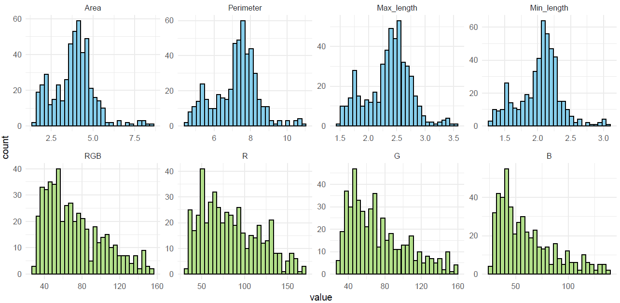
Figure S1. Distribution of seed size and seed coat color traits in Perilla frutescens. Histograms showing the frequency distribution of seed morphological traits (area (㎟), perimeter (㎜), maximum length (㎜), and minimum length (㎜)) and color traits (RGB, R, G, and B) measured across 493 accessions.

Figure S2. Overlap of SNPs identified using ApeKI and PstI–MspI in Perilla frutescens. Venn diagram showing the number of shared and unique SNPs detected by two genotyping-by-sequencing enzyme strategies. A total of 38,320 and 22,517 SNPs were identified using ApeKI and PstI–MspI, respectively, with 2,562 SNPs shared between the two methods, indicating partially overlapping but distinct genomic coverage.

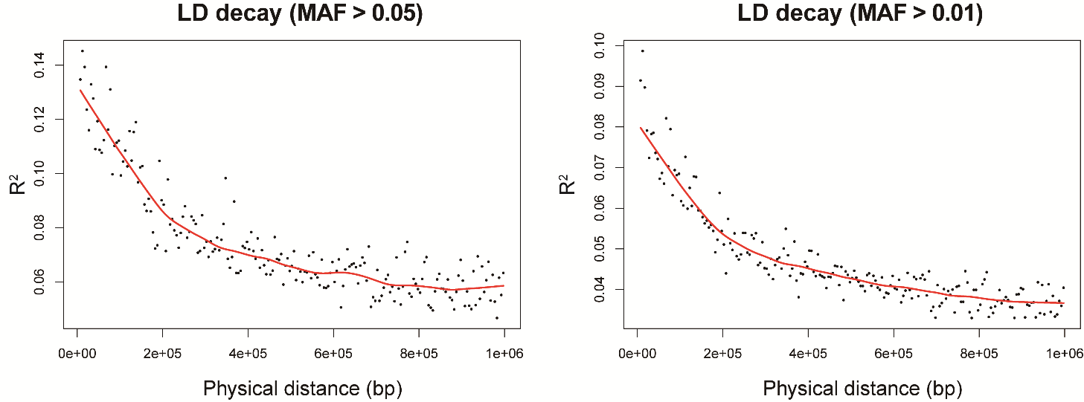
Figure S3. Genome-wide linkage disequilibrium (LD) decay in Perilla frutescens. LD decay was estimated by plotting pairwise r² values against physical distance using SNP markers. Two minor allele frequency (MAF) thresholds were applied (MAF > 0.05 and MAF > 0.01). The red line represents the locally weighted regression (LOESS) curve, illustrating the decay of LD with increasing physical distance.

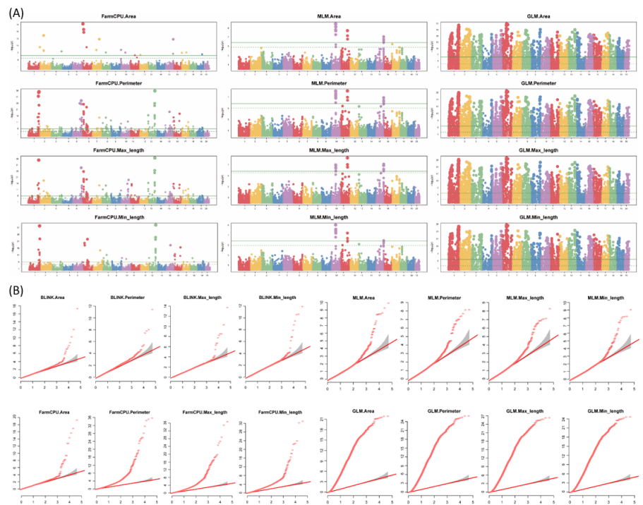
Figure S4. Figure S4. GWAS results and Q–Q plots for seed size-related traits using multiple models in Perilla frutescens. (A) Manhattan plots for seed size-related traits (area, perimeter, maximum length, and minimum length) generated using multiple GWAS models (FarmCPU, MLM, and GLM). The horizontal dashed line indicates the significance threshold. (B) Quantile–quantile (Q–Q) plots for each trait and model, showing the observed versus expected −log₁₀P values to assess model performance and control of false-positive associations.
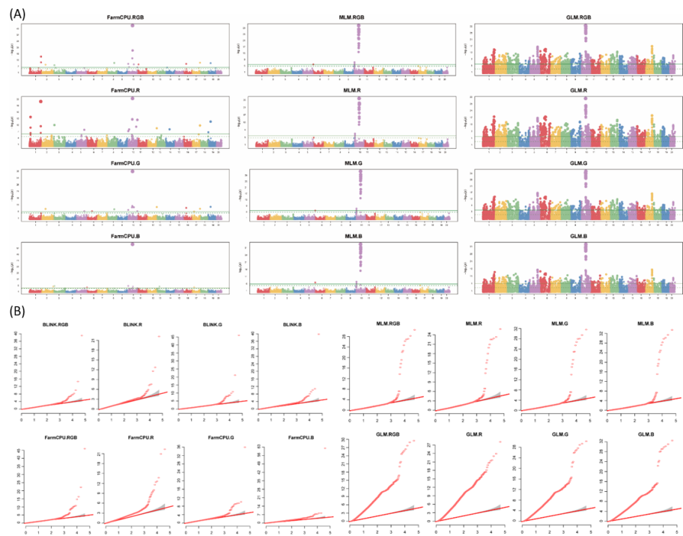
Figure S5. GWAS results and Q–Q plots for seed coat color traits using multiple models in Perilla frutescens. (A) Manhattan plots for seed coat color-related traits (RGB, R, G, and B) generated using multiple GWAS models (GLM, MLM, FarmCPU, and BLINK). The horizontal dashed line indicates the significance threshold. (B) Quantile–quantile (Q–Q) plots for each trait and model, showing the observed versus expected −log₁₀P values to assess model performance and control of false-positive associations.

