Construction of molecular identities and development of a strain identification kit based on fluorescent simple sequence repeat markers in maize
Shuozheng Mei^{1,2}, Feng Wang², Tao Zhang², Zhiyong Fan², Ailin Wan¹, Jing Wang¹, Ruihan Zhang¹, Jiatong Xie¹, Jiwei Xie¹, Qingyou Xia¹, Haibo Rong^{2*}, Genhong Wang^{1*}
¹ Integrative Science Center of Germplasm Creation in Western China (CHONGQING) Science City, Chongqing Technology Innovation Center of Breeding, Biological Science Research Center, Southwest University, Chongqing 400715, China
² First Research Institute of the Ministry of Public Security, Beijing 100048, China
*Corresponding author: wanggh168@swu.edu.cn or ronghb@fiscan.cn

Supplementary Figure 1-9
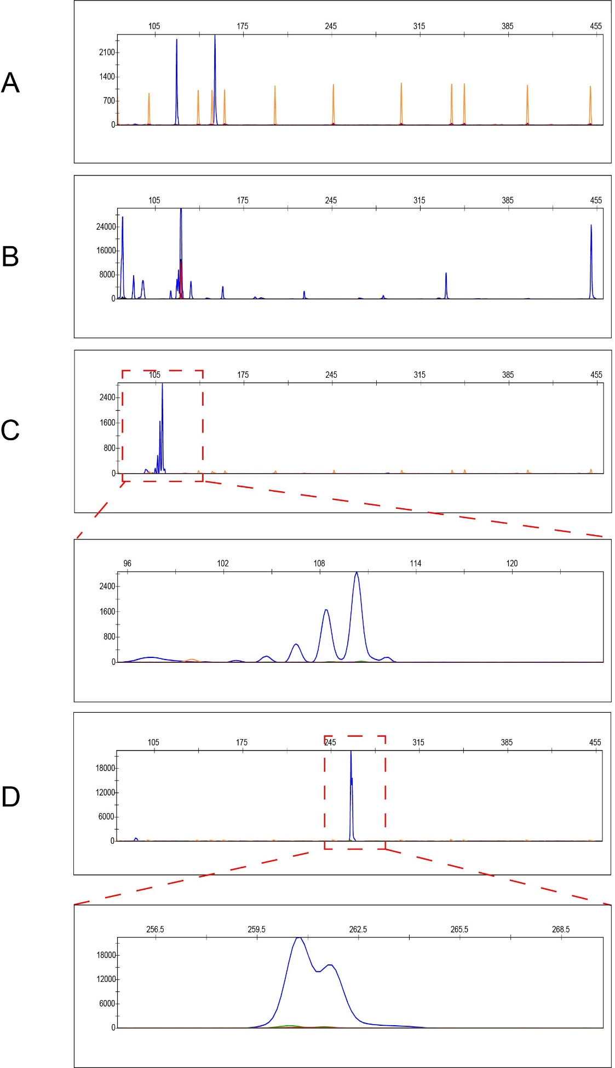
Supplementary Figure 1. Schematic diagram of primer amplification effect (A) Amplification profile of JAAS3790, showing a symmetrical peak shape, sharp peak, no interfering peaks, and excellent amplification performance. (B) Amplification profile of phi080k15, showing numerous non-specific amplification peaks and poor amplification performance. (C) Amplification profile of umc2163w3, showing stutter peaks and poor amplification performance. (D) Amplification profile of umc1231k4, showing incomplete A-addition peaks and poor amplification performance.

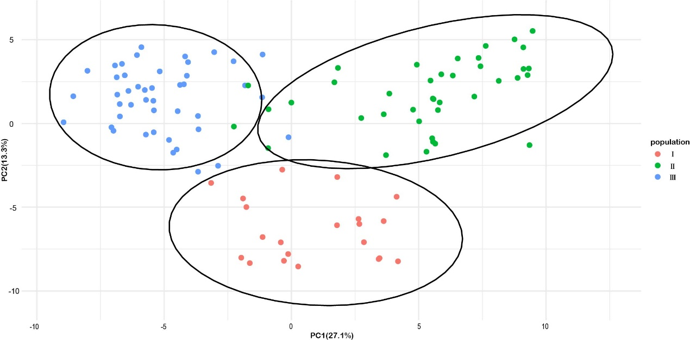
Supplementary Figure 2. Principal component analysis of 104 maize materials based on SSR markers.

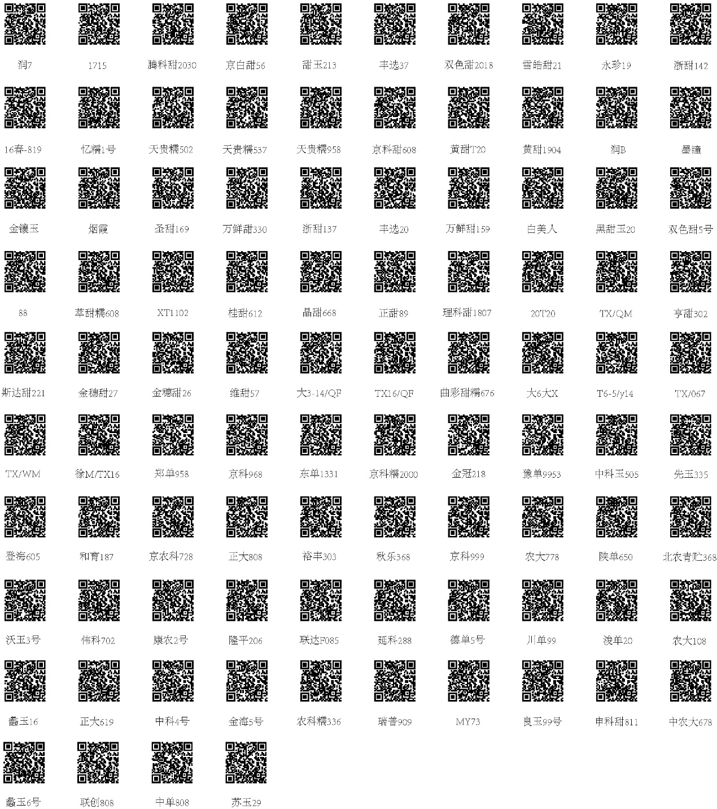
Supplementary Figure 3. QR codes for the remaining maize materials.

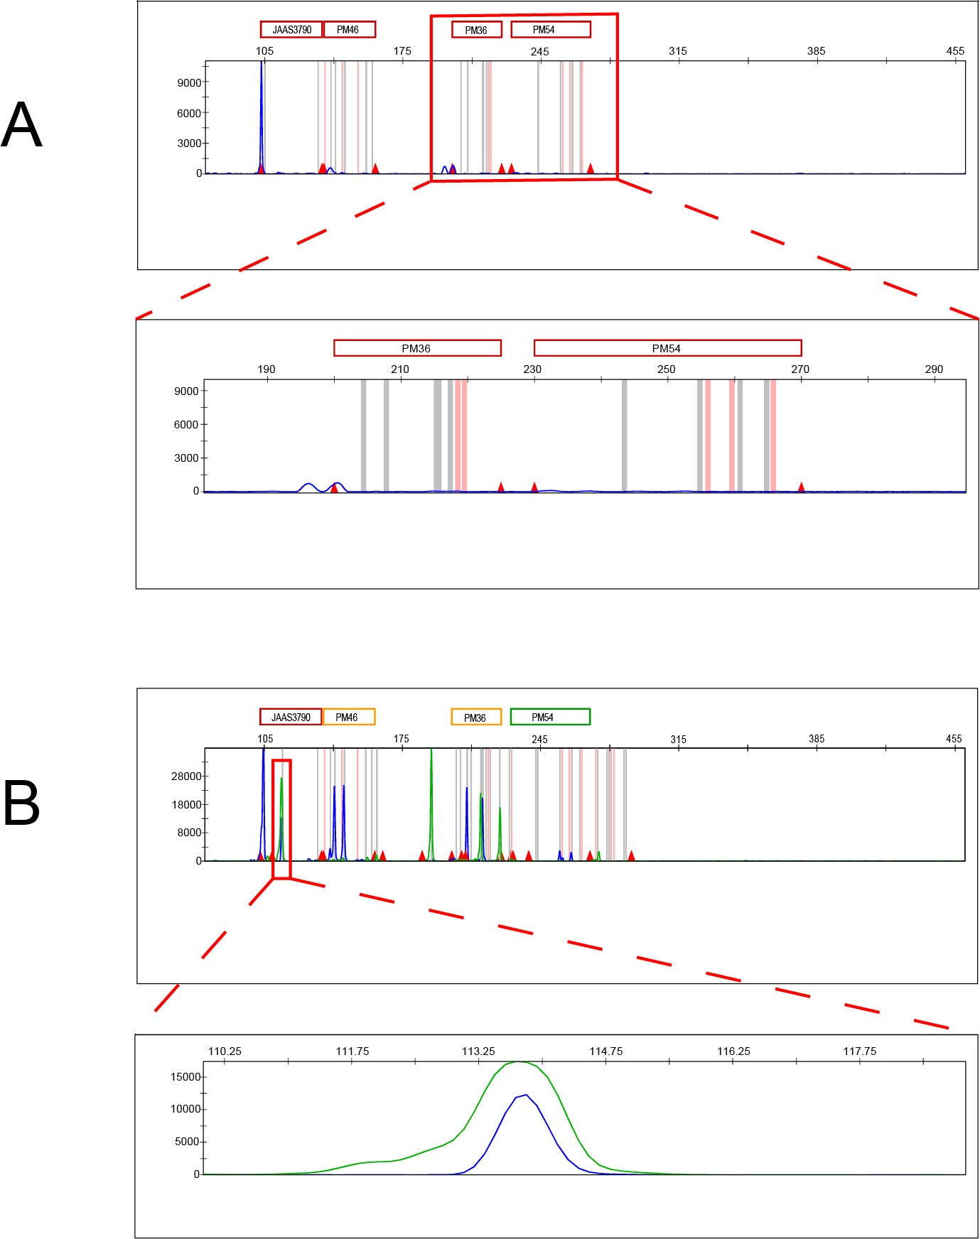
Supplementary Figure 4. Diagram showing the amplification effects of different PCR cycle numbers. (A) At 27 cycles, most loci failed to produce amplification products. (B) At 31 cycles, the product peak amplified by the HEX-labeled primer was too high, resulting in a blue pull-up peak.

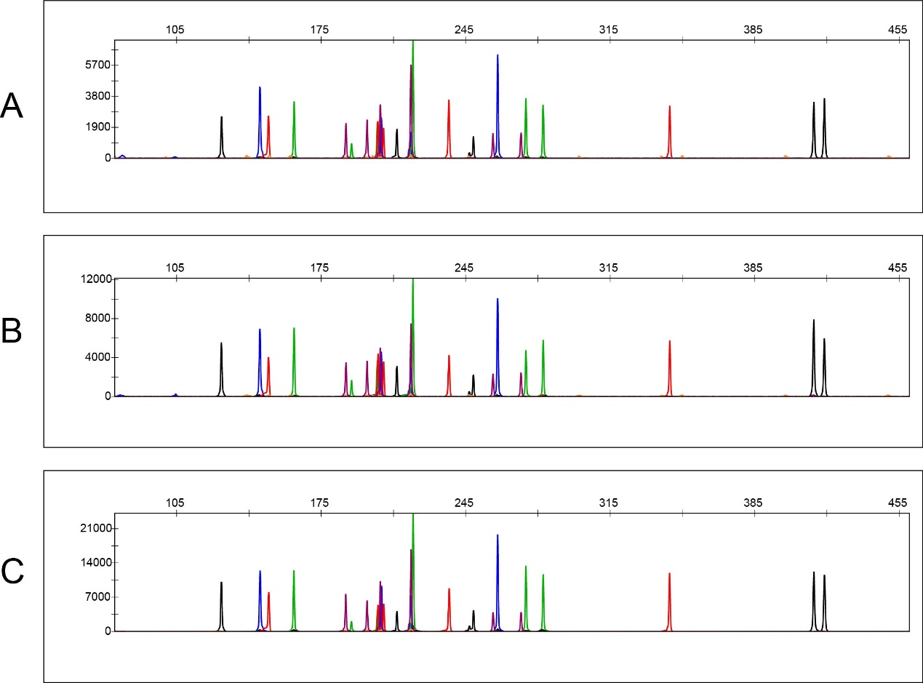
Supplementary Figure 5. Amplification profiles obtained using different PCR cycle numbers. (A) 28 cycles. (B) 29 cycles. (C) 30 cycles.

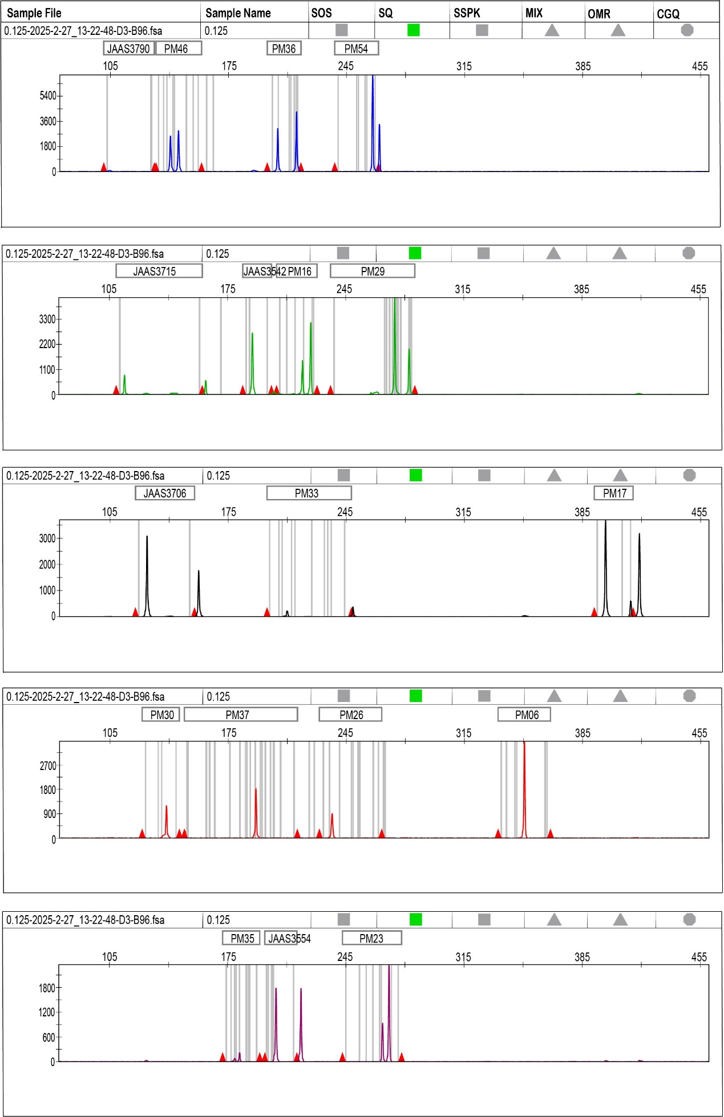
Supplementary Figure 6. Amplification profile of Beinongqingzhu368 using 0.125 ng DNA template.

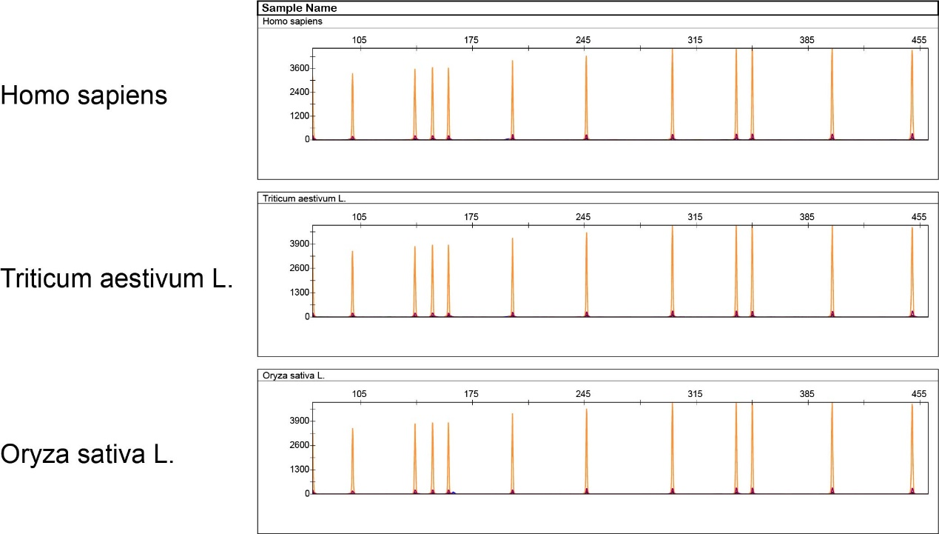
Supplementary Figure 7. Specificity test of the reagent kit.

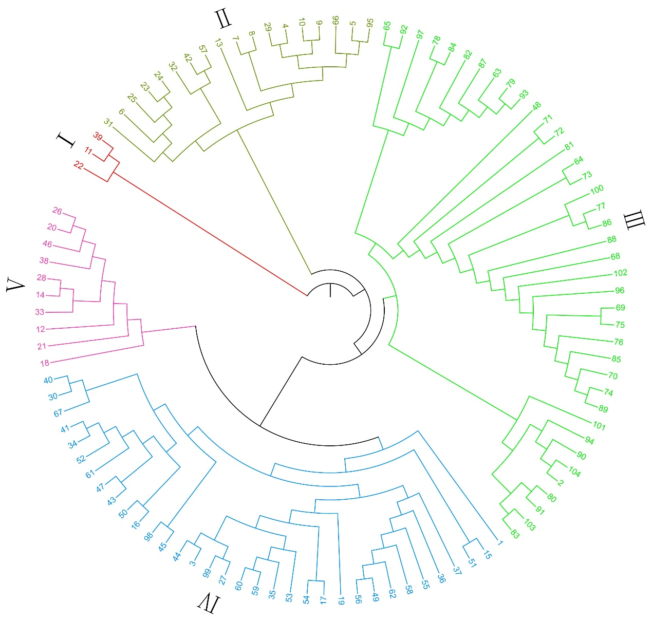
Supplementary Figure 8. UPGMA clustering diagram of 104 maize germplasms divided into five groups.

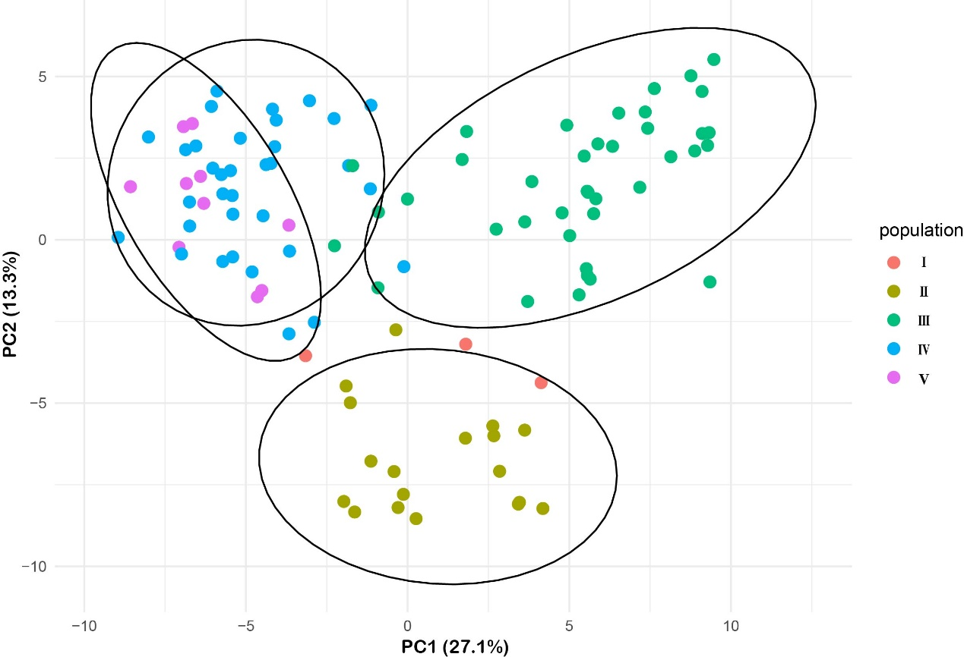
Supplementary Figure 9. Principal component analysis of 104 maize materials divided into five groups based on SSR markers.

Supplementary Table 1-3
Supplementary Table 1. Information on the 39 primer pairs.
Locus | Forward Primer | Reverse Primer
JAAS3533 | GGCATCGTAGCATCCCTCTCC | CATCAAAGCAAGAAGGCAACCC
JAAS3542 | GCCATAGCGACCACCAACAATC | GACCACAGGGATGGGAAACTTG
JAAS3554 | TCAAACAGGGTGGACGAAGAGG | TCACTACGCACTCGATCCCTTC
JAAS3637 | CCGAGTTGTTGCCTCAAATCCC | CTGCTTGGTGGTGGTTGTTCC
JAAS3642 | CATCAAAGCAAGAAGGCAACCC | GGCATCGTAGCATCCCTCTCC
JAAS3706 | GCCCTTTATCAAACCAACCCACAC | GCGTCAGAGCCTAGTTCTATGGTC
JAAS3715 | CCTACCCACAGACGCCCTTTG | TGGCTCTTTCAGTGGCTATTCCTC
JAAS3790 | AACCTTTTGTGGGAGCAGTTACTTG | TGTTGGTGTCGCCCTGTTGTC
phi053k2 | CCCTGCCTCTCAGATTCAGAGATTG | TAGGCTGGCTGGAAGTTTGTTGC
bnlg2305k4 | CCCCTCTTCCTCAGCACCTTG | CGTCTTGTCTCCGTCCGTGTG
umc1545y2 | AATGCCGTTATCATGCGATGC | GCTTGCTGCTTCTTGAATTGCGT
phi080k15 | TGAACCACCCGATGCAACTTG | TTGATGGGCACGATCTCGTAGTC
phi065k9 | CGCCTTCAAGAATATCCTTGTGCC | GGACCCAGACCAGGTTCCACC
umc1492y13 | GCGGAAGAGTAGTCGTAGGGCTAGTGTAG | AACCAAGTTCTTCAGACGCTTCAGG
umc1506k12 | GAGGAATGATGTCCGCGAAGAAG | TTCAGTCGAGCGCCCAACAC
umc1147y4 | AAGAACAGGACTACATGAGGTGCGATAC | GTTTCCTATGGTACAGTTCTCCCTCGC
phi96100y1 | TTTTGCACGAGCCATCGTATAACG | CCATCTGCTGATCCGAATACCC
umc1536k9 | TGATAGGTAGTTAGCATATCCCTGGTATCG | GAGCATAGAAAAAGTTGAGGTTAATATGGAGC
umc1489y3 | GCGGAACAAAGGCACCTTCATA | CTAGCTGCCGCCCTTCGTTAT
bnlg490y4 | GGTGTTGGAGTCGCTGGGAAAG | TTCTCAGCCAGTGCCAGCTCTTATTA
umc1999y3 | GGCCACGTTATTGCTCATTTGC | GCAACAACAAATGGGATCTCCG
umc2115k3 | CGGTTTTCACCAACGGGGAT | CACTGGCAACTGTACCCATC
umc1429y7 | CTTCTCCTCGGCATCATCCAAAC | GGTGGCCCTGTTAATCCTCATCTG
phi299852y2 | AGCAAGCAGTAGGTGGAGGAAGG | AGCTGTTGTGGCTCTTTGCCTGT
umc2160k3 | TCATTCCCAGAGTACCTTAACACTG | CTGTGCTCGTGCTTCTCTCT
bnlg2235y5 | CGCACGGCACGATAGAGGTG | AACTGCTTGCCACTGGTACGGTCT
phi233376y1 | CCGGCAGTCGATTACTCCACG | CAGTAGCCCCTCAAGCAAAACATTC
umc2084w2 | ACTGATCGCGACGAGTTAATTCAAAC | TACCGAAGAACAACGTCATTTCAGC
umc1261k10 | TGGTAATGGTATGTAGAAGAAGTGCGTATG | CAGCGACAAGAGCAGCGTG
bnlg1523k3 | GTTTCGGACGAAAGCCTAATAACCC | AGCCGCGTAGTGGATAGGAGC
umc1136y2 | CCTCTCGTCTCATCACCTTTCCC | GCTGCATACAGACATCCAACCAAAG
phi021y8 | CCAAGTGTAAAGAGTGCGAAGAAGCAG | CCATCACGAAAGGTGGAGGTAGAAGA
mmc0081k1 | GAAAACCATTCCCAGTTAGGAGCAG | GGTTGTTTGCCTCTTCTGTACTCTGTTG
umc1127k1 | CCCCCCTCCCTAATTTTGCTTC | GCACATCTTACGGATCTAGCTGGACTG
phi328175y4 | CTGGAACACCTTCACGCCCTCT | CGGCGACCCACTCATCTCATT
phi116k1 | GTACTTCAACACCGACCTCACCG | CGGCCATGGATGGGATACAA
umc1741w1 | CATGCGCTTGGCATCTCCATGTATATC | CTGGTGCAGCAATGGCCGAG
bnlg162k2 | GGCTCACGTCCGTATCCAAACC | TCAGTTCAGGTCCGTCGTCCAG
bnlg1712k17 | CGATTTCACGGCTCGTGGC | GAAAATACCCTTGGTTCTCCTTCCTGG

Supplementary Table 2. Information on the 104 core maize germplasms.
Number | Name | Number | Name | Number | Name
1 | S010 | 36 | Fengxuan20 | 71 | Denghai605
2 | Zhengtian66 | 37 | Wanxiantian159 | 72 | Heyu187
3 | Huangbaitian11 | 38 | Baimeiren | 73 | Jingnongke728
4 | Wannuo2000 | 39 | Heitianyu20 | 74 | Zhengda808
5 | Baitiannuo336 | 40 | Shuangsetian5hao | 75 | Yufeng303
6 | Caitiannuo932 | 41 | 88 | 76 | Qiule368
7 | Run20 | 42 | Cuitiannuo608 | 77 | Jingke999
8 | Run19 | 43 | XT1102 | 78 | Nongda778
9 | Run18 | 44 | Guitian612 | 79 | Shandan650
10 | Run16 | 45 | Jingtian668 | 80 | Beinongqingzhu368
11 | Run7 | 46 | Zhengtian89 | 81 | Woyu3hao
12 | 1715 | 47 | Liketian1807 | 82 | Weike702
13 | Tengketian2030 | 48 | 20T20 | 83 | Kangnong2hao
14 | Jingbaitian56 | 49 | TX/QM | 84 | Longping206
15 | Tianyu213 | 50 | Hengtian302 | 85 | Liandaf085
16 | Fengxuan37 | 51 | Sidatian221 | 86 | Yanke288
17 | Shuangsetian2018 | 52 | Jinsuitian27 | 87 | Dedan5hao
18 | Xuehaotian21 | 53 | Jinsuitian26 | 88 | Chuandan99
19 | Yongzhen19 | 54 | Weitian57 | 89 | Jundan20
20 | Zhetian142 | 55 | Da3-14/QF | 90 | Nongda108
21 | 16chun-819 | 56 | TX16/QF | 91 | Liyu16
22 | Yinuo1hao | 57 | Qucaitiannuo676 | 92 | Zhengda619
23 | Tianguinuo502 | 58 | Da6daX | 93 | Zhongke4hao
24 | Tianguinuo537 | 59 | T6-5/y14 | 94 | Jinhai5hao
25 | Tianguinuo958 | 60 | TX/067 | 95 | Nongkenuo336
26 | Jingketian608 | 61 | TX/WM | 96 | Ruipu909
27 | HuangtianT20 | 62 | XuM/TX16 | 97 | MY73
28 | Huangtian1904 | 63 | Zhengdan958 | 98 | Liangyu99hao
29 | RunB | 64 | Jingke968 | 99 | Shenketian811
30 | Motong | 65 | Dongdan1331 | 100 | Zhongnongda678
31 | Jinxiangyu | 66 | Jingkenuo2000 | 101 | Liyu6hao
32 | Yanxia | 67 | Jinguan218 | 102 | Lianchuang808
33 | Shengtian169 | 68 | Yudan9953 | 103 | Zhongdan808
34 | Wanxiantian330 | 69 | Zhongkeyu505 | 104 | Suyu29
35 | Zhetian137 | 70 | Xianyu335

Supplementary Table 3. Optimal parameters of the kit.
Parameter | Volume per reaction
Optimal template quantity | 1 ng
Optimal cycle number | 28 cycle
Optimal primer concentration | 2 μl
Optimal injection volume | 1 μl

