BcPHT1;9 mediates phosphate uptake and modulates root architecture in flowering Chinese cabbage
Wenjie Yang#, Yanxu Xue#, Ali Anwar, Caizhu Hu, Mengge Zhang, Chunfeng Chen, Jinmiao Wang, Shiwei Song*
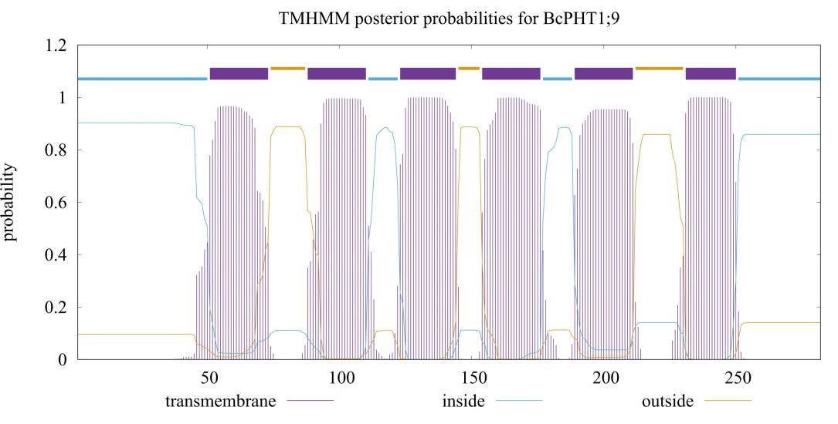
Figure S1 Prediction of Transmembrane Domain of BcPHT1;9 protein from flowering Chinese cabbage

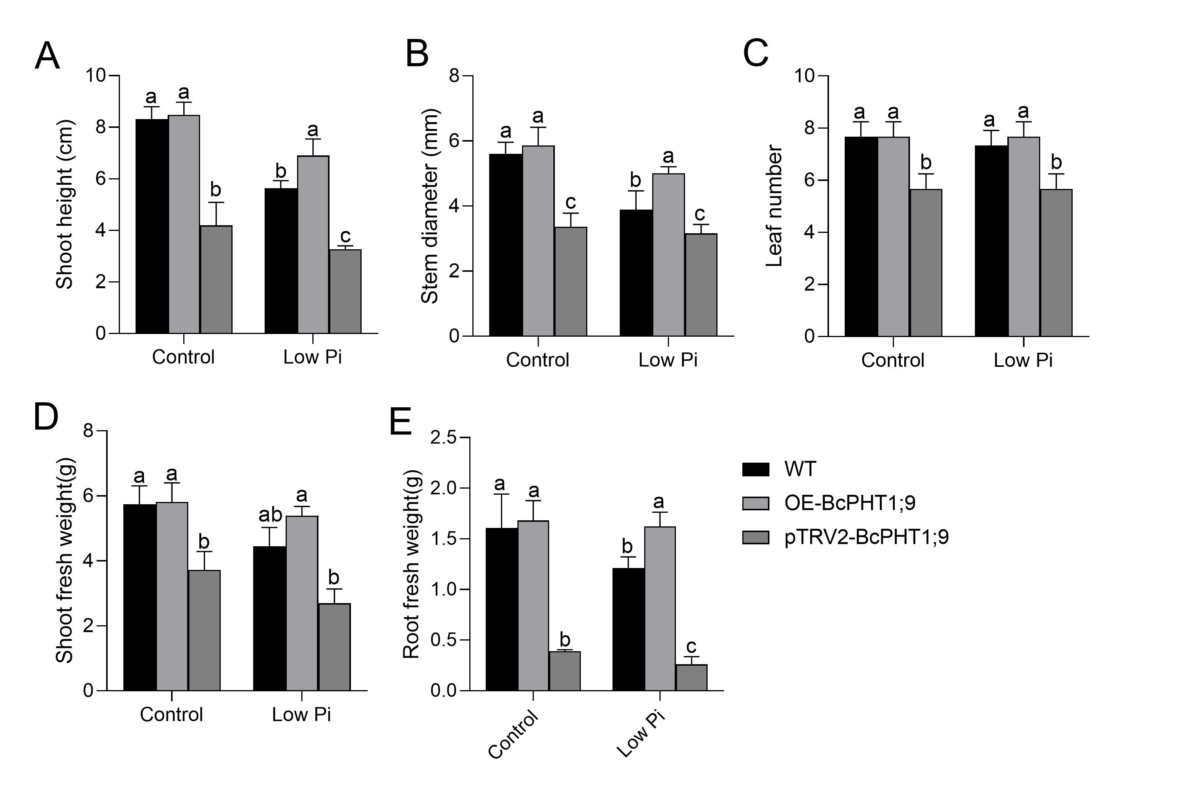
Figure S2 Shoot height(A), Stem diameter(B),Leaf number(C), Shoot fresh weight(D) and Root fresh weight(E) in OE-BcPHT1;9 and BcPHT1;9-silenced plants of flowering Chinese cabbage. Statistical differences among multiple groups were determined by two-way ANOVA followed by Tukey’s post-hoc test at P < 0.05.
Table S1 Gene IDs of BcPHT1 family genes in flowering Chinese cabbage
Gene | Gene ID
BcPHT1;1 | Bra_cxA02g016880.3
BcPHT1;2 | Bra_cxA02g016810.1
BcPHT1;3 | Bra_cxA03g050060.1
BcPHT1;4 | Bra_cxA03g046920.3
BcPHT1;5 | Bra_cxA04g007220.1
BcPHT1;6 | Bra_cxA04g005310.1
BcPHT1;7 | Bra_cxA06g001300.1
BcPHT1;8 | Bra_cxA06g001280.3
BcPHT1;9 | Bra_cxA07g016190.1
BcPHT1;10 | Bra_cxA07g003280.1
BcPHT1;11 | Bra_cxA07g003270.1
BcPHT1;12 | Bra_cxA09g049580.3
BcPHT1;13 | Bra_cxA09g049310.1

Table S2 Primer sequences used for the subcellular localization analysis
 | Forward primer (5′→3′) | Reverse primer (5′→3′)
BcPHT1;9-GFP | gagaacacgggggactctagaATGCCGGAGTTAAGAGTGTTATC | ataagggactgaccacccgggTTCTATAGGGAATAACTCATTACCAGAAG
PBI121-eGFP | CCACTGACGTAAGGGATGACGC | CATCGCAAGACCGGCAACAG

Table S3 Primer sequences used for the quantitative real-time PCR assay
Gene | Forward primer (5′→3′) | Reverse primer (5′→3′)
BcPHT1;1 | CAAAGCTGATTAAGATTGGACA | GCATCGGTAAAGAAACCCAT
BcPHT1;2 | AAGACTCGTGGTGGGTTCAT | AGGTACAGTCGAGGCATACG
BcPHT1;3 | ACCCAAACTCCTTCGGCTTA | TGGAAGAGGTTGCTGCTGTA
BcPHT1;4 | GACCACTGGACTCACAAGGA | ACCATGGCATGTGGATCTGA
BcPHT1;5 | ACTCGTGGAGCGTTTATTGC | TGAGAAACCGTGGATCCCAA
BcPHT1;6 | CCTATGCGGATGATGCCTTG | AGCTGTGTACCTTGCTGTCT
BcPHT1;7 | ACTACCACAAGAACGGAGCA | TCTCCAAGCCACCCAAAGAA
BcPHT1;8 | GGTGACTACCCTCTCTCTGC | AACCTCCGGCTAAGATACCG
BcPHT1;9 | CATGGTGTTCAGCTCCTTCG | AGAGGGTAGTCTCCACCGAT
BcPHT1;10 | CCTGCGCCAAGAGTGTTATC | GGTCATAAGCGTCGGTGAAG
BcPHT1;11 | ACCGACGCTTACGATCTCTT | CGTCCGACTCTGTCACCTAA
BcPHT1;12 | ATACCGGCCGAGATATTCCC | CACCAAGCGTGATCAGTGAG
BcPHT1;13 | TGCTGTCTCTTCCATTTTCG | ATAACAACGAAGCCGATACG

Table S4 Primer sequences used for VIGS
 | Forward primer (5′→3′) | Reverse primer (5′→3′)
pTRV2-BcPHT1;9 | TAAGGTTACCGAATTCATGCCGGAGTTAAGAGTGTTATCGG | GCTCGGTACCGGATCCATGATCAAGAGACAGAGACCGTATACTTT
pTRV2 | TGAGGGAAAAGTAGAGAACG | CCTATGGTAAGACAATGAGT
pTRV1 | CTTGAAGAAGAAGACTTTCGAAGTCTC | GTAAAATCATTGATAACAACACAGACAAAC

Table S5 Primer sequences used for gene overexpression
 | Forward primer (5′→3′) | Reverse primer (5′→3′)
pC1300-BcPHT1;9 | atttggagaggacagggtaccATGCCGGAGTTAAGAGTGTTATCG | agtgtcgactctagaggatccTTCTATAGGGAATAACTCATTACCAGAAG
pC1300 | CTATCCTTCGCAAGACCC | CCCAATGCCATAATACTCG

