Ion homeostasis and redox stability are associated with cultivar-dependent preservation of essential oil quality in salt-stressed Pelargonium graveolens
Ekta Pandey^{1*}, Rinkee Kumari¹, and Shahla Faizan¹
¹Environmental Physiology Laboratory, Department of Botany, Aligarh Muslim University, Aligarh 202002 (U.P.), India
*Corresponding Authors:
Ekta Pandey

*E-mail: gm6367@myamu.ac.in; epandey251@gmail.com

ORCiD: 0009–0001-0780–9975

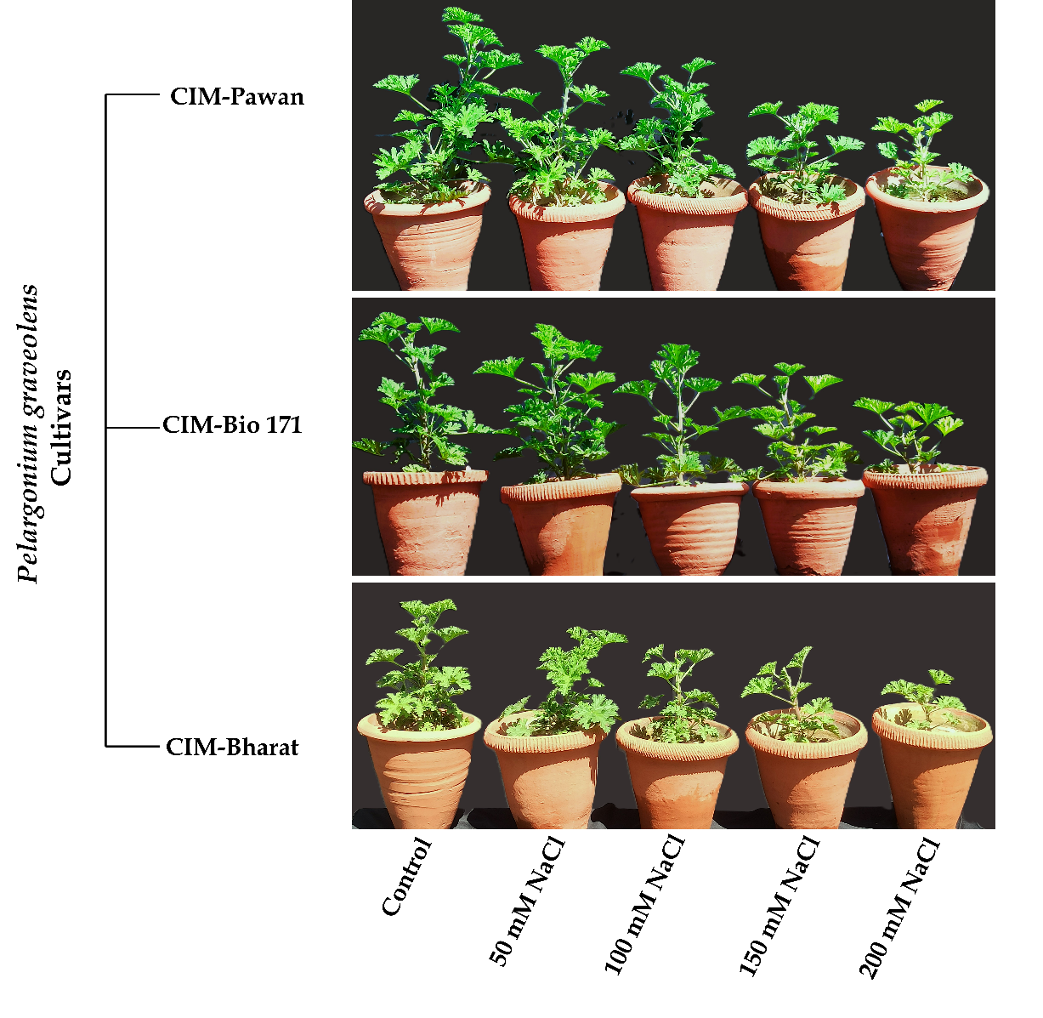
Figure S1. Morphological appearance of Pelargonium graveolens cultivars 30 days after exposure to different NaCl concentrations (0–200 mM). Representative potted plants illustrate the cultivar-specific effects of salinity on plant growth and morphology.
Table S1. Effects of different NaCl concentrations (50–200 mM) on the physiological attributes of Pelargonium graveolens cultivars. Values are presented as mean ± SE (n = 5). Within each cultivar, means followed by different superscript letters (a–e) differ significantly among treatments (Duncan’s multiple range test, p < 0.05). Two-way ANOVA was used to evaluate the main effects of salinity, cultivar, and their interaction. ns, nonsignificant; *, p < 0.05; **, p < 0.01; ***, p < 0.001.
Cultivar | NaCl  Treatment | Plant height  (cm) | Fresh weight (g) | Dry weight (g) | Branch number (Plant⁻¹) | Leaf number (Plant⁻¹) | Leaf area  (cm² Plan⁻¹)
CIM-Pawan | Control  50mM  100mM  150mM  200mM |  | 2.8×10²±5.87ª  2.8×10²±5.55ª  2.6×10²±7.82^{b}  2.2×10²±7.23^{c}  2.1×10²±5.92^{d} | 68.4±0.91ª  66.8±0.76^{b}  59.4±1.16^{c}  51.9±0.88^{d}  47.7±0.88e | 14±0.67ª  12±0.31^{b}  9±0.24^{c}  7±0.32^{d}  6±0.24^{d} | 50±1.71ª  47±0.44^{ab}  44±0.86^{b}  39±0.86^{c}  35±1.60^{d}
  42.7±0.94ª
  41.8±1.14^{b}
  37.2±1.22^{c}
  32.6±0.88^{d}
  29.2±1.33e
  2.7×10³±33.7ª
  2.5×10³±17.4^{b}
  2.1×10³±21.2^{c}
  1.7×10³±17.2^{d}
  1.5×10³±13.9e
CIM- Bio-171 | Control  50mM  100mM  150mM  200mM |  | 2.9×10²±8.77ª  2.8×10²±7.28ª  2.5×10²±5.88^{b}  2.2×10²±5.28^{c}  1.9×10²±4.06^{d} | 68.9±1.24ª  65.9±0.71^{b}  60.9±0.82^{c}  50.9±0.96^{d}  46.0±0.87e | 14±0.73ª  11±0.58^{b}  8±0.58^{c}  6±0.37^{d}  5±0.24^{d} | 51±1.56ª  46±1.63ª  41±1.43^{b}  31±1.15^{c}  26±0.67^{c}
  44.2±0.74ª
  41.2±1.23^{b}
  36.0±0.97^{c}
  33.0±1.10^{d}
  28.8±1.04e
  2.7×10³±14.2ª
  2.4×10³±17.4^{b}
  2.0×10³±24.0^{c}
  1.6×10³±21.6^{d}
  1.2×10³±22.3e
CIM-Bharat | Control  50mM  100mM  150mM  200mM |  | 2.8×10²±7.13ª  2.6×10²±5.84^{b}  2.3×10²±4.88^{c}  2.0×10²±5.65^{d}  1.7×10²±5.54e | 64.2±0.96ª  60.6±0.90^{b}  52.2±0.79^{c}  44.6±0.75^{d}  38.2±1.18e | 13±0.70ª  10±0.40^{b}  7±0.31^{c}  5±0.24^{d}  4±0.31e | 42±1.24ª  38±1.21ª  30±1.36^{b}  26±1.69^{b}  18±0.99^{c}
  38.4±1.19ª
  34.8±0.80^{b}
  28.9±0.57^{c}
  24.2±1.27^{d}
  19.0±1.15e
  2.3×10³±25.3ª
  1.9×10³±23.6^{b}
  1.6×10³±20.3^{c}
  1.2×10³±21.6^{d}
  0.9×10³±14.5e
Two-way Anova | Salinity  Cultivar  Salinity× Cultivar | ***  ***  *** | ***  ***  *** | ***  ***  * | ***  ***  ns | ***  ***  * | ***  ***  *

Table S2. Effects of different NaCl concentrations (50–200 mM) on the essential oil and trichome attributes of Pelargonium graveolens cultivars. Values are presented as mean ± SE (n = 5). Within each cultivar, means followed by different superscript letters (a–e) differ significantly among treatments (Duncan’s multiple range test, p < 0.05). Two-way ANOVA was used to evaluate the main effects of salinity, cultivar, and their interaction. ns, nonsignificant; *, p < 0.05; **, p < 0.01; ***, p < 0.001.
Cultivar | NaCl  Treatment | Essential oil % | Essential oil yield  (mL Plant⁻¹) | Total trichome density (mm-2) | Average width of trichomes (µm) | Average length of trichomes (µm)
CIM-Pawan | Control  50mM  100mM  150mM  200mM |  | 1.24±0.05ª  1.26±0.04ª  0.99±0.03^{b}  0.65±0.02^{c}  0.46±0.02^{d} | 35.8±0.86ª  37.4±1.21ª  27.6±1.07^{b}  24.6±0.66^{c}  22.8±0.58^{c} | 45.8±1.12ª  46.4±0.73ª  40.8±0.95^{b}  37.9±0.80^{c}  36.9±0.82^{c} | 52.2±0.87ª  51.1±0.81^{b}  48.3±0.94^{c}  46.5±0.91^{d}  43.3±0.72e
  0.43±0.18ª
  0.45±0.15ª
  0.38±0.12^{b}
  0.28±0.01^{c}
  0.22±0.11^{d}
CIM- Bio-171 | Control  50mM  100mM  150mM  200mM |  | 1.21±0.02ª  1.20±0.03ª  0.93±0.01^{b}  0.55±0.02^{c}  0.40±0.02^{d} | 36.0±1.05ª  36.5±1.63ª  25.6±0.93^{b}  23.8±0.96^{bc}  22.0±0.54^{c} | 36.9±1.18ª  35.7±0.70ª  30.3±0.36^{b}  28.2±0.48^{c}  25.5±0.64^{d} | 47.9±0.99ª  45.5±0.89^{b}  40.3±0.73^{c}  37.9±0.84^{d}  36.5±0.77e
  0.41±0.01ª
  0.42±0.11ª
  0.36±0.01^{b}
  0.25±0.01^{c}
  0.20±0.01^{d}
CIM-Bharat | Control  50mM  100mM  150mM  200mM |  | 1.27±0.04ª  1.19±0.03ª  0.91±0.02^{b}  0.55±0.03^{c}  0.34±0.02^{d} | 38.0±1.20ª  35.8±1.01ª  26.2±0.86^{b}  24.6±0.60^{bc}  22.2±0.66^{c} | 35.0±0.85ª  30.7±0.59^{b}  28.5±0.66^{c}  25.4±0.48^{d}  22.4±0.41e | 51.0±1.12ª  46.0±1.05^{b}  39.2±0.84^{c}  34.8±0.78^{d}  31.9±0.53e
  0.45±0.02ª
  0.45±0.01ª
  0.38±0.01^{b}
  0.27±0.04^{c}
  0.19±0.02^{d}
Two-way Anova | Salinity  Cultivar  Salinity× Cultivar | ***  **  ns | ***  **  * | ***  ns  ns | ***  ***  ** | ***  ***  ***

Table S3. Effects of different NaCl concentrations (50–200 mM) on stem, root, and leaf anatomical attributes of Pelargonium graveolens cultivars. Values are presented as mean ± SE (n = 5). Within each cultivar, means followed by different superscript letters (a–e) differ significantly among treatments (Duncan’s multiple range test, p < 0.05). Two-way ANOVA was used to evaluate the main effects of salinity, cultivar, and their interaction. ns, nonsignificant; *, p < 0.05; **, p < 0.01; ***, p < 0.001.
Cultivar | NaCl  Treatment | Stem |  |  | Root |  |  | Leaf
Cultivar | NaCl  Treatment | Cortex Thickness (μm) | Xylem Diameter  (μm) | Vascular bundle area (μm²) | Cortex Thickness (μm) | Xylem Diameter (μm) | Vascular cylinder area (μm²) | Parenchyma Thickness (μm) | Xylem Diameter (μm) | Vascular bundle area (μm²)
CIM-Pawan | Control | 271.5±5.1ª | 77.9±1.2ª | 1.39×10⁵±1280ª | 256.1±3.1ª | 70.5±1.6ª | 2.12×10⁵±1720ª | 184.1±1.9ª | 53.6±0.5ª | 1.18×10⁵±1208ª
CIM-Pawan | 50mM | 267.8±3.8ª | 75.2±0.9ª | 1.35×10⁵±1356ª | 241.3±2.3^{b} | 66.4±0.9^{b} | 1.99×10⁵±1400^{b} | 178.4±1.1^{b} | 51.1±0.3^{b} | 1.19×10⁵±1816ª
CIM-Pawan | 100mM | 239.8±4.2^{b} | 70.3±1.3^{b} | 1.20×10⁵±1536^{b} | 213.2±2.3^{c} | 59.6±0.3^{c} | 1.72×10⁵±927^{c} | 163.5±0.9^{c} | 47.2±0.6^{c} | 1.12×10⁵±1208^{b}
CIM-Pawan | 150mM | 201.3±3.5^{c} | 57.5±0.5^{c} | 1.11×10⁵±3075^{c} | 181.6±2.5^{d} | 51.4±0.8^{d} | 1.58×10⁵±1166^{d} | 154.3±1.8^{d} | 40.4±1.1^{d} | 1.07×10⁵±1503^{c}
CIM-Pawan | 200mM | 174.6±5.5^{d} | 49.9±0.7^{d} | 0.90×10⁵±2336^{d} | 167.1±1.6e | 40.7±1.1e | 1.28×10⁵±1516e | 141.4±2.9e | 36.4±1.1e | 0.97×10⁵±2014^{d}
CIM-  Bio-171 | Control | 265.2±5.3ª | 76.2±0.6ª | 1.39×10⁵±1183ª | 253.4±4.3ª | 67.3±1.1ª | 2.08×10⁵±1462ª | 181.4±2.1ª | 55.9±0.9ª | 1.19×10⁵±1356ª
CIM-  Bio-171 | 50mM | 270.5±5.6ª | 73.5±0.5^{b} | 1.32×10⁵±1248^{b} | 238.4±3.8^{b} | 62.8±0.7^{b} | 1.91×10⁵±1356^{b} | 172.1±0.9^{b} | 50.2±0.6^{b} | 1.19×10⁵±860ª
CIM-  Bio-171 | 100mM | 229.2±2.5^{b} | 66.7±0.2^{c} | 1.16×10⁵±2731^{c} | 207.8±4.1^{c} | 57.1±0.3^{c} | 1.67×10⁵±2501^{c} | 156.6±1.1^{c} | 47.7±0.3^{b} | 1.10×10⁵±1414^{b}
CIM-  Bio-171 | 150mM | 192.1±3.4^{c} | 55.5±0.4^{d} | 1.10×10⁵±1288^{c} | 174.1±3.2^{d} | 45.7±0.7^{d} | 1.46×10⁵±2351^{d} | 144.1±3.6^{d} | 40.4±1.2^{c} | 0.97×10⁵±1029^{c}
CIM-  Bio-171 | 200mM | 162.4±3.5^{d} | 45.9±0.9e | 0.86×10⁵±3187^{d} | 158.9±3.8e | 37.3±0.8e | 1.19×10⁵±2549e | 133.7±1.9e | 36.5±0.8^{d} | 0.91×10⁵±583^{d}
CIM-Bharat | Control | 297.6±7.7ª | 76.7±1.2ª | 1.34×10⁵±1208ª | 261.7±3.6ª | 68.6±0.7ª | 2.21×10⁵±2217ª | 182.4±1.2ª | 52.3±0.6ª | 1.27×10⁵±678ª
CIM-Bharat | 50mM | 278.3±5.2^{b} | 74.9±0.3ª | 1.27×10⁵±1881^{b} | 241.3±5.1^{b} | 62.8±0.3^{b} | 1.94×10⁵±1077^{b} | 171.3±2.4^{b} | 48.7±0.5^{b} | 1.21×10⁵±1805^{b}
CIM-Bharat | 100mM | 244.6±4.3^{c} | 63.4±0.4^{b} | 1.08×10⁵±1720^{c} | 215.4±2.9^{c} | 53.5±0.7^{c} | 1.75×10⁵±1019^{c} | 152.8±1.1^{c} | 41.8±0.5^{c} | 1.16×10⁵±1280^{c}
CIM-Bharat | 150mM | 206.1±2.3^{d} | 55.4±0.1^{c} | 0.96×10⁵±1067^{d} | 174.6±3.3^{d} | 46.5±0.5^{d} | 1.51×10⁵±2690^{d} | 140.6±3.3^{d} | 35.2±0.6^{d} | 0.94×10⁵±1157^{d}
CIM-Bharat | 200mM | 177.3±3.2e | 39.6±1.1^{d} | 0.75×10⁵±1593e | 149.2±3.4e | 34.8±0.2e | 1.22×10⁵±2135e | 126.7±2.4e | 28.4±0.7e | 0.89×10⁵±1772e
Two-way Anova | Salinity  Cultivar  Salinity× Cultivar | ***  ***  ns | ***  ***  *** | ***  ***  ns | ***  **  ** | ***  ***  ns | ***  ***  ** | ***  ***  ns | ***  ***  ** | ***  ***  ***

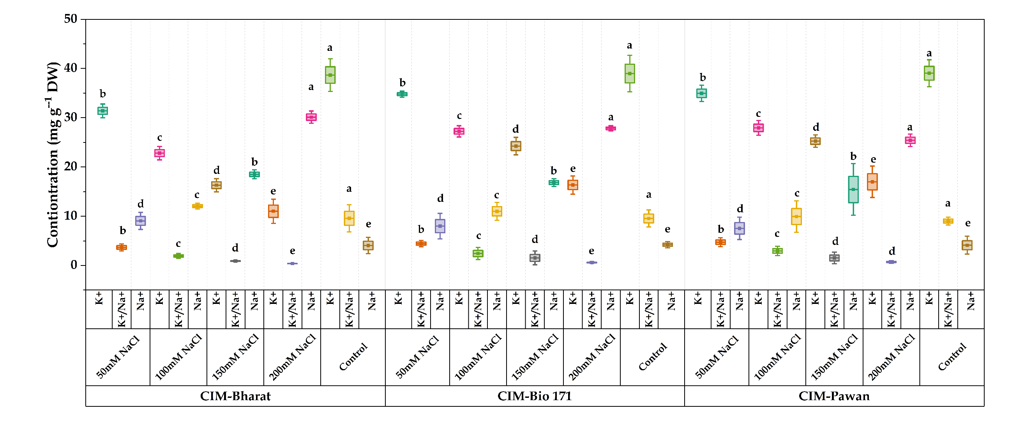
(A)
Figure S2. Salinity-induced changes in ionic homeostasis in Pelargonium graveolens under 0–200 mM NaCl. (A) K⁺, Na⁺, and K⁺/Na⁺ ratio showing cultivar-dependent ionic regulation. Values are presented as mean ± SE (n = 5). Within each cultivar, means followed by different superscript letters (a–e) differ significantly among treatments (Duncan’s multiple range test, p < 0.05).

