Fig. S1 Preliminary germination experiments screened for optimal ZnO NPs concentrations. (A) Biomass and (B) of 7-day-old alfalfa seedlings germinated with water and 10, 20, 30 and 40 mg/L ZnO NPs, respectively. CK: Distilled water; S: 200mmol/L NaCl
Fig. S2 Effects of exogenous ZnO NPs applied under salt stress on photosynthetic indexes of alfalfa leaves. Note: (A) Chlorophyll Content (SPAD); (B) PSII maximum optical quantum yield Fv/Fm

Fig. S3. Effects of exogenous ZnO NPs on physiological indexes of alfalfa under salt stress. Note: (A) total antioxidant capacity (T-AOC); (B) DPPH radical scavenging activity; (C) Stem tip tolerance index (STl); (D) Malondialdehyde content (MDA). The data represent the mean ± SEM. Different letters signifying p-values of < 0.05.
Fig. S4. Effects of ZnO NPs (20 mg/L) alone on Na⁺ content (A), K⁺ content (B), and K⁺/Na⁺ (C) of alfalfa under 200 mM NaCl treatment. The data represent the mean ± SEM. Different letters signifying p-values of < 0.05.

Fig. S5. Principal component analysis (PCA) of the samples. Plants were treated with zinc oxide nanoparticles (ZnO NPs, 20 mg/L) and kept in 200 mM NaCl treated conditions for 30 days.
Fig. S6. The Gene Ontology (GO) term analysis of differentially expressed genes (DEGs) in different comparisons. (A) S vs CK. (B) S vs Z. (C) SZ vs CK. (D) SZ vs S. (E) SZ vs Z. CK: control; S: 200 mM NaCl; Z: 20 mg/ZnO NPs ; SZ: 200 mM NaCl plus 20 mg/ZnO NPs.

Figure S7. qRT-PCR validation of five differentially expressed genes identified by RNA-seq. Relative expression levels of ZIP4 (MsG0380017268.01), WRKY33 (MsG0480018500.01), CML45 (MsG0780036291.01), ERF098 (MsG0180003830.01), and CaCA (MsG0280010132.01) were determined under the CK, S, Z, and SZ treatments. Bars represent qRT-PCR relative-expression values, while the overlaid lines represent the corresponding RNA-seq expression trends. Data are presented as mean ± SEM of three independent biological replicates, with three technical replicates per biological replicate. Different lowercase letters indicate significant differences among treatments according to one-way ANOVA followed by Duncan’s multiple range test at P < 0.05.
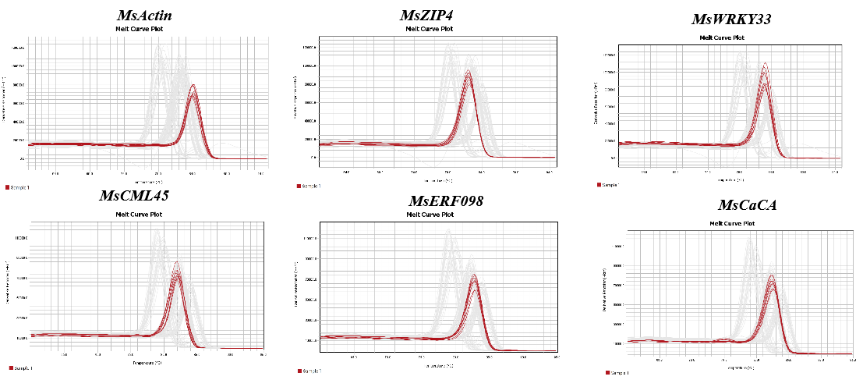
Figure S8. Melt-curve analysis of qPCR amplicons. Single melting peaks were obtained for the reference gene MsActin and the five target genes MsZIP4, MsWRKY33, MsCML45, MsERF098, and MsCaCA, supporting the specificity of the qPCR amplification.

