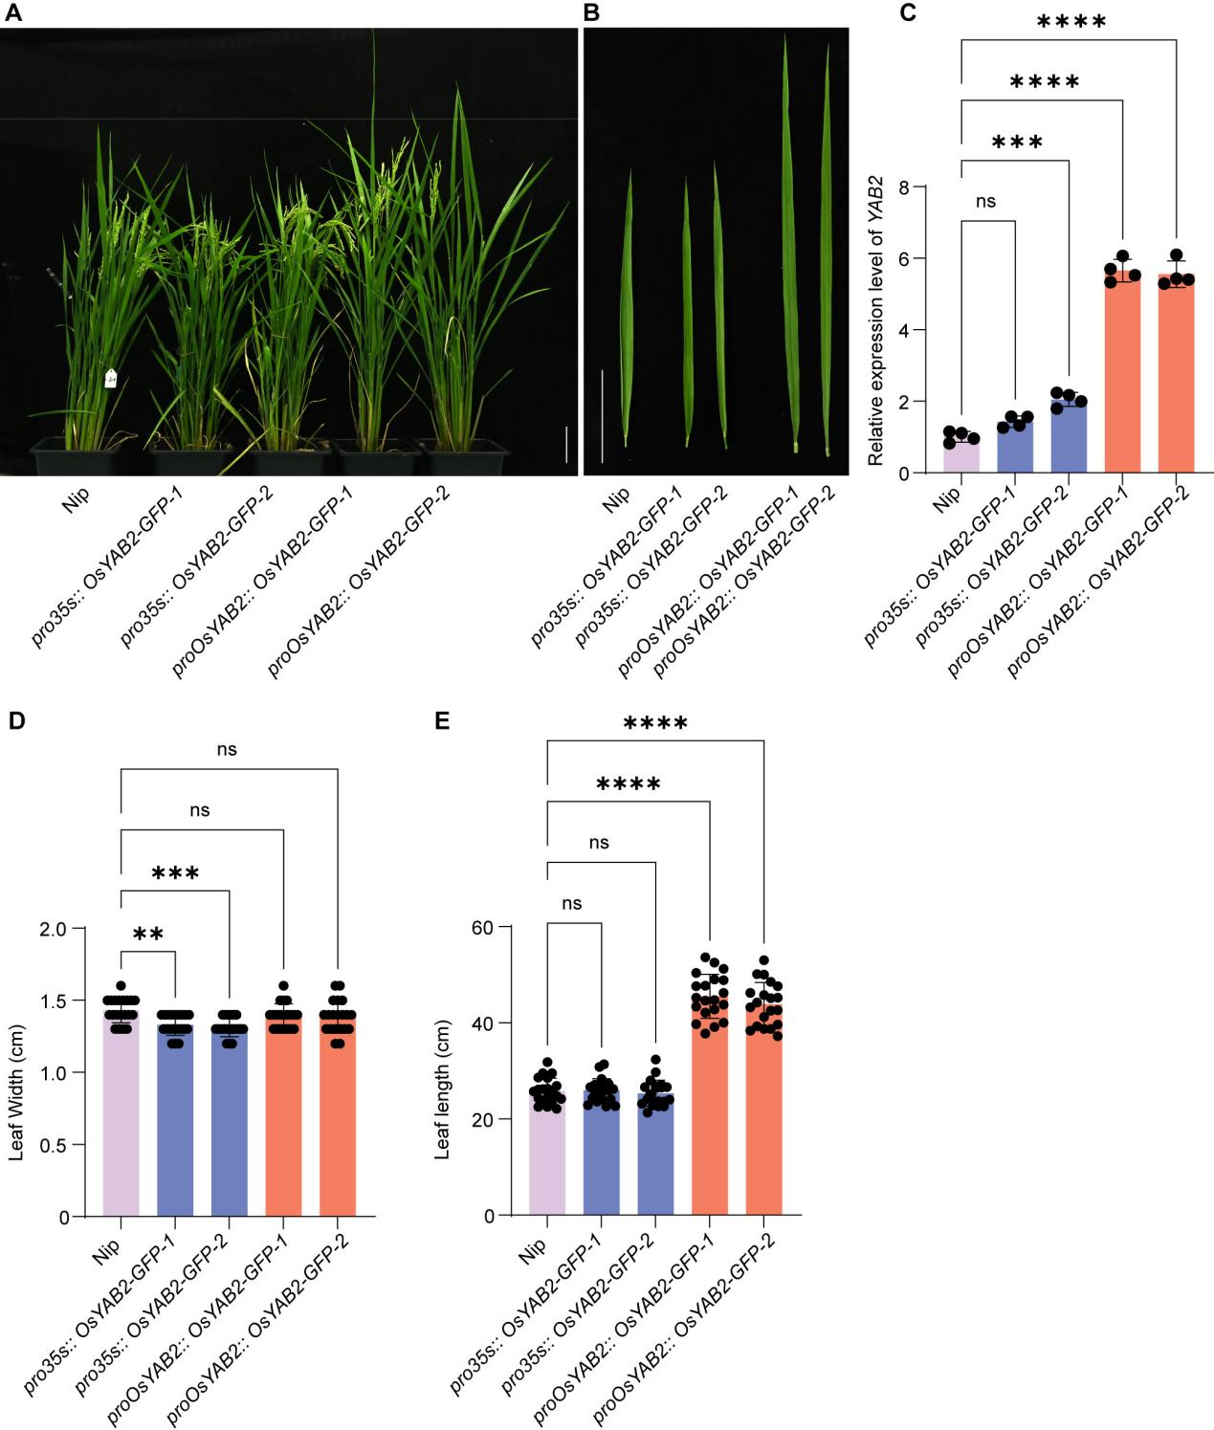
Figure S1 Effects of OsYAB2 expression driven by different promoters on rice plant growth and leaf phenotypes. A Representative plant phenotypes of Nip, two independent pro35S::OsYAB2–GFP transgenic lines (-1 and -2), and two independent proOsYAB2::OsYAB2–GFP transgenic lines (-1 and -2). B Representative leaf morphologies of the indicated genotypes. C Relative OsYAB2 transcript levels in the indicated genotypes, as determined by qRT–PCR. Data are presented as the mean ± SD. Black dots represent independent biological replicates (n = 4). D and E Statistics on the length and width of leaves of proOsYAB2::OsYAB2, and pro35S::OsYAB2 at heading stage. Statistical significance in C to E was analyzed by One-Way ANOVA, ns, not significant, P** < 0.01, P*** < 0.001, P**** < 0.0001.

Figure S2 Effects of OsYAB2 expression driven by different promoters on the formation and statistics of leaf epidermal appendages in rice based on SEM observation. A-C, numbers of macrohairs (A) on the adaxial leaf midribs, microhairs (B) on the adaxial leaf midrib and two adjacent lateral veins, and nodular papillae (C) on the abaxial leaf midribs on the leaf epidermis of Nip, proOsYAB2::OsYAB2-GFP, and pro35S::OsYAB2-GFP plants under SEM observation. For each line, the density of macrohair cells, microhair cells and nodular papillae were all calculated under scanning electron microscopy at 100× magnification, respectively, based on 5 penultimate leaves at 6 leaf stage. Data are presented as the mean ± SD. Black dots represent independent biological replicates (n = 5). Statistical significance was analyzed by One-Way ANOVA, ns, not significant; P* < 0.05; P*** < 0.001; P**** < 0.0001.

Figure S3 Venn diagrams showing shared and unique genes among Nip, pro35S:OsYAB2-GFP, and proOsYAB2:OsYAB2-GFP across different expression intervals based on TPM values. A TPM 0–1; B TPM 1–10; C TPM 10–100; and D TPM 100–1000. The diagrams illustrate the overlap and genotype-specific distribution of genes within each expression range.

Figure S4 Gene Ontology (GO) enrichment analysis of highly expressed genes (TPM > 1000) in Nip (A), pro35S:OsYAB2-GFP (B) , and proOsYAB2:OsYAB2-GFP (C). Enriched terms are grouped into the biological process (BP), cellular component (CC), and molecular function (MF) categories.

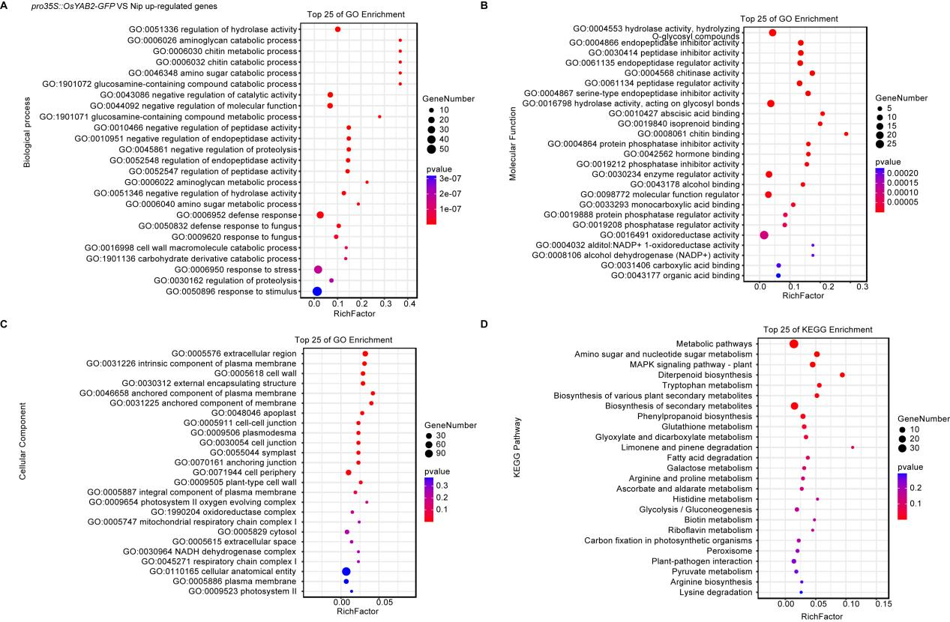
Figure S5 GO and Kyoto Encyclopedia of Genes and Genomes (KEGG) enrichment analyses of upregulated genes in pro35S::OsYAB2-GFP relative to Nip. A Top 25 enriched GO terms in biological process (BP); B top 25 enriched GO terms in molecular function (MF); C top 25 enriched GO terms in cellular component (CC); D top 25 enriched KEGG pathways. In the dot plots, the x-axis indicates the rich factor, the y-axis shows enriched terms or pathways, dot size represents gene number, and dot color indicates enrichment significance.

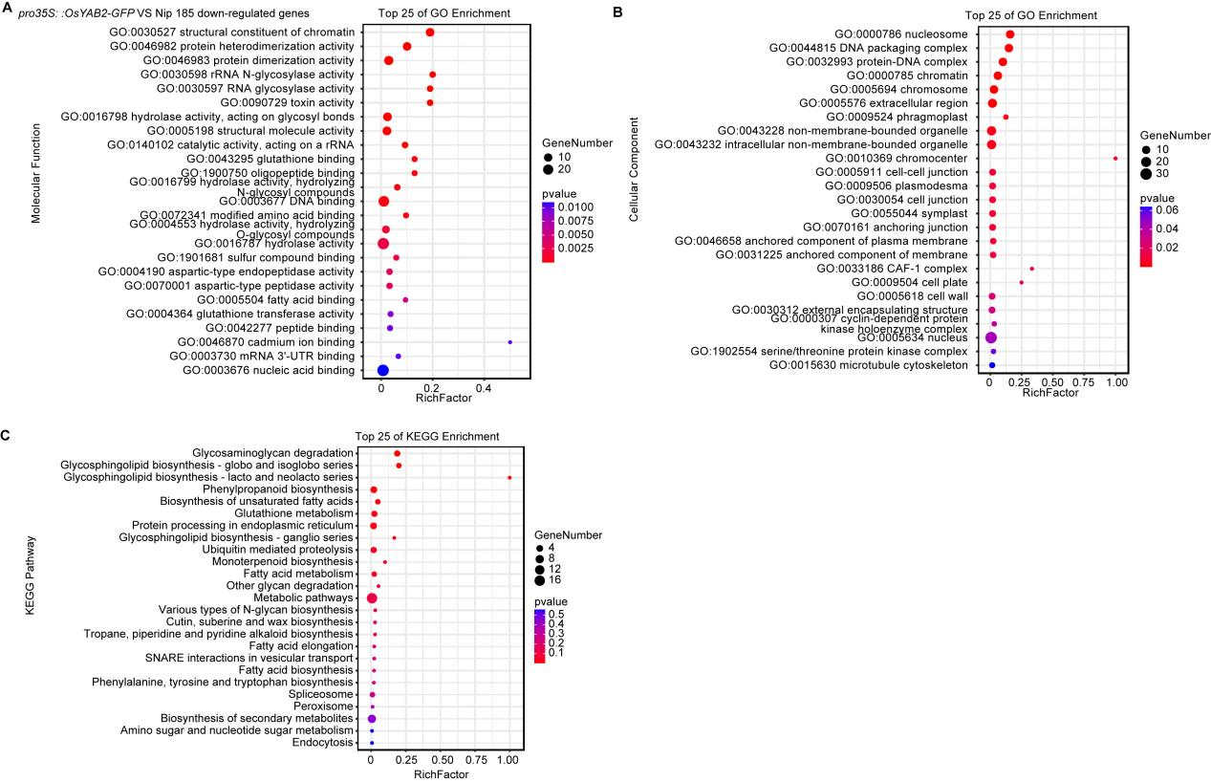
Figure S6 GO and KEGG enrichment analyses of downregulated genes in pro35S::OsYAB2-GFP relative to Nip. A Top enriched GO terms in molecular function (MF); B top enriched GO terms in cellular component (CC); C top enriched KEGG pathways. In the dot plots, the x-axis indicates the rich factor, the y-axis shows enriched terms or pathways, dot size represents gene number, and dot color indicates enrichment significance.

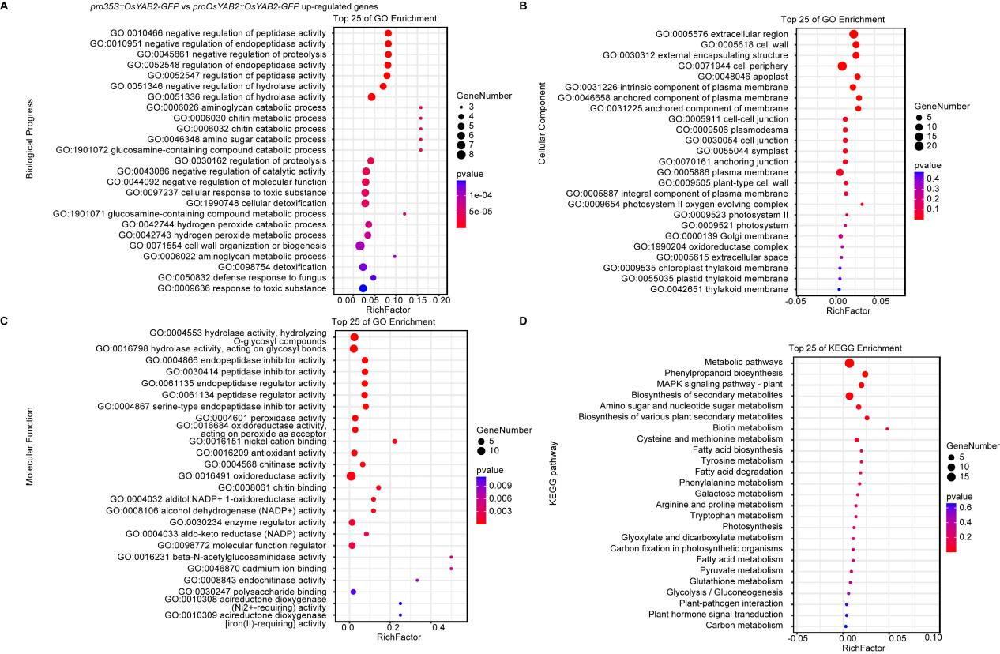
Figure S7 GO and KEGG enrichment analyses of upregulated genes in pro35S::OsYAB2-GFP relative to proOsYAB2::OsYAB2-GFP. A Top 25 enriched GO terms in biological process (BP); B top 25 enriched GO terms in cellular component (CC); C top 25 enriched GO terms in molecular function (MF); D top 25 enriched KEGG pathways. In the dot plots, the x-axis indicates the rich factor, the y-axis shows enriched terms or pathways, dot size represents gene number, and dot color indicates enrichment significance.

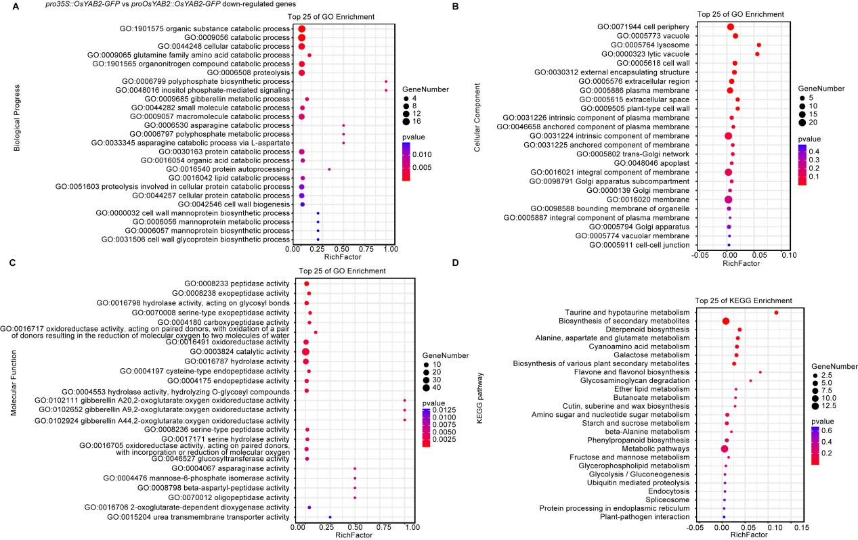
Figure S8 GO and KEGG enrichment analyses of downregulated genes in pro35S::OsYAB2-GFP relative to proOsYAB2::OsYAB2-GFP. A Top 25 enriched GO terms in biological process (BP); B top 25 enriched GO terms in cellular component (CC); C top 25 enriched GO terms in molecular function (MF); D top 25 enriched KEGG pathways. In the dot plots, the x-axis indicates the rich factor, the y-axis shows enriched terms or pathways, dot size represents gene number, and dot color indicates enrichment significance.

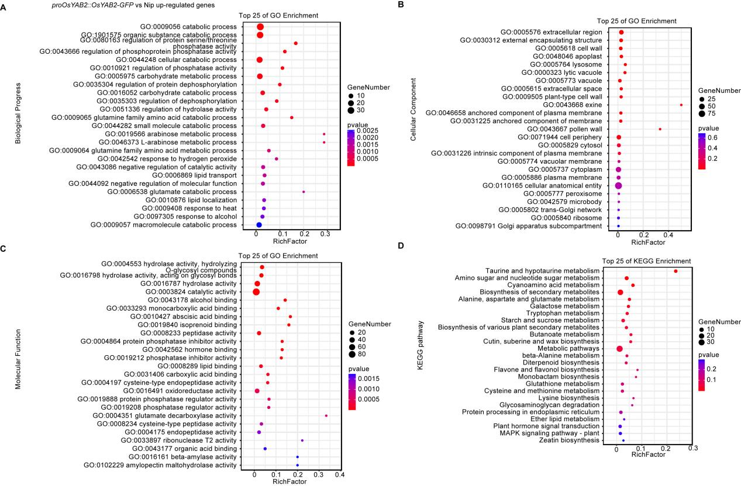
Figure S9 GO and KEGG enrichment analyses of upregulated genes in proOsYAB2::OsYAB2-GFP relative to Nip. A Top 25 enriched GO terms in biological process (BP); B top 25 enriched GO terms in cellular component (CC); C top 25 enriched GO terms in molecular function (MF); D top 25 enriched KEGG pathways. In the dot plots, the x-axis indicates the rich factor, the y-axis shows enriched terms or pathways, dot size represents gene number, and dot color indicates enrichment significance.

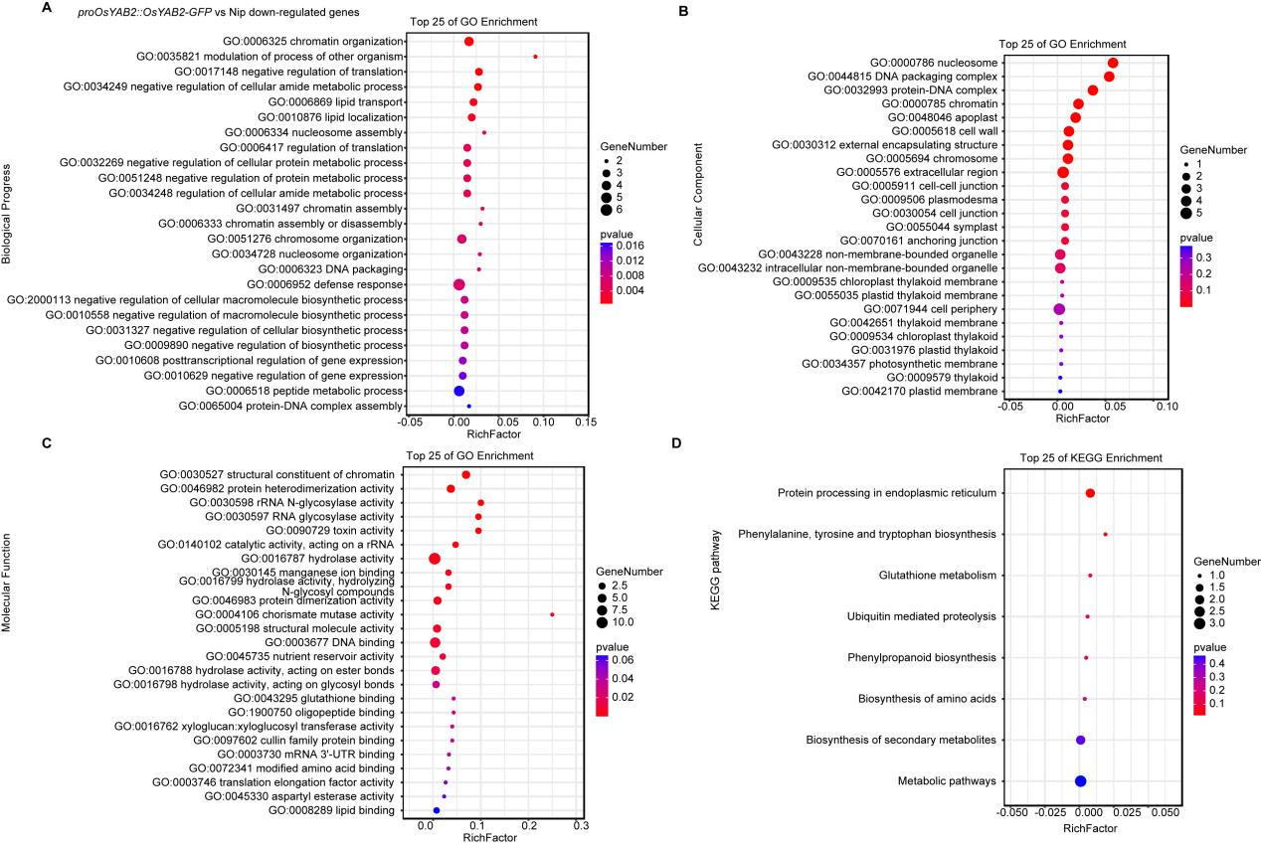
Figure S10 GO and KEGG enrichment analyses of downregulated genes in proOsYAB2::OsYAB2-GFP relative to Nip. A Top 25 enriched GO terms in biological process (BP); B top 25 enriched GO terms in cellular component (CC); C top 25 enriched GO terms in molecular function (MF); D top 25 enriched KEGG pathways. In the dot plots, the x-axis indicates the rich factor, the y-axis shows enriched terms or pathways, dot size represents gene number, and dot color indicates enrichment significance.

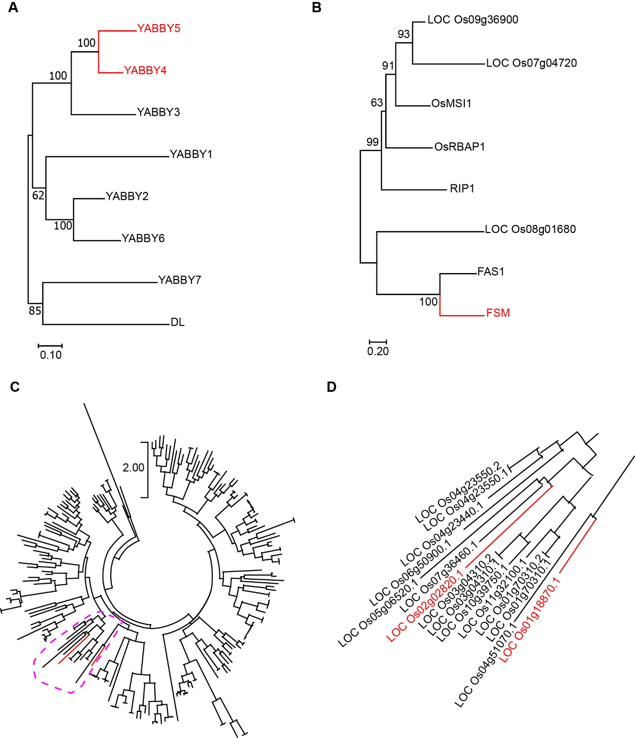
Figure S11 Phylogenetic analyses of selected rice gene families based on amino acid sequences. A Phylogenetic tree of the YABBY gene family. B Phylogenetic tree of CAF-1-related genes. C Phylogenetic tree of selected bHLH family members, with the subgroup of interest indicated by a dashed line. D Enlarged view of the highlighted clade in (C), with selected genes marked in red.

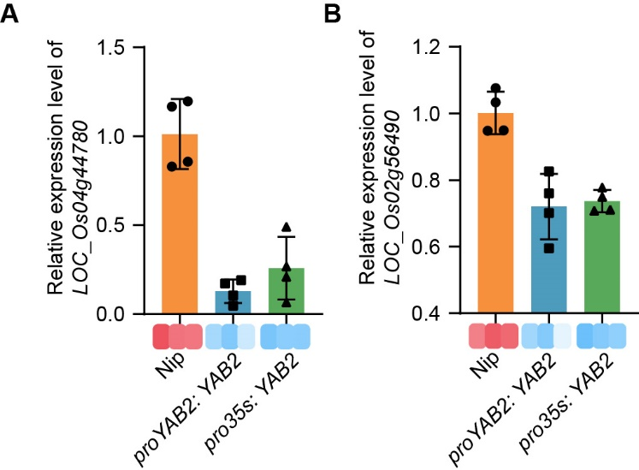
Figure S12 Relative expression levels of LOC_Os04g44780 and LOC_Os02g56490 in different rice lines. A Relative expression of LOC_Os04g44780 in Nip, proOsYAB2::OsYAB2-GFP, and pro35S::OsYAB2-GFP. B Relative expression of LOC_Os02g56490 in the same genotypes. Error bars indicate SD (n = 4 biological replicates). The accompanying heat maps show the relative expression patterns of the corresponding genes across the indicated genotypes.

