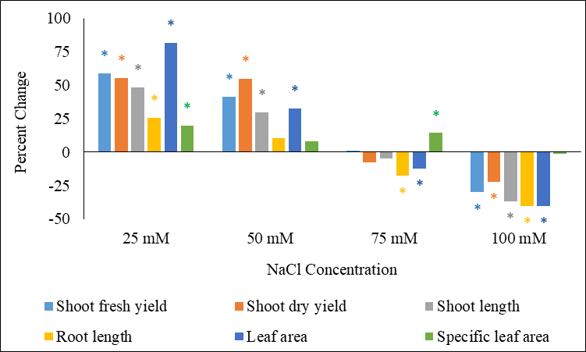
Figure S1. Percent change in growth parameters of sunflower microgreens as affected by different NaCl concentrations (25, 50, 75, and 100 mM) compared with control (0 mM NaCl). Asterisk refers to significant difference from control at p ≤ 0.05 based on Tukey’s test.

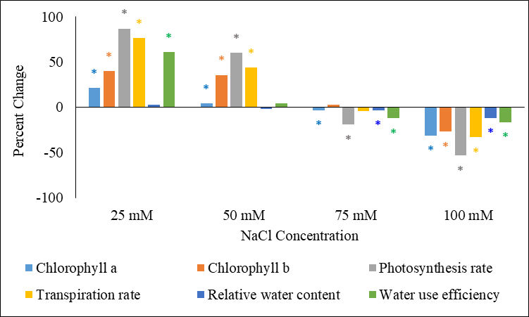
Figure S2. Percent change in physiological status of sunflower microgreens as affected by different NaCl concentrations (25, 50, 75, and 100 mM) compared with control (0 mM NaCl). Asterisk refers to significant difference from control at p ≤ 0.05 based on Tukey’s test.

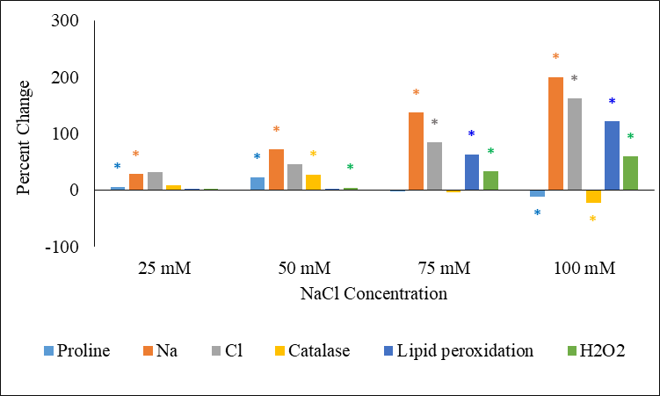
Figure S3. Percent change in stress biomarkers of sunflower microgreens as affected by different NaCl concentrations (25, 50, 75, and 100 mM) compared with control (0 mM NaCl). Asterisk refers to significant difference from control at p ≤ 0.05 based on Tukey’s test.

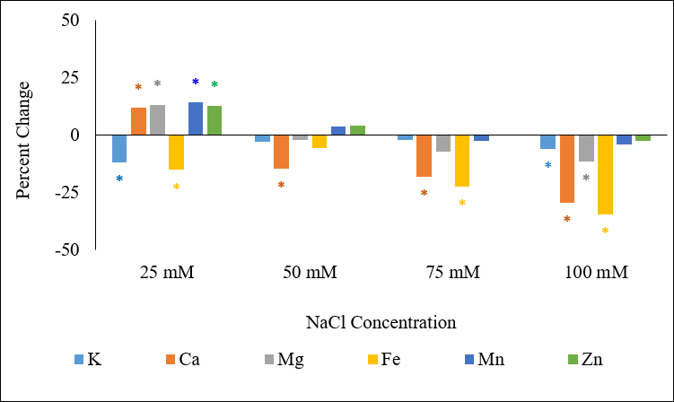
Figure S4. Percent change in proximate composition of sunflower microgreens as affected by different NaCl concentrations (25, 50, 75, and 100 mM) compared with control (0 mM NaCl). Asterisk refers to significant difference from control at p ≤ 0.05 based on Tukey’s test.

Figure S5. Percent change in minerals content of sunflower microgreens as affected by different NaCl concentrations (25, 50, 75, and 100 mM) compared with control (0 mM NaCl). Asterisk refers to significant difference from control at p ≤ 0.05 based on Tukey’s test.

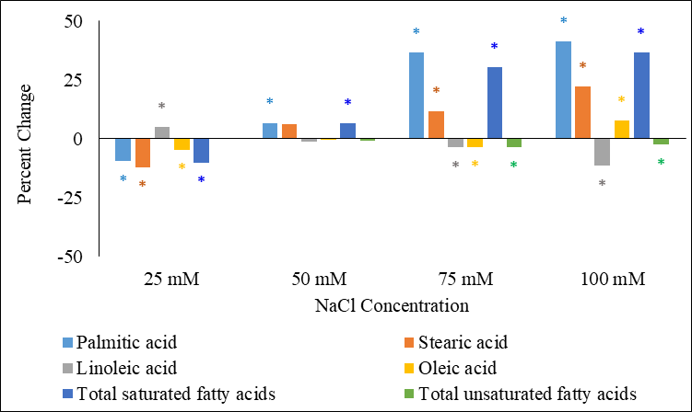
Figure S6. Percent change in fatty acids profile of sunflower microgreens as affected by different NaCl concentrations (25, 50, 75, and 100 mM) compared with control (0 mM NaCl). Asterisk refers to significant difference from control at p ≤ 0.05 based on Tukey’s test.

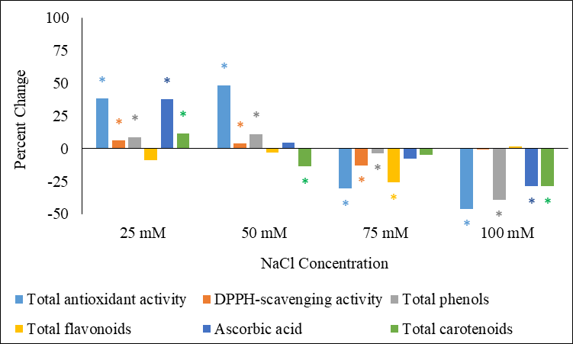
Figure S7. Percent change in antioxidant capacity of sunflower microgreens as affected by different NaCl concentrations (25, 50, 75, and 100 mM) compared with control (0 mM NaCl). Asterisk refers to significant difference from control at p ≤ 0.05 based on Tukey’s test.

Table S1. Loading plot of principal components (PCs) based on the concerned traits of sunflower microgreens as affected by different NaCl concentrations
Trait |  | PC1 | PC2
Growth parameters | Shoot fresh yield | 0.25 | 0.14
Growth parameters | Shoot dry yield | 0.01 | 0.01
Growth parameters | Shoot length | 0.04 | 0.01
Growth parameters | Root length | 0.03 | -0.01
Growth parameters | Leaf area | 0.01 | 0.01
Growth parameters | Specific leaf area | 0.06 | 0.15
Physiological status | Chlorophyll a | 0.62 | -0.03
Physiological status | Chlorophyll b | 0.57 | 0.15
Physiological status | Photosynthesis rate | 0.02 | 0.01
Physiological status | Transpiration rate | 0.00 | 0.00
Physiological status | Relative water content | 0.06 | -0.05
Physiological status | Water use efficiency | 0.24 | 0.38
Stress biomarkers | Proline | 0.01 | -0.01
Stress biomarkers | Na | 0.00 | 0.01
Stress biomarkers | Cl | -0.01 | 0.02
Stress biomarkers | Catalase | 0.00 | 0.00
Stress biomarkers | Lipid peroxidation | -0.04 | 0.07
Stress biomarkers | H₂O₂ | -0.15 | 0.24
Proximate composition | Moisture content | 0.01 | -0.01
Proximate composition | Ash content | -0.01 | 0.01
Proximate composition | Total carbohydrates | 0.00 | 0.00
Proximate composition | Total proteins | 0.00 | 0.00
Proximate composition | Total fats | -0.01 | 0.00
Proximate composition | Energy content | -0.03 | 0.02
Minerals content | K | 0.00 | -0.02
Minerals content | Ca | 0.01 | 0.00
Minerals content | Mg | 0.01 | 0.00
Minerals content | Fe | 0.21 | -0.81
Minerals content | Mn | 0.02 | 0.03
Minerals content | Zn | 0.09 | 0.13
Fatty acids profile | Palmitic acid | -0.02 | 0.02
Fatty acids profile | Stearic acid | 0.00 | 0.00
Fatty acids profile | Linoleic acid | 0.04 | -0.01
Fatty acids profile | Oleic acid | -0.02 | 0.00
Fatty acids profile | Total saturated fatty acids | -0.02 | 0.02
Fatty acids profile | Total unsaturated fatty acids | 0.02 | -0.01
Antioxidant capacity | Total antioxidant activity | 0.00 | 0.00
Antioxidant capacity | DPPH-scavenging activity | 0.04 | 0.03
Antioxidant capacity | Total phenols | 0.15 | -0.15
Antioxidant capacity | Total flavonoids | 0.00 | 0.00
Antioxidant capacity | Ascorbic acid | 0.21 | 0.13
Antioxidant capacity | Total carotenoids | 0.08 | -0.01

Table S2. Treatment scores plot of principal components (PCs) based on the concerned traits of sunflower microgreens as affected by different NaCl concentrations
Treatment | PC1 | PC2
0 mM | -1.93 | -31.65
25 mM | 85.48 | 23.46
50 mM | 41.02 | -9.79
75 mM | -18.83 | 2.72
100 mM | -105.74 | 15.26

