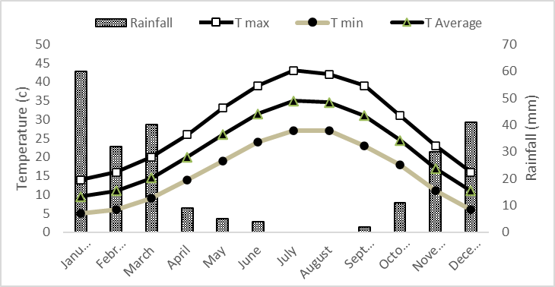
Fig S1 The thermo-pluviometric trend diagram at the research ﬁeld (Kirkuk Governorate. Iraq)

Table S1. Analysis of variance for the effects of different levels of drought stress (DS), amino acids (AA) and nono-zinc (NZ) on measured traits in apple tree
 | Yield
 | DF | Sum Sq | Mean Sq | F
Drought | 3 | 65.247 | 21.74 | 26.42***
AA | 2 | 2.604 | 1.3 | 1.58ns
NZ | 2 | 7.220 | 3.61 | 4.38*
Drought×AA | 4 | 21.567 | 5.39 | 6.55***
Drought×NZ | 4 | 10.008 | 2.5 | 3.04*
AA×NZ | 4 | 8.841 | 20.21 | 2.68*
Drought×AA×NZ | 8 | 20.584 | 20.57 | 3.12**
 | FW
 | DF | Sum Sq | Mean Sq | Value
Drought | 3 | 11827.5 | 3942.5 | 142.64***
AA | 2 | 533.3 | 266.7 | 9.64*
NZ | 2 | 2400.1 | 1200 | 43.42***
Drought×AA | 4 | 3111 | 777.8 | 28.14***
Drought×NZ | 4 | 355.6 | 88.9 | 3.21*
AA×NZ | 4 | 509.1 | 127.3 | 4.6**
Drought×AA×NZ | 8 | 923.2 | 115.4 | 4.1***
 | FF
 | DF | Sum Sq | Mean Sq | Value
Drought | 3 | 6.49 | 2.16 | 7.03***
AA | 2 | 4.6 | 2.3 | 7.48**
NZ | 2 | 8.09 | 4.04 | 13.16***
Drought×AA | 4 | 19.8 | 4.97 | 16.09***
Drought×NZ | 4 | 3.99 | 0.99 | 3.24*
AA×NZ | 4 | 2.92 | 0.73 | 2.38ns
Drought×AA×NZ | 8 | 8.59 | 1.07 | 3.49**
 | TChl
 | DF | Sum Sq | Mean Sq | Value
Drought | 3 | 19.85 | 6.61 | 2.63***
AA | 2 | 1.19 | 0.59 | 2.48ns
NZ | 2 | 1.97 | 0.98 | 4.11*
Drought×AA | 4 | 5.03 | 1.25 | 5.25**
Drought×NZ | 4 | 0.58 | 0.14 | 0.61ns
AA×NZ | 4 | 0.26 | 0.06 | 0.27ns
Drought×AA×NZ | 8 | 7.04 | 0.88 | 3.67**
 | RWC
 | DF | Sum Sq | Mean Sq | Value
Drought | 3 | 5359.6 | 1789.5 | 261.4***
AA | 2 | 284.9 | 142.4 | 20.84***
NZ | 2 | 85.2 | 42.62 | 6.23**
Drought×AA | 4 | 35.4 | 8.85 | 1.29ns
Drought×NZ | 4 | 101.3 | 25.33 | 3.7**
AA×NZ | 4 | 54 | 13.49 | 1.97ns
Drought×AA×NZ | 8 | 147.3 | 18.41 | 2.69*
 | TSS
 | DF | Sum Sq | Mean Sq | Value
Drought | 3 | 8522.5 | 2840.83 | 402.5***
AA | 2 | 42.6 | 21.32 | 3.02ns
NZ | 2 | 57 | 28.51 | 4.04*
Drought×AA | 4 | 106.3 | 26.57 | 3.76**
Drought×NZ | 4 | 192 | 48 | 6.8***
AA×NZ | 4 | 59 | 14.87 | 2.1ns
Drought×AA×NZ | 8 | 226.1 | 28.27 | 4***
 | POD
 | DF | Sum Sq | Mean Sq | Value
Drought | 3 | 0.97 | 0.32 | 151.6***
AA | 2 | 0.005 | 0.002 | 1.32ns
NZ | 2 | 0.017 | 0.008 | 4.08*
Drought×AA | 4 | 0.08 | 0.021 | 9.97***
Drought×NZ | 4 | 0.011 | 0.002 | 1.32ns
AA×NZ | 4 | 0.027 | 0.006 | 2.23*
Drought×AA×NZ | 8 | 0.065 | 0.008 | 3.8**
 | AXP
 | DF | Sum Sq | Mean Sq | Value
Drought | 3 | 0.217 | 0.07 | 321.8***
AA | 2 | 0.0006 | 0.0003 | 1.355ns
NZ | 2 | 0.0006 | 0.0003 | 1.3554ns
Drought×AA | 4 | 0.0013 | 0.00034 | 1.528ns
Drought×NZ | 4 | 0.0014 | 0.00036 | 1.626ns
AA×NZ | 4 | 0.001 | 0.00027 | 1.198ns
Drought×AA×NZ | 8 | 0.0026 | 0.00022 | 1.470ns
 | CAT
 | DF | Sum Sq | Mean Sq | Value
Drought | 3 | 0.014 | 0.0047 | 36.03***
AA | 2 | 0.0002 | 0.0001 | 0.79ns
NZ | 2 | 0.0003 | 0.00019 | 1.47ns
Drought×AA | 4 | 0.0027 | 0.00069 | 5.33**
Drought×NZ | 4 | 0.002 | 0.0005 | 3.84**
AA×NZ | 4 | 0.0006 | 0.00016 | 1.24
Drought×AA×NZ | 8 | 0.0016 | 0.00021 | 1.6
 | Ca
 | DF | Sum Sq | Mean Sq | Value
Drought | 3 | 12.24 | 4.08 | 37.38***
AA | 2 | 0.207 | 0.103 | 0.951ns
NZ | 2 | 0.725 | 0.376 | 3.44*
Drought×AA | 4 | 1.028 | 0.257 | 2.35ns
Drought×NZ | 4 | 2.72 | 0.68 | 6.22***
AA×NZ | 4 | 1.184 | 0.296 | 2.71*
Drought×AA×NZ | 8 | 2.742 | 0.342 | 3.13**
 | Zn
 | DF | Sum Sq | Mean Sq | Value
Drought | 3 | 0.0029 | 0.0009 | 35.72***
AA | 2 | 0.0005 | 0.0002 | 10.62ns
NZ | 2 | 0.0008 | 0.0004 | 16.003ns
Drought×AA | 4 | 0.0001 | 0.00004 | 1.51**
Drought×NZ | 4 | 0.00023 | 0.00005 | 2.14**
AA×NZ | 4 | 0.00029 | 0.00007 | 2.64ns
Drought×AA×NZ | 8 | 0.0006 | 0.00007 | 2.76ns
 | AsA
 | DF | Sum Sq | Mean Sq | Value
Drought | 3 | 0.0141 | 0.0047 | 36.03***
AA | 2 | 0.0002 | 0.0001 | 0.79ns
NZ | 2 | 0.00038 | 0.00019 | 1.47ns
Drought×AA | 4 | 0.0027 | 0.000069 | 5.33**
Drought×NZ | 4 | 0.002 | 0.0005 | 3.84**
AA×NZ | 4 | 0.0006 | 0.00016 | 1.24
Drought×AA×NZ | 8 | 0.0016 | 0.0002 | 1.6
Proline
 | DF | Sum Sq | Mean Sq | Value
Drought | 3 | 85.17 | 28.39 | 174.34***
AA | 2 | 0.42 | 0.21 | 1.29ns
NZ | 2 | 0.93 | 0.46 | 2.86ns
Drought×AA | 4 | 1.71 | 0.42 | 2.63*
Drought×NZ | 4 | 1.26 | 0.31 | 1.94ns
AA×NZ | 4 | 4.26 | 1.06 | 6.54***
Drought×AA×NZ | 8 | 2.93 | 0.36 | 2.25*
TA
 | DF | Sum Sq | Mean Sq | Value
Drought | 3 | 0.00186 | 0.00062 | 79.78***
AA | 2 | 0.00009 | 0.00004 | 6.02**
NZ | 2 | 0.00008 | 0.000041 | 5.35**
Drought×AA | 4 | 0.00018 | 0.000045 | 5.84***
Drought×NZ | 4 | 0.00015 | 0.000037 | 4.84**
AA×NZ | 4 | 0.00017 | 0.000043 | 5.65***
Drought×AA×NZ | 8 | 0.00014 | 0.00018 | 2.38*

