The supplementary file includes Figures S1–S4 and Table S1–S2
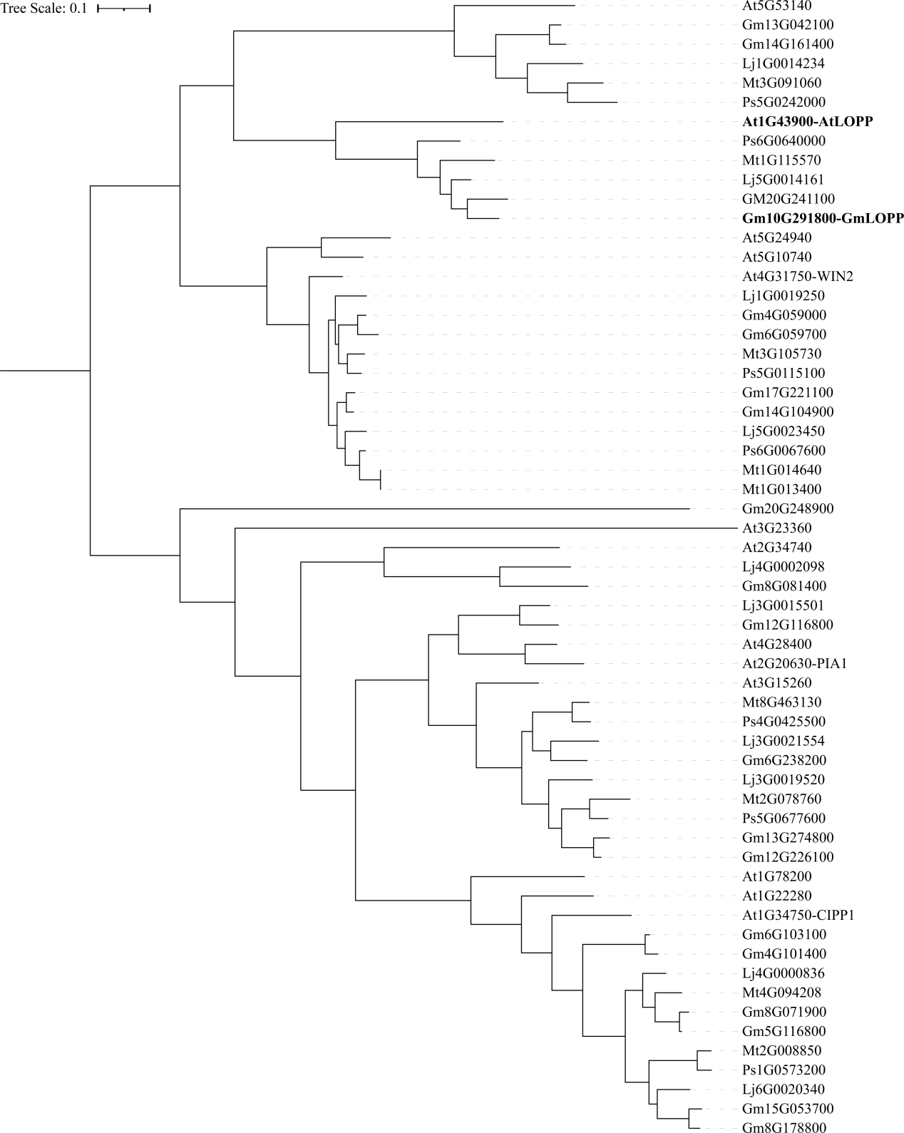
Supplementary Figure 1. Phylogenetic tree of the LOPP clade. The tree was constructed using the maximum-likelihood method in MEGA 11, based on amino acid sequences retrieved from Phytozome. The tree scale bar, 0.1. At, Arabidopsis thaliana; Mt, Medicago truncatula; Lj, Lotus japonicus; Gm, Glycine max; Ps, Pisum sativum.
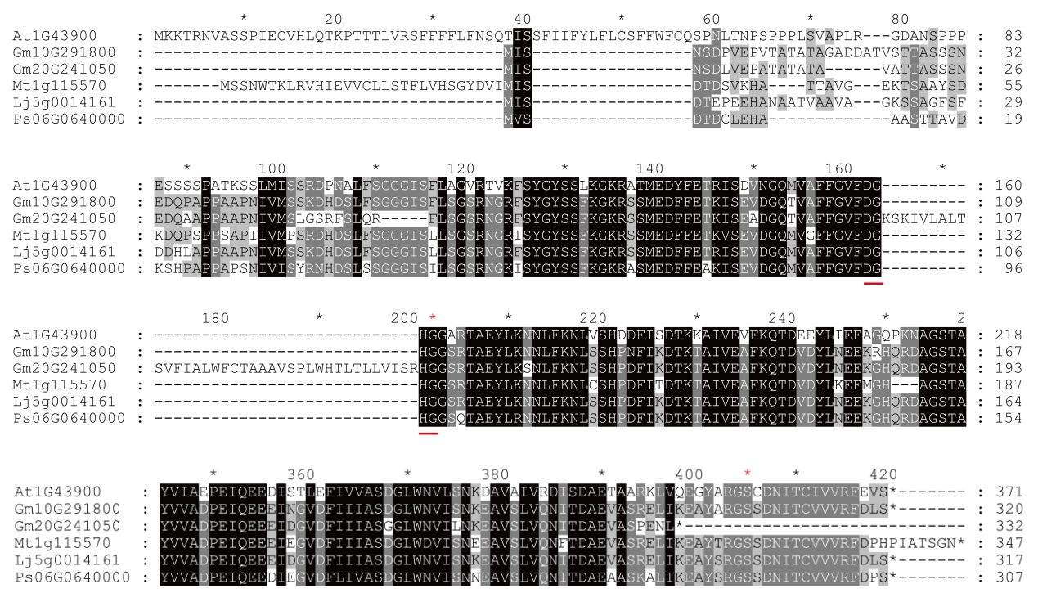
Supplementary Figure 2. Sequence alignment. The amino acid sequences of LOPP and its closely related legume homologs were aligned using MEGA 11 and visualized by GeneDoc to highlight conserved residues. The first “G” residue in the red-underlined sequence mediated PP2C phosphatase activity^{[43]}, the “S” residue in the C-terminal region is phosphorylated by LORE^{[36]}.
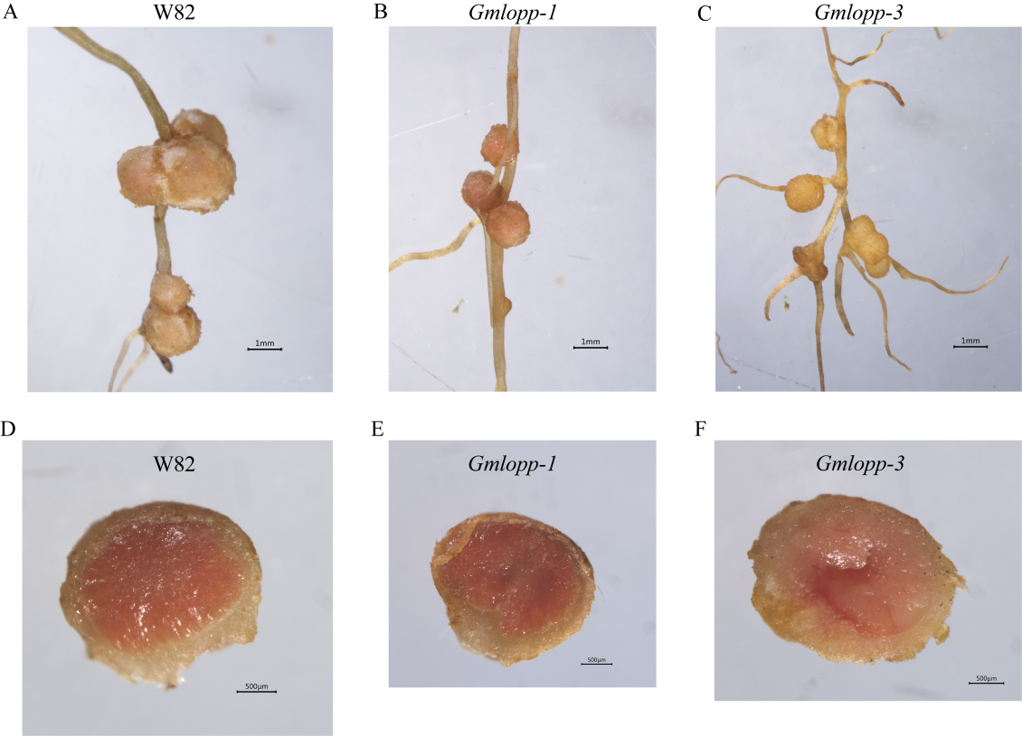
Supplementary Figure 3. Representative images of nodules inoculated with Sinorhizobium fredii HH103. Images were taken 1 month after inoculation.
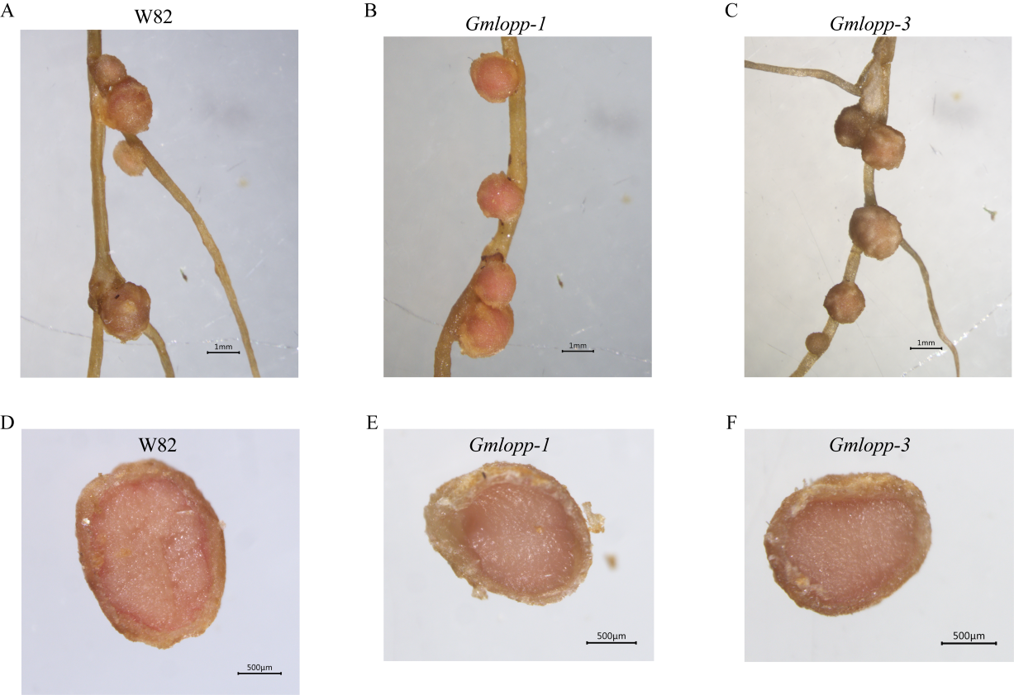
Supplementary Figure 4. Representative images of nodules inoculated with Bradyrhizobium diazoefficiens USDA110. Images were taken 1 month after inoculation.
Supplemental Table 1. Strains, plasmids, and plants used in this study
Strains, plasmids or plants | Description | Source or reference
Strain of Escherichia coli
DH5α | Recombinant plasmid replication | Laboratory stock
Strains of Agrobacterium tumefaciens
GV3101 | Transient transformation | Laboratory stock
EHA105 | Stable transformation | Laboratory stock
Strains of plant pathogenic bacteria
Pseudomonas savastanoi pv. glycinea | Soybean pathogenic bacterium of bacterial blight disease | Huijun Wu (Nanjing Agricultural University, China)
Xanthomonas axonopodis pv. glycines | Soybean pathogenic bacterium of bacterial pustule disease | Huijun Wu (Nanjing Agricultural University, China)
Strains of rhizobia
Bradyrhizobium diazoefficiens USDA110 | Symbiosis with soybean | Laboratory stock
Sinorhizobium fredii HH103 | Symbiosis with soybean | Laboratory stock
Plasmids
pCAMBIA | Plant expression vector | Laboratory stock
pDONR | Gateway entry vector | Laboratory stock
pGWB5 | Vector for C‑terminal GFP tagging | Laboratory stock
Plants
Williams 82 | Wild type | Laboratory stock
Gmlopp mutant | Knockout of GmLOPP | This study

Supplemental Table 2. Primers used in this study
Primer name | Sequence (5' → 3')
Primers for mutant identification
GmLOPP-F | GTGGGTCTTTCCTGCTTACTTTG
GmLOPP-R | GCATGACCATCAACCAATGACAT
Cas9-F | GTGGCCTATTCTGTGCTGGT
Cas9-R | ATCCCGGTGCTTGTTGTAGG
Primers for RT-PCR
GmLOPP_CDS0-F | ATGATCTCAAACTCGGACCCC
GmLOPP_CDS0-R | GGATAGATCAAATCGAACAACAACAC
GmActin-F | AGCATTGTAGGTCGTCCTC
GmActin-R | CACGCTCAGTCAAGATTTTCATC
Primers for RT-qPCR
GmLOPP-qPCR-F | GATCTGATGAACGTCGAAGG
GmLOPP-qPCR-R | CAGGTGATGTTATCTGAGCTTC
GmOXI1-qPCR-F | ATAGGGTCGTTGGGTTCGCC
GmOXI1-qPCR-R | CAATTCCGCAGCGTAAAACCTGAT
GmWRKY33-qPCR-F | TGAGTTCCCTCCTGGTTTTG
GmWRKY33-qPCR-R | GAGGCACGTGGTTTGTTTTT
GmActin-qPCR-F | GGTGGTTCTATCTTGGCATC
GmActin-qPCR-R | CTTTCGCTTCAATAACCCTA
Primers for Gateway cloning
Gateway_adaptor_F | GGGGACAAGTTTGTACAAAAAAGCAGGCT
Gateway_adaptor_R | GGGGACCACTTTGTACAAGAAAGCTGGGT
GmLOPP-Gt-L-F | GGGGACAAGTTTGTACAAAAAAGCAGGCTACATGATCTCAAACTCGGACCCC
GmLOPP-Gt-L-R | GGGGACCACTTTGTACAAGAAAGCTGGGTCGGATAGATCAAATCGAACAACAACAC
M13-F | CAGGAAACAGCTATGACC
M13-R | CAGGAAACAGCTATGACC

