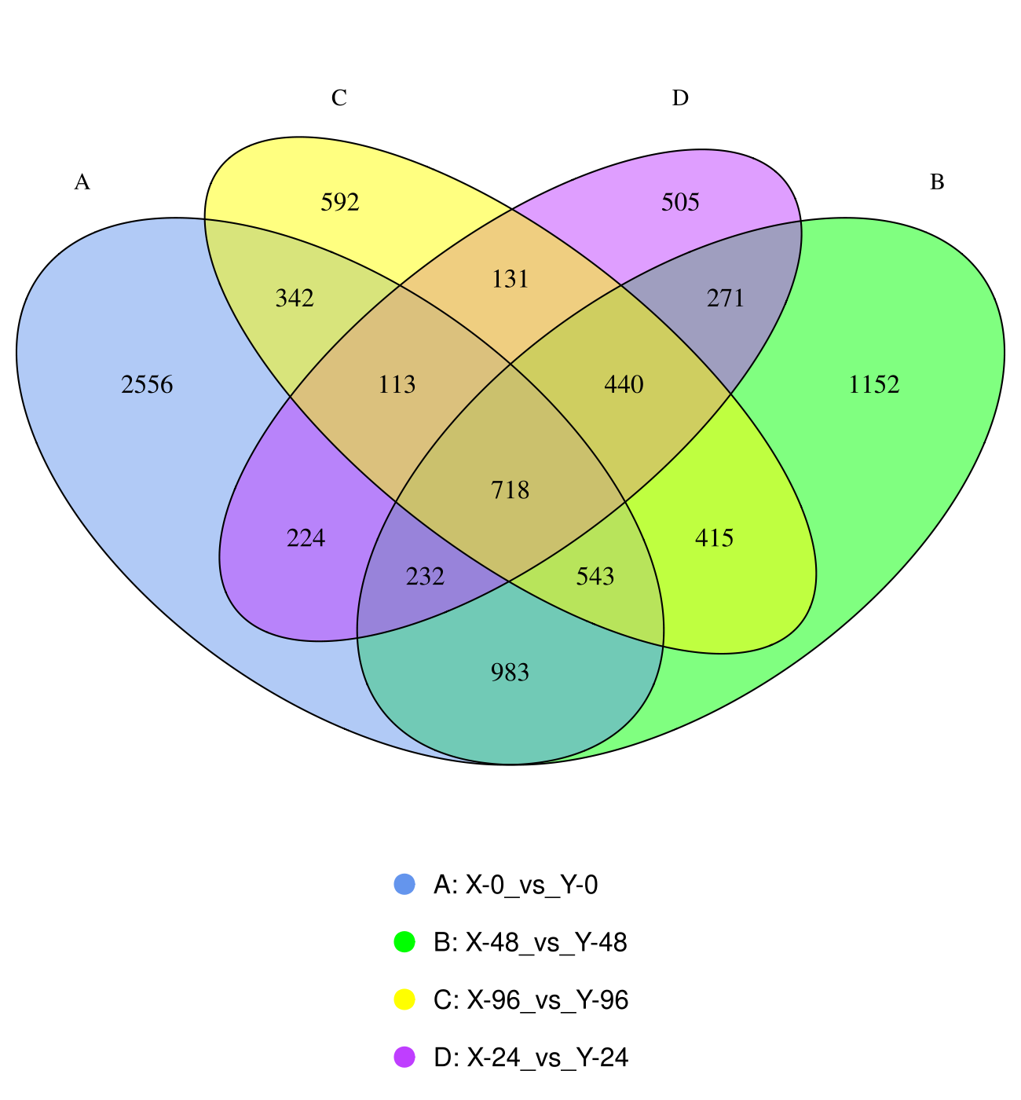
Figure S1 Venn Diagram of Differential Gene Sets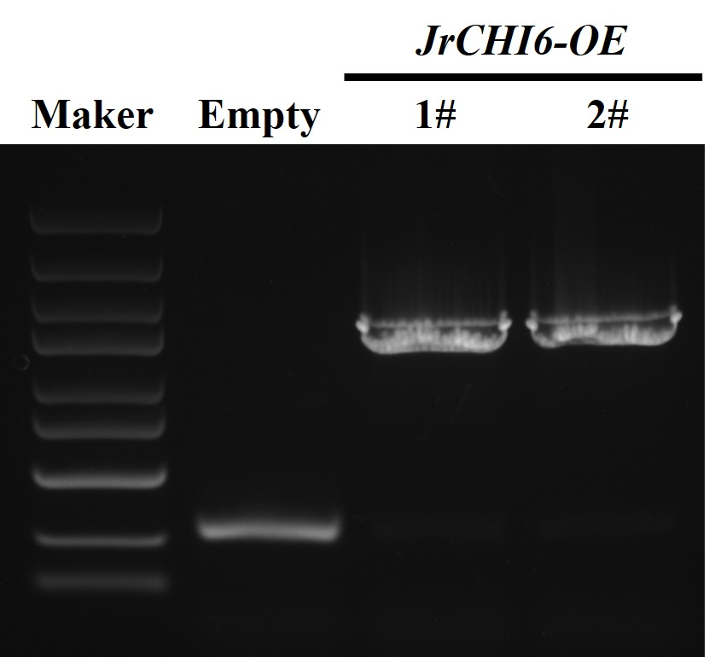
Figure S2 PCR amplification was used to verify the presence of the transgene in JrCHI6-OE.
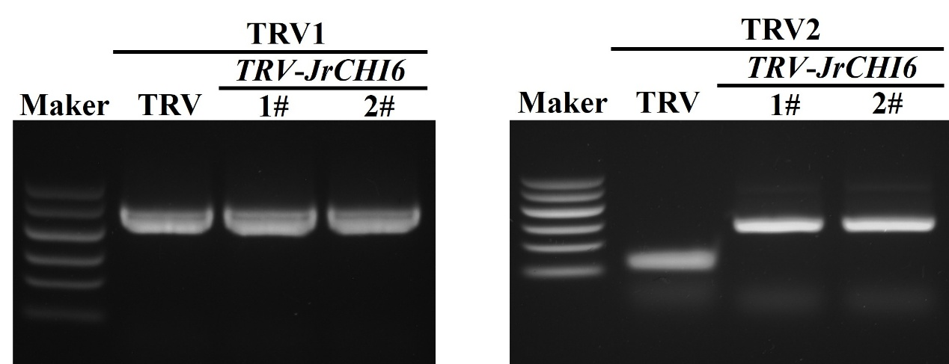
Figure S3 PCR identification of TRV-JrCHI24 in walnut leaves.
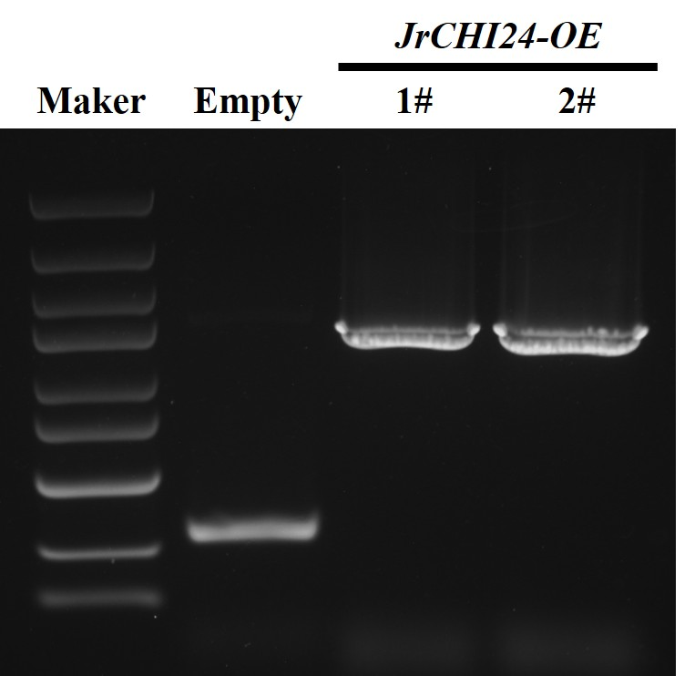
Figure S4 PCR amplification was used to verify the presence of the transgene in JrCHI24-OE.
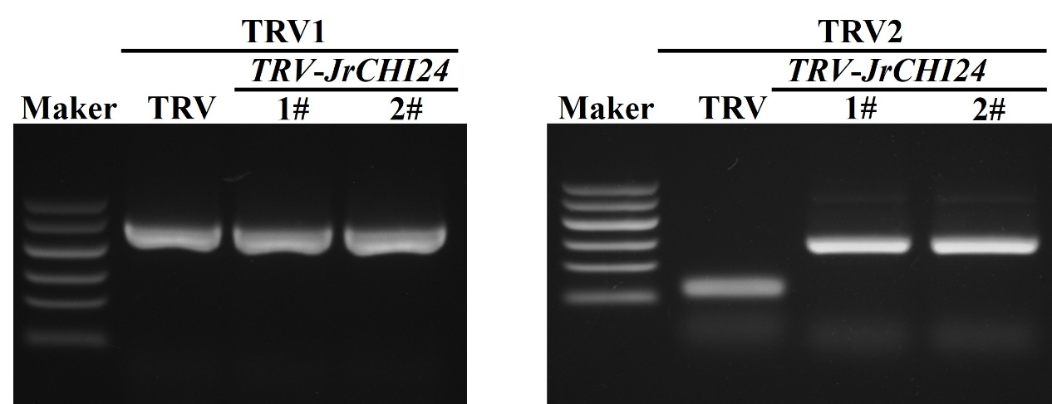
Figure S5 PCR identification of TRV-JrCHI24 in walnut leaves.

