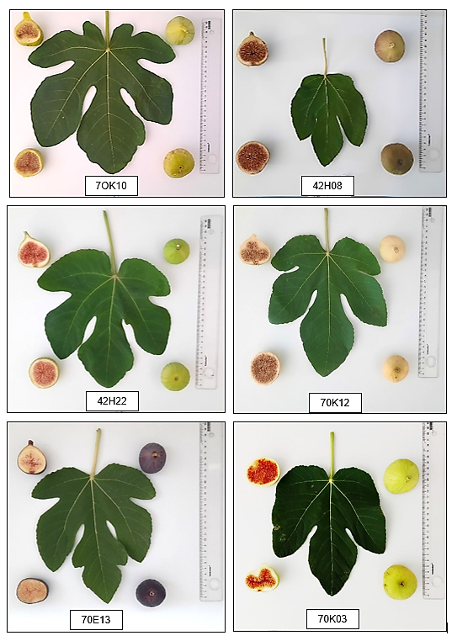
Supplementary Figure S1. Fruit and leaf characteristics of the six highest-ranked fig genotypes identified using the weighted grading method.

