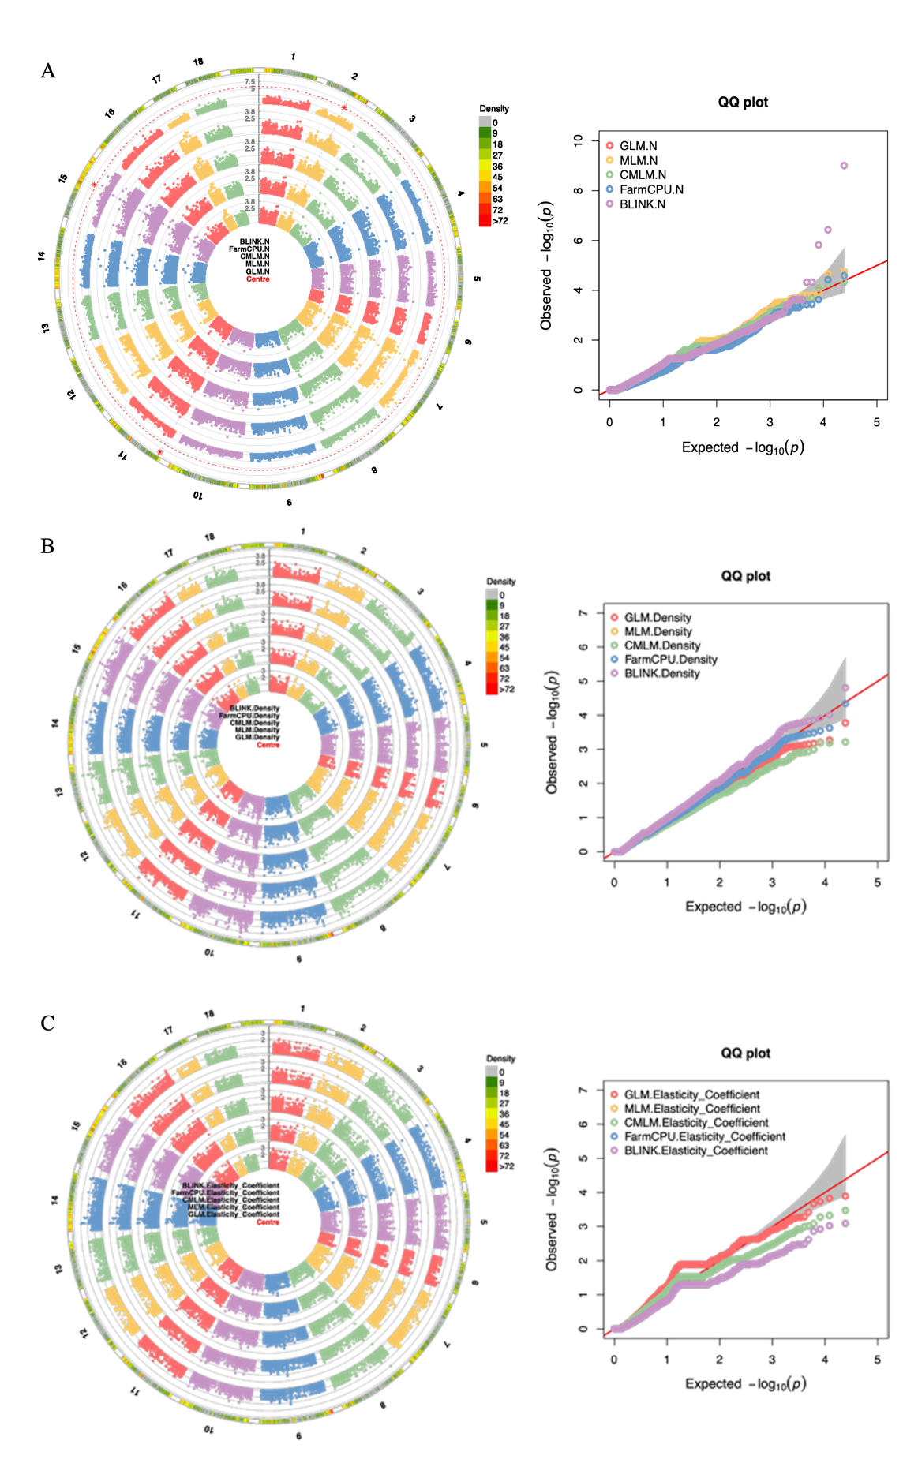
Supplementary Fig. S1. Circular Manhattan and Q–Q plots for selected wood and biomass-related traits in the Hevea brasiliensis association panel. (A) Nitrogen, (B) wood density, and (C) modulus of elasticity. GWAS was performed using GLM, MLM, CMLM, FarmCPU, and BLINK. Genome-wide significant associations were defined as P < 2.06 × 10⁻⁶ [−log₁₀(P) > 5.69], whereas associations with −log₁₀(P) > 4.0 but below the Bonferroni threshold were considered suggestive.
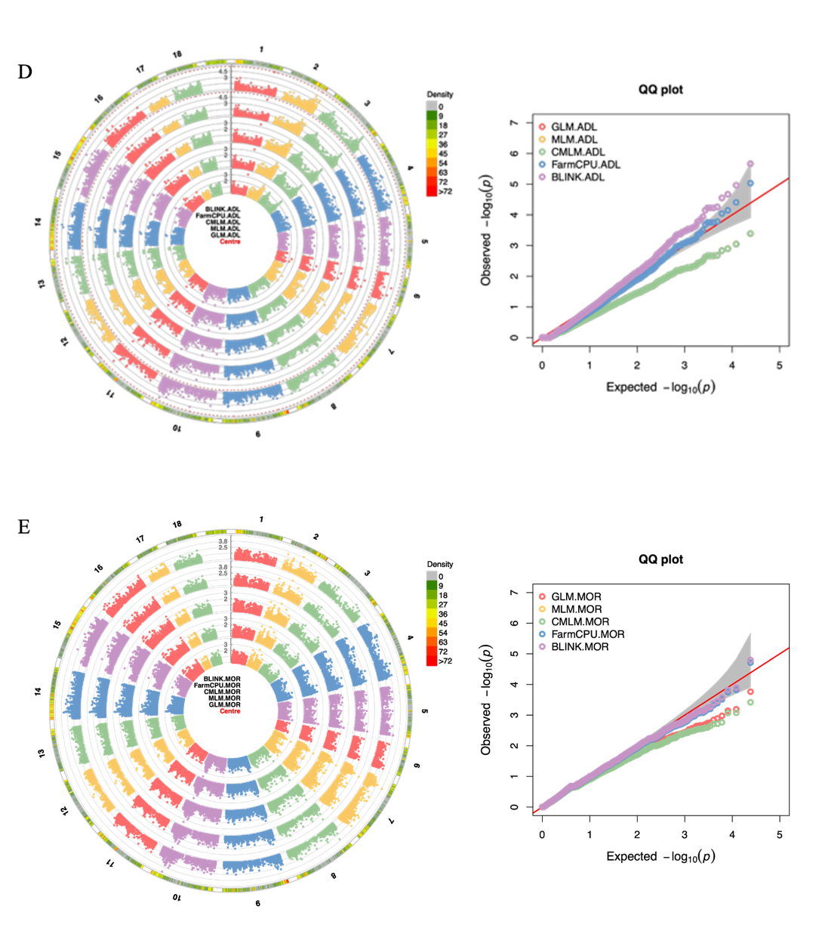
Supplementary Fig. S2. Circular Manhattan and Q–Q plots for selected wood and biomass-related traits in the Hevea brasiliensis association panel. (D) lignin (ADL) and (E) modulus of rupture (MOR). GWAS was performed using GLM, MLM, CMLM, FarmCPU, and BLINK. Genome-wide significant associations were defined as P < 2.06 × 10⁻⁶ [−log₁₀(P) > 5.69], whereas associations with −log₁₀(P) > 4.0 but below the Bonferroni threshold were considered suggestive.

