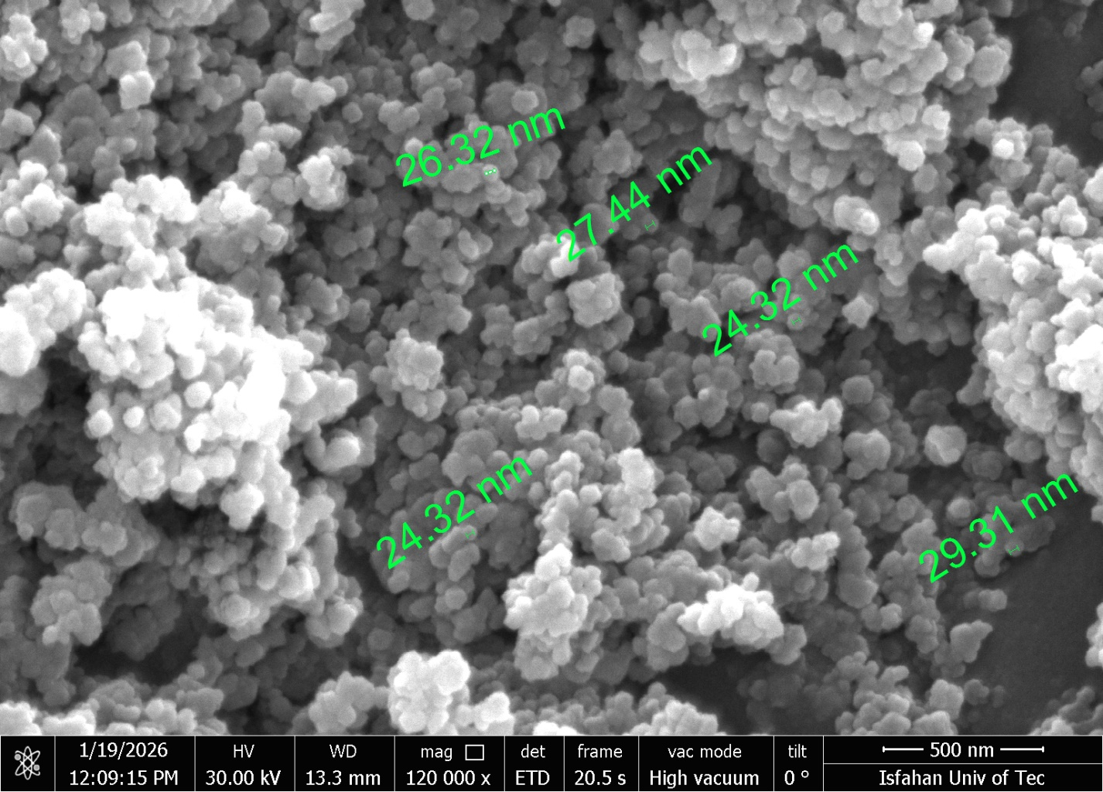

Supplementary1, Fig S1. The SEM microscopy imaging of TiO₂ nanoparticles used in the study.

