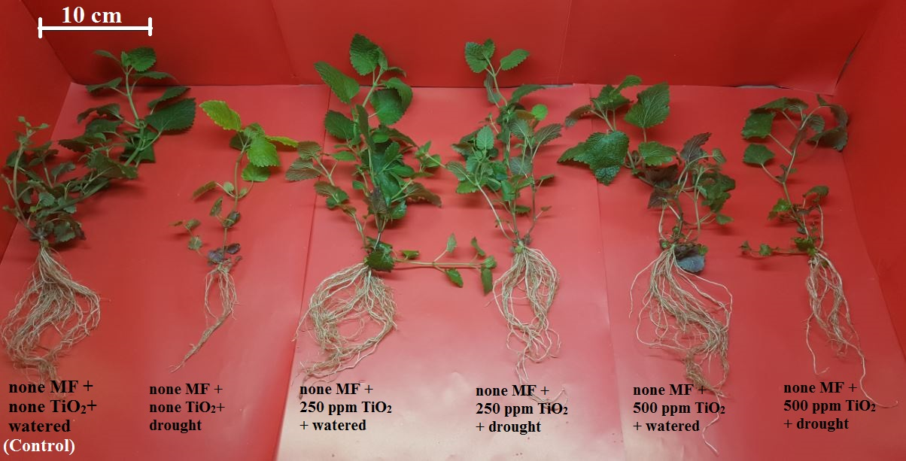
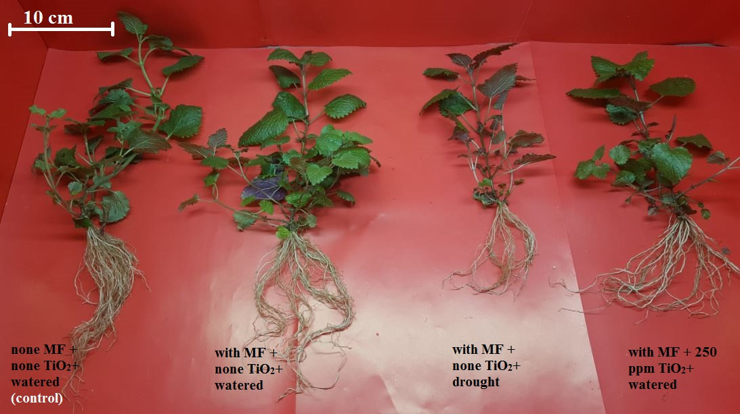
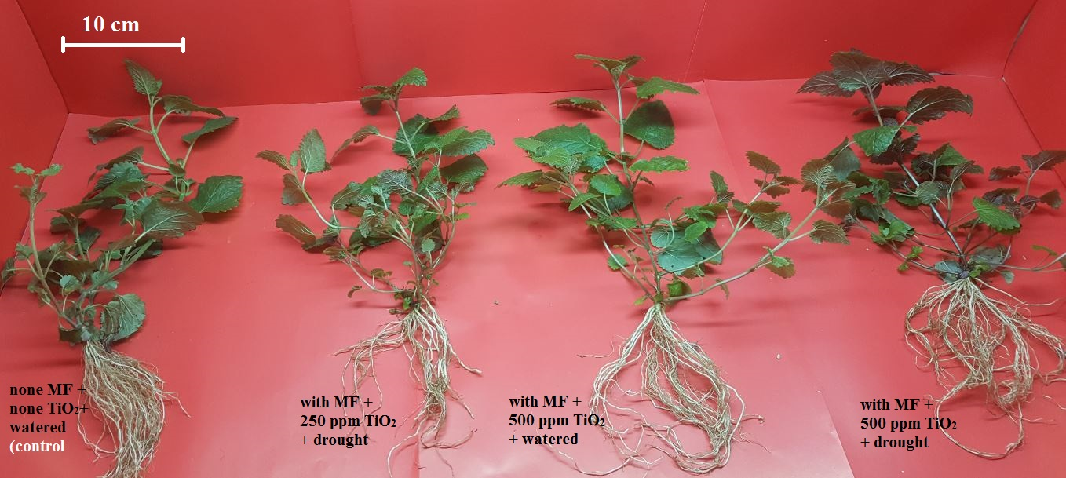
Supplementary 3. The effects of different levels of TiO₂ nanoparticles (TiO₂ NP) with/without mycorrhizal fungus (F. mosseae) inoculation on Melissa officinalis plants under drought stress levels compared with the control grown in soil media. (a) none MF + none TiO₂ NP+ watered (control), (b) none MF + none TiO₂ NP+ drought, (c) none MF + 250 ppm TiO₂ NP+ watered, (d) none MF + 250 ppm TiO₂ NP+ drought, (e) none MF + 500 ppm TiO₂ NP+ watered, (F) none MF + 500 ppm TiO₂ NP+ drought, (g) with MF + none TiO₂ NP+ watered, (h) with MF + none TiO₂ NP+ drought, (i) with MF + 250 ppm TiO₂ NP+ watered, (j) with MF + 250 ppm TiO₂ NP+ drought, (k) with MF + 500 ppm TiO₂ NP+ watered, (l) with MF + 500 ppm TiO₂ NP+ drought.

