Comparative and phylogenomic analyses of 19 Petrocodon (Gesneriaceae) species from the Guizhou karst plateau, China, featuring 13 newly assembled chloroplast genomes

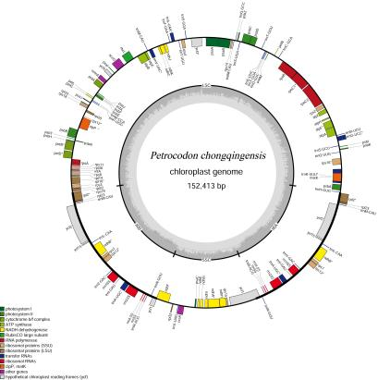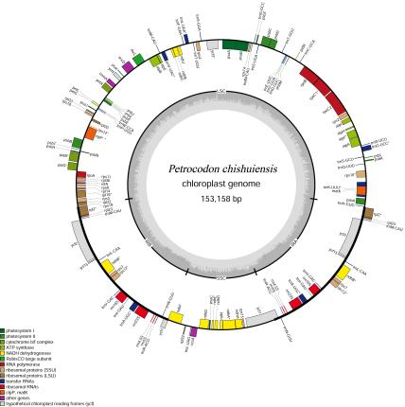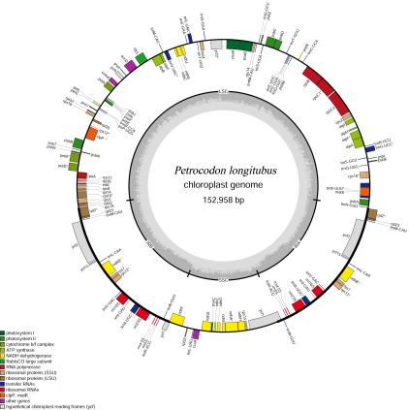
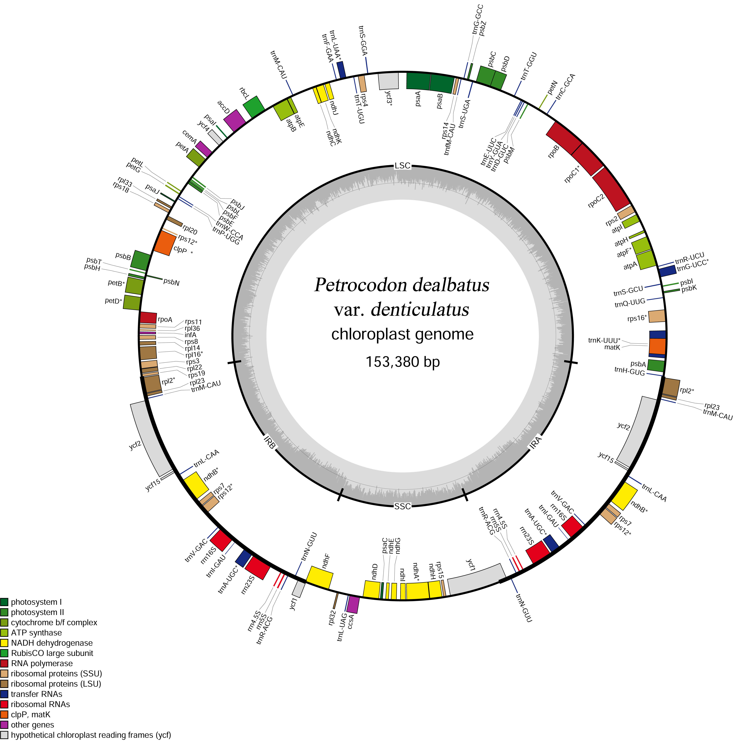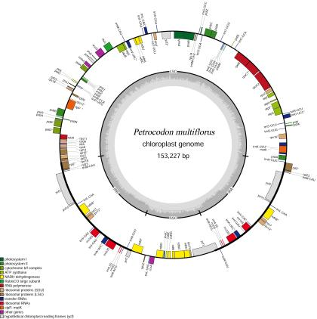
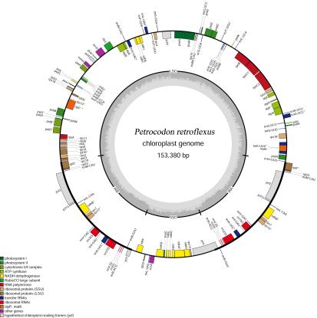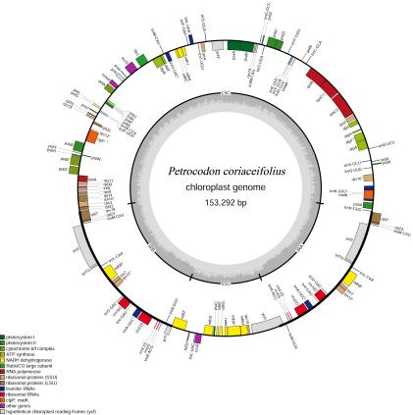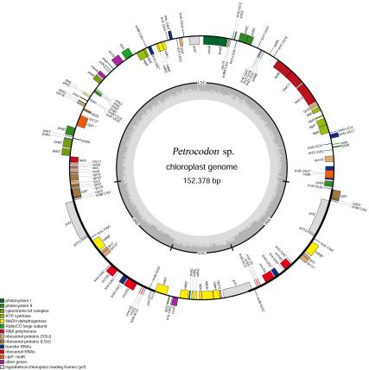
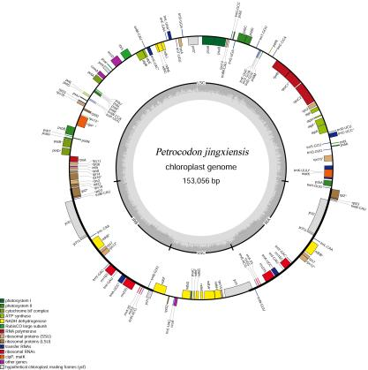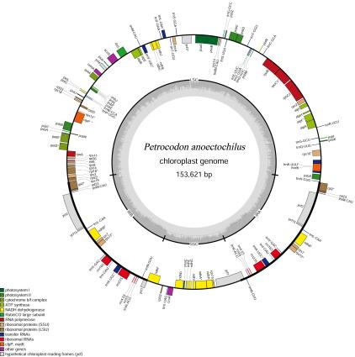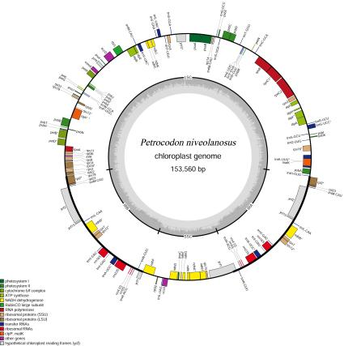
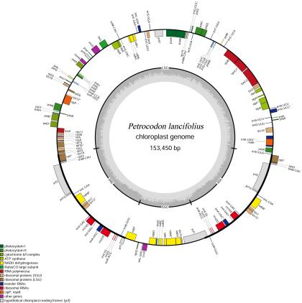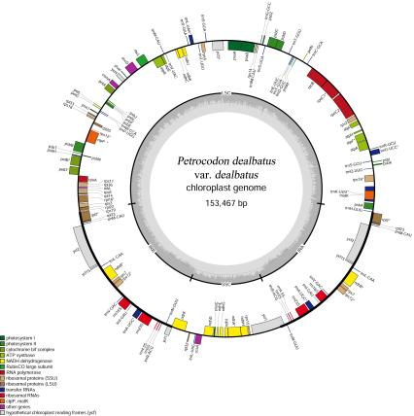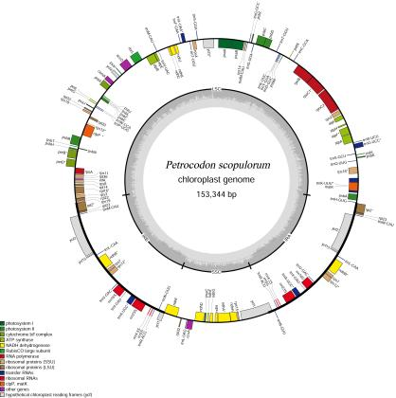
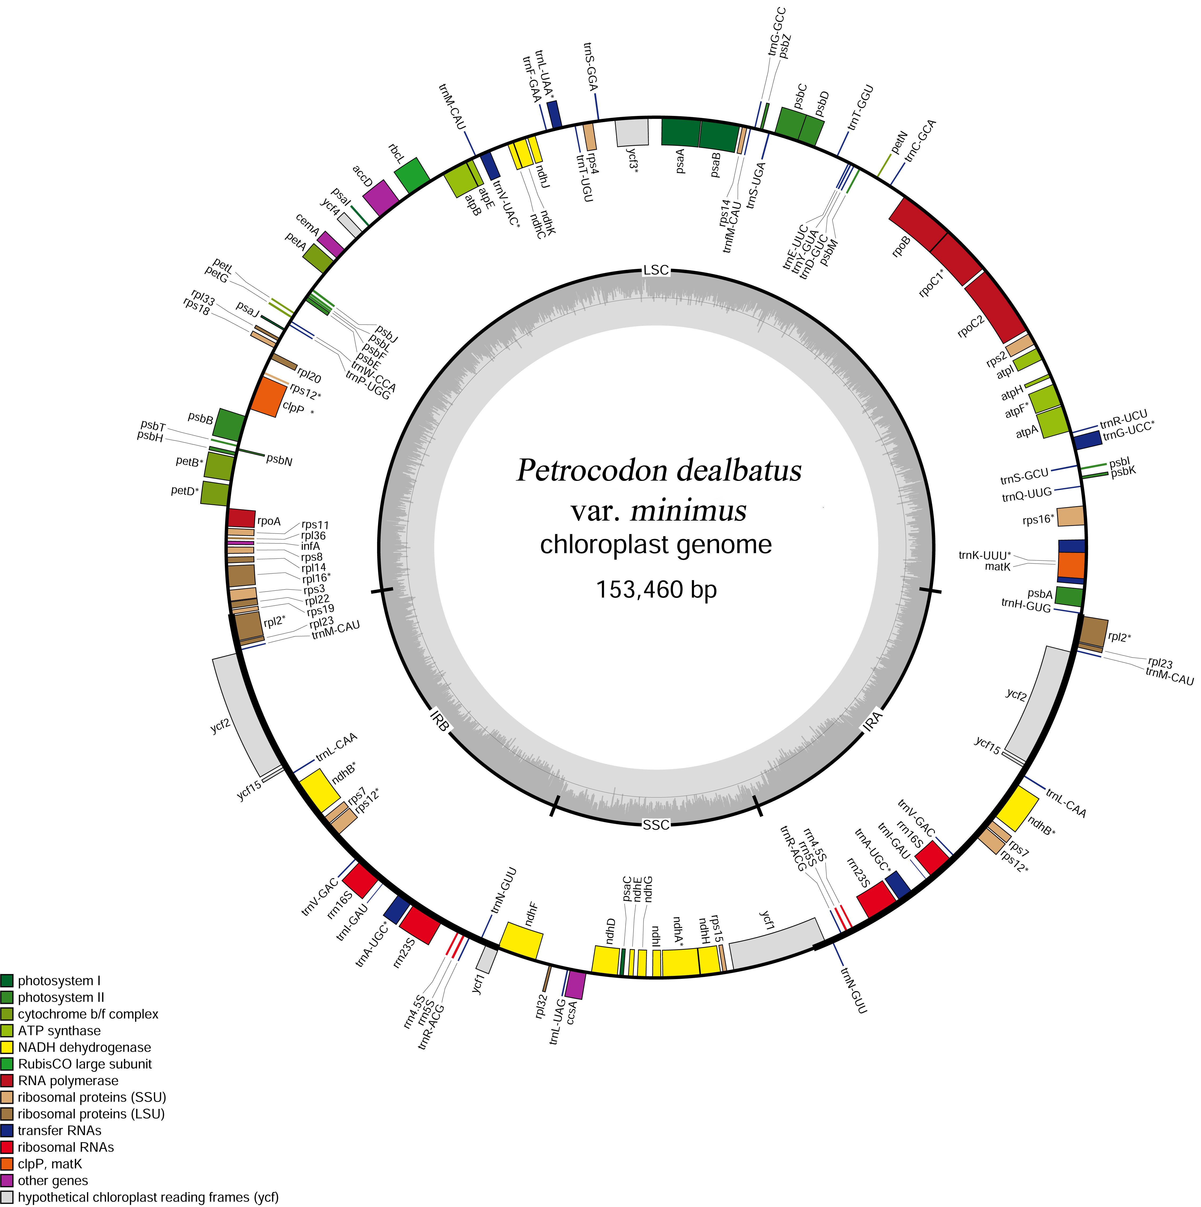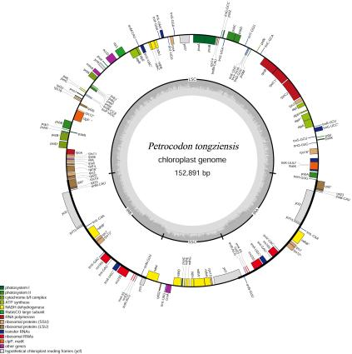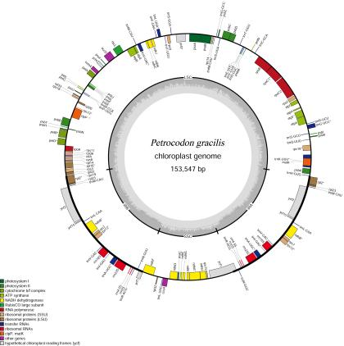
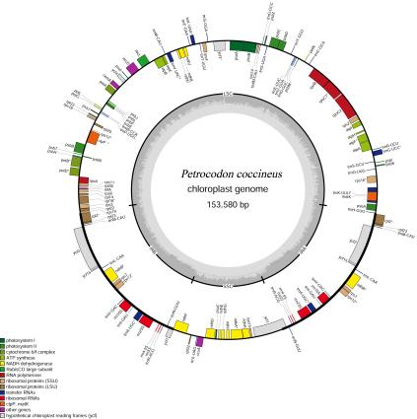

Supplementary Figure S1. Circular maps of the 19 Petrocodon chloroplast genomes.

Category | Gene group | Gene name
Protein synthesis and DNA–replication | Transfer RNA genes | rrn4.5 (×2), rrn5 (×2), rrn16 (×2), rrn23 (×2)
Protein synthesis and DNA–replication | Transfer RNA genes | trnA–UGC* (×2), trnC–GCA, trnD–GUC, trnE–UUC, trnF–GAA, trnG–GCC, trnG–UCC*, trnH–GUG, trnI–GAU* (×2), trnK–UUU*, trnL–CAA (×2), trnL–UAA*, trnL–UAG, trnM–CAU (LSC), trnM–CAU (×2) (IR), trnfM–CAU, trnN–GUU (×2), trnP–UGG, trnQ–UUG, trnR–ACG (×2), trnR–UCU, trnS–GCU, trnS–GGA, trnS–UGA, trnT–GGU, trnT–UGU, trnV–GAC (×2), trnV–UAC*, trnW–CCA, trnY–GUA
Protein synthesis and DNA–replication | Ribosomal protein genes (larger subunit) | rpl2* (×2), rpl14, rpl16*, rpl20, rpl22, rpl23, rpl32 (×2), rpl33, rpl36
Protein synthesis and DNA–replication | Ribosomal protein genes (smaller subunit) | rps2, rps3, rps4, rps7 (×2), rps8, rps11, rps12* (×2), rps14, rps15, rps16*, rps18, rps19
Protein synthesis and DNA–replication | RNA polymerase | rpoA, rpoB, rpoC1*, rpoC2
Photosynthesis | Photosystem I | psaA, psaB, psaC, psaI, psaJ
Photosynthesis | Photosystem II | psbA, psbB, psbC, psbD, psbE, psbF, psbH, psbI, psbJ, psbK, psbL, psbM, psbN, psbT, psbZ
Photosynthesis | Cytochrome b/f complex | petA, petB*, petD*, petG, petL, petN
Photosynthesis | ATP synthase | atpA, atpB, atpE, atpF*, atpH, atpI
Photosynthesis | Rubisco large subunit | rbcL
Photosynthesis | NADH dehydrogenase | ndhA*, ndhB* (×2), ndhC, ndhD, ndhE, ndhF, ndhG, ndhH, ndhI, ndhJ, ndhK
Other genes coding for proteins | ATP–dependent protease | clpP**
Other genes coding for proteins | Maturase | matK
Other genes coding for proteins | Acetyl–CoA carboxylase | accD
Other genes coding for proteins | Translation initiation factor | infA
Other genes coding for proteins | Cytochrome c biogenesis | ccsA
Other genes coding for proteins | Inner membrane protein | cemA
Genes of unknown function | Hypothetical chloroplast reading frames (ycf) | ycf1, ycf2 (×2), ycf3**, ycf4, ycf15 (×2)

* indicates the presence of one intron.
** indicates the presence of two introns.
The trnG-UCC gene is absent in P. anoectochilus and P. coriaceifolius.
The gene integrity of the trnV-UAC gene in P. dealbatus var. denticulatus was less than 50%; thus, it was annotated as a pseudogene.
The ndhK gene of P. chongqingensis was deleted due to a base substitution at the start codon.
The trnM-CAU gene sequences in the LSC and IR regions differ and were classified as two distinct gene copies.

Supplementary Table S1. Genes annotated in the 19 chloroplast genomes.

 |  | P. coccineus | P. tongziensis | P. scopulorum | P. dealbatus  var. dealbatus | P. lancifolius | P. chishuiensis | P. niveolanosus | P. dealbatus var. minimus | P. longitubus | P. multiflorus
SSRs | Mono | 16 | 14 | 14 | 19 | 21 | 15 | 19 | 21 | 20 | 21
SSRs | Di | 9 | 8 | 9 | 8 | 8 | 8 | 9 | 9 | 10 | 10
SSRs | Tri | 1 | 4 | 2 | 2 | 2 | 4 | 4 | 3 | 2 | 2
SSRs | Tetra | 8 | 11 | 8 | 8 | 7 | 11 | 6 | 7 | 9 | 8
SSRs | Penta | 3 | 2 | 1 | 1 | 2 | 1 | 1 | 0 | 1 | 1
SSRs | Hexa | 0 | 0 | 0 | 0 | 0 | 0 | 0 | 0 | 0 | 0
Total of SSRs |  | 37 | 39 | 34 | 38 | 40 | 39 | 39 | 40 | 42 | 42
DRs | Forward | 21 | 11 | 15 | 14 | 12 | 13 | 12 | 18 | 11 | 11
DRs | Palindromic | 24 | 17 | 19 | 18 | 15 | 16 | 17 | 23 | 17 | 14
DRs | Reverse | 2 | 1 | 2 | 2 | 2 | 0 | 1 | 3 | 1 | 2
DRs | Complement | 7 | 0 | 0 | 0 | 0 | 0 | 0 | 0 | 0 | 0
Total of DRs |  | 54 | 29 | 36 | 34 | 29 | 29 | 30 | 44 | 29 | 27

 |  | P. jingxiensis | P. hancei | P. gracilis | P. retroflexus | P. sp. | P. anoectochilus | P. coriaceifolius | P.dealbatus var. denticulatus | P. chongqingensis
SSRs | Mono | 16 | 22 | 22 | 22 | 25 | 16 | 18 | 20 | 16
SSRs | Di | 11 | 10 | 11 | 11 | 7 | 11 | 8 | 9 | 8
SSRs | Tri | 2 | 3 | 2 | 3 | 4 | 1 | 1 | 2 | 4
SSRs | Tetra | 6 | 5 | 10 | 11 | 9 | 9 | 8 | 8 | 10
SSRs | Penta | 1 | 1 | 1 | 0 | 0 | 1 | 2 | 1 | 1
SSRs | Hexa | 0 | 0 | 0 | 0 | 0 | 0 | 0 | 0 | 0
Total of SSRs |  | 36 | 41 | 46 | 47 | 45 | 38 | 37 | 40 | 39
DRs | Forward | 14 | 16 | 12 | 12 | 13 | 14 | 14 | 19 | 12
DRs | Palindromic | 21 | 21 | 17 | 16 | 16 | 18 | 20 | 22 | 17
DRs | Reverse | 3 | 1 | 1 | 0 | 0 | 0 | 1 | 1 | 0
DRs | Complement | 0 | 0 | 0 | 0 | 0 | 1 | 0 | 0 | 0
Total of DRs |  | 38 | 38 | 30 | 28 | 29 | 33 | 35 | 42 | 29

Supplementary Table S2. Number of SSRs and dispersed repeats (DRs) in the 19 chloroplast genomes.
Symbol | AminoAcid | Codon | P. coccineus | P. tongziensis | P. scopulorum | P. dealbatus var. dealbatus | P. lancifolius | P. chishuiensis | P. niveolanosus | P. dealbatus var. minimus | P. longitubus | P. multiflorus | P. jingxiensis | P. hancei | P. gracilis | P. retroflexus | P. sp. | P. anoectochilus | P. coriaceifolius | P.dealbatus var. denticulatus | P. chongqingensis | Total of Codon | Total of Amino acid
* | Ter | UAA | 41 | 43 | 40 | 40 | 40 | 44 | 41 | 41 | 41 | 41 | 43 | 41 | 41 | 43 | 41 | 40 | 41 | 41 | 42 | 785 | 1520
* | Ter | UAG | 21 | 21 | 22 | 22 | 22 | 20 | 21 | 21 | 23 | 21 | 21 | 21 | 21 | 20 | 22 | 21 | 21 | 21 | 21 | 403 | 1520
* | Ter | UGA | 18 | 16 | 18 | 18 | 18 | 16 | 18 | 18 | 16 | 18 | 17 | 18 | 18 | 17 | 17 | 19 | 18 | 18 | 16 | 332 | 1520
A | Ala | GCA | 365 | 370 | 368 | 368 | 370 | 370 | 369 | 373 | 368 | 371 | 363 | 368 | 371 | 361 | 374 | 368 | 370 | 370 | 359 | 6996 | 23672
A | Ala | GCC | 198 | 195 | 197 | 197 | 196 | 194 | 199 | 199 | 194 | 197 | 197 | 198 | 200 | 194 | 197 | 198 | 196 | 198 | 188 | 3732 | 23672
A | Ala | GCG | 129 | 126 | 128 | 128 | 130 | 129 | 127 | 124 | 125 | 126 | 122 | 128 | 123 | 126 | 125 | 127 | 127 | 124 | 122 | 2396 | 23672
A | Ala | GCU | 554 | 558 | 553 | 553 | 553 | 558 | 559 | 559 | 563 | 554 | 554 | 551 | 559 | 550 | 554 | 556 | 555 | 559 | 546 | 10548 | 23672
C | Cys | UGC | 69 | 69 | 69 | 69 | 68 | 70 | 70 | 71 | 70 | 67 | 70 | 67 | 69 | 68 | 71 | 67 | 70 | 70 | 70 | 1314 | 4872
C | Cys | UGU | 188 | 192 | 189 | 188 | 188 | 188 | 189 | 189 | 186 | 186 | 185 | 190 | 190 | 184 | 186 | 186 | 185 | 185 | 184 | 3558 | 4872
D | Asp | GAC | 169 | 171 | 175 | 175 | 173 | 171 | 170 | 174 | 172 | 173 | 176 | 174 | 174 | 170 | 172 | 177 | 175 | 177 | 166 | 3284 | 17401
D | Asp | GAU | 748 | 745 | 745 | 743 | 743 | 746 | 746 | 748 | 744 | 743 | 736 | 748 | 740 | 729 | 740 | 744 | 744 | 746 | 739 | 14117 | 17401
E | Glu | GAA | 912 | 913 | 909 | 906 | 907 | 912 | 908 | 906 | 906 | 912 | 908 | 905 | 910 | 895 | 905 | 918 | 907 | 912 | 897 | 17248 | 22350
E | Glu | GAG | 271 | 270 | 270 | 270 | 267 | 267 | 272 | 269 | 269 | 270 | 265 | 267 | 270 | 265 | 269 | 267 | 269 | 270 | 265 | 5102 | 22350
F | Phe | UUC | 425 | 425 | 426 | 425 | 424 | 426 | 428 | 427 | 423 | 428 | 423 | 422 | 420 | 416 | 420 | 429 | 428 | 428 | 416 | 8059 | 24756
F | Phe | UUU | 879 | 884 | 882 | 882 | 884 | 886 | 877 | 884 | 889 | 874 | 862 | 887 | 885 | 856 | 887 | 884 | 877 | 885 | 853 | 16697 | 24756
G | Gly | GGA | 616 | 620 | 623 | 623 | 624 | 616 | 615 | 624 | 623 | 620 | 612 | 620 | 620 | 609 | 613 | 620 | 621 | 621 | 592 | 11732 | 29735
G | Gly | GGC | 153 | 153 | 153 | 152 | 153 | 157 | 159 | 151 | 160 | 155 | 157 | 151 | 153 | 151 | 156 | 154 | 152 | 151 | 155 | 2926 | 29735
G | Gly | GGG | 270 | 267 | 267 | 266 | 267 | 268 | 272 | 266 | 265 | 270 | 263 | 268 | 270 | 263 | 267 | 267 | 266 | 267 | 265 | 5074 | 29735
G | Gly | GGU | 526 | 527 | 527 | 529 | 527 | 523 | 527 | 530 | 525 | 525 | 519 | 533 | 524 | 527 | 534 | 527 | 532 | 532 | 509 | 10003 | 29735
H | His | CAC | 117 | 117 | 116 | 117 | 115 | 121 | 119 | 117 | 119 | 117 | 117 | 115 | 116 | 118 | 119 | 119 | 115 | 118 | 118 | 2230 | 9943
H | His | CAU | 406 | 408 | 407 | 407 | 407 | 405 | 407 | 408 | 406 | 405 | 404 | 409 | 406 | 402 | 407 | 405 | 410 | 407 | 397 | 7713 | 9943
I | Ile | AUA | 610 | 621 | 604 | 606 | 603 | 608 | 601 | 605 | 606 | 612 | 602 | 612 | 616 | 602 | 613 | 611 | 604 | 609 | 597 | 11542 | 37730
I | Ile | AUC | 410 | 398 | 407 | 408 | 405 | 406 | 414 | 411 | 409 | 409 | 401 | 412 | 410 | 407 | 411 | 408 | 412 | 409 | 396 | 7743 | 37730
I | Ile | AUU | 966 | 979 | 972 | 974 | 975 | 982 | 964 | 968 | 975 | 974 | 955 | 974 | 976 | 962 | 968 | 981 | 971 | 975 | 954 | 18445 | 37730
K | Lys | AAA | 917 | 921 | 926 | 924 | 924 | 923 | 922 | 929 | 914 | 920 | 912 | 919 | 919 | 911 | 924 | 928 | 918 | 927 | 914 | 17492 | 23266
K | Lys | AAG | 308 | 303 | 302 | 302 | 304 | 304 | 309 | 306 | 306 | 302 | 297 | 305 | 307 | 298 | 303 | 311 | 303 | 302 | 302 | 5774 | 23266
L | Leu | CUA | 330 | 330 | 328 | 328 | 329 | 329 | 329 | 330 | 331 | 326 | 324 | 330 | 331 | 318 | 330 | 333 | 330 | 332 | 312 | 6230 | 45545
L | Leu | CUC | 139 | 138 | 139 | 139 | 139 | 142 | 141 | 140 | 142 | 139 | 138 | 139 | 139 | 144 | 144 | 140 | 140 | 141 | 138 | 2661 | 45545
L | Leu | CUG | 157 | 158 | 160 | 158 | 158 | 161 | 155 | 158 | 156 | 154 | 157 | 158 | 160 | 156 | 156 | 156 | 156 | 156 | 153 | 2983 | 45545
L | Leu | CUU | 512 | 510 | 515 | 515 | 515 | 506 | 513 | 515 | 513 | 518 | 504 | 516 | 514 | 502 | 516 | 516 | 516 | 515 | 494 | 9725 | 45545
L | Leu | UUA | 775 | 787 | 786 | 786 | 787 | 788 | 785 | 786 | 790 | 784 | 769 | 789 | 789 | 773 | 785 | 786 | 781 | 784 | 752 | 14862 | 45545
L | Leu | UUG | 481 | 478 | 479 | 480 | 478 | 476 | 487 | 476 | 476 | 486 | 475 | 481 | 481 | 463 | 486 | 480 | 479 | 475 | 467 | 9084 | 45545
M | Met | AUG | 546 | 553 | 552 | 552 | 552 | 551 | 556 | 553 | 554 | 553 | 548 | 546 | 543 | 546 | 551 | 551 | 553 | 552 | 528 | 10440 | 10440
N | Asn | AAC | 235 | 239 | 231 | 229 | 231 | 236 | 240 | 233 | 239 | 239 | 233 | 242 | 236 | 234 | 240 | 232 | 232 | 235 | 237 | 4473 | 20286
N | Asn | AAU | 828 | 843 | 835 | 836 | 835 | 839 | 830 | 828 | 840 | 833 | 814 | 832 | 835 | 811 | 840 | 835 | 830 | 833 | 836 | 15813 | 20286
P | Pro | CCA | 266 | 273 | 271 | 271 | 271 | 273 | 270 | 269 | 275 | 267 | 265 | 268 | 269 | 266 | 266 | 269 | 269 | 268 | 263 | 5109 | 17823
P | Pro | CCC | 172 | 168 | 172 | 171 | 171 | 169 | 170 | 171 | 168 | 171 | 171 | 172 | 170 | 168 | 172 | 171 | 170 | 172 | 166 | 3235 | 17823
P | Pro | CCG | 127 | 126 | 124 | 125 | 125 | 126 | 129 | 127 | 124 | 127 | 121 | 124 | 127 | 126 | 127 | 125 | 126 | 124 | 122 | 2382 | 17823
P | Pro | CCU | 373 | 377 | 373 | 374 | 375 | 377 | 376 | 372 | 376 | 371 | 371 | 374 | 376 | 372 | 373 | 372 | 375 | 374 | 366 | 7097 | 17823
Q | Gln | CAA | 617 | 617 | 625 | 625 | 625 | 618 | 622 | 624 | 622 | 621 | 611 | 627 | 622 | 611 | 623 | 618 | 621 | 618 | 616 | 11783 | 15310
Q | Gln | CAG | 186 | 185 | 185 | 186 | 187 | 185 | 186 | 186 | 188 | 186 | 184 | 185 | 188 | 186 | 184 | 186 | 186 | 187 | 181 | 3527 | 15310
R | Arg | AGA | 402 | 406 | 403 | 404 | 402 | 406 | 408 | 406 | 410 | 407 | 401 | 408 | 408 | 402 | 408 | 404 | 405 | 407 | 405 | 7702 | 26053
R | Arg | AGG | 142 | 142 | 145 | 147 | 143 | 143 | 139 | 143 | 143 | 138 | 139 | 143 | 139 | 136 | 142 | 138 | 144 | 144 | 142 | 2692 | 26053
R | Arg | CGA | 336 | 334 | 334 | 334 | 334 | 335 | 333 | 333 | 331 | 337 | 331 | 336 | 333 | 324 | 332 | 334 | 333 | 334 | 329 | 6327 | 26053
R | Arg | CGC | 93 | 94 | 92 | 92 | 92 | 93 | 94 | 93 | 93 | 94 | 91 | 91 | 89 | 89 | 90 | 94 | 90 | 93 | 93 | 1750 | 26053
R | Arg | CGG | 92 | 94 | 93 | 92 | 92 | 95 | 98 | 92 | 96 | 93 | 94 | 94 | 89 | 95 | 95 | 93 | 91 | 92 | 92 | 1772 | 26053
R | Arg | CGU | 307 | 304 | 308 | 308 | 307 | 304 | 303 | 306 | 299 | 309 | 306 | 304 | 309 | 303 | 309 | 309 | 309 | 306 | 300 | 5810 | 26053
S | Ser | AGC | 91 | 89 | 91 | 91 | 91 | 88 | 92 | 91 | 90 | 93 | 88 | 92 | 93 | 95 | 92 | 93 | 92 | 89 | 88 | 1729 | 33599
S | Ser | AGU | 373 | 378 | 377 | 377 | 376 | 383 | 380 | 381 | 379 | 375 | 372 | 375 | 378 | 366 | 374 | 377 | 377 | 378 | 377 | 7153 | 33599
S | Ser | UCA | 361 | 365 | 368 | 367 | 367 | 359 | 361 | 360 | 366 | 364 | 364 | 361 | 364 | 356 | 361 | 359 | 360 | 364 | 361 | 6888 | 33599
S | Ser | UCC | 270 | 278 | 271 | 273 | 272 | 278 | 275 | 269 | 278 | 275 | 267 | 272 | 270 | 270 | 279 | 275 | 269 | 271 | 274 | 5186 | 33599
S | Ser | UCG | 156 | 155 | 156 | 155 | 156 | 155 | 162 | 160 | 152 | 158 | 155 | 159 | 158 | 156 | 158 | 157 | 160 | 160 | 155 | 2983 | 33599
S | Ser | UCU | 512 | 508 | 512 | 513 | 511 | 510 | 504 | 518 | 509 | 510 | 506 | 511 | 508 | 480 | 509 | 508 | 518 | 516 | 497 | 9660 | 33599
U | Thr | ACA | 344 | 349 | 354 | 352 | 352 | 348 | 349 | 346 | 350 | 348 | 339 | 351 | 351 | 340 | 344 | 348 | 346 | 352 | 344 | 6607 | 22080
U | Thr | ACC | 206 | 202 | 207 | 207 | 207 | 208 | 204 | 208 | 206 | 211 | 205 | 211 | 203 | 202 | 206 | 209 | 208 | 206 | 202 | 3918 | 22080
U | Thr | ACG | 116 | 122 | 115 | 116 | 117 | 123 | 119 | 117 | 120 | 118 | 117 | 116 | 116 | 114 | 124 | 116 | 115 | 117 | 120 | 2238 | 22080
U | Thr | ACU | 489 | 493 | 497 | 497 | 493 | 489 | 489 | 492 | 490 | 493 | 483 | 494 | 495 | 480 | 491 | 489 | 492 | 496 | 475 | 9317 | 22080
V | Val | GUA | 496 | 500 | 498 | 497 | 498 | 503 | 496 | 497 | 499 | 503 | 485 | 496 | 496 | 490 | 496 | 491 | 496 | 493 | 495 | 9425 | 24263
V | Val | GUC | 138 | 136 | 137 | 137 | 137 | 133 | 136 | 130 | 135 | 132 | 135 | 134 | 134 | 136 | 136 | 129 | 134 | 135 | 132 | 2556 | 24263
V | Val | GUG | 163 | 161 | 165 | 164 | 165 | 161 | 163 | 166 | 163 | 164 | 168 | 164 | 167 | 163 | 162 | 167 | 165 | 164 | 160 | 3115 | 24263
V | Val | GUU | 482 | 482 | 486 | 487 | 486 | 483 | 481 | 485 | 480 | 487 | 483 | 482 | 482 | 471 | 479 | 488 | 483 | 485 | 475 | 9167 | 24263
W | Trp | UGG | 397 | 397 | 401 | 402 | 403 | 400 | 400 | 400 | 400 | 402 | 389 | 401 | 400 | 395 | 401 | 401 | 399 | 400 | 391 | 7579 | 7579
Y | Tyr | UAC | 153 | 153 | 153 | 153 | 153 | 151 | 151 | 154 | 150 | 154 | 152 | 157 | 150 | 151 | 153 | 151 | 152 | 148 | 149 | 2888 | 16078
Y | Tyr | UAU | 689 | 700 | 697 | 697 | 695 | 697 | 692 | 698 | 698 | 695 | 683 | 697 | 700 | 684 | 691 | 698 | 701 | 705 | 673 | 13190 | 16078

Supplementary Table S3. Number of amino acids and codons in the 19 chloroplast genomes.

Genes | P. chishuiensis | P. longitubus | P. dealbatus  var. denticulatus | P. multiflorus | P. hancei | P. retroflexus | P. coriaceifolius | P. sp. | P. jingxiensis | P. niveolanosus | P. lancifolius | P. dealbatus  var. dealbatus | P. scopulorum | P. dealbatus  var. minimus | P. tongziensis | P. gracilis | P. coccineus | P. anoectochilus
accD | 0.259 | 1.296 | 0.498 | 0.605 | 0.397 | 1.125 | 0.719 | 0.720 | 0.665 | 0.777 | 0.498 | 0.448 | 0.448 | 0.499 | 1.558 | 0.777 | 0.778 | 0.665
atpA | 0.482 | 0.000 | 0.036 | 0.000 | 0.000 | 0.046 | 0.000 | 0.129 | 0.000 | 0.241 | 0.046 | 0.054 | 0.054 | 0.107 | 0.107 | 0.000 | 0.054 | 0.000
atpB | 0.000 | 0.000 | 0.111 | 0.111 | 0.166 | 0.047 | 0.066 | 0.000 | 0.165 | 0.055 | 0.111 | 0.111 | 0.166 | 0.133 | 0.066 | 0.055 | 0.083 | 0.165
atpE | 0.000 | NA | 0.302 | NA | NA | NA | 0.302 | NA | NA | NA | 0.607 | 0.911 | 0.607 | 0.604 | 0.302 | NA | NA | NA
atpF | 0.282 | NA | 0.854 | 0.569 | 0.569 | 0.850 | 0.711 | 0.571 | 0.284 | 0.852 | 0.852 | 0.711 | 0.711 | 0.850 | 0.282 | 1.138 | 0.712 | 0.284
atpH | NA | 0.000 | 0.000 | 0.000 | 0.000 | 0.000 | 0.000 | 0.000 | 0.000 | 0.000 | 0.000 | 0.000 | 0.000 | 0.000 | NA | 0.000 | 0.000 | 0.000
atpI | NA | 0.321 | 0.160 | 0.107 | 0.107 | 0.323 | 0.160 | 0.000 | 0.213 | 0.107 | 0.213 | 0.213 | 0.213 | 0.160 | NA | 0.323 | 0.080 | 0.213
ccsA | 0.289 | 1.725 | 0.720 | 0.577 | 0.719 | 2.028 | 1.441 | 3.170 | 0.593 | 0.404 | 1.296 | 1.150 | 1.150 | 1.866 | 0.721 | 1.153 | 0.670 | 0.593
cemA | 0.536 | 0.358 | 0.201 | 0.161 | 0.134 | 0.358 | 0.179 | 0.538 | 0.200 | 0.334 | 0.268 | 0.357 | 0.357 | 0.267 | 0.536 | 0.134 | 0.179 | 0.200
clpP | NA | NA | NA | NA | 0.318 | 0.317 | 0.318 | 0.954 | NA | 0.159 | 0.318 | NA | NA | NA | 0.159 | NA | NA | NA
infA | NA | NA | NA | NA | NA | 0.000 | NA | NA | NA | 0.000 | NA | NA | NA | NA | NA | NA | NA | NA
matK | 0.937 | 1.051 | 1.404 | 0.960 | 0.840 | 0.717 | 1.122 | 0.701 | 0.962 | 1.013 | 1.003 | 1.003 | 1.044 | 1.295 | 1.129 | 0.734 | 1.233 | 0.962
ndhA | NA | NA | 0.382 | 0.784 | 0.545 | 1.084 | 0.436 | 0.514 | 0.614 | 0.590 | 0.382 | 0.382 | 0.382 | 0.435 | NA | 0.815 | 1.052 | 0.614
ndhB | NA | 0.000 | 0.000 | 0.156 | 0.000 | 0.000 | 0.000 | 0.000 | 0.312 | 0.624 | 0.000 | 0.000 | 0.000 | 0.312 | NA | 0.000 | 0.313 | 0.312
ndhC | 0.000 | 0.295 | 0.588 | 0.295 | 0.295 | 0.000 | 0.295 | 0.098 | 0.147 | 0.295 | 0.295 | 0.295 | 0.295 | 0.295 | 0.295 | 0.147 | 0.295 | 0.147
ndhE | 0.148 | 0.890 | 0.298 | 0.446 | 0.298 | 0.298 | 0.298 | 0.149 | 0.444 | 0.445 | 0.298 | 0.298 | 0.298 | 0.446 | 0.296 | 0.893 | 0.397 | 0.444
ndhF | 0.576 | 0.620 | 1.204 | 1.617 | 0.832 | 1.328 | 1.156 | 0.850 | 1.443 | 0.758 | 0.611 | 0.644 | 0.755 | 1.636 | 1.157 | 1.130 | 1.088 | 1.443
ndhG | 0.155 | 0.310 | 0.778 | 0.729 | 0.728 | 0.931 | 0.778 | 0.778 | 0.776 | 0.415 | 0.619 | 0.619 | 0.619 | 1.093 | 0.310 | 0.775 | 0.928 | 0.776
ndhH | 0.572 | 0.715 | 0.238 | 0.238 | 0.204 | 0.172 | 0.286 | 0.668 | 0.383 | 0.214 | 0.204 | 0.179 | 0.179 | 0.245 | 0.191 | 0.178 | 0.159 | 0.383
ndhI | 0.287 | 0.000 | 0.429 | 0.191 | 0.383 | 0.433 | 0.429 | 0.383 | 0.688 | 0.571 | 0.429 | 0.429 | 0.573 | 0.429 | 0.000 | 0.287 | 0.191 | 0.688
ndhJ | NA | NA | 0.092 | 0.275 | 0.825 | 0.415 | 0.275 | 0.275 | 0.275 | 0.275 | 0.092 | 0.092 | 0.092 | 0.138 | NA | 0.184 | 0.092 | 0.275
ndhK | NA | 0.304 | 0.307 | 0.306 | 1.534 | 1.516 | 0.460 | 0.612 | 0.715 | 0.611 | 0.613 | 0.613 | 0.613 | 0.460 | 0.203 | 0.920 | 1.226 | 0.715
petA | 0.311 | 0.311 | 0.518 | 0.374 | 0.374 | 0.133 | 1.245 | 0.233 | 0.466 | 0.620 | 0.466 | 0.372 | 0.373 | 1.087 | 0.621 | 0.389 | 0.777 | 0.466
petB | NA | NA | 0.314 | 0.157 | NA | 0.314 | 0.314 | 0.209 | 0.627 | 0.314 | NA | 0.314 | NA | NA | NA | NA | NA | 0.627
petD | 0.000 | 0.000 | 0.000 | 0.000 | 0.000 | 0.326 | 0.163 | 0.000 | 0.000 | 0.000 | 0.000 | 0.000 | 0.000 | 0.325 | 0.000 | 0.000 | 0.000 | 0.000
petG | NA | NA | NA | NA | NA | NA | 0.674 | NA | NA | NA | NA | NA | NA | NA | NA | NA | NA | NA
petL | NA | NA | NA | NA | NA | NA | NA | NA | NA | NA | NA | NA | NA | NA | 0.000 | NA | NA | NA
petN | 0.000 | 0.000 | NA | NA | 0.311 | NA | NA | NA | NA | NA | NA | NA | NA | NA | NA | NA | NA | NA
psaA | 0.000 | 0.383 | 0.204 | 0.219 | 0.368 | 0.262 | 0.255 | 0.307 | 0.306 | 0.153 | 0.153 | 0.153 | 0.153 | 0.153 | 0.153 | 0.245 | 0.204 | 0.306
psaB | 0.154 | 0.049 | 0.196 | 0.168 | 0.147 | 0.253 | 0.211 | 0.164 | 0.196 | 0.210 | 0.210 | 0.184 | 0.210 | 0.210 | 0.294 | 0.164 | 0.294 | 0.196
psaC | NA | NA | 0.000 | 0.000 | 0.000 | 0.000 | 0.000 | 0.000 | 0.000 | 0.305 | 0.000 | 0.000 | 0.000 | 0.000 | NA | 0.000 | 0.000 | 0.000
psaI | NA | NA | 0.000 | 0.000 | 0.000 | NA | 0.000 | 0.000 | 0.000 | 0.000 | 0.324 | 0.324 | 0.324 | 0.000 | 0.324 | 0.000 | 0.000 | 0.000
psaJ | 0.000 | 0.338 | 0.000 | 0.000 | 0.000 | 0.000 | 0.000 | 0.000 | 0.333 | 0.000 | 0.000 | 0.000 | 0.000 | 0.000 | 0.000 | 0.338 | 0.000 | 0.333
psbA | NA | 0.000 | 0.000 | 0.000 | 0.000 | 0.076 | 0.153 | 0.076 | 0.000 | 0.000 | 0.000 | 0.000 | 0.000 | 0.000 | NA | 0.000 | 0.102 | 0.000
psbB | 0.000 | 0.156 | 0.035 | 0.070 | 0.035 | 0.234 | 0.062 | 0.078 | 0.089 | 0.117 | 0.062 | 0.035 | 0.031 | 0.028 | 0.000 | 0.039 | 0.039 | 0.089
psbC | 0.000 | 0.108 | 0.000 | 0.000 | 0.000 | 0.000 | 0.000 | 0.000 | 0.000 | 0.000 | 0.000 | 0.000 | 0.000 | 0.000 | 0.000 | 0.000 | 0.129 | 0.000
psbD | 0.000 | 0.000 | 0.000 | 0.000 | 0.000 | 0.000 | 0.000 | 0.000 | 0.000 | 0.000 | 0.000 | 0.000 | 0.000 | 0.000 | 0.000 | 0.000 | 0.153 | 0.000
psbE | NA | NA | 0.149 | 0.150 | 0.599 | 0.300 | 0.149 | 0.449 | 0.300 | 0.100 | 0.300 | 0.300 | 0.300 | 0.149 | NA | 0.300 | 0.300 | 0.300
psbF | NA | NA | NA | NA | NA | NA | NA | NA | NA | NA | NA | NA | NA | NA | NA | 0.000 | NA | NA
psbH | NA | NA | 0.325 | 0.650 | 0.650 | 0.325 | 0.325 | 0.333 | 0.325 | 0.652 | 0.654 | 0.327 | 0.654 | 0.333 | NA | 0.325 | 0.325 | 0.325
psbI | 0.000 | NA | NA | NA | NA | NA | NA | NA | 0.000 | NA | NA | NA | NA | NA | 0.000 | NA | NA | 0.000
psbJ | NA | NA | NA | NA | NA | NA | NA | NA | NA | NA | NA | NA | NA | NA | NA | NA | NA | NA
psbK | 0.000 | NA | NA | NA | NA | NA | NA | NA | NA | NA | NA | NA | NA | NA | NA | NA | NA | NA
psbL | NA | NA | NA | NA | 0.000 | 0.262 | NA | NA | NA | NA | NA | NA | NA | NA | NA | NA | NA | NA
psbM | NA | NA | NA | NA | NA | NA | NA | NA | NA | NA | NA | NA | NA | NA | NA | NA | NA | NA
psbT | NA | NA | 0.000 | 0.000 | 0.000 | NA | 0.000 | NA | NA | NA | 0.000 | 0.000 | 0.000 | 0.000 | NA | NA | NA | NA
psbZ | NA | NA | 0.000 | 0.000 | 0.000 | NA | 0.658 | NA | 0.000 | NA | 0.000 | 0.000 | 0.000 | 0.000 | NA | 0.000 | 0.000 | 0.000
rbcL | NA | 0.620 | 0.000 | 0.000 | 0.000 | 0.103 | 0.078 | 0.000 | 0.052 | 0.155 | 0.103 | 0.103 | 0.103 | 0.000 | 0.310 | 0.000 | 0.104 | 0.052
rpl14 | NA | 0.629 | 0.314 | 0.158 | 0.315 | 0.105 | 0.314 | 0.315 | 0.158 | 0.317 | 0.158 | 0.158 | 0.158 | 0.105 | NA | 0.105 | 0.158 | 0.158
rpl16 | NA | 0.335 | 0.336 | 0.000 | 0.000 | 0.336 | 0.669 | 0.000 | 0.000 | 0.334 | 0.000 | 0.084 | 0.084 | 0.112 | NA | 0.000 | 0.334 | 0.000
rpl2 | NA | NA | NA | NA | NA | NA | NA | 0.648 | NA | NA | NA | NA | NA | NA | NA | NA | NA | NA
rpl20 | 0.626 | 0.314 | 0.208 | 0.312 | 0.311 | 1.861 | 0.312 | 1.857 | 0.312 | 0.940 | 0.312 | 0.312 | 0.312 | 0.312 | 0.939 | 0.623 | 0.321 | 0.312
rpl22 | 0.892 | 0.595 | 0.898 | 1.790 | 1.202 | 0.298 | 1.797 | 0.599 | 0.796 | 0.449 | 2.096 | 2.096 | 2.096 | 0.898 | 0.595 | 1.499 | 0.749 | 0.796
rpl23 | NA | NA | NA | NA | NA | NA | NA | NA | NA | NA | NA | NA | NA | NA | NA | NA | NA | NA
rpl32 | NA | NA | NA | NA | NA | 3.251 | 0.603 | NA | 0.603 | NA | NA | NA | NA | NA | NA | NA | 2.537 | 0.603
rpl33 | NA | NA | 0.000 | 0.000 | 0.286 | NA | 0.000 | NA | NA | NA | 0.000 | 0.000 | 0.000 | 0.000 | NA | NA | NA | NA
rpl36 | NA | NA | 0.000 | 0.000 | 0.000 | 0.000 | 0.000 | 0.000 | 0.000 | 0.000 | 0.000 | 0.000 | 0.000 | 0.000 | NA | 0.310 | 0.313 | 0.000
rpoA | 0.276 | 0.166 | 0.235 | 0.276 | 0.274 | 0.275 | 0.308 | 0.315 | 0.313 | 0.236 | 0.354 | 0.354 | 0.315 | 0.219 | 0.459 | 0.363 | 0.433 | 0.313
rpoB | 0.306 | 0.306 | 0.649 | 0.726 | 0.500 | 0.334 | 0.519 | 0.476 | 1.283 | 0.306 | 0.866 | 0.786 | 0.698 | 0.491 | 0.305 | 0.398 | 0.551 | 1.283
rpoC1 | NA | 0.304 | 0.607 | 0.709 | 0.607 | 0.607 | 0.532 | 1.521 | 0.682 | 0.531 | 0.548 | 0.546 | 0.546 | 0.758 | 1.822 | 0.425 | 0.608 | 0.682
rpoC2 | 0.447 | 1.071 | 0.490 | 0.497 | 0.557 | 0.665 | 0.490 | 0.317 | 0.386 | 0.383 | 0.597 | 0.671 | 0.647 | 0.478 | 0.425 | 0.478 | 0.418 | 0.386
rps11 | NA | NA | 0.356 | 0.356 | 0.356 | NA | 0.178 | NA | 0.356 | 1.067 | 0.178 | 0.178 | 0.178 | 0.178 | 0.357 | 0.178 | 0.356 | 0.356
rps12 | 0.000 | NA | NA | NA | 0.000 | 0.000 | NA | 0.353 | NA | NA | NA | NA | NA | NA | NA | NA | NA | NA
rps14 | NA | NA | 0.097 | 0.000 | 0.000 | 0.290 | 0.000 | 0.291 | 0.000 | 0.000 | 0.000 | 0.000 | 0.000 | 0.000 | NA | 0.144 | 0.000 | 0.000
rps15 | 0.197 | 0.294 | 0.493 | 0.890 | 0.597 | 0.589 | 0.896 | 0.595 | 0.597 | 0.395 | 0.506 | 0.506 | 0.498 | 0.510 | 0.148 | 0.890 | 0.597 | 0.597
rps16 | NA | NA | NA | 1.316 | NA | NA | NA | NA | NA | NA | NA | NA | NA | NA | NA | NA | NA | NA
rps18 | NA | NA | NA | NA | 0.895 | 0.599 | NA | NA | NA | 0.299 | NA | NA | NA | NA | NA | NA | 0.598 | NA
rps19 | NA | NA | 0.451 | 0.302 | 0.226 | 0.441 | 0.598 | 0.903 | 0.301 | 0.602 | 0.301 | 0.301 | 0.301 | 0.300 | NA | 0.452 | 0.301 | 0.301
rps2 | 0.294 | 0.884 | 0.884 | 1.469 | 1.030 | 0.588 | 1.177 | 0.441 | 0.885 | 0.883 | 1.470 | 1.470 | 1.470 | 0.589 | NA | 0.294 | 0.393 | 0.885
rps3 | 0.577 | NA | 0.477 | 1.003 | 0.574 | 0.717 | 0.669 | 0.861 | 0.858 | 2.009 | 0.287 | 0.230 | 0.287 | 0.717 | 0.144 | 0.384 | 0.287 | 0.858
rps4 | 0.310 | 0.155 | 0.773 | 1.236 | 1.236 | 0.927 | 0.616 | 0.464 | 0.927 | 0.929 | 1.236 | 1.236 | 1.236 | 0.929 | 0.310 | 1.543 | 0.618 | 0.927
rps7 | NA | NA | NA | NA | NA | NA | NA | NA | NA | NA | NA | NA | NA | NA | NA | NA | NA | NA
rps8 | NA | NA | 1.582 | 1.269 | 1.269 | NA | 1.266 | 0.635 | 0.949 | NA | 0.789 | 0.789 | 0.789 | 0.785 | NA | 1.583 | NA | 0.949
ycf1 | 0.668 | 0.863 | 0.877 | 0.742 | 0.708 | 0.973 | 0.857 | 0.817 | 0.967 | 0.923 | 0.745 | 0.764 | 0.726 | 1.012 | 1.057 | 0.853 | 0.752 | 0.967
ycf15 | 0.000 | NA | 0.000 | 0.000 | 0.000 | 0.000 | 0.000 | 0.000 | 0.000 | 0.000 | 0.000 | 0.000 | 0.000 | 0.000 | NA | 0.000 | 0.000 | 0.000
ycf2 | 0.418 | 0.836 | 0.502 | 0.447 | 0.726 | 0.628 | 0.488 | 0.767 | 0.725 | 0.767 | 0.558 | 0.558 | 0.511 | 0.418 | NA | 0.446 | 0.390 | 0.725
ycf3 | NA | NA | 0.283 | 0.283 | NA | NA | NA | NA | NA | 0.284 | 0.000 | 0.000 | 0.000 | NA | NA | NA | NA | NA
ycf4 | 0.299 | 0.300 | 1.046 | 1.046 | 0.746 | 0.750 | 1.196 | 0.702 | 0.894 | 0.750 | 1.046 | 1.046 | 1.046 | 1.053 | 0.300 | 0.895 | 1.019 | 0.894

Supplementary Table S4. Ka/Ks ratios of 78 protein-coding genes in 18 Petrocodon species compared with P. chongqingensis (Reference).

Species | GenBank accession number | Voucher specimen
Corallodiscus lanuginosus | MT012414.1 | ——
Haberlea rhodopensis | KX657870.1 | ——
Beccarinda tonkinensis | OM403997.1 | ——
Beccarinda cordifolia | OM176662.1 | ——
Actinostephanus enpingensis | OM176663.1 | ——
Leptoboea multiflora | OM176668.1 | ——
Boeica ferruginea | OM176670.1 | ——
Rhynchotechum nirijuliense | OM176666.1 | ——
Rhynchotechum vestitum | OM176667.1 | ——
Paraboea sinensis | MZ465380.1 | ——
Paraboea swinhoei | MZ465378.1 | ——
Paraboea peltifolia | MZ465386.1 | ——
Paraboea filipes | MZ465379.1 | ——
Paraboea guilinensis | MZ465377.1 | ——
Damrongia clarkeana | OR778394.1 | ——
Dorcoceras hygrometricum | JN107811.1 | ——
Streptocarpus teitensis | MF596485.1 | ——
Streptocarpus ionanthus subsp. rupicola | MN935473.1 | ——
Streptocarpus ionanthus subsp. velutinus | MN935472.1 | ——
Streptocarpus ionanthus subsp. grandifolius | MN935471.1 | ——
Streptocarpus ionanthus subsp. orbicularis | MN935470.1 | ——
Streptocarpus ionanthus subsp. grotei | MN935469.1 | ——
Henckelia pumila | MZ351199.1 | ——
Oreocharis notochlaena | MK342624.1 | ——
Oreocharis cotinifolia | MN579510.1 | ——
Oreocharis esquirolii | MT612436.1 | ——
Oreocharis burtii | PP054832.1 | ——
Oreocharis auricula | OQ924174.1 | ——
Oreocharis qingyunshanensis | OR992089.1 | ——
Oreocharis argyreia var. angustifolia | ON872365.1 | JLSXGL20220512
Oreocharis chienii | OQ924173.1 | ——
Primulina linearifolia | MF472013.1 | ——
Primulina eburnea | MF472011.1 | ——
Primulina hunanensis | ON456288.1 | YLH907
Primulina silaniae | PP954909.1 | ——
Primulina secundiflora | PP954908.1 | ——
Primulina malingheensis | PP954906.1 | ——
Primulina liboensis | MF177039.1 | CLIB14R20170516
Primulina cardaminifolia | OP470732.1 | ——
Primulina hezhouensis | MZ675551.1 | HAST: K.F. Chung 2914
Primulina fimbrisepala | MZ675550.1 | KFC4144
Primulina hedyotidea | OM283823.1 | ——
Primulina tabacum | ON456296.1 | LSFC59-2
Primulina renifolia | ON456294.1 | GXDA03
Primulina maciejewskii | ON456292.1 | LSFC63-1
Didymocarpus anningensis | PP313049.1 | ——
Didymocarpus glandulosus var. minor | PP296632.1 | ——
Didymocarpus cortusifolius | PP296633.1 | ——
Didymocarpus heucherifolius | PP296630.1 | ——
Didymocarpus lobulatus | PP296629.1 | ——
Didymocarpus salviiflorus | PP296628.1 | ——
Didymocarpus dissectus | PP296624.1 | ——
Didymocarpus sinoprimulinus | PP296623.1 | ——
Didymocarpus purpureobracteatus | PP296622.1 | ——
Didymocarpus yuenlingensis | PP296620.1 | ——
Petrocosmea pengzhouensis | PV750053.1 | ——
Petrocosmea rotundifolia | PQ279902.1 | ——
Petrocosmea minor | PQ279901.1 | ——
Petrocosmea chiwui | PQ279899.1 | ——
Petrocosmea duyunensis | PQ279898.1 | ——
Petrocosmea grandifolia | PQ279897.1 | ——
Petrocosmea forrestii | PQ279896.1 | ——
Pseudochirita guangxiensis | ON950736.1 | ——
Loxostigma griffithii | ON950735.1 | ——
Loxostigma kurzii | ON950733.1 | ——
Lysionotus forrestii | PQ468993.1 | ——
Lysionotus pauciflorus | KX752081.1 | ——
Lysionotus heterophyllus | PQ468988.1 | ——
Lysionotus chingii | PQ468980.1 | ——
Lysionotus gamosepalus | PQ468978.1 | ——
Lysionotus serratus | PQ468976.1 | ——
Lysionotus kwangsiensis | PQ468975.1 | ——
Lysionotus metuoensis | PQ468974.1 | ——
Lysionotus pubescens | PQ468973.1 | ——
Lysionotus aeschynanthoides | PQ468968.1 | ——
Lysionotus denticulosus | PQ468966.1 | ——
Lysionotus oblongifolius | PQ468965.1 | ——
Lysionotus longipedunculatus | PQ468964.1 | ——
Raphiocarpus begoniifolius | ON950734.1 | ——
Anna submontana | OQ641805.1 | ——
Anna rubidiflora | OQ641804.1 | ——
Anna ophiorrhizoides | OQ641803.1 | ——
Anna mollifolia | OQ641802.1 | ——
Hemiboea ovalifolia | MW145180.1 | ——
Hemiboea subcapitata | PX505294.1 | ——
Hemiboea purpureotincta | OQ799919.1 | ——
Hemiboea parvibracteata | OQ799918.1 | ——

Supplementary Table S5. Species information used for constructing the phylogenetic trees.

