Multi-objective optimization of subsurface drip fertigation for winter wheat in the North China Plain: balancing grain yield, resource use efficiency, and soil quality

Fig. S1 Bulk soil organic carbon in the 0-40 cm soil layers under nine drip fertigation treatments
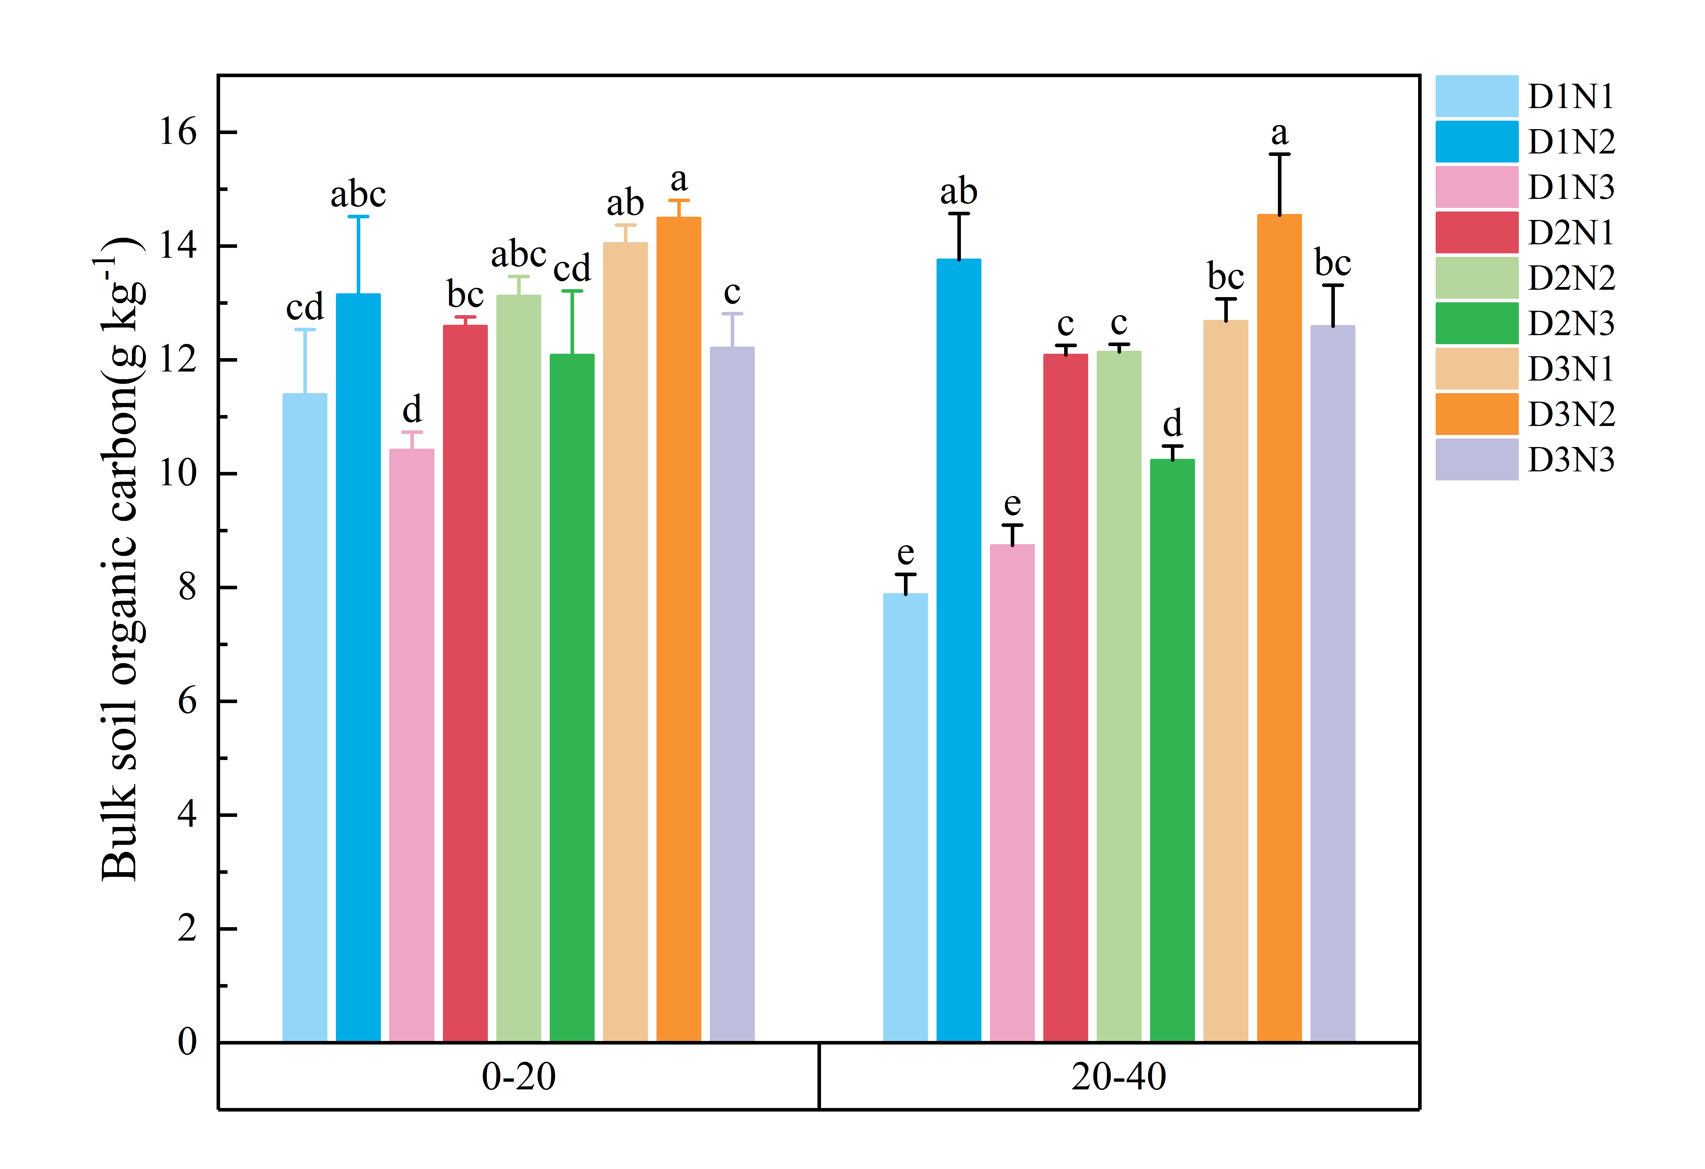
Fig. S2 Soil biological indicators in the 0-20 cm rhizosphere soil layers under nine drip fertigation treatments

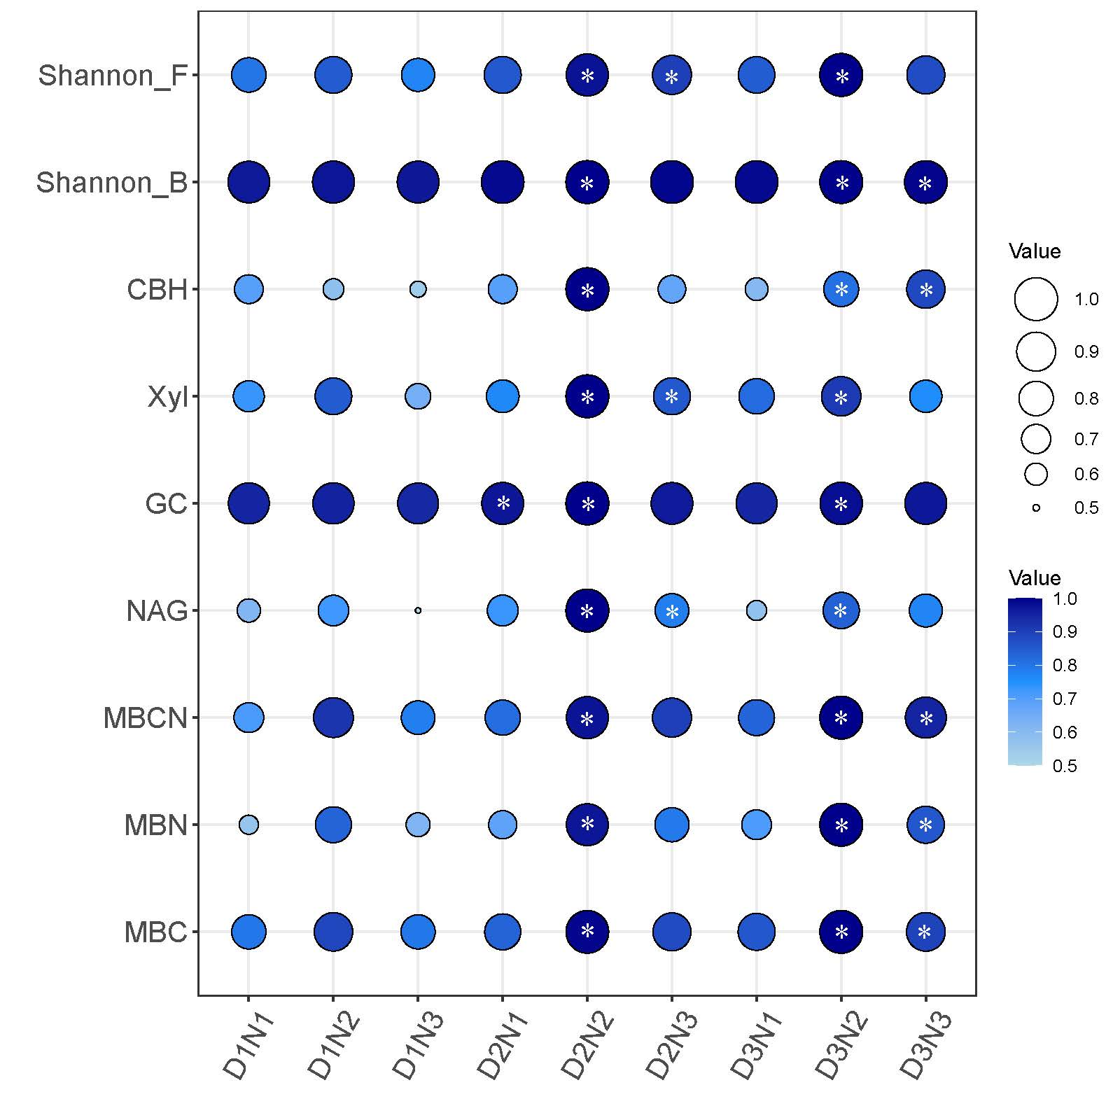
Note: “*” represents the value under specific treatment ranked top 3 among nine treatments
Fig. S3 Water use efficiency under nine drip fertigation treatments
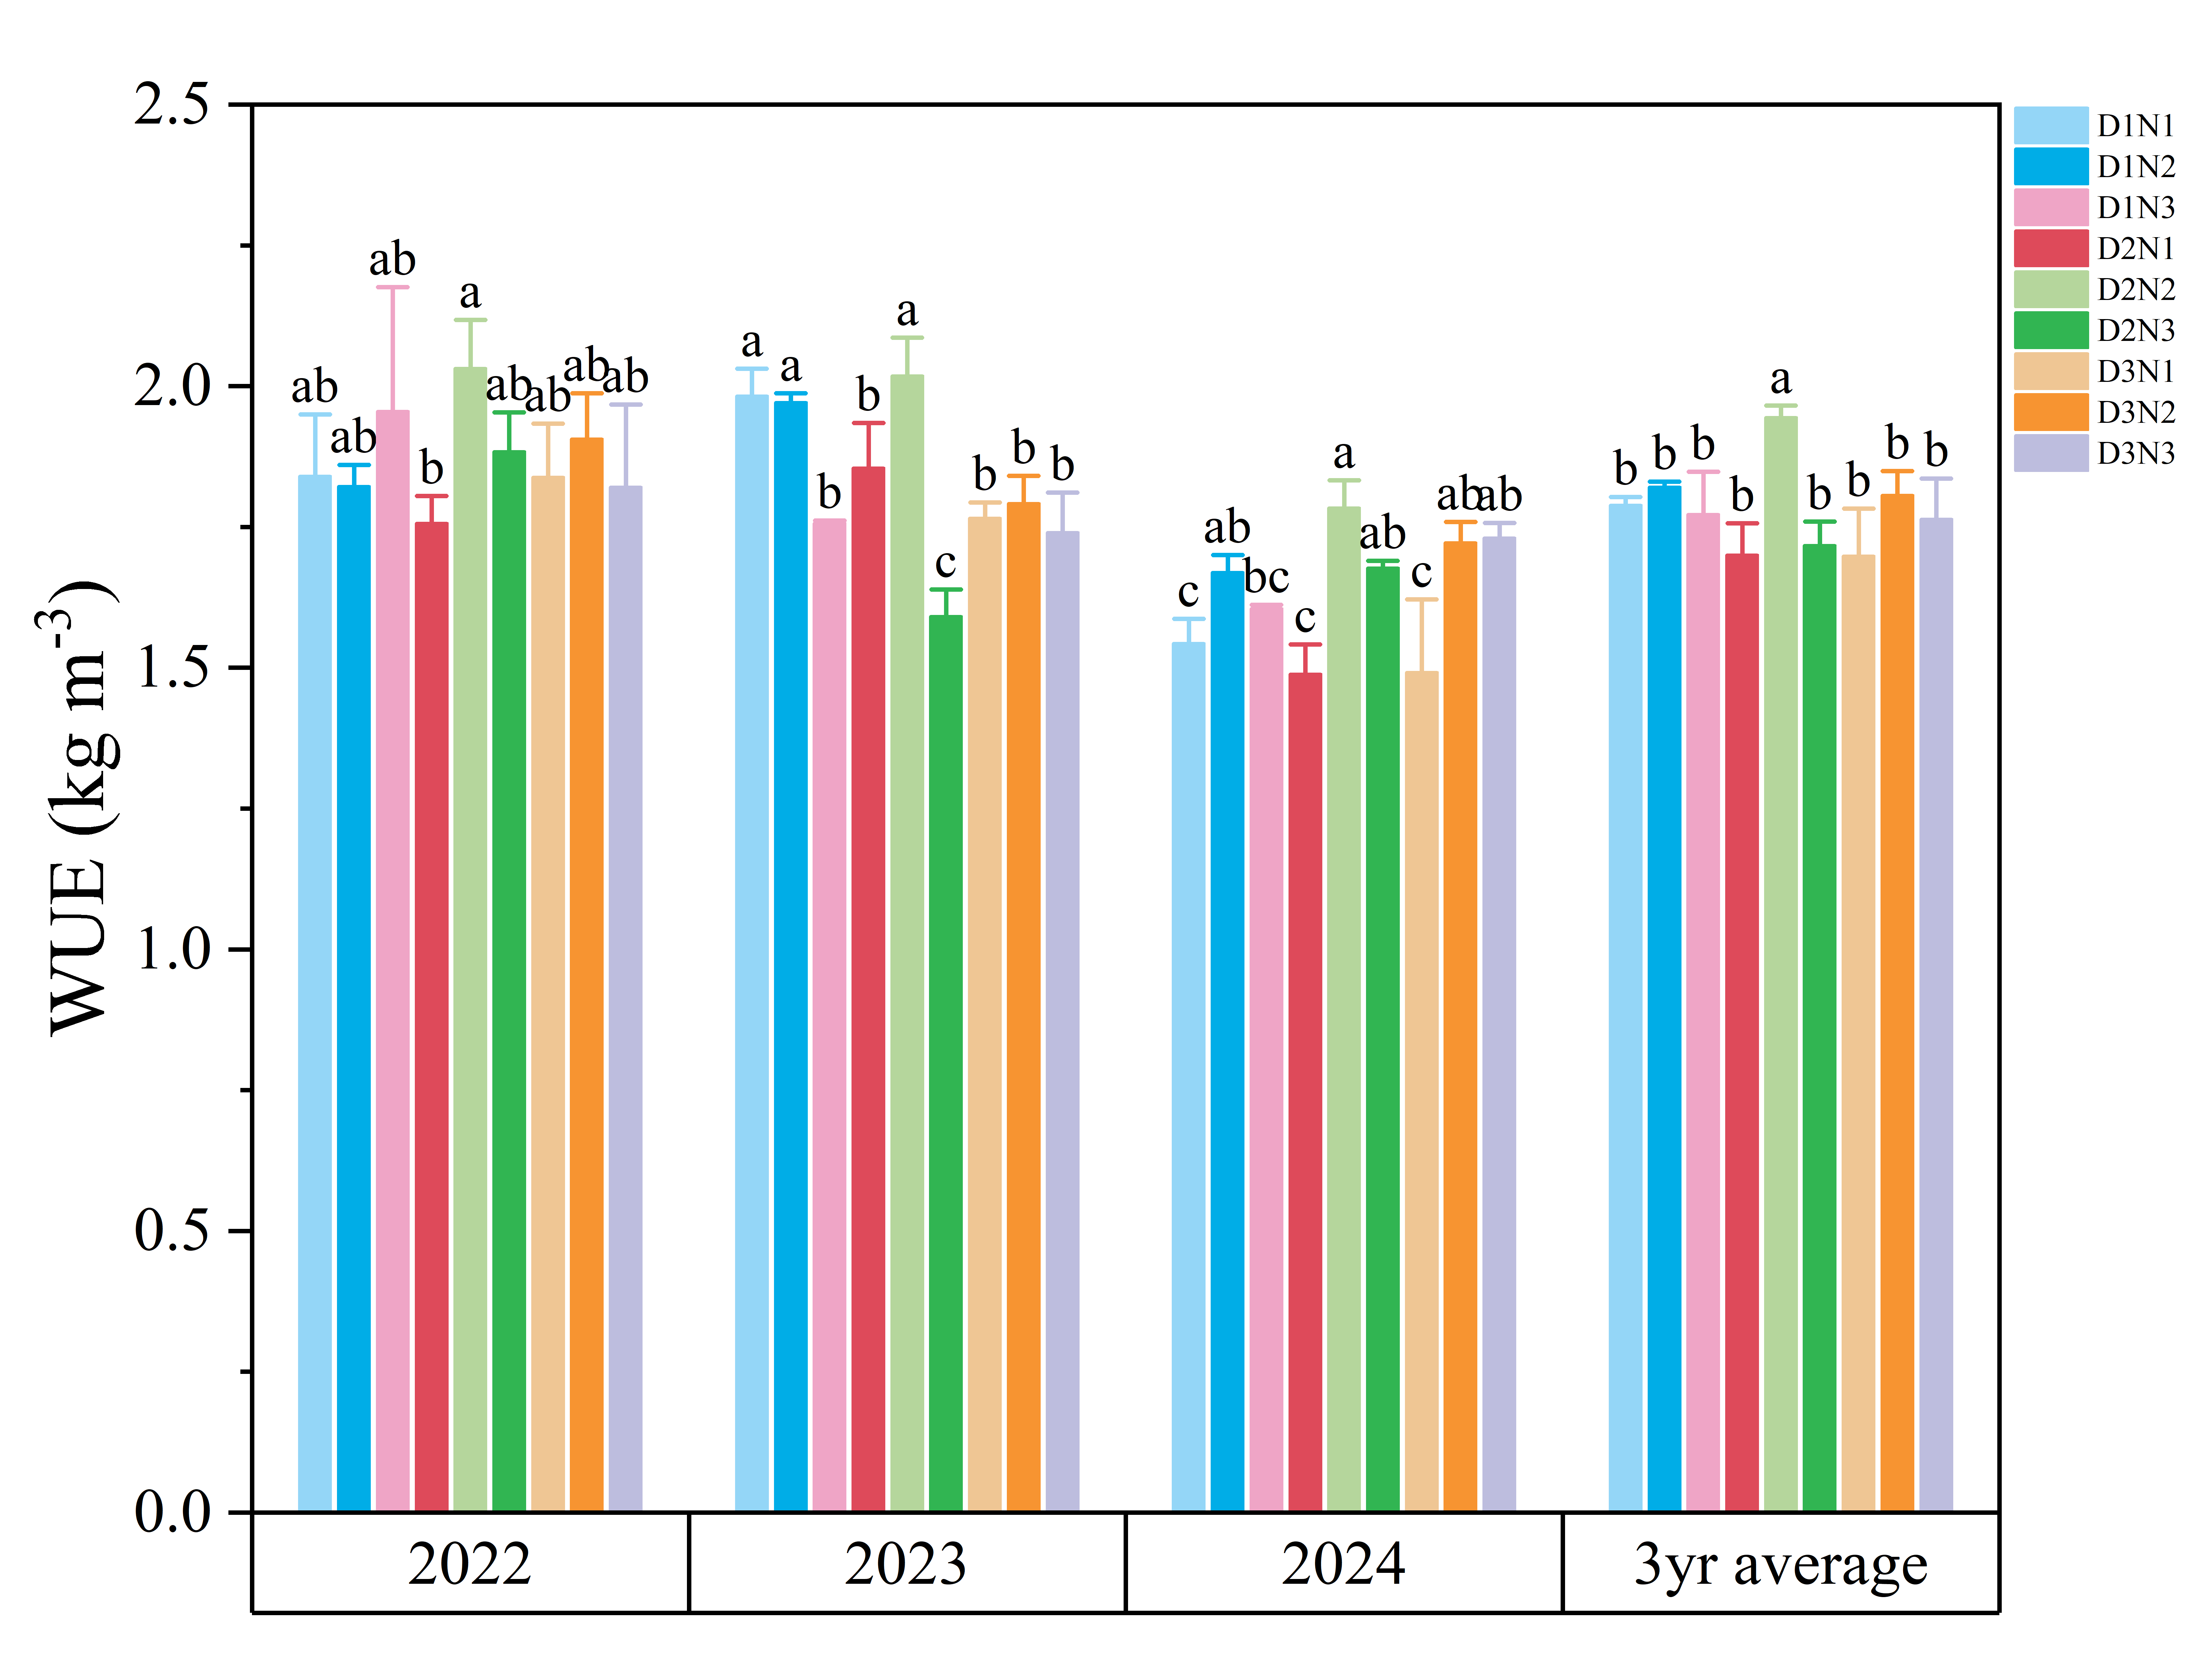

Fig. S4 Daily precipitation (mm) and daily mean temperature (℃) during 2021-2024.

Table S1 Measuring methods for soil indicators
Indicators | Methods
SOC | K₂Cr₂O₇-H₂SO₄ oxidation method (Bao 2000)
TN | Kjeldahl methods (Bao 2000)
NO₃⁻-N | Extracted by 0.5 M K2SO4 and then determined by the colorimetric method (Bao 2000)
NH₄⁺-N
AP | Oleson method (Olsen et al., 1954)
AK | Flame atomic absorption spectrometry method (Bao 2000)
BD | Cutting ring method
PO | Calculated from bulk density as described by (Lin et al., 2013)
SWC | Oven-drying method (105 °C for 24 h) (Wu et al., 2022)
MBC | Chloroform-fumigation extraction method (Vance et al., 1987)
MBN | Chloroform-fumigation extraction method (Vance et al., 1987)
DOC | Chloroform-fumigation extraction method (Vance et al., 1987)
DON | Chloroform-fumigation extraction method (Vance et al., 1987)
β-1,4-glucosidase (GC) | Using Assay Kits (Yang et al., 2025) provided by the Grace Bio-technology Co. Ltd.
β-cellobiohydrolase (CBH)
β-xylosidase (Xyl)
β-1,4-Nacetylglucosaminidase (NAG)

Table S2 The regression coefficients and R² of the binary quadratic regression equation for each objective
 | y₀ | a | b | c | d | e | R²
NPFP | 65.7 | 0.4521 | -0.2098 | -0.001486 | 0.00004217 | -0.00016 | 0.989
SQI | -3.237 | 0.08232 | 0.008014 | -0.0005684 | -0.00002395 | 0.00003426 | 0.97
Yield | -2451 | 74.94 | 71.49 | -0.49387 | -0.19527 | 0.18969 | 0.83
WUE | 0.3747 | 0.009478 | 0.0113 | -0.0001233 | -0.00003254 | 0.000034 | 0.445
Note: y₀ is the intercept, a, b, c, d, e are the regression coefficients need to be determined.

Table S3 Pearson correlation analysis among soil indicators
 | BD | SWC_B | SOC_B | SWC_R | SOC_R | TN_B | TN_R | NO3_R | NH4_R | NO3_B | NH4_B | DOC | DON | MBC | MBN
BD | 1
SWC_B | 0.266 | 1
SOC_B | -0.496** | -0.328 | 1
SWC_R | -0.593** | -0.301 | 0.460* | 1
SOC_R | -0.786** | -0.427* | 0.312 | 0.378 | 1
TN_B | -0.118 | -0.057 | -0.285 | 0.139 | 0.363 | 1
TN_R | -0.034 | 0.127 | -0.11 | -0.018 | 0.244 | 0.669** | 1
NO3_R | -0.476* | -0.077 | 0.169 | 0.223 | 0.575** | 0.644** | 0.606** | 1
NH4_R | -0.653** | -0.006 | 0.053 | 0.168 | 0.763** | 0.450* | 0.414* | 0.737** | 1
NO3_B | -0.317 | -0.174 | -0.024 | 0.19 | 0.455* | 0.700** | 0.753** | 0.778** | 0.538** | 1
NH4_B | 0.205 | 0.007 | -0.324 | -0.251 | 0.038 | 0.759** | 0.678** | 0.594** | 0.246 | 0.735** | 1
DOC | -0.618** | -0.299 | 0.36 | 0.525** | 0.724** | 0.490** | 0.415* | 0.659** | 0.527** | 0.569** | 0.186 | 1
DON | -0.521** | -0.371 | 0.379 | 0.421* | 0.669** | 0.558** | 0.490** | 0.539** | 0.422* | 0.505** | 0.24 | 0.789** | 1
MBC | -0.641** | -0.524** | 0.587** | 0.619** | 0.571** | 0.355 | 0.217 | 0.418* | 0.36 | 0.424* | 0.045 | 0.585** | 0.752** | 1
MBN | -0.660** | -0.38 | 0.444* | 0.490** | 0.649** | 0.417* | 0.424* | 0.542** | 0.464* | 0.602** | 0.132 | 0.771** | 0.835** | 0.796** | 1
Note: SWC_R means soil water content in rhizosphere, SWC_B means soil water content in bulk soil. * p<0.05 ** p<0.01.
Table S4 The effect of irrigation and fertilization and their interactions on wheat yield
Treatment | Yield2022  (kg ha⁻¹) | Yield2023  (kg ha⁻¹) | Yield2024  (kg ha⁻¹) | Yield 3yr average  (kg ha⁻¹) | CV  (%) | SYI  (%)
D1N1 | 8828±213c | 9144±192cde | 7658±32.8f | 8544±31.7c | 7.72±0.23a | 85.9±1.47cd
D1N2 | 9889±31.7ab | 9268±86.6bcd | 8715±76.1d | 9291±29.0b | 5.20±0.32bc | 89.1±0.66bcd
D1N3 | 9231±282bc | 8785±137de | 8189±192e | 8735±192c | 4.94±0.62bcd | 90.0±1.66abcd
D2N1 | 8858±400c | 9136±390cde | 8055±34.7e | 8683±62.7c | 6.18±1.69ab | 87.8±4.39cd
D2N2 | 10273±498a | 10123±202a | 9829±72.3ab | 10075±107a | 3.20±1.21cde | 93.0±3.01ab
D2N3 | 9571±270ab | 8653±291e | 9315±183c | 9180±112b | 4.73±1.27bcd | 90.5±2.13abc
D3N1 | 9980±142a | 9517±123bc | 8230±240e | 9242±159b | 8.03±0.78a | 85.2±0.95d
D3N2 | 10186±74.6a | 9797±277ab | 9655±57.9b | 9879±90.9a | 2.65±0.46e | 94.4±1.01a
D3N3 | 10159±503a | 9496±378bc | 10011±278a | 9889±380a | 3.10±0.06de | 93.6±0.28ab
ANOVA
D | 0.001** | 0.006** | 0.000*** | 0.000*** | 0.032* | 0.088ns
N | 0.000*** | 0.000*** | 0.000*** | 0.000*** | 0.000*** | 0.000***
D*N | 0.133ns | 0.029* | 0.000*** | 0.005** | 0.072ns | 0.223ns
Note: Different letters in the column indicate significant differences between treatments (p < 0.05, one-way ANOVA). *, ** and *** indicates significant differences at 0.05, 0.01 and 0.001 level based on two-way ANOVA. Values behind “±” represents standard deviation (mean ± SD).
Table S5 The effect of irrigation and fertilization and their interactions on soil bulk density and porosity and soil water content
Soil layer | Treatment | BD (g cm⁻³) | PO (%) | SWC at Jointing (%) | SWC at Anthesis (%) | SWC at Maturity (%)
0-20 cm | D1N1 | 1.349±0.017a | 49.10±0.63d | 15.2±2.18c | 16.9±3.46ab | 11.9±2.04a
0-20 cm | D1N2 | 1.320±0.021ab | 50.18±0.79cd | 15.2±1.16c | 15.2±2.59b | 11.4±1.99a
0-20 cm | D1N3 | 1.320±0.019ab | 50.20±0.71cd | 16.6±2.81abc | 16.3±1.58ab | 12.3±1.85a
0-20 cm | D2N1 | 1.295±0.017bc | 51.15±0.66bc | 17.8±1.54ab | 17.0±2.22ab | 13.0±2.84a
0-20 cm | D2N2 | 1.266±0.009cd | 52.25±0.35ab | 15.6±2.46bc | 16.1±2.28ab | 12.6±1.26a
0-20 cm | D2N3 | 1.283±0.014c | 51.57±0.52b | 16.3±1.45abc | 16.2±1.85ab | 12.7±0.86a
0-20 cm | D3N1 | 1.259±0.015cd | 52.49±0.56ab | 17.0±1.67abc | 17.0±2.76ab | 12.0±1.83a
0-20 cm | D3N2 | 1.244±0.022d | 53.07±0.83a | 16.8±1.58abc | 15.4±2.02ab | 11.9±2.01a
0-20 cm | D3N3 | 1.242±0.003d | 53.12±0.10a | 18.1±2.51a | 17.7±1.42a | 12.4±1.07a
ANOVA | D | 0.000*** | 0.000*** | 0.025* | 0.695ns | 0.213ns
ANOVA | N | 0.044* | 0.044* | 0.133ns | 0.087ns | 0.635ns
ANOVA | D *N | 0.853ns | 0.853ns | 0.272ns | 0.737ns | 0.960ns
20-40 cm | D1N1 | 1.363±0.019b | 48.58±0.71a | 18.3±2.81ab | 17.1±2.56ab | 11.4±1.84b
20-40 cm | D1N2 | 1.353±0.015b | 48.93±0.55a | 16.9±2.23b | 14.4±4.49b | 11.5±1.16b
20-40 cm | D1N3 | 1.352±0.007b | 48.99±0.25a | 18.6±3.05ab | 17.3±1.43ab | 14.0±2.35a
20-40 cm | D2N1 | 1.379±0.018b | 47.95±0.67a | 20.2±2.02a | 17.7±1.69ab | 12.8±2.11ab
20-40 cm | D2N2 | 1.347±0.016b | 49.15±0.60a | 19.1±4.12ab | 16.9±2.27b | 12.6±1.58ab
20-40 cm | D2N3 | 1.353±0.010b | 48.96±0.38a | 19.4±1.49ab | 17.3±2.64ab | 13.6±1.77ab
20-40 cm | D3N1 | 1.426±0.013a | 46.17±0.48b | 19.3±2.45ab | 17.8±2.39ab | 12.6±1.51ab
20-40 cm | D3N2 | 1.444±0.021a | 45.51±0.80b | 20.0±1.27a | 18.0±3.37ab | 14.1±3.24a
20-40 cm | D3N3 | 1.427±0.010a | 46.16±0.38b | 20.7±2.75a | 19.8±2.17a | 12.7±1.07ab
ANOVA | D | 0.000*** | 0.000*** | 0.020* | 0.020* | 0.321ns
ANOVA | N | 0.367ns | 0.367ns | 0.508ns | 0.090ns | 0.115ns
ANOVA | D*N | 0.275ns | 0.275ns | 0.667ns | 0.422ns | 0.081ns
Note: Different letters in the column indicate significant differences between treatments (p < 0.05, one-way ANOVA). *, ** and *** indicates significant differences at 0.05, 0.01 and 0.001 level based on two-way ANOVA. Values behind “±” represents standard deviation (mean ± SD).
Table S6 The effect of irrigation and fertilization and their interactions on soil nitrogen
Soil layer | Treatment | TN  (g kg⁻¹) | NO₃⁻-N  (mg kg⁻¹) | NH₄⁺-N  (mg kg⁻¹)
0-20 cm | D1N1 | 0.80±0.22ab | 24.1±13.0ab | 1.90±0.78cd
0-20 cm | D1N2 | 0.78±0.28ab | 25.8±5.97a | 2.71±0.74ab
0-20 cm | D1N3 | 0.84±0.23ab | 29.3±5.71a | 2.86±0.53ab
0-20 cm | D2N1 | 0.77±0.25ab | 19.8±8.89bc | 1.80±0.64cd
0-20 cm | D2N2 | 1.02±0.16a | 27.1±6.34a | 2.79±0.64ab
0-20 cm | D2N3 | 0.90±0.23ab | 27.0±7.16a | 2.94±0.63a
0-20 cm | D3N1 | 0.75±0.20b | 19.6±8.99bc | 1.54±0.55d
0-20 cm | D3N2 | 0.78±0.25ab | 17.9±8.06c | 2.02±0.77c
0-20 cm | D3N3 | 0.88±0.23ab | 24.0±6.59ab | 2.46±0.57b
ANOVA | D | 0.285ns | 0.000*** | 0.000***
ANOVA | N | 0.219ns | 0.001** | 0.000***
ANOVA | D*N | 0.439ns | 0.172ns | 0.007**
20-40 cm | D1N1 | 0.58±0.06b | 14.4±5.09c | 1.54±0.66cd
20-40 cm | D1N2 | 0.58±0.14b | 19.4±5.15ab | 2.30±0.66a
20-40 cm | D1N3 | 0.62±0.13b | 21.0±2.81a | 2.33±0.33a
20-40 cm | D2N1 | 0.61±0.12b | 15.0±5.79c | 1.48±0.60cd
20-40 cm | D2N2 | 0.77±0.06a | 21.4±3.43a | 2.23±0.62a
20-40 cm | D2N3 | 0.58±0.13b | 18.9±4.19ab | 2.34±0.43a
20-40 cm | D3N1 | 0.57±0.06b | 14.6±6.10c | 1.30±0.45d
20-40 cm | D3N2 | 0.60±0.13b | 14.1±6.22c | 1.84±0.66bc
20-40 cm | D3N3 | 0.64±0.11b | 16.8±3.85bc | 1.96±0.49ab
ANOVA | D | 0.136ns | 0.000*** | 0.001**
ANOVA | N | 0.134ns | 0.000*** | 0.000***
ANOVA | D*N | 0.014* | 0.494ns | 0.868ns
Note: Different letters in the column indicate significant differences between treatments (p < 0.05, one-way ANOVA). *, ** and *** indicates significant differences at 0.05, 0.01 and 0.001 level based on two-way ANOVA. Values behind “±” represents standard deviation (mean ± SD).
Table S7 The effect of irrigation and fertilization and their interactions on rhizosphere soil properties
Treatment | SWC  (%) | TN  (g kg⁻¹) | SOC  (g kg⁻¹) | CNratio | NO₃⁻-N  (mg kg⁻¹) | NH₄⁺-N  (mg kg⁻¹) | AP  (mg kg⁻¹) | AK  (mg kg⁻¹) | DOC  (mg kg⁻¹) | DON  (mg kg⁻¹)
D1N1 | 12.1±0.77c | 0.70±0.09d | 10.5±0.05e | 15.3±2.07abc | 28.6±3.41g | 2.94±0.10g | 20.4±0.81cd | 199±0.78d | 84.0±0.21e | 24.6±0.58e
D1N2 | 14.0±0.20bc | 1.03±0.04a | 11.1±0.15de | 10.8±0.29e | 42.0±1.22c | 3.23±0.12f | 20.5±1.15cd | 207±1.92bc | 105±5.00bc | 32.2±0.15bc
D1N3 | 11.9±1.31c | 0.91±0.05bc | 11.4±0.04cd | 12.6±0.74de | 37.8±0.60de | 4.07±0.08cd | 17.4±0.15d | 208±6.39bc | 90.6±2.46de | 26.4±4.02de
D2N1 | 16.1±0.38ab | 0.84±0.02c | 11.0±0.16de | 13.2±0.41cd | 33.2±0.90f | 3.37±0.07ef | 23.2±0.41bc | 203±2.10cd | 97.7±4.21cd | 28.0±1.83de
D2N2 | 17.3±1.84a | 0.88±0.03bc | 12.6±0.21b | 14.4±0.67bcd | 43.2±2.43c | 3.85±0.17d | 25.7±0.31b | 210±2.48ab | 111±2.83ab | 37.0±0.22a
D2N3 | 14.7±0.33b | 0.96±0.02ab | 12.0±0.25bc | 12.5±0.42de | 53.1±1.45a | 4.33±0.19b | 30.1±2.84a | 210±2.93ab | 103±1.76bc | 29.6±1.45cd
D3N1 | 15.9±1.09ab | 0.70±0.06d | 11.8±0.49bcd | 16.9±1.89a | 36.7±1.62ef | 3.60±0.07e | 21.0±2.05c | 206±1.00bc | 98.4±2.47cd | 26.2±0.53de
D3N2 | 15.1±0.66b | 0.88±0.01bc | 13.7±0.11a | 15.6±0.14ab | 41.5±1.22cd | 4.18±0.07bc | 20.8±0.69c | 216±1.37a | 107±1.81abc | 35.5±2.35ab
D3N3 | 15.4±0.94ab | 0.92±0.04abc | 14.3±0.97a | 15.4±0.53abc | 47.7±2.05b | 4.66±0.05a | 24.3±1.83b | 211±3.06ab | 115±9.83a | 34.0±2.27ab
ANOVA
D | 0.000*** | 0.118ns | 0.000*** | 0.000*** | 0.000*** | 0.000*** | 0.000*** | 0.006** | 0.000*** | 0.002**
N | 0.059* | 0.000*** | 0.000*** | 0.021* | 0.000*** | 0.000*** | 0.031* | 0.000*** | 0.000*** | 0.000***
D*N | 0.201ns | 0.006** | 0.018* | 0.018* | 0.000*** | 0.150ns | 0.001** | 0.597ns | 0.029* | 0.134ns
Note: Different letters in the column indicate significant differences between treatments (p < 0.05, one-way ANOVA). *, ** and *** indicates significant differences at 0.05, 0.01 and 0.001 level based on two-way ANOVA. Values behind “±” represents standard deviation (mean ± SD).
Table S8 The effect of irrigation and fertilization and their interactions on soil quality
Treatment | SQI | SPI | SCI | SBI
D1N1 | 0.71±0.006f | 0.08±0.002e | 0.25±0.004e | 0.37±0.002g
D1N2 | 0.81±0.017d | 0.09±0.001cd | 0.31±0.003c | 0.42±0.014de
D1N3 | 0.73±0.011f | 0.08±0.003de | 0.29±0.008d | 0.36±0.004g
D2N1 | 0.78±0.012e | 0.09±0.000ab | 0.29±0.004d | 0.40±0.009ef
D2N2 | 0.91±0.005a | 0.10±0.004a | 0.33±0.004ab | 0.49±0.006a
D2N3 | 0.85±0.003c | 0.09±0.001bc | 0.34±0.002a | 0.43±0.005cd
D3N1 | 0.76±0.003e | 0.09±0.002ab | 0.28±0.006d | 0.39±0.001f
D3N2 | 0.88±0.001b | 0.09±0.002ab | 0.32±0.003bc | 0.47±0.006b
D3N3 | 0.86±0.008bc | 0.09±0.002ab | 0.34±0.007a | 0.43±0.010c
ANOVA
D | 0.000*** | 0.000*** | 0.000*** | 0.000***
N | 0.000*** | 0.043* | 0.000*** | 0.000***
D*N | 0.000*** | 0.170ns | 0.000*** | 0.000***
Note: Different letters in the column indicate significant differences between treatments (p < 0.05, one-way ANOVA). *, ** and *** indicates significant differences at 0.05, 0.01 and 0.001 level based on two-way ANOVA. Values behind “±” represents standard deviation (mean ± SD).

Table S9 The effect of irrigation and fertilization and their interactions on NPFP and WUE
Treatment | NPFP2022  (kg kg⁻¹) | NPFP2023  (kg kg⁻¹) | NPFP2024  (kg kg⁻¹) | NPFP3yr average  (kg kg⁻¹) | WUE2022  (kg m⁻³) | WUE2023  (kg m⁻³) | WUE2024  (kg m⁻³) | WUE3yr average(kg m⁻³)
D1N1 | 58.9±1.42b | 61.0±1.28a | 51.1±0.22b | 57.0±0.21b | 1.84±0.11ab | 1.98±0.05a | 1.54±0.04c | 1.79±0.01b
D1N2 | 47.1±0.15c | 44.1±0.41c | 41.5±0.36d | 44.2±0.14d | 1.82±0.04ab | 1.97±0.02a | 1.67±0.03ab | 1.82±0.01b
D1N3 | 34.2±1.04e | 32.5±0.51de | 30.3±0.71g | 32.4±0.71g | 1.96±0.22ab | 1.76±0.01b | 1.61±0.01bc | 1.77±0.08b
D2N1 | 59.1±2.66b | 60.9±2.60a | 53.7±0.23a | 57.9±0.42b | 1.76±0.05b | 1.85±0.08b | 1.49±0.05c | 1.70±0.06b
D2N2 | 48.9±2.37c | 48.2±0.96b | 46.8±0.34c | 48.0±0.51c | 2.03±0.09a | 2.02±0.07a | 1.78±0.05a | 1.94±0.02a
D2N3 | 35.4±1.00de | 32.0±1.08e | 34.5±0.68f | 34.0±0.41f | 1.88±0.07ab | 1.59±0.05c | 1.68±0.01ab | 1.72±0.04b
D3N1 | 66.5±0.95a | 63.4±0.82a | 54.9±1.60a | 61.6±1.06a | 1.84±0.10ab | 1.77±0.03b | 1.49±0.13c | 1.70±0.08b
D3N2 | 48.5±0.36c | 46.7±1.32bc | 46.0±0.28c | 47.0±0.43c | 1.91±0.08ab | 1.79±0.05b | 1.72±0.04ab | 1.81±0.04b
D3N3 | 37.6±1.86d | 35.2±1.40d | 37.1±1.03e | 36.6±1.41e | 1.82±0.15ab | 1.74±0.07b | 1.73±0.03ab | 1.76±0.07b
ANOVA
D | 0.001** | 0.012* | 0.000*** | 0.000*** | 0.862ns | 0.001** | 0.313ns | 0.445ns
N | 0.000*** | 0.000*** | 0.000*** | 0.000*** | 0.261ns | 0.000*** | 0.000*** | 0.001**
D*N | 0.021* | 0.077ns | 0.014* | 0.003** | 0.295ns | 0.001** | 0.121ns | 0.055ns
Note: Different letters in the column indicate significant differences between treatments (p < 0.05, one-way ANOVA). *, ** and *** indicates significant differences at 0.05, 0.01 and 0.001 level based on two-way ANOVA. Values behind “±” represents standard deviation (mean ± SD).

Methods S1 The detailed information for DNA extraction and PCR amplification and extraction condition
Rhizosphere soil samples (0-20 cm soil layer) at the anthesis stage were used for DNA extraction and high-throughput sequencing. Soil DNA was extracted from 0.5 g of soil samples using the E.Z.N.A.® soil DNA Kit (Omega Bio-tek, Norcross, GA, USA). The quality and concentration of DNA were determined by 1.0% agarose gel electrophoresis and a NanoDrop2000 spectrophotometer (Thermo Scientific, USA) and then kept at -80 ℃.

Using the primer pairs of 338F/806R and ITS1F/ITS2R to amplify the bacterial 16S rRNA V3-V4 region and the fungal ITS region respectively. PCR amplification was conducted using Transtar FastPfu DNA Polymerase (TransGen AP221-02) on ABIGeneAmp®9700. The PCR product was extracted from a 2% agarose gel and purified using the PCR Clean-Up Kit (YuHua, Shanghai, China). Purified amplicons were paired-end sequenced on an Illumina PE300 platform (Illumina, San Diego, USA). Operational taxonomic units (OTUs) were clustered with 97% sequence similarity using UPARSE 7.1. The Ribosomal Database Project (RDP) classifier was used to annotate the species of the representative sequences of the OTU by setting confidence threshold to 0.7 (Silva v138 and UNITE v8 database).

Methods S2 Detailed data standardization process of soil indicators
All the soil indicators in the total dataset should be standardized. For “more is better” indicators (e.g., soil organic carbon, total nitrogen), use equation 1. As for “less is better” indicators (e.g., soil penetration resistance), use equation 2:
$S=\frac{X_{i}}{X_{max}}$ (1)
$S=\frac{X_{min}}{X_{i}}$ (2)
where S represents the score of soil indicator i, Xi is the observed value of soil indicator i, Xmax and Xmin represent the highest and lowest values for indicator i.

Reference
Bao, S., 2000. Soil Agro-Chemistrical Analysis, third ed. China Agricultural Press, Beijing, China.
Wu, G., Ling, J., Zhao, D.Q., Xu, Y.P., Liu, Z.X., Wen, Y., Zhou, S.L., 2022. Deep-injected straw incorporation improves subsoil fertility and crop productivity in a wheat-maize rotation system in the North China Plain. Field Crop Res. 286. https://doi.org/10.1016/j.fcr.2022.108612.
Olsen, S.R., Cole, C.V., Watanabe, F.S., et al., 1954. Estimation of available phosphorus in soils by extraction with sodium bicarbonate. Circular. United States Department of Agriculture 939, 19.
Vance, E.D., Brookes, P.C., Jenkinson, D.S., 1987. An extraction method for measuring soil microbial biomass C. Soil Biol Biochem. 19, 703–707.
Yang, J., Zhang, S., Zhang, J., Zhao, S., Lu, H., Li, L., Liu, L., Wang, G., 2025. Incorporating crop rotation into the winter wheat-summer maize system to enhance soil multifunctionality and sustainable grain production in the North China Plain. Field Crops Research. 325. https://doi.org/10.1016/j.fcr.2025.109834.
Lin, S., Iqbal, J., Hu, R., Shaaban, M., Cai, J., Chen, X., 2013. Nitrous oxide emissions from yellow brown soil as affected by incorporation of crop residues with different carbon-to-nitrogen ratios: a case study in central China. Arch Environ Contam Toxicol. 65(2), 183-192. https://doi.org/10.1007/s00244-013-9903-7.

