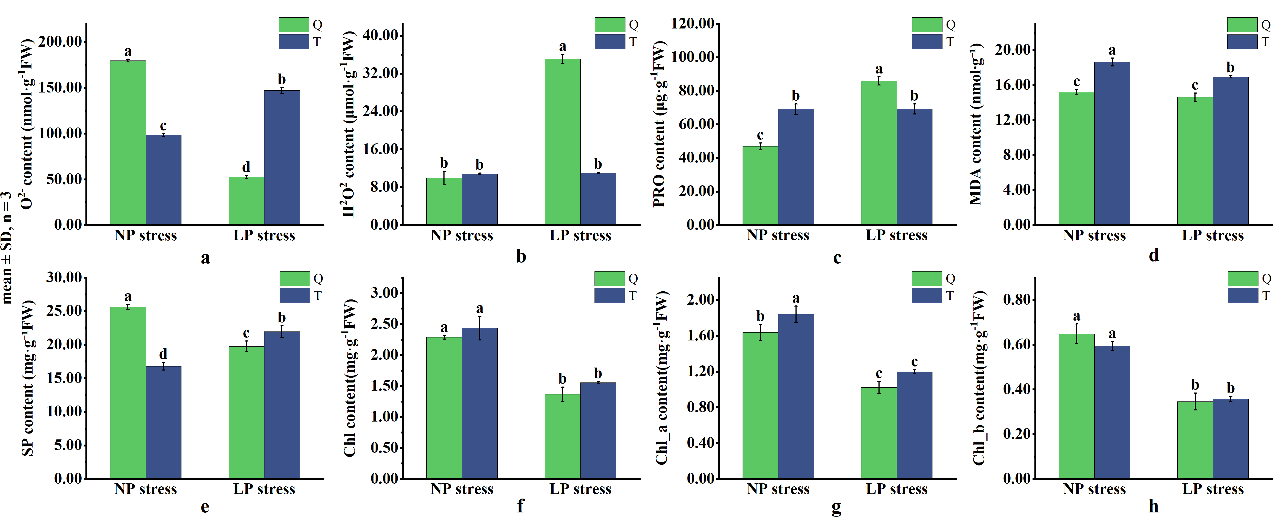
Figure S1. Oxidative-stress-related, osmotic, and chlorophyll responses of the LP-sensitive cultivar QH444 (Q) and the LP-tolerant cultivar TY2 (T) under normal-phosphorus (NP) and low-phosphorus (LP) conditions.
(a) Superoxide anion (O₂⁻·) content; (b) hydrogen peroxide (H₂O₂) content; (c) proline (Pro) content; (d) malondialdehyde (MDA) content; (e) soluble protein (SP) content; (f) total chlorophyll (Chl) content; (g) chlorophyll a (Chl a) content; and (h) chlorophyll b (Chl b) content. Values are presented as means ± SD (n = 3 biological replicates). Different lowercase letters indicate significant differences among genotype × phosphorus treatment combinations according to Tukey’s HSD test (P < 0.05).
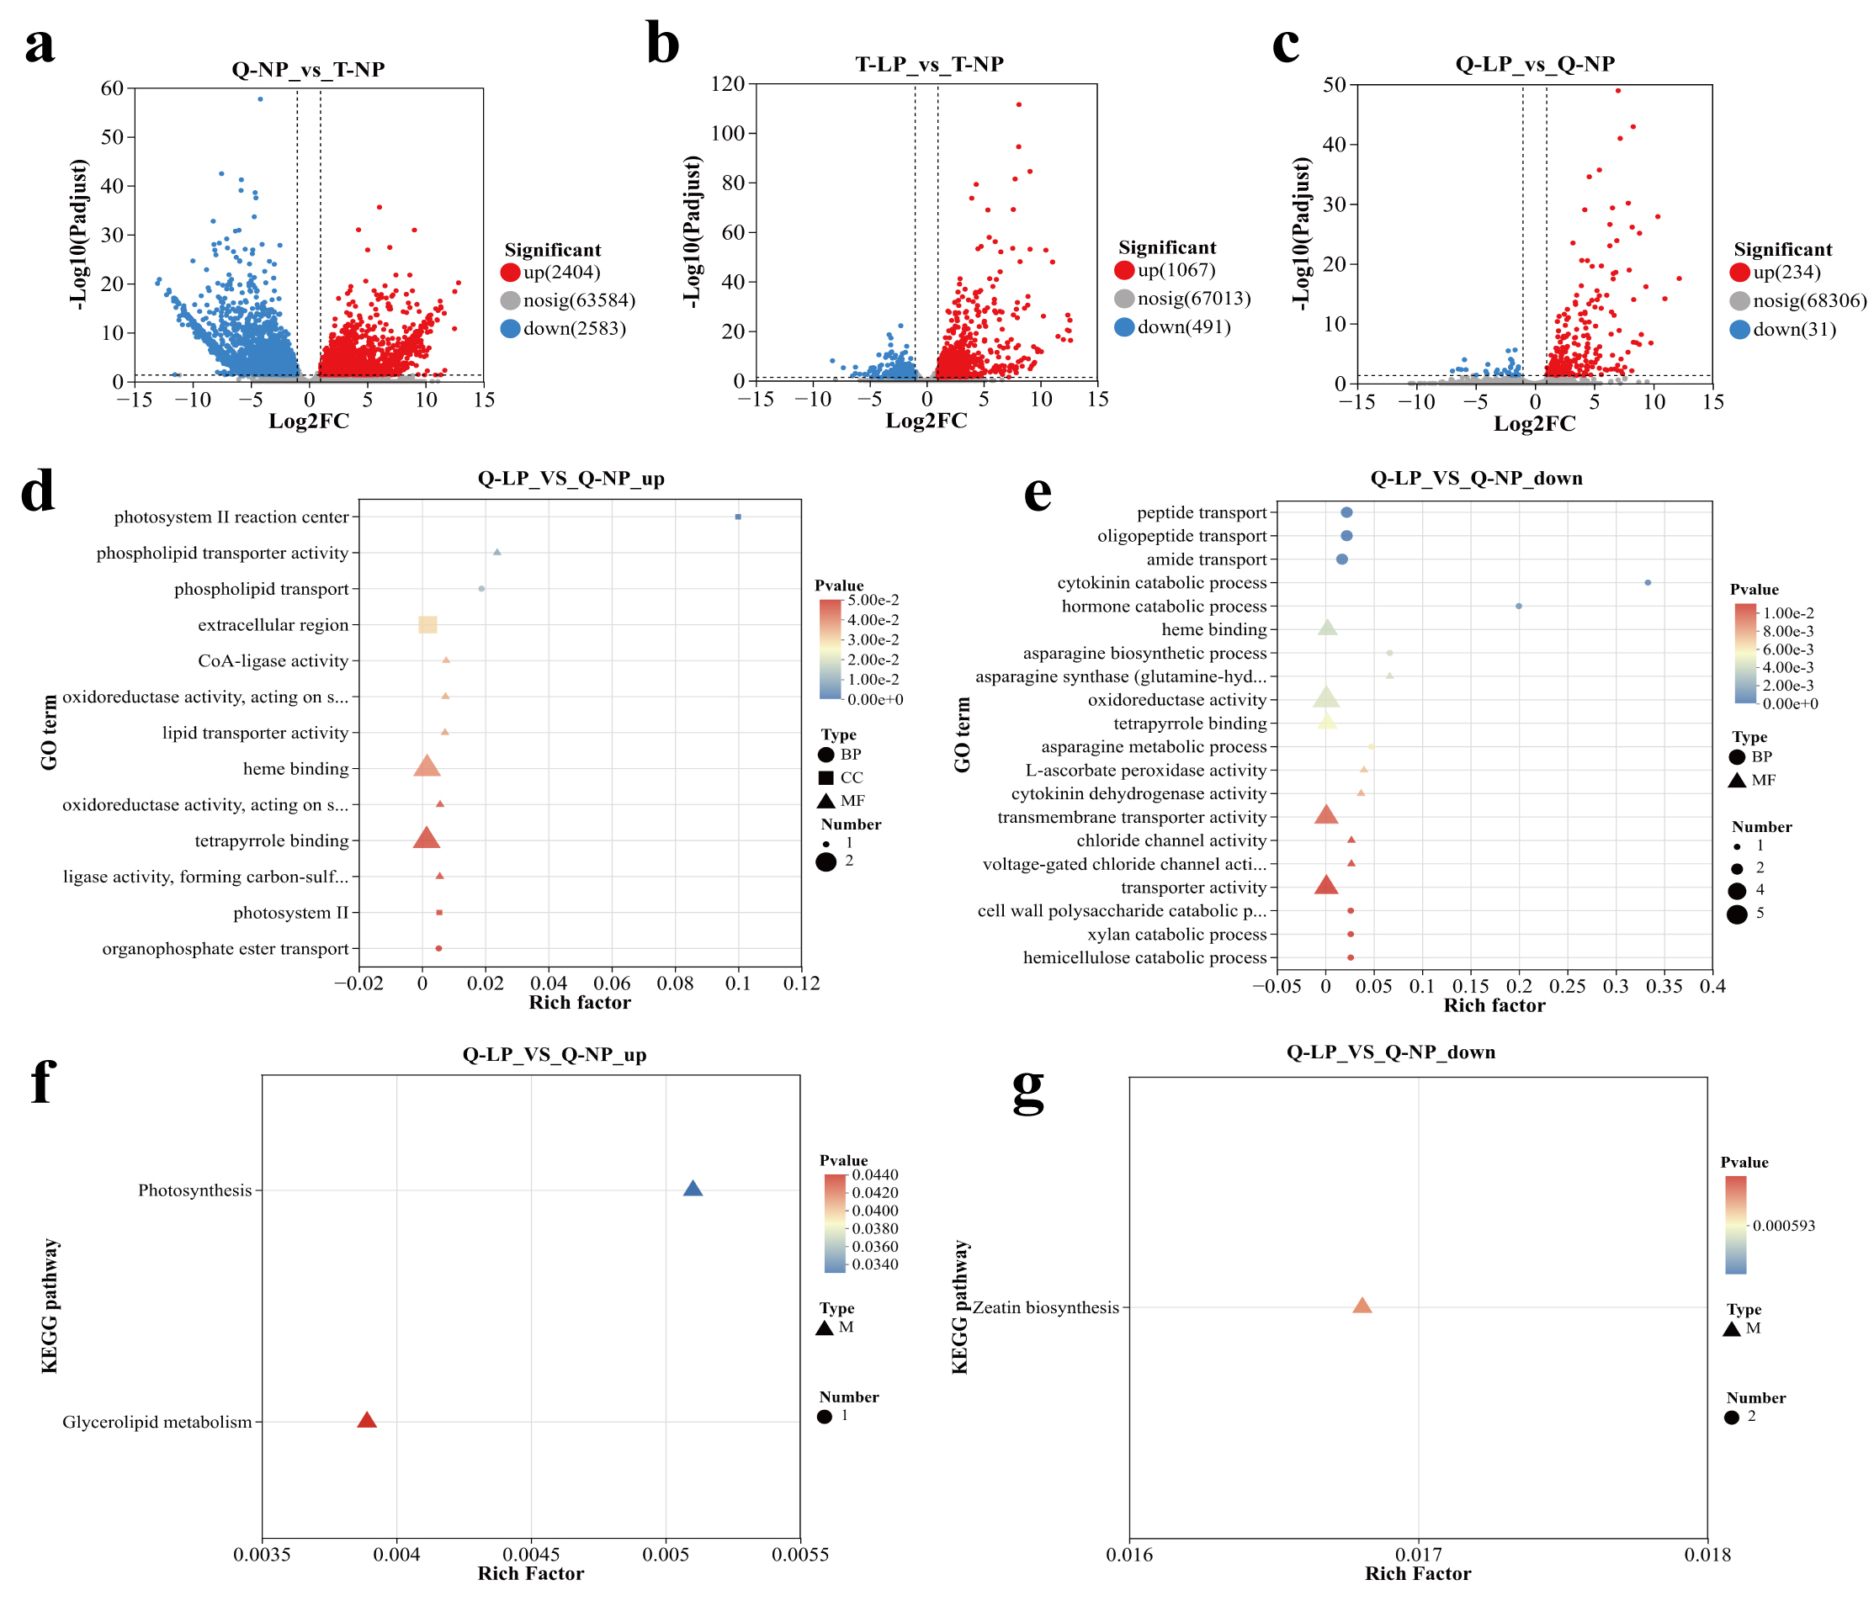
Figure S2. Differential gene-expression patterns and exploratory functional enrichment of QH444 under low-phosphorus treatment.
Differential gene-expression patterns and exploratory GO and KEGG enrichment analyses associated with low-phosphorus responses in QH444 and TY2. Q and T represent QH444 and TY2, respectively; NP and LP represent normal-phosphorus and low-phosphorus conditions, respectively. (a) Volcano plot of Q-LP vs Q-NP. (b) Volcano plot of T-LP vs T-NP. (c) Volcano plot of Q-NP vs T-NP, illustrating constitutive transcriptional differences between the two cultivars under NP conditions. Red and blue points represent significantly upregulated and downregulated genes, respectively, whereas gray points represent genes not meeting the differential-expression criteria. DEGs were defined using |log₂FC| ≥ 1 and BH-adjusted P < 0.05. (d, e) Exploratory GO enrichment analyses of the upregulated and downregulated LP-responsive DEG subsets detected specifically in the QH444 comparison, respectively. (f, g) Exploratory KEGG enrichment analyses of the corresponding upregulated and downregulated QH444 LP-responsive DEG subsets. Because no QH444-specific GO terms or KEGG pathways remained significant after BH correction, panels (d–g) display nominally enriched terms or pathways (P < 0.05) for exploratory purposes only and should not be interpreted as statistically significant after multiple-testing correction.
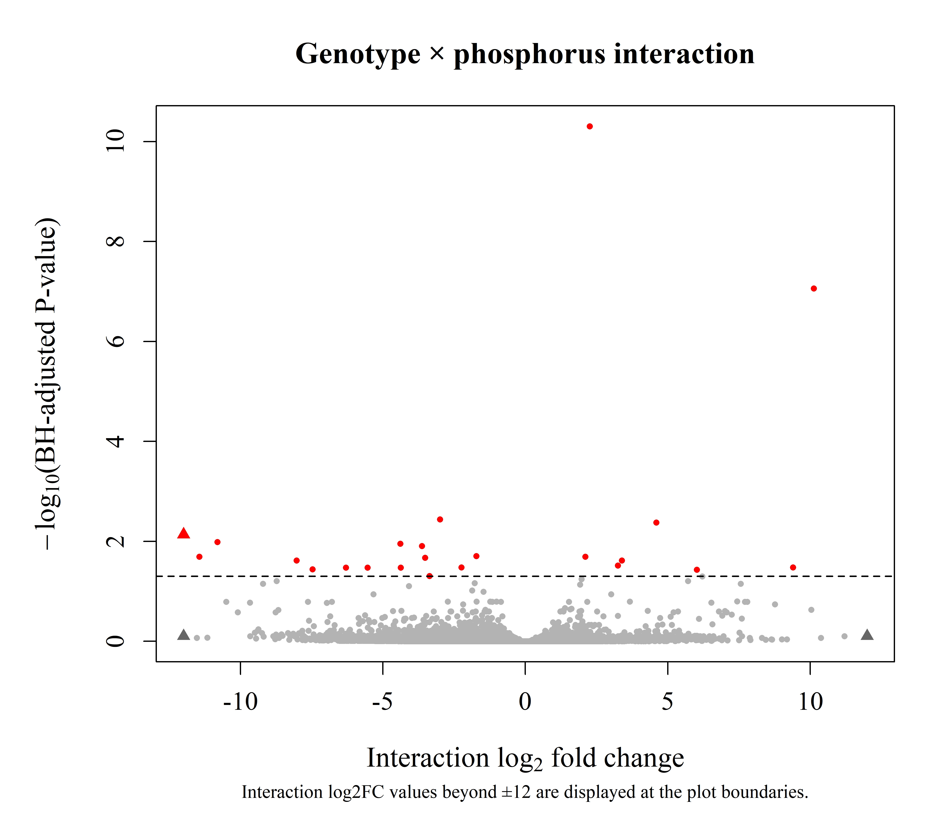
Figure S3. Genotype × phosphorus interaction analysis of the leaf transcriptome in QH444 and TY2 under normal- and low-phosphorus conditions. The interaction term was tested using DESeq2 with the model ~ genotype + phosphorus + genotype:phosphorus. The interaction coefficient represents (TY2-LP − TY2-NP) − (QH444-LP− QH444-NP). Genes with a Benjamini–Hochberg-adjusted P value < 0.05 were considered to show significant genotype × phosphorus interactions. Red points indicate significant interaction genes, whereas grey points indicate non-significant genes. For visualization, interaction log2_2 fold-change values beyond ±12 were displayed at the plot boundaries and indicated by triangles. Two significant genes with interaction log2_2 fold-change values below −12 had identical adjusted P values and therefore overlap at the left plot boundary. A total of 24 genes showed significant genotype × phosphorus interactions, including 8 positive and 16 negative interaction coefficients.

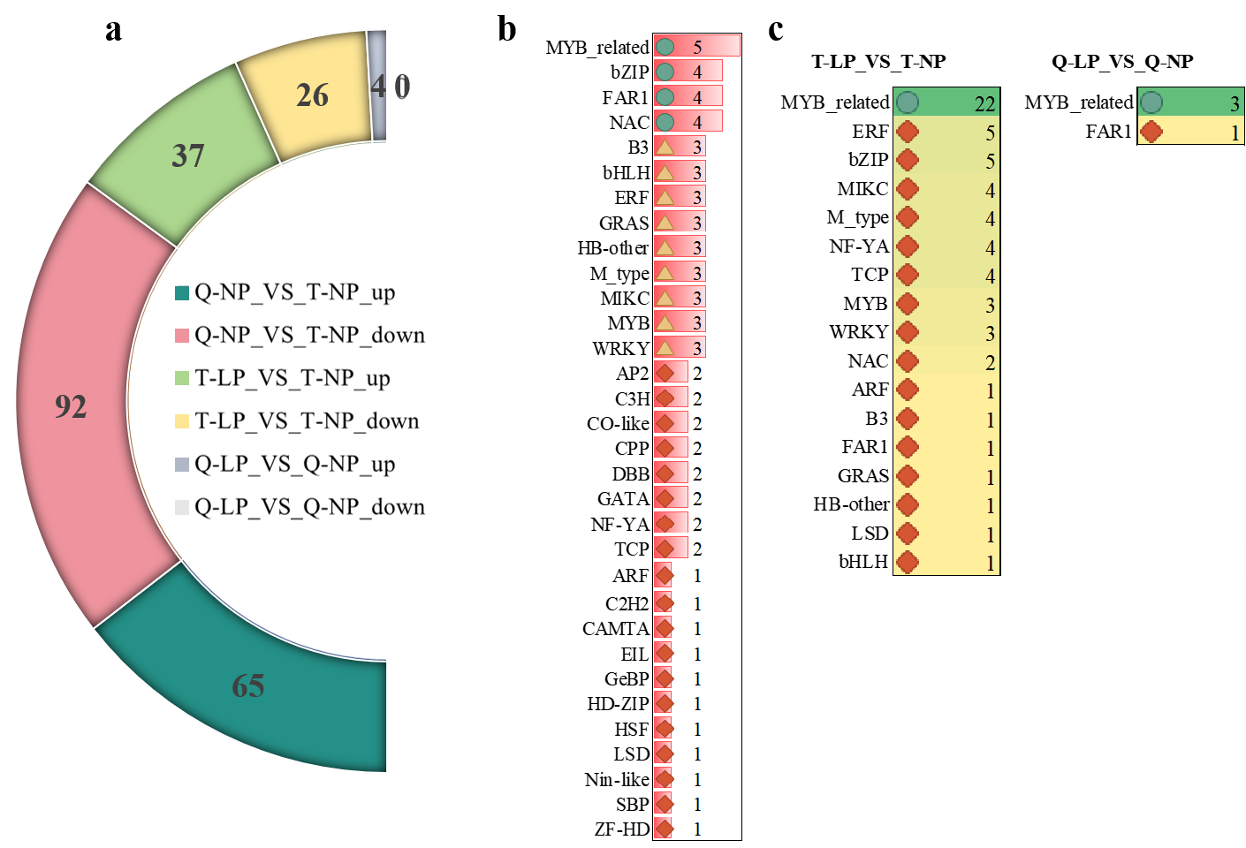
Figure S4. Distribution and family composition of differentially expressed transcription factors (DETFs) in QH444 and TY2 under low-phosphorus stress.
Q and T represent the LP-sensitive cultivar QH444 and the LP-tolerant cultivar TY2, respectively; NP and LP represent normal-phosphorus and low-phosphorus conditions, respectively. (a) Summary of the numbers of DETFs identified in the different transcriptomic comparisons. Colored sectors correspond to the comparison groups indicated in the legend, and the numbers denote the counts of DETFs in each group. (b) Family distribution of all identified DETFs. Transcription factor families are ranked according to the number of DETFs assigned to each family, and the numbers indicate the corresponding gene counts. (c) Comparison of TF-family composition of LP-responsive DETFs in QH444 and TY2. The numbers indicate the counts of DETFs assigned to each TF family in the corresponding cultivar, and different colors distinguish cultivar-specific or shared family distributions.
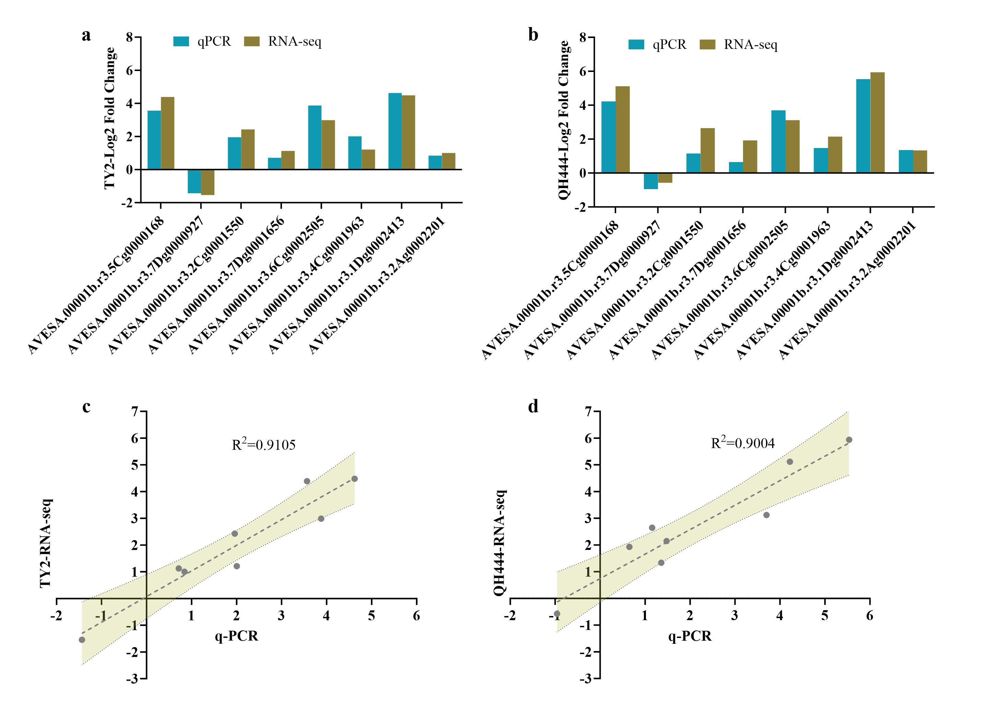
Figure S5. RT-qPCR validation of selected low-phosphorus-responsive genes in QH444 and TY2.
(a, b) Comparison of log₂-transformed expression fold changes obtained by RT-qPCR and RNA-seq for eight selected DEGs in TY2 (a) and QH444 (b), respectively. (c, d) Relationships between RT-qPCR- and RNA-seq-derived expression changes for the corresponding genes in TY2 (c) and QH444 (d), respectively. Dashed lines indicate linear regression fits, and shaded areas represent 95% confidence intervals. The coefficients of determination were R² = 0.9105 for TY2 and R² = 0.9004 for QH444, indicating close agreement between the two methods.

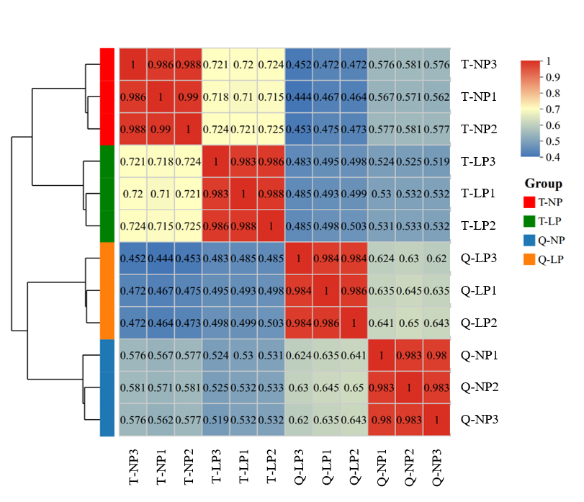
Figure S6. Sample correlation analysis of the proteomic dataset.
Pairwise correlation heatmap and hierarchical clustering of proteomic profiles from the LP-sensitive cultivar QH444 (Q) and the LP-tolerant cultivar TY2 (T) under normal-phosphorus (NP) and low-phosphorus (LP) conditions. Each treatment contained three biological replicates. Values within the heatmap represent pairwise correlation coefficients between samples, with warmer colors indicating higher similarity. Biological replicates within the same genotype × phosphorus treatment generally showed high correlations and clustered together, supporting the reproducibility of the proteomic dataset.

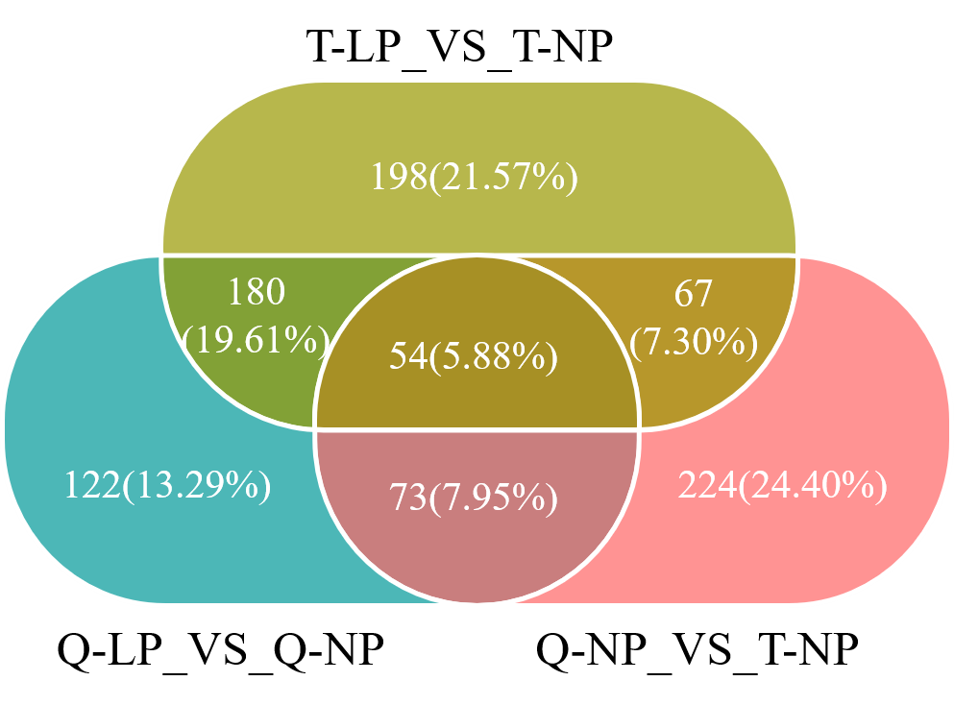
Figure S7. Venn analysis of differential-metabolite sets identified among the three pairwise comparisons.
The diagram shows the overlap among differential metabolites identified in Q-LP vs Q-NP, T-LP vs T-NP, and Q-NP vs T-NP. Numbers in the non-overlapping regions indicate metabolites unique to each comparison, numbers in the pairwise overlapping regions indicate metabolites shared between two comparisons, and the central region indicates metabolites shared among all three comparisons. Percentages represent the proportion of each subset relative to the total number of metabolites represented in the Venn diagram.

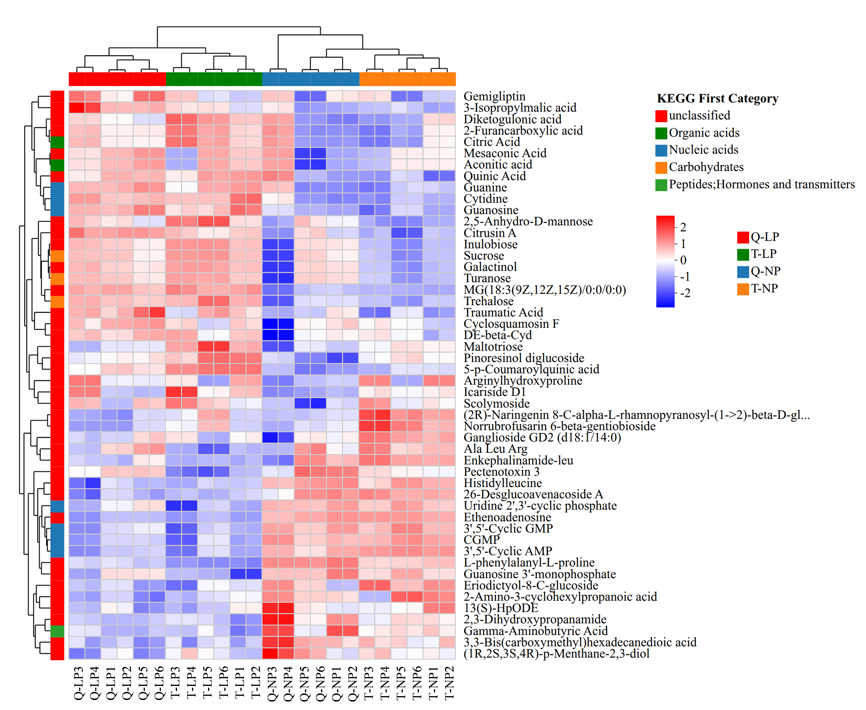
Figure S8. Hierarchical clustering heatmap of representative differential metabolites in QH444 and TY2 under normal- and low-phosphorus conditions.
Each row represents a differential metabolite and each column represents one biological sample from QH444 (Q) or TY2 (T) under normal-phosphorus (NP) or low-phosphorus (LP) conditions. Metabolite abundances were standardized across samples, with red and blue indicating relatively higher and lower abundance, respectively. The dendrograms indicate hierarchical clustering relationships among samples and metabolites. The colored annotation bar above the heatmap denotes the four genotype × phosphorus treatment groups, whereas the colored annotation bar on the left indicates the KEGG first-category classification of each metabolite, including unclassified compounds, organic acids, nucleic acids, carbohydrates, and peptides/hormones/transmitters.
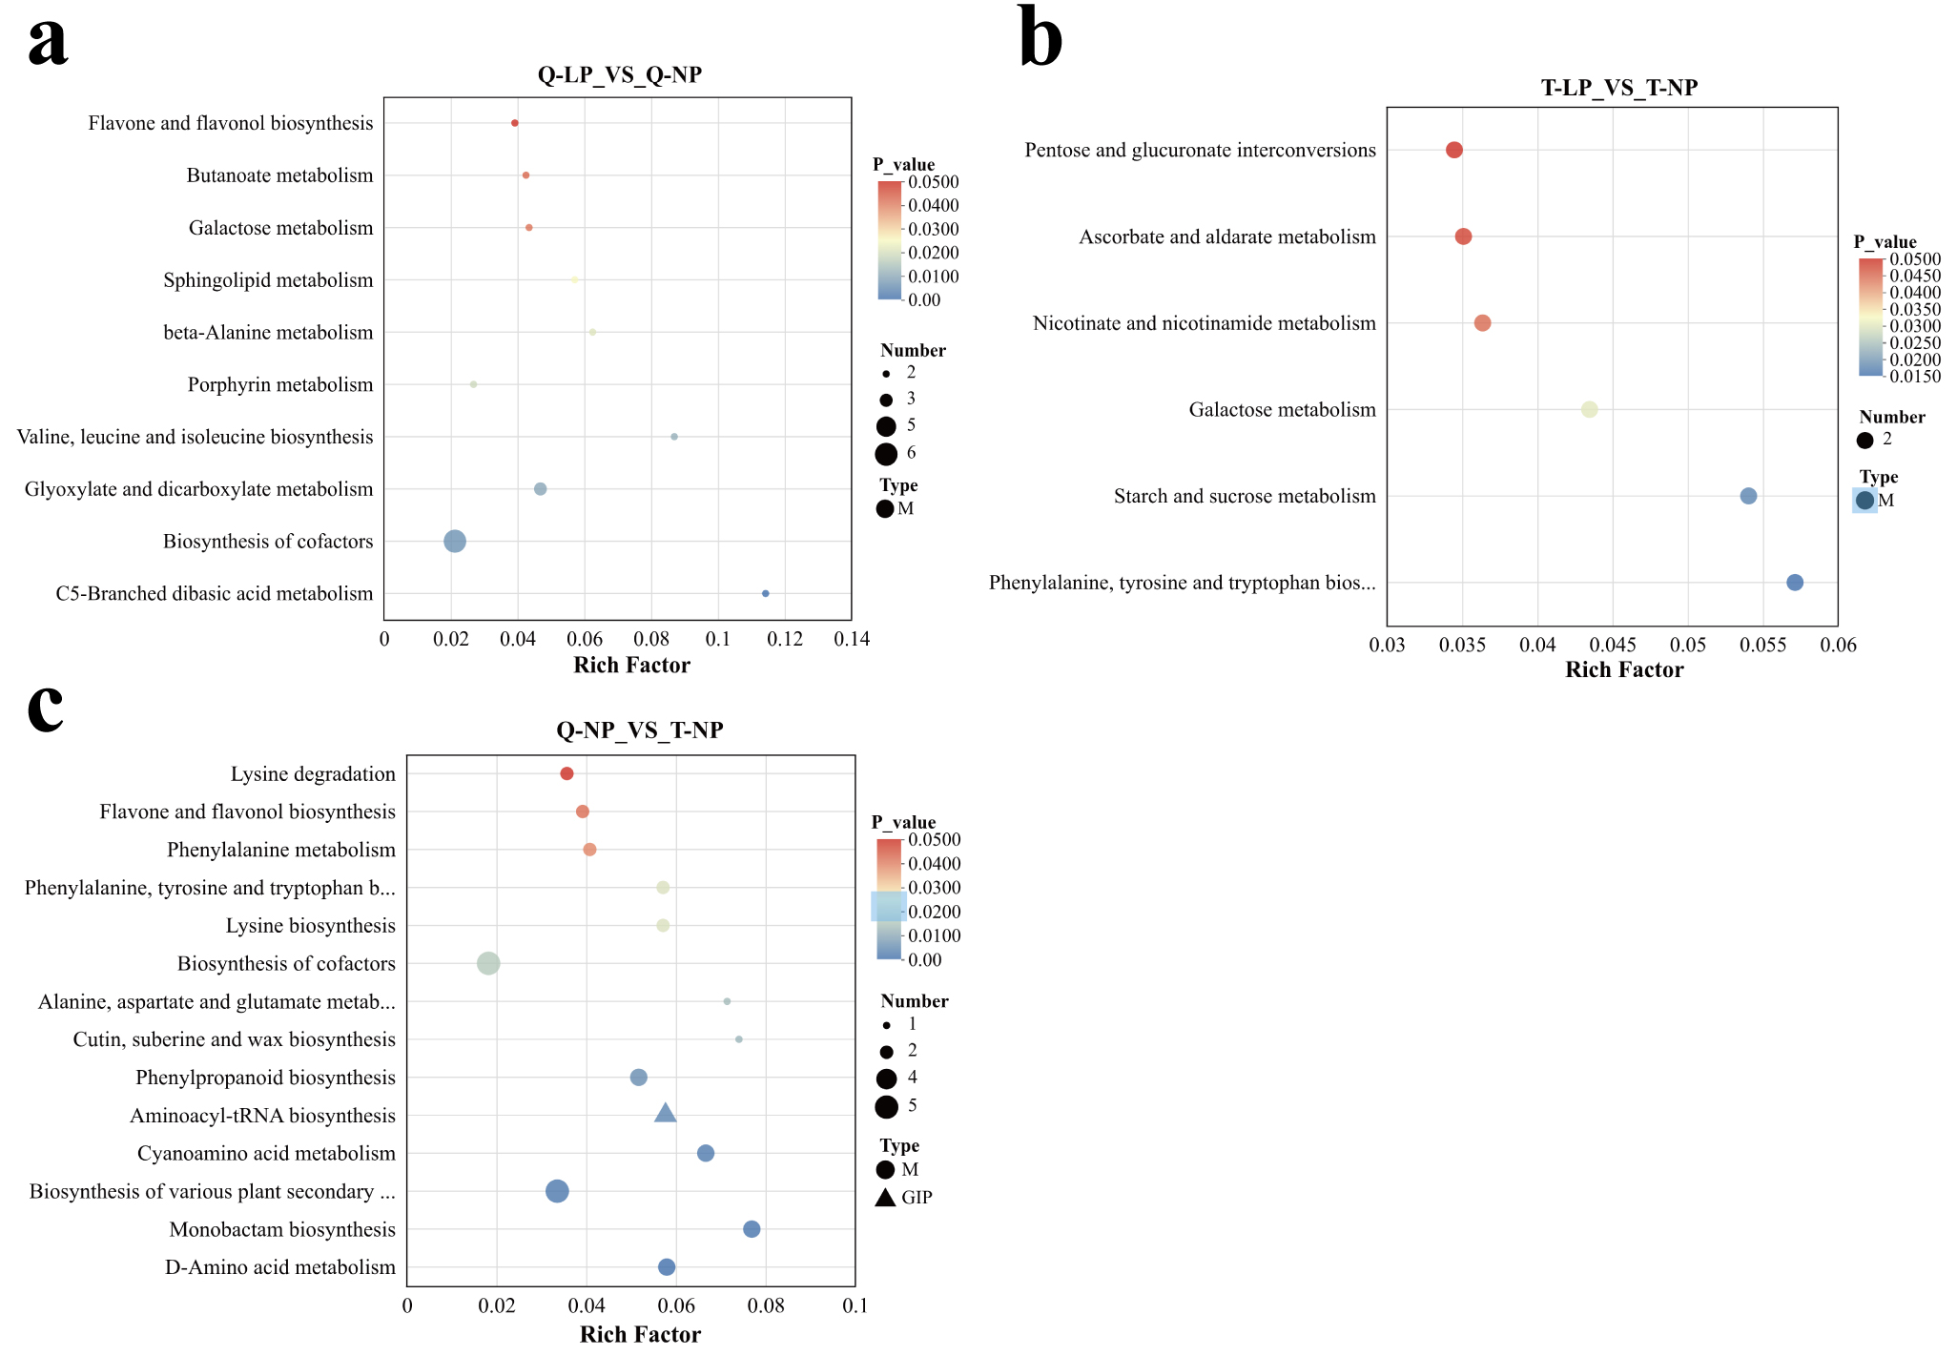
Figure S9. KEGG pathway enrichment of comparison-specific differential-metabolite sets in QH444 and TY2.
(a) KEGG enrichment of differential metabolites detected specifically in the QH444 LP-versus-NP comparison. (b) KEGG enrichment of differential metabolites detected specifically in the TY2 LP-versus-NP comparison. (c) KEGG enrichment of differential metabolites distinguishing QH444 and TY2 under normal-phosphorus (NP) conditions. Bubble size represents the number of differential metabolites annotated to each pathway, the x-axis indicates the rich factor, and bubble color represents the enrichment P value. Only pathways remaining significant after Benjamini–Hochberg correction (BH-adjusted P < 0.05) were interpreted as statistically significant; raw enrichment P values are displayed in the color scale for visualization.

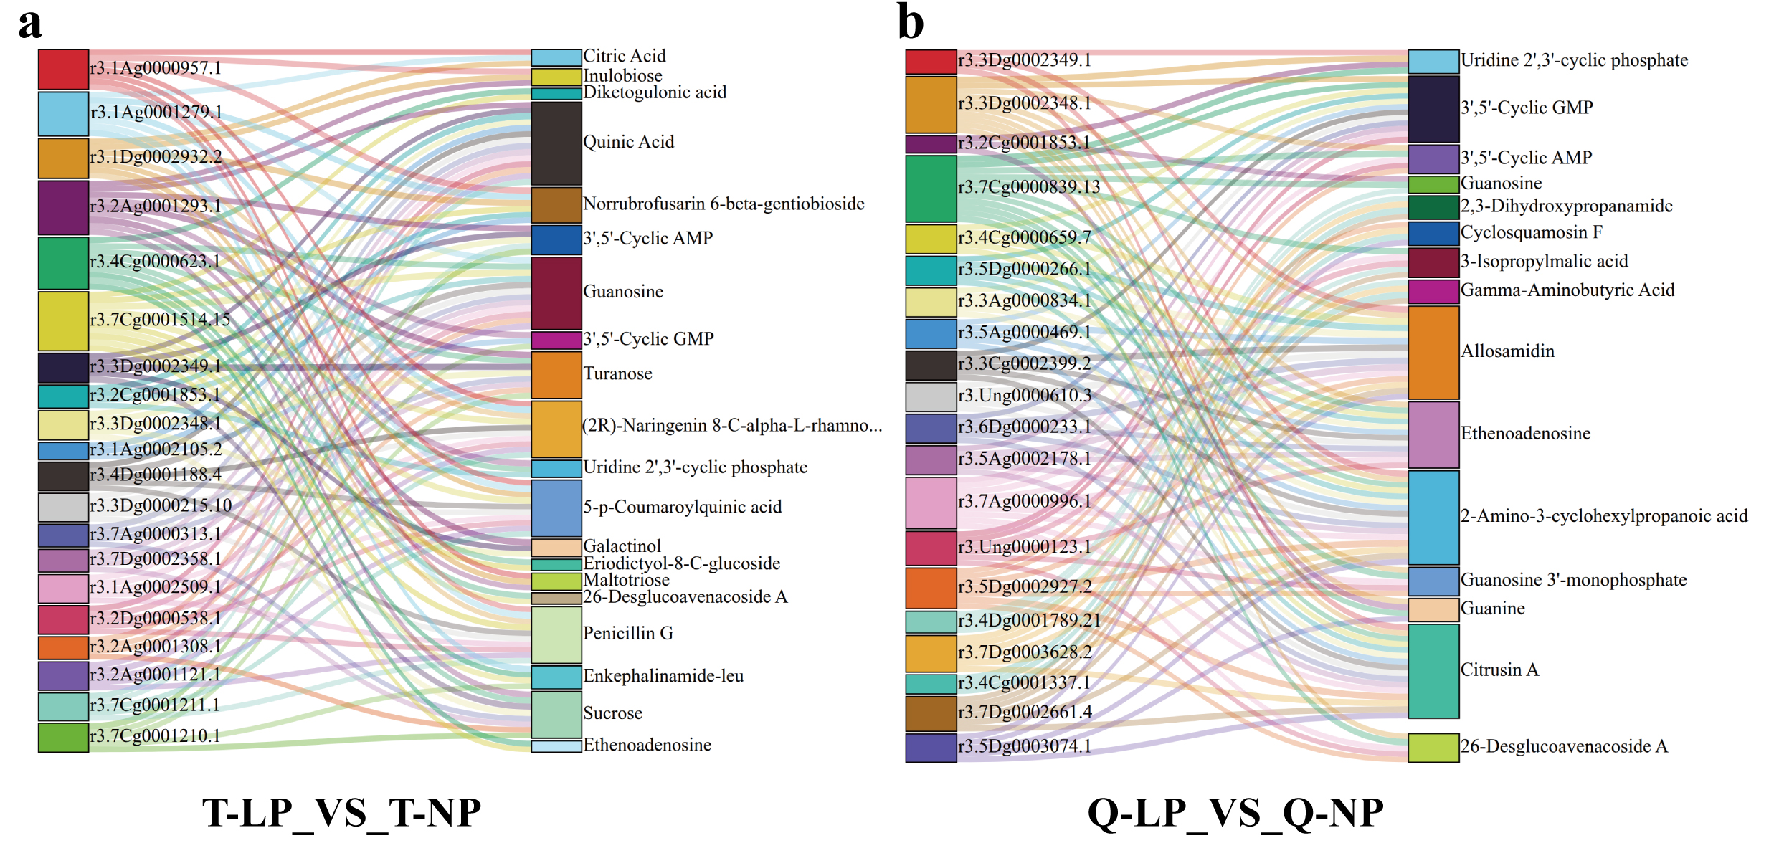
Figure S10. Cross-omic protein–metabolite association patterns in QH444 and TY2 under low-phosphorus treatment.
(a) Protein–metabolite associations identified in the LP-tolerant cultivar TY2 (T) for the T-LP vs T-NP comparison. (b) Protein–metabolite associations identified in the LP-sensitive cultivar QH444 (Q) for the Q-LP vs Q-NP comparison. In each panel, proteins are shown on the left and metabolites on the right. Connecting lines represent protein–metabolite pairs showing significant correlations (P ≤ 0.05). The diagrams visualize the composition of significant cross-omic associations in each cultivar and should not be interpreted as evidence of direct biochemical or regulatory interactions.

