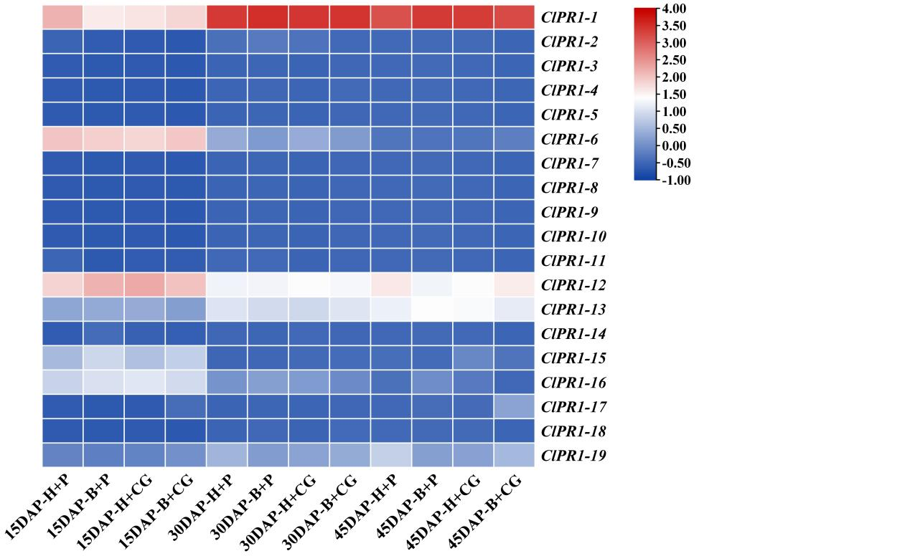
Fig. S1 The expression pattern of ClPR1 gene under different time points of CGMMV infection condition and boron treatment

