Supplementary Appendix
Taxonomic status and typification of Q. longinux complex
Hayata (1911) described three new species: Q. longinux, Q. pseudomyrsiniifolia, and Q. taichuensis, all of which resembled Q. myrsiniifolia and differed mainly in leaf morphology. The three species were subsequently recorded by Sasaki (1928) and Masamune (1936). However, Kanehira (1936) proposed a different treatment, regarding these species as one and treating Q. pseudomyrsinifolia and Q. taichuensis as synonyms of Q. longinux; Yang (2019) adopted the same treatment. Liu and Liao (1976) proposed another treatment, synonymizing Q. taichuensis with Q. longinux and treating Q. pseudomyrsinifolia as a variety of Q. longinux. Furthermore, Liao (1982) described two new varieties of Q. longinux based on leaf morphology: Q. longinux var. lativiolacifolia and Q. longinux var. kuoi. Later, Liao (1990) treated Q. longinux var. pseudomyrsinifolia as a synonym of Q. longinux. This most recent treatment of the Q. longinux complex, comprising one species with two varieties, was adopted in subsequent studies (Liao 1996)

Q. longinux complex has several heterotypic names, including Q. longinux Hayata, Q. pseudomyrsinifolia Hayata, Q. taichuensis, Q. longinux var. lativiolaciifolia J.C. Liao, and Q. longinux var. kuoi J.C. Liao. Examination of the original material indicated that the types of several names require lectotypification or further explanation. In the protologue of Quercus longinux (Hayata, 1911), Hayata cited a single collection represented by two specimens but did not designate either as the type. These specimens were deposited in the TI (TI00261354) and TAIF (TAIF007582) herbaria. We found Hayata’s handwritten annotation “Typus!” on the TI specimen but no such annotation on the TAIF specimen. Although Hayata did not designate a type in the protologue, this annotation clearly indicates his intention. Therefore, we regard the TI specimen as the holotype and the TAIF specimen as the isotype. The same situation also applies to the types of Q. taichuensis. Three specimens from a single collection were found in the TI and TAIF herbaria. We also found the handwritten annotation “Typus!” on one TI specimen (TI00261352); therefore, we regard it as the holotype and the other two specimens (TI00261351 and TAIF007591) as isotypes.

For Q. longinux var. lativiolaciifolia, Liao (1987) designated a single specimen deposited at NTUF as the holotype. All NTUF specimens were subsequently transferred to the TAI herbarium. However, the holotype could not be located after we examined all specimens of the Q. longinux complex at TAI. The holotype may have been lost; therefore, a lectotype is required under ICN Article 9.11 (Turland et al., 2018). Fortunately, two isotypes were found at TAIF (TAIF137226 and TAIF137227), and we designate the latter as the lectotype because it is better preserved.

Regarding the taxonomic status of var. lativiolaciifolia, Liao (1982) distinguished this variety on the basis of its rounded leaf base and the violet abaxial surface of dried leaves. However, our field observations and specimen examination, including material collected from the type locality, indicate that these characters are highly variable and taxonomically unreliable. The rounded leaf base varies among individuals within the same population, while the violet coloration on the abaxial leaf surface may also vary within a single individual, with some leaves exhibiting this feature and others lacking it. Furthermore, neither character corresponds to any distinct genetic component. Accordingly, these features cannot be regarded as diagnostic, and var. lativiolaciifolia is therefore best treated as a synonym of Q. longinux.

All type specimens of Quercus longinux var. kuoi also appear to have been lost. Liao (1987) designated two different collections deposited at NTUF as types in the protologue; these constitute syntypes under ICN Article 9.6 (Turland et al., 2018). However, our examination indicated that all of them were lost. Therefore, a lectotype should be selected from the remaining original material. Of the two paratypes at TAI, we select F00017873 as the lectotype.

Taxonomic treatment of the Q. longinux complex
Quercus longinux Hayata in Journal of the College of Science, Imperial University of Tokyo 30(1): 292–293, 1911. Type: Shinko, Uraisha, Jul. 1906, T. Kawakami et U. Mori 1384 (Lectotype designated here, TI00261354!, isolectotype, TAIF007582).
Cyclobalanopsis longinux var. lativiolaciifolia J.C. Liao in Exp. For. Taiwan Univ. Techn. Bull. 138: 4. 1982. syn. nov. Type: Ilan County, Lotung Town (Rotung), Tayuenshan, 4 Jul. 1960, Liao & Kuo 1939 (Lectotype designated here: TAIF137227, isolectotype, TAIF137226).
Q. glauca var. longinux (Hayata) Menitsky in Novosti Sistematiki Vysshchikh Rastenii 13: 68. 1976.
Q. glauca subsp. longinux (Hayata) Menitsky in Novosti Sistematiki Vysshchikh Rastenii 14: 64. 1977.
Q. longinux var. lativiolaciifolia (J. C. Liao) J. C. Liao in Quart. J. Exp. Forest NTU 4(1): 110. 1990.
Q. pseudomyrsiniifolia Hayata in Journal of the College of Science, Imperial University of Tokyo 30(1): 295. 1911. Type: Taipei, Shinko, Agiyokuzan, Dec. 1905, T. Kawakami & K. Hino 5779 (lectotype: TAIF007616, photo!); syntype: Taipei, Heirinbi, Shishikyakukozan, Nov. 1902, N. Konishi 22 (TI00261358!).
C. pseudomyrsiniifolia (Hayata) Schottky in Botanische Jahrbücher für Systematik, Pflanzengeschichte und Pflanzengeographie 47: 657. 1912.
Q. longinux var. pseudomyrsiniifolia (Hayata) J. C. Liao in Memoirs of the College of Agriculture, National Taiwan University 11: 45. 1970.
Q. taichuensis Hayata in Journal of the College of Science, Imperial University of Tokyo 30(1): 292–293, 1911. Type: Taichu, Kasigatani, G. Nakahara (Lectotype designated here: TI00261352, isolectotype, TI00261351, TAIF007591).
C. taichuensis (Hayata) Schottky in Botanische Jahrbücher für Systematik, Pflanzengeschichte und Pflanzengeographie 47: 683. 1912.
Q. longinux var. kanehirai (Nakai) J.C. Liao in Memoirs of the College of Agriculture, National Taiwan University 11: 45. 1970. excl. basionym

Q. kuoi (J.C. Liao) C.T. Chao, P.W. Sun, P.C. Liao stat. nov.
C. longinux var. kuoi J. C. Liao in Exp. For. Taiwan Univ. Techn. Bull. 138: 4. 1982. TYPE: Taitung County, Peinan Township, Chipen, the 26 compartment, 11 Dec. 1968, Mizushimas et Liao 10862 (Lectotype designated here, TAIF00017873!, isolectotype TAIF00017874!).
Q. longinux var. kuoi (J.C. Liao) J.C. Liao in Quart. J. Exp. Forest NTU 4: 110. 1990.
Q. longinux var. kuoi (J.C. Liao) C.F. Shen in Taxon. & Pollen Morph. Fagaceae Taiwan 56. 1984. nom. inval.

Diagnosis: Quercus kuoi resembles Q. longinux but is distinguished by its consistently green, non-glaucous abaxial leaf surface and relatively broader leaf shape; in the analyzed material, it also forms a geographically restricted and genetically differentiated lineage.

Distribution: Endemic to southern Taiwan and currently known from the Hengchun Peninsula, including the GS, LZ, and SK populations sampled in this study.

Taxonomic status of var. lativiolaciifolia: The morphological and genomic analyses do not support reciprocal differentiation of var. lativiolaciifolia from var. longinux; it is therefore treated here as a synonym of Quercus longinux.

Note: The two type specimens of var. kuoi designated by Liao (1982) and deposited at TAI have both been lost. Under ICN Article 9.11 (Turland et al., 2018), a lectotype may be designated in this situation. Under Article 9.12, the lectotype must be selected from original material. We therefore select a specimen formerly deposited at NTUF (F00017873; now at TAI) as the lectotype. Further details of the taxonomic status and typification of the Q. longinux complex are provided above.

References
Hayata, B. (1911). Materials for a Flora of Formosa. The Journal of the College of Science, Imperial University of Tokyo. 30: 1–471.
Kanehira, R. (1936). Formosan Trees Indigenous to the Island. Tokyo, Japan: Inoue Book Company.
Liao, J.C. (1990). The total revisions on the scientific names of the family Fagaceae in Taiwan. Quarterly Journal of Experimental Forest of National Taiwan University, 4: 95–115.
Liao, J.C. (1982). A Revision of the Scientific Names of the Family Fagaceae in Taiwan. Quarterly Journal of Experimental Forest of National Taiwan University. 138: 1–11.
Liao, J.C. (1987) Notes on the Nomenclature problems of the Fagaceae in Taiwan (II). Quartery Journal of Chinese Forestry 20: 47–52.
Liao, J.C. (1996). 5. Fagaceae. In Flora of Taiwan (second edition ed., Vol. 2, pp. 51–123). Taipei, Taiwan: Dep. of Botany, National Taiwan Univ.
Liu, T.S. and J.C. Liao (1976) 5. Fagaceae. Flora of Taiwan vol. 2. Epoch Publishing, Taipei. p. 49–104.
Masamune, G. (1936) Short Flora of Formosa. The Editorial Department of KUDOA, Taihoku, Taiwan.
Sasaki, S. (1928) List of Plants of Formosa. The Natural History Society of Formosa, Taihoku.
Turland, N.J., Wiersema, J.H., Barrie, F.R., Greuter, W., Hawksworth, D.L., Herendeen, P.S., . . . Marhold, K. (2018). International Code of Nomenclature for algae, fungi, and plants (Shenzhen Code) adopted by the Nineteenth International Botanical Congress Shenzhen, China, July 2017: Koeltz botanical books.
Yang, C. K. (2019). Taxonomy of Fagaceae in Taiwan. (Doctor Thesis), National Taiwan Normal University, Taipei.

Supplementary Figures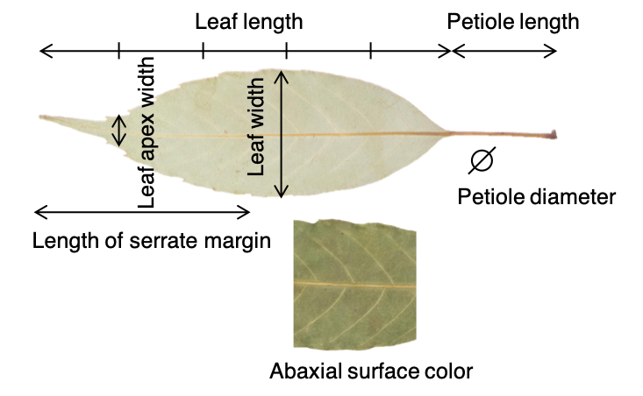
Figure S1. The diagram showing the measured leaf traits in Sun et al. (2024). Trait abbreviations are defined in the main-text Figure 1 caption. This figure was published in Sun et al. (2024).

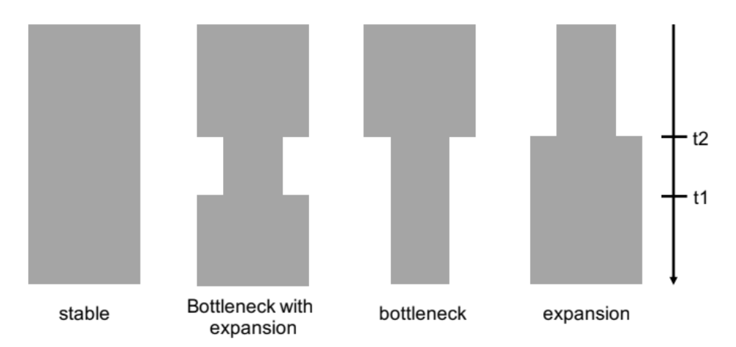
Figure S2. Four demographic scenarios modelled in fastsimcoal2. Parameter estimates include current (CN) and ancestral (AN) effective population sizes and timing of demographic events in generations (t2 and t1).

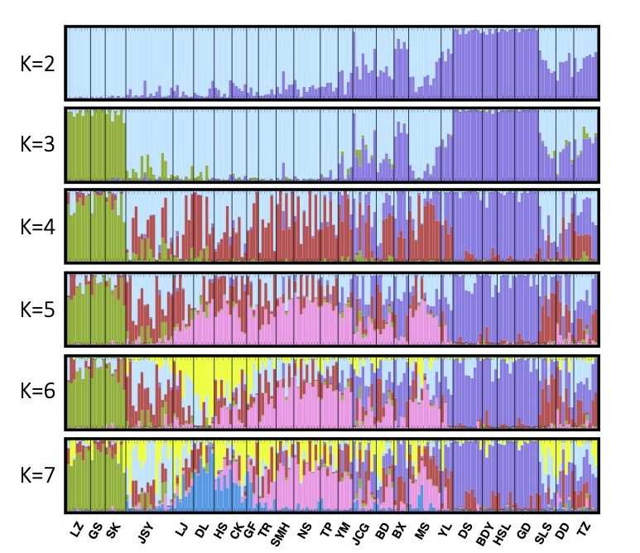
Figure S3. STRUCTURE ancestry coefficients for K = 2–7 from the 1,291 LD-pruned SNPs. Ten independent runs were completed for each K.
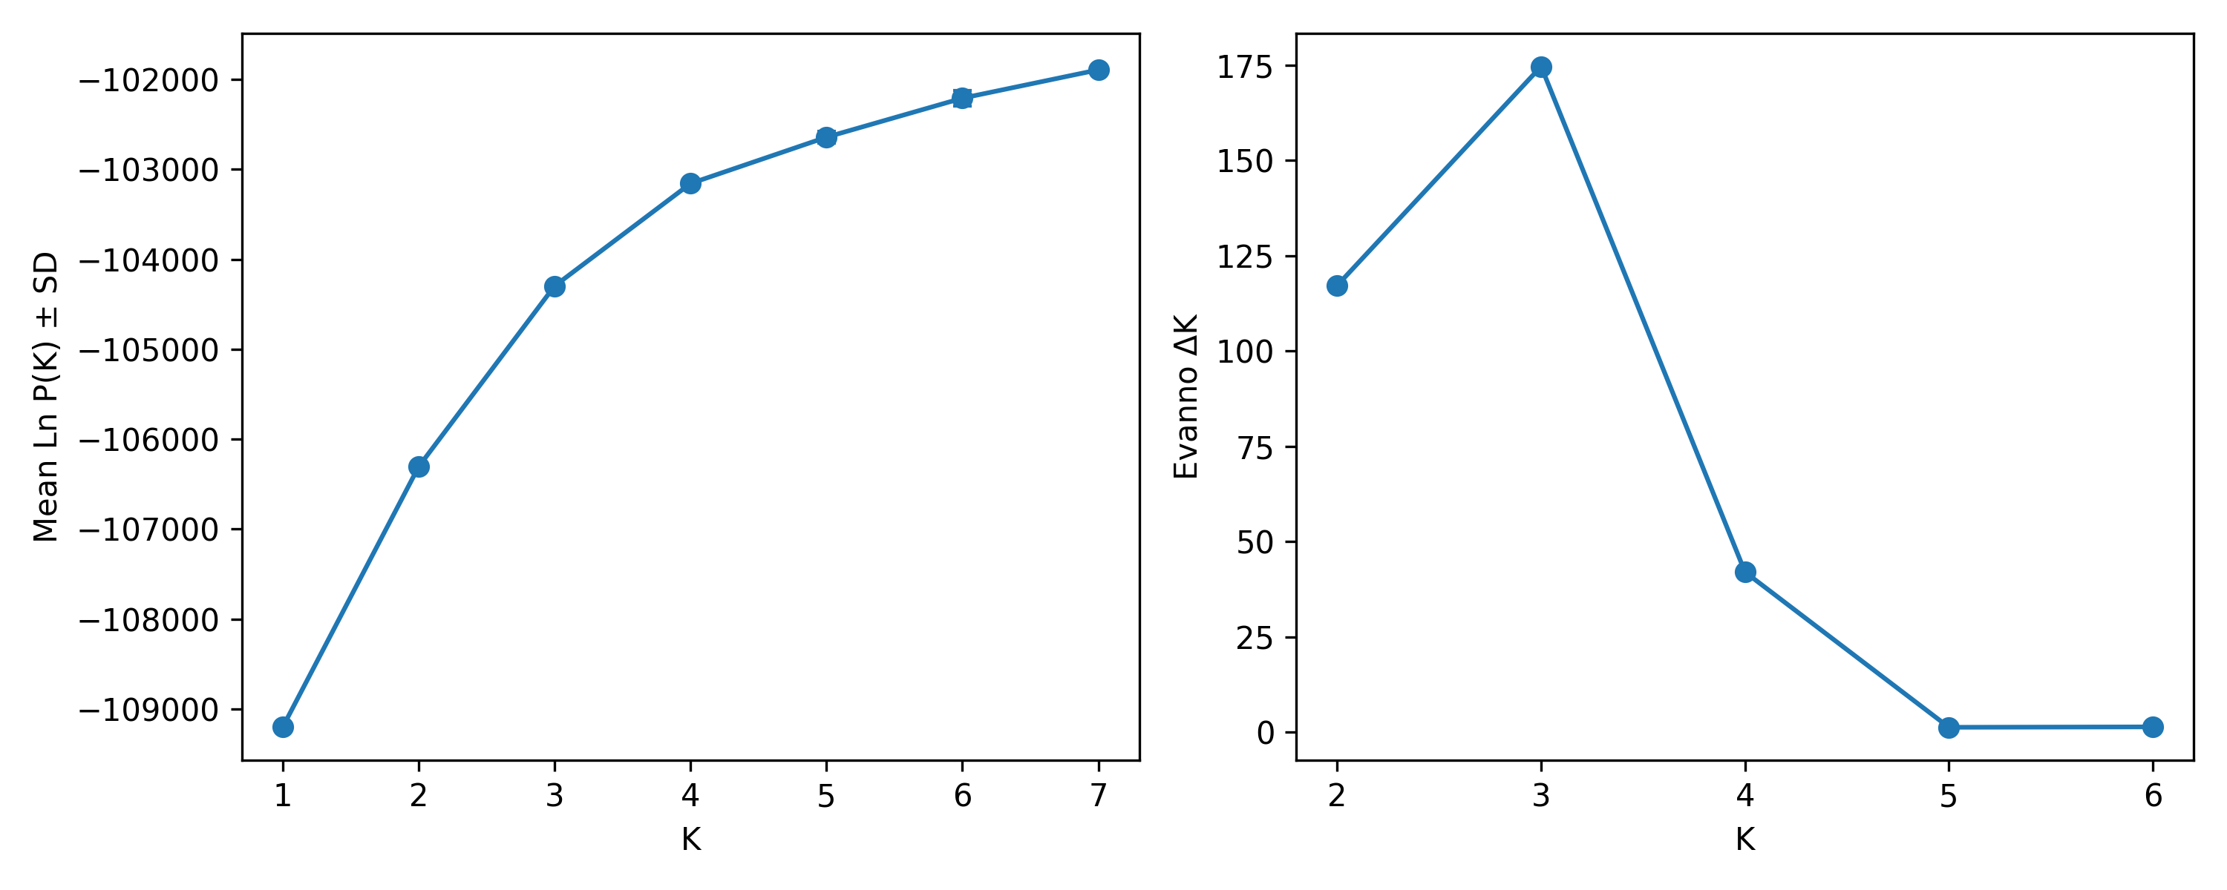
Figure S4. STRUCTURE likelihood and Evanno ΔK profiles for K = 1–7. Points show mean log likelihood across 10 independent runs. ΔK was maximal at K = 3.

Figure S5. Pairwise F_{ST} and genetic diversity among Quercus longinux populations and varieties. (a) Heatmap of pairwise F_{ST} values, with rows and columns clustered by complete linkage. (b) Population-level genetic-diversity metrics grouped by variety. Brackets retain the original unadjusted pairwise two-sided Wilcoxon rank-sum test annotations; exact raw and Holm-adjusted p values are reported in Table S5. F_{IS}, fixation index; H_{e}, expected heterozygosity; H_{o}, observed heterozygosity; NS, nonsignificant; *p < 0.05; **p < 0.01; ***p < 0.001.

Figure S6. The maximum-likelihood (ML) cladogram based on unlinked SNPs constructed by TreeMix. The numbers on the branches are the bootstrap support values. The classified variety corresponding to each population is annotated on the right side.

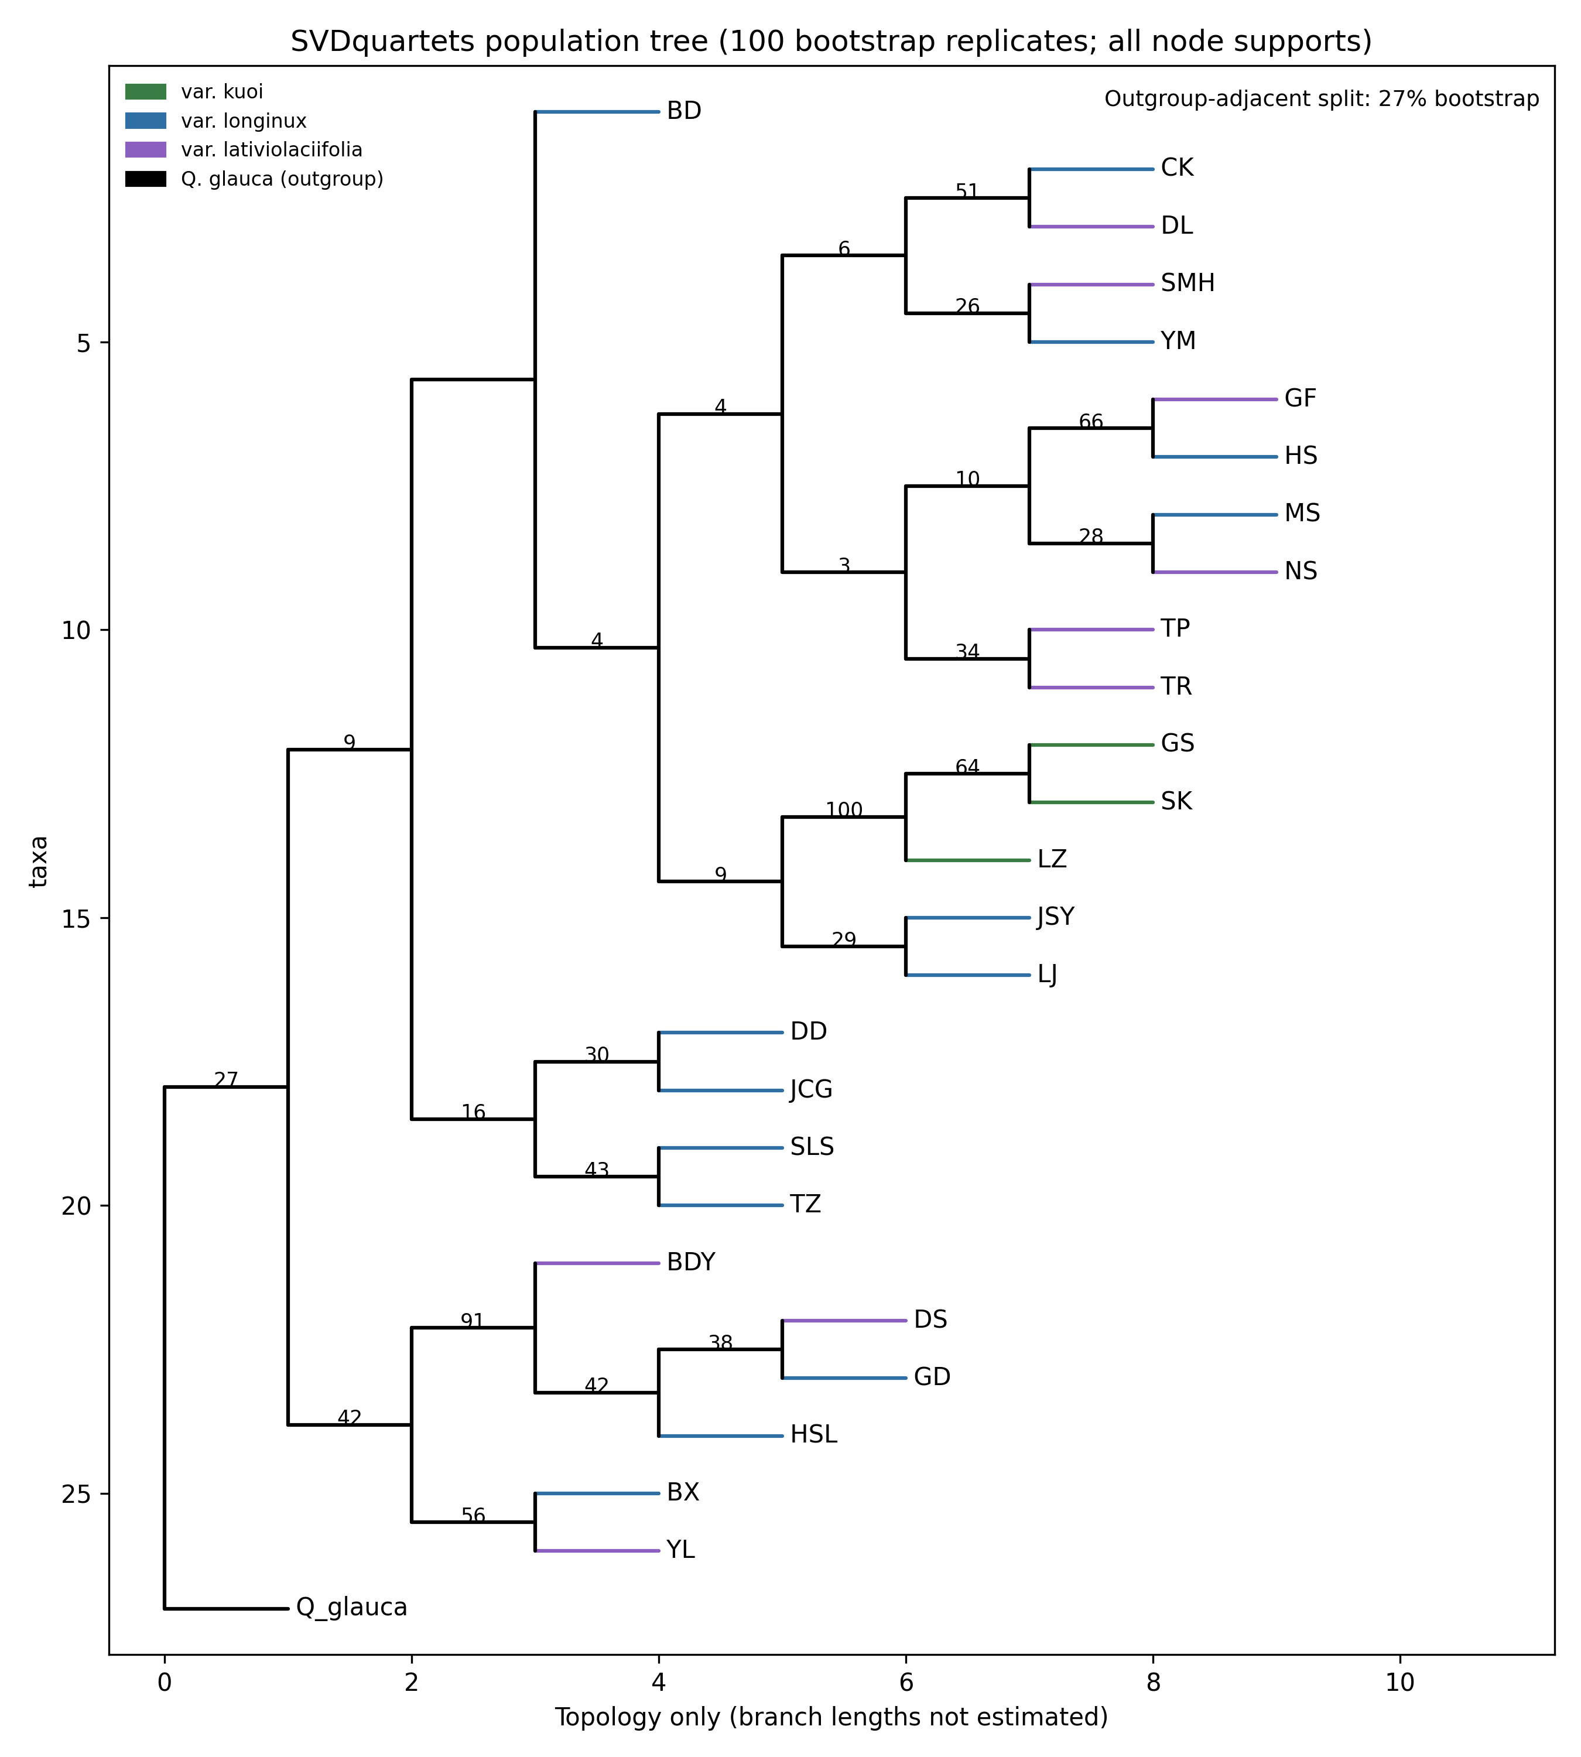

Figure S7. SVDquartets population tree inferred from 1,291 LD-pruned RAD SNPs. Individuals were assigned to 27 population/species partitions. All internal bootstrap values are shown. SVDquartets estimates an unrooted topology, which was rooted post hoc on Q. glauca. Branch lengths are for display only.

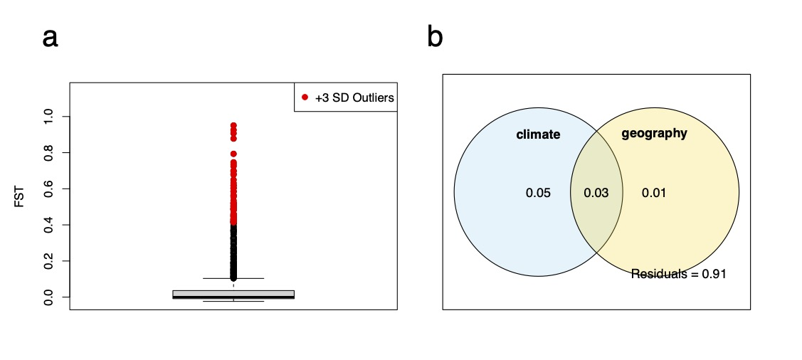
Figure S8. F_{ST} outlier detection and partial redundancy analysis. (a) Distribution of locus-specific F_{ST} values; candidates above the mean plus three standard deviations are colored red. (b) Variation partitioning for the partial-RDA model.

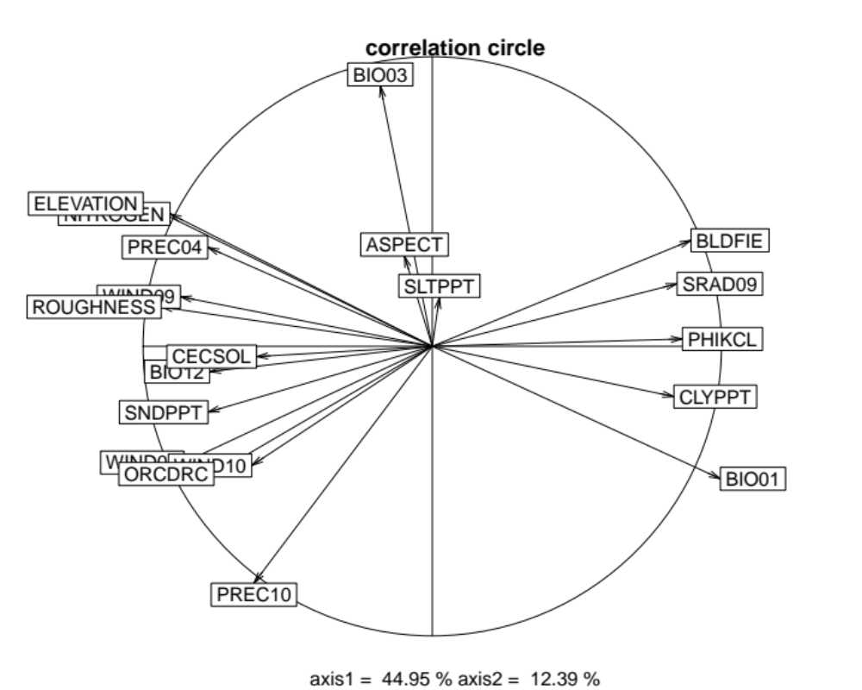Figure S9. Environmental PCA constructed by ecospat. The correlation circles represent the variable importance along the first two principal axes. The description of each variable is shown in Table S1.

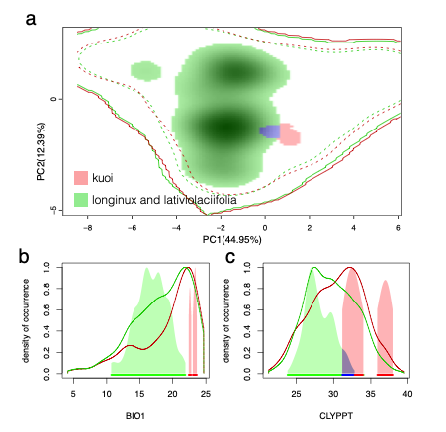
Figure S10. Niche comparisons within the Q. longinux complex. (a) Niche overlap based on principal component analysis between Q. longinux var. kuoi and the combination of Q. longinux var. longinux and Q. longinux var. lativiolaciifolia. Solid and dashed lines indicate 100% and 90% of all the available environments, respectively. The blue color represents the niche overlap between Q. longinux var. kuoi and the combination of Q. longinux var. longinux and Q. longinux var. lativiolaciifolia. Kernel density of occurrence is based on one environmental gradient of (b) BIO1 and (c) CLYPPT. Solid lines indicate all available environments of the associated variable.

Figure S11. Relative importance of each variable in the niche models constructed with (a) Q. longinux var. kuoi and (b) the combination of Q. longinux var. longinux and Q. longinux var. lativiolaciifolia.
Figure S12. Response curve of each variable in the niche models constructed with (a) Q. longinux var. kuoi and (b) the combination of Q. longinux var. longinux and Q. longinux var. lativiolaciifolia.

Figure S13. Geographic origin of range expansion. Yellow cells indicate a likely origin, red cells indicate an unlikely origin, and grey cells represent locations with a negative correlation between diversity and the origin. The potential origin is marked with the symbol “X”.
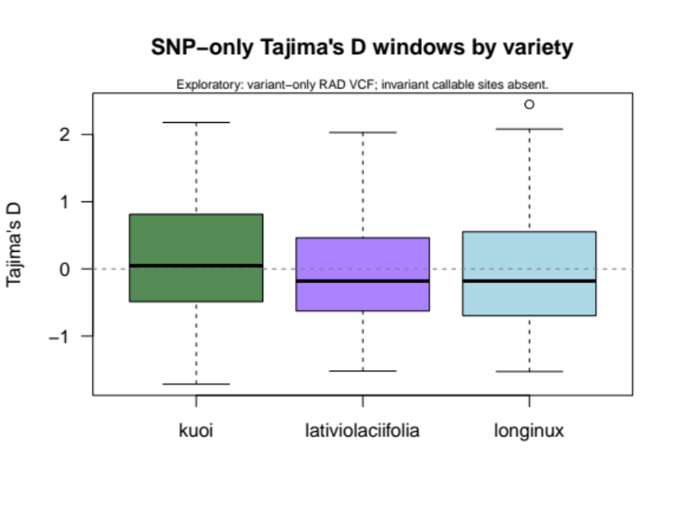
Figure S14. SNP-only Tajima’s D across varieties. Boxplots show the distributions of window-level estimates. Mean values were 0.165 for var. kuoi, −0.038 for var. lativiolaciifolia, and −0.028 for var. longinux. Because invariant callable sites were not included, these values are interpreted only as relative exploratory summaries.
Figure S15. Correlation between genetic diversity and geographic distance to the potential expansion origin. The fitted regression model is represented by the blue line, and the 95% confidence interval (CI) is indicated by the grey shading. The R², Spearman correlation coefficient (r), and p value are shown for each model. F_{IS}, fixation index; H_{e}, expected heterozygosity; H_{o}, observed heterozygosity; π, nucleotide diversity.

Figure S16. Overall importance of each variable in the optimized gradient forest (GF) model.

Figure S17. Split‐density graph of the five climate predictors. Gray bars, binned raw importance density generated by the random forest output; black line, raw importance density I(x); red line, density of data d(x); blue line, estimated importance f(x) = I(x)/d(x); dashed horizontal line, where the f(x) ratio is one.

Figure S18. Loci cumulative importance curves for the five climate predictors. The key in the top left of each panel shows the loci with significant turnover in allele frequencies associated with each variable in order from high to low (top to bottom). The shape of each function indicates how the rate of change in allele frequencies varies along the gradient.
Figure S19. Predictor cumulative importance curves for the five predictors.

Figure S20. Comparison of Gradient Forest projections based on adaptive SNPs and all 1,291 LD-pruned SNPs. Scatterplots compare PCA scores from the two GF models for current and LGM projections. High correlations across PC1-PC3 indicate that putatively adaptive and genome-wide SNP sets recover similar broad spatial turnover.

