Supplementary Material
Integrated Multi-Omics Analysis Reveals Responsive Regulation of Pistia stratiotes to Combined Nanoplastic and Cadmium Stress
Sixi Zhu ¹, Yutian Lv ¹, Shaoxiong Lin ¹, Junwei Zhang ¹, Kapparage Kavinda Sandaruwan ², Muhammad Arif ^{3, *}
¹College of Eco-environment Engineering, Guizhou Minzu University; The Karst Environmental Geological Hazard Prevention of Key Laboratory of State Ethnic Affairs Commission, Guiyang 550025, China.
²State Key Laboratory of Green Pesticide, Key Laboratory of Green Pesticide and Agricultural Bioengineering, Ministry of Education, Center for Research and Development of Fine Chemicals, Guizhou University, Guiyang 550025, China.
³College of Agriculture, Guizhou University, Guiyang 550025, China.
Corresponding authors *: Dr. Muhammad Arif (arif@gzu.edu.cn)

Table S1. Physicochemical characterization of NPs in deionized water. Data are presented as mean ± SD (n = 3).

Dispersion medium | Zeta potential (mV) | Hydrodynamic diameter (nm) | PDI
Deionized water | −35.2 ± 1.8 | 65.4 ± 3.2 | 0.05 ± 0.01

Table S2. Fresh weight and biomass growth rate of P. stratiotes under single and combined exposure of NPs and Cd. Data are presented as mean±SD (n = 3).

Treatment | Initial fresh weight (g) | Final fresh weight (g) | GRB (%)
CK | 18.90 ± 0.16 | 26.08 ± 1.11 | 37.93 ± 4.72
NPs | 18.98 ± 0.14 | 25.22 ± 1.07 | 32.87 ± 4.74
Cd | 18.95 ± 0.08 | 15.34 ± 1.16 | −19.07 ± 5.76
Cd–NPs | 18.97 ± 0.16 | 16.48 ± 1.00 | −13.07 ± 5.75

Table S3. Summary of sequencing data statistics. Raw and quality-filtered read counts for each sample are presented.

Sample | Raw reads | Raw bases | Clean reads | Clean bases | Error rate  (%) | Q20  (%) | Q30  (%) | GC content  (%)
CK-1 | 46626854 | 7040654954 | 46101064 | 6883285450 | 0.012 | 98.77 | 96.1 | 50.95
CK-2 | 44338134 | 6695058234 | 43831220 | 6538493866 | 0.012 | 98.73 | 96 | 51.01
CK-3 | 45502638 | 6870898338 | 44948470 | 6707595536 | 0.012 | 98.72 | 95.94 | 50.95
NPs-1 | 49363324 | 7453861924 | 48830598 | 7237629536 | 0.012 | 98.77 | 96.11 | 50.54
NPs-2 | 46048660 | 6953347660 | 45534838 | 6768145342 | 0.0119 | 98.8 | 96.19 | 50.47
NPs-3 | 47050022 | 7104553322 | 46535518 | 6903433781 | 0.012 | 98.77 | 96.08 | 50.47
Cd-1 | 43313226 | 6540297126 | 42865370 | 6423008941 | 0.0119 | 98.79 | 96.15 | 50.41
Cd-2 | 45370310 | 6850916810 | 44880376 | 6674167379 | 0.0119 | 98.8 | 96.19 | 50.36
Cd-3 | 41978822 | 6338802122 | 41509910 | 6183046236 | 0.012 | 98.75 | 96.03 | 50.38
Cd-NPs-1 | 48843540 | 7375374540 | 48315328 | 7162189464 | 0.0119 | 98.79 | 96.14 | 50.51
Cd-NPs-2 | 41069132 | 6201438932 | 40640802 | 6028543403 | 0.012 | 98.77 | 96.08 | 50.38
Cd-NPs-3 | 48104228 | 7263738428 | 47548914 | 6999344114 | 0.0119 | 98.79 | 96.16 | 50.51

Table S4. Alignment statistics of transcriptomic sequencing data. Summary of clean reads, mapped reads, and mapping ratios for P. stratiotes across different treatments, indicating high-quality sequencing and consistent alignment among samples.

Sample | Clean reads | Mapped reads | Mapped ratio
CK-1 | 23050532 | 20127921 | 0.8732
CK-2 | 21915610 | 19079248 | 0.8706
CK-3 | 22474235 | 19649010 | 0.8743
NPs-1 | 24415299 | 21440577 | 0.8782
NPs-2 | 22767419 | 19879083 | 0.8731
NPs-3 | 23267759 | 20405318 | 0.877
Cd-1 | 21432685 | 18747053 | 0.8747
Cd-2 | 22440188 | 19776961 | 0.8813
Cd-3 | 20754955 | 18232197 | 0.8785
Cd-NPs-1 | 24157664 | 21245221 | 0.8794
Cd-NPs-2 | 20320401 | 17837312 | 0.8778
Cd-NPs-3 | 23774457 | 20959998 | 0.8816

Table S5. Cadmium (Cd) accumulation and translocation in P. stratiotes. Data are presented as mean ± SD (n = 3). The table summarizes Cd content in the culture medium and plant tissues, along with the calculated bioconcentration factor (BCF) and translocation factor (TF) under different treatments. No Cd was added to the CK and NPs groups.
Treatment Group | Initial cadmium concentration in the culture medium (mg/L) | The residual concentration of cadmium in the aqueous solution (mg/L) | Cadmium content in leaves (mg/g DW) | Cadmium Content in Roots (mg/g DW) | Bioconcentration Factor (BCF) | Translocation Factor (TF)
Cd | 14.99±0.04 | 6.93±0.38 | 0.68±0.10 | 3.32±0.24 | 0.48±0.06 | 0.2±0.01
Cd-NPs | 15±0.02 | 7.09±0.35 | 0.63±0.13 | 3.12±0.28 | 0.44±0.06 | 0.2±0.02

Table S6. KEGG pathway enrichment analysis of differentially expressed genes. Significantly enriched metabolic and signaling pathways (p < 0.05) identified from transcriptomic comparisons among treatments in P. stratiotes, highlighting key processes related to photosynthesis, hormone signaling, secondary metabolism, and stress responses.

ID | Description | GeneRatio | BgRatio | pvalue | qvalue | Count
map04075 | Plant hormone signal transduction | 52/1708 | 439/41588 | 9.94757E-12 | 1.27748E-09 | 52
map00940 | Phenylpropanoid biosynthesis | 30/1708 | 179/41588 | 5.85785E-11 | 3.76136E-09 | 30
map00196 | Photosynthesis - antenna proteins | 48/1708 | 484/41588 | 2.18573E-08 | 9.35646E-07 | 48
map00941 | Flavonoid biosynthesis | 12/1708 | 42/41588 | 7.7867E-08 | 2.49994E-06 | 12
map00195 | Photosynthesis | 57/1708 | 678/41588 | 3.36911E-07 | 8.6533E-06 | 57
map04626 | Plant-pathogen interaction | 65/1708 | 1031/41588 | 0.000473985 | 0.009001433 | 65
map04712 | Circadian rhythm - plant | 15/1708 | 136/41588 | 0.000490652 | 0.009001433 | 15
map00592 | alpha-Linolenic acid metabolism | 21/1708 | 261/41588 | 0.002764225 | 0.044288465 | 21
map00945 | Stilbenoid, diarylheptanoid and gingerol biosynthesis | 5/1708 | 25/41588 | 0.003103823 | 0.044288465 | 5

Table S7. KO annotation and expression levels of key pathway-related genes in P. stratiotes under different treatments. Data are presented as mean ± SD (n = 3).

Gene ID | KO id | CK | NPs | Cd | Cd–NPs | Pathway | Description
TRINITY_DN33648_c0_g1 | K00083 | 545.57 ± 42.58 | 767.82 ± 21.77 | 1077.73 ± 121.29 | 632.10 ± 82.21 | map00940 | Phenylpropanoid biosynthesis
TRINITY_DN8460_c1_g1 | K00083 | 110.64 ± 14.55 | 59.57 ± 3.33 | 37.76 ± 5.59 | 31.47 ± 6.82 | map00940 | Phenylpropanoid biosynthesis
TRINITY_DN65_c5_g1 | K00083 | 107.71 ± 4.80 | 72.37 ± 3.08 | 55.78 ± 0.36 | 49.62 ± 0.50 | map00940 | Phenylpropanoid biosynthesis
TRINITY_DN15345_c0_g1 | K00083 | 22.67 ± 1.07 | 25.94 ± 1.30 | 47.52 ± 4.34 | 29.56 ± 1.53 | map00940 | Phenylpropanoid biosynthesis
TRINITY_DN15425_c0_g1 | K00224 | 18.97 ± 0.86 | 23.59 ± 0.93 | 36.90 ± 2.18 | 27.90 ± 0.60 | map00592 | alpha-Linolenic acid metabolism
TRINITY_DN12576_c0_g1 | K00224 | 46.98 ± 1.79 | 51.64 ± 3.38 | 117.22 ± 12.32 | 103.00 ± 2.61 | map00592 | alpha-Linolenic acid metabolism
TRINITY_DN213_c5_g1 | K00430 | 1.46 ± 0.59 | 8.01 ± 0.39 | 72.33 ± 8.37 | 40.00 ± 2.59 | map00940 | Phenylpropanoid biosynthesis
TRINITY_DN3524_c1_g1 | K00430 | 230.49 ± 11.09 | 179.22 ± 4.65 | 139.51 ± 3.55 | 136.17 ± 14.75 | map00940 | Phenylpropanoid biosynthesis
TRINITY_DN87817_c0_g1 | K00430 | 3.76 ± 1.81 | 10.94 ± 2.82 | 170.54 ± 6.94 | 182.93 ± 10.38 | map00940 | Phenylpropanoid biosynthesis
TRINITY_DN34648_c0_g1 | K00430 | 14.55 ± 4.38 | 107.92 ± 13.69 | 140.29 ± 6.62 | 295.63 ± 10.27 | map00940 | Phenylpropanoid biosynthesis
TRINITY_DN2061_c2_g1 | K00430 | 0.73 ± 0.21 | 9.17 ± 1.42 | 8.29 ± 2.05 | 20.56 ± 7.81 | map00940 | Phenylpropanoid biosynthesis
TRINITY_DN37965_c0_g1 | K00430 | 2.70 ± 0.76 | 46.10 ± 5.47 | 14.51 ± 4.30 | 35.19 ± 5.15 | map00940 | Phenylpropanoid biosynthesis
TRINITY_DN8156_c0_g1 | K00430 | 47.63 ± 13.61 | 322.37 ± 31.64 | 188.87 ± 50.78 | 329.78 ± 81.73 | map00940 | Phenylpropanoid biosynthesis
TRINITY_DN12358_c0_g1 | K00430 | 3.69 ± 0.52 | 17.64 ± 2.79 | 58.91 ± 5.88 | 44.98 ± 4.90 | map00940 | Phenylpropanoid biosynthesis
TRINITY_DN4211_c0_g1 | K00430 | 51.85 ± 6.76 | 30.07 ± 1.16 | 18.27 ± 0.43 | 16.35 ± 2.55 | map00940 | Phenylpropanoid biosynthesis
TRINITY_DN15557_c0_g1 | K00430 | 27.97 ± 3.56 | 26.49 ± 3.35 | 5.56 ± 0.96 | 7.49 ± 1.34 | map00940 | Phenylpropanoid biosynthesis
TRINITY_DN1619_c0_g1 | K00430 | 8.92 ± 0.48 | 30.29 ± 3.07 | 571.68 ± 26.31 | 416.50 ± 19.18 | map00940 | Phenylpropanoid biosynthesis
TRINITY_DN5124_c0_g3 | K00430 | 8.53 ± 1.22 | 14.93 ± 0.81 | 29.59 ± 5.69 | 40.75 ± 4.99 | map00940 | Phenylpropanoid biosynthesis
TRINITY_DN6061_c0_g1 | K00430 | 12.28 ± 2.46 | 56.39 ± 5.03 | 48.23 ± 7.14 | 85.15 ± 13.94 | map00940 | Phenylpropanoid biosynthesis
TRINITY_DN1619_c0_g2 | K00430 | 5.13 ± 1.18 | 40.90 ± 1.68 | 360.70 ± 27.99 | 214.30 ± 15.60 | map00940 | Phenylpropanoid biosynthesis
TRINITY_DN2405_c0_g1 | K00454 | 20.71 ± 1.45 | 25.67 ± 1.33 | 41.06 ± 1.38 | 36.89 ± 1.17 | map00592 | alpha-Linolenic acid metabolism
TRINITY_DN12985_c0_g1 | K00454 | 37.72 ± 5.64 | 56.87 ± 4.22 | 55.22 ± 2.97 | 55.60 ± 3.40 | map00592 | alpha-Linolenic acid metabolism
TRINITY_DN868_c0_g1 | K00454 | 103.96 ± 5.79 | 84.03 ± 3.30 | 180.14 ± 13.46 | 82.46 ± 7.59 | map00592 | alpha-Linolenic acid metabolism
TRINITY_DN6016_c0_g1 | K02636 | 298.45 ± 21.52 | 177.07 ± 6.57 | 68.72 ± 1.36 | 85.43 ± 5.57 | map00195 | Photosynthesis
TRINITY_DN14588_c0_g2 | K02636 | 4.50 ± 0.29 | 4.54 ± 0.80 | 28.26 ± 9.71 | 8.50 ± 0.86 | map00195 | Photosynthesis
TRINITY_DN4504_c0_g2 | K02638 | 507.40 ± 20.76 | 305.40 ± 15.80 | 117.20 ± 7.47 | 134.28 ± 6.01 | map00195 | Photosynthesis
TRINITY_DN15708_c2_g1 | K02638 | 25.61 ± 1.77 | 17.51 ± 1.59 | 5.28 ± 3.68 | 9.91 ± 2.71 | map00195 | Photosynthesis
TRINITY_DN1690_c0_g1 | K02638 | 12.56 ± 1.60 | 14.21 ± 1.94 | 117.10 ± 35.85 | 44.04 ± 2.28 | map00195 | Photosynthesis
TRINITY_DN7313_c0_g2 | K02641 | 520.25 ± 23.31 | 344.50 ± 23.89 | 77.19 ± 0.58 | 88.68 ± 5.26 | map00195 | Photosynthesis
TRINITY_DN4122_c0_g2 | K02690 | 30.07 ± 1.40 | 34.08 ± 1.98 | 57.39 ± 1.23 | 49.98 ± 2.33 | map00195 | Photosynthesis
TRINITY_DN4312_c0_g1 | K02692 | 8.33 ± 0.60 | 10.27 ± 1.77 | 93.19 ± 26.02 | 29.94 ± 1.41 | map00195 | Photosynthesis
TRINITY_DN4312_c0_g2 | K02692 | 4.10 ± 0.79 | 7.91 ± 1.49 | 15.76 ± 4.86 | 22.56 ± 2.66 | map00195 | Photosynthesis
TRINITY_DN27684_c0_g1 | K02692 | 611.80 ± 45.13 | 381.04 ± 19.80 | 90.87 ± 4.68 | 146.34 ± 7.24 | map00195 | Photosynthesis
TRINITY_DN6276_c1_g1 | K02693 | 1.63 ± 0.33 | 0.34 ± 0.17 | 0.29 ± 0.50 | 20.07 ± 2.57 | map00195 | Photosynthesis
TRINITY_DN2671_c0_g1 | K02693 | 9.47 ± 0.78 | 10.48 ± 0.44 | 96.64 ± 24.28 | 34.28 ± 4.84 | map00195 | Photosynthesis
TRINITY_DN5420_c0_g1 | K02695 | 10.29 ± 2.01 | 11.42 ± 1.94 | 98.98 ± 30.95 | 33.34 ± 0.87 | map00195 | Photosynthesis
TRINITY_DN2159_c0_g1 | K02698 | 8.83 ± 0.90 | 8.71 ± 1.83 | 78.90 ± 24.60 | 22.68 ± 1.91 | map00195 | Photosynthesis
TRINITY_DN11788_c0_g1 | K02698 | 1375.44 ± 84.69 | 827.94 ± 61.14 | 123.46 ± 0.56 | 199.58 ± 6.29 | map00195 | Photosynthesis
TRINITY_DN896_c0_g1 | K02703 | 55.12 ± 19.14 | 38.57 ± 5.93 | 12.83 ± 1.72 | 15.86 ± 4.21 | map00195 | Photosynthesis
TRINITY_DN896_c0_g2 | K02705 | 114.94 ± 4.86 | 81.20 ± 0.90 | 46.80 ± 1.65 | 40.42 ± 1.26 | map00195 | Photosynthesis
TRINITY_DN4652_c0_g1 | K02716 | 1430.11 ± 70.20 | 885.74 ± 33.07 | 199.25 ± 4.13 | 253.30 ± 7.10 | map00195 | Photosynthesis
TRINITY_DN10286_c0_g2 | K02716 | 9.81 ± 1.11 | 10.29 ± 0.89 | 84.27 ± 25.13 | 22.29 ± 2.41 | map00195 | Photosynthesis
TRINITY_DN3893_c0_g1 | K02717 | 92.68 ± 7.73 | 62.68 ± 1.82 | 19.14 ± 1.56 | 21.26 ± 3.32 | map00195 | Photosynthesis
TRINITY_DN5603_c1_g1 | K02717 | 13.19 ± 5.36 | 22.44 ± 5.28 | 4.19 ± 2.12 | 16.64 ± 2.30 | map00195 | Photosynthesis
TRINITY_DN7544_c0_g1 | K02717 | 813.12 ± 57.49 | 580.49 ± 44.77 | 101.01 ± 5.08 | 114.86 ± 3.18 | map00195 | Photosynthesis
TRINITY_DN94_c0_g1 | K02717 | 11.65 ± 0.95 | 12.44 ± 1.24 | 95.65 ± 28.80 | 32.60 ± 3.27 | map00195 | Photosynthesis
TRINITY_DN5389_c0_g1 | K02717 | 3.43 ± 1.75 | 7.13 ± 0.88 | 13.39 ± 3.82 | 20.05 ± 2.23 | map00195 | Photosynthesis
TRINITY_DN4158_c0_g1 | K03542 | 212.72 ± 21.87 | 150.16 ± 5.25 | 60.75 ± 4.85 | 72.62 ± 4.75 | map00195 | Photosynthesis
TRINITY_DN3114_c0_g1 | K05894 | 84.24 ± 10.19 | 111.06 ± 8.21 | 221.68 ± 12.06 | 200.20 ± 3.55 | map00592 | alpha-Linolenic acid metabolism
TRINITY_DN961_c0_g2 | K05894 | 68.48 ± 5.59 | 86.59 ± 2.25 | 197.50 ± 5.91 | 161.17 ± 5.15 | map00592 | alpha-Linolenic acid metabolism
TRINITY_DN10202_c0_g1 | K07513 | 220.77 ± 7.71 | 255.37 ± 13.39 | 431.45 ± 4.36 | 368.08 ± 20.08 | map00592 | alpha-Linolenic acid metabolism
TRINITY_DN14142_c0_g1 | K08901 | 6.55 ± 0.99 | 6.01 ± 0.20 | 64.62 ± 20.66 | 24.89 ± 1.93 | map00195 | Photosynthesis
TRINITY_DN3594_c0_g1 | K08901 | 59.70 ± 2.07 | 36.29 ± 2.41 | 8.47 ± 2.23 | 7.89 ± 0.56 | map00195 | Photosynthesis
TRINITY_DN17927_c0_g1 | K08901 | 967.36 ± 65.22 | 592.48 ± 40.23 | 100.38 ± 1.45 | 164.74 ± 8.29 | map00195 | Photosynthesis
TRINITY_DN16399_c0_g1 | K08902 | 103.96 ± 5.33 | 70.73 ± 7.83 | 6.95 ± 0.37 | 9.13 ± 1.90 | map00195 | Photosynthesis
TRINITY_DN357_c0_g1 | K09754 | 20.28 ± 1.71 | 27.70 ± 1.10 | 92.70 ± 7.03 | 114.20 ± 4.99 | map00940 | Phenylpropanoid biosynthesis; Flavonoid biosynthesis; Stilbenoid, diarylheptanoid and gingerol biosynthesis
 |  |  |  |  |  | map00941
 |  |  |  |  |  | map00945
TRINITY_DN12703_c0_g1 | K10527 | 44.42 ± 2.19 | 57.61 ± 1.00 | 77.45 ± 6.33 | 83.79 ± 4.01 | map00592 | alpha-Linolenic acid metabolism
TRINITY_DN12357_c0_g1 | K10529 | 131.61 ± 13.83 | 242.19 ± 10.58 | 448.62 ± 18.54 | 621.79 ± 41.17 | map00592 | alpha-Linolenic acid metabolism
TRINITY_DN4235_c1_g1 | K10529 | 19.59 ± 3.19 | 34.13 ± 0.72 | 26.25 ± 1.49 | 7.94 ± 1.87 | map00592 | alpha-Linolenic acid metabolism
TRINITY_DN10359_c0_g3 | K10775 | 3.72 ± 1.01 | 12.93 ± 0.35 | 17.24 ± 2.78 | 24.18 ± 0.31 | map00940 | Phenylpropanoid biosynthesis
TRINITY_DN40613_c0_g1 | K12355 | 63.51 ± 1.02 | 114.42 ± 7.63 | 262.09 ± 30.35 | 300.86 ± 29.25 | map00940 | Phenylpropanoid biosynthesis
TRINITY_DN21011_c0_g1 | K13065 | 3.58 ± 0.50 | 7.23 ± 0.71 | 32.36 ± 1.02 | 20.52 ± 1.81 | map00940 | Phenylpropanoid biosynthesis; Flavonoid biosynthesis; Stilbenoid, diarylheptanoid and gingerol biosynthesis
 |  |  |  |  |  | map00941
 |  |  |  |  |  | map00945
TRINITY_DN5052_c0_g1 | K13065 | 45.66 ± 2.26 | 66.33 ± 5.26 | 196.90 ± 2.80 | 190.69 ± 7.24 | map00940 | Phenylpropanoid biosynthesis; Flavonoid biosynthesis; Stilbenoid, diarylheptanoid and gingerol biosynthesis
 |  |  |  |  |  | map00941
 |  |  |  |  |  | map00945
Table S8. KEGG pathway enrichment analysis of characteristic proteins. Significantly enriched pathways (p < 0.05) identified from proteomic comparisons among three treatment groups in P. stratiotes.

ID | Description | GeneRatio | BgRatio | pvalue | qvalue | Count
map00195 | Photosynthesis | 31/689 | 310/14028 | 0.000136932 | 0.00435699 | 31
map00030 | Pentose phosphate pathway | 23/689 | 198/14028 | 0.000110983 | 0.00435699 | 23
map00592 | alpha-Linolenic acid metabolism | 11/689 | 81/14028 | 0.000147826 | 0.00435699 | 11
map00940 | Phenylpropanoid biosynthesis | 12/689 | 89/14028 | 0.00131973 | 0.029172974 | 12
Table S9. KO annotation and abundance levels of key pathway-related proteins in P. stratiotes under different treatments. Data are presented as mean ± SD (n = 3).
Accession | KO id | CK | NPs | Cd | Cd–NPs | Pathway | Description
TRINITY_DN65_c3_g1_i2_orfp1 | K00083 | 4853.20 ± 776.90 | 5343.58 ± 777.52 | 2807.87 ± 421.70 | 2451.08 ± 202.58 | map00940 | Phenylpropanoid biosynthesis
TRINITY_DN65_c5_g1_i4_orfp1 | K00083 | 6097.55 ± 710.49 | 5911.33 ± 1625.19 | 2962.65 ± 306.81 | 2742.14 ± 204.36 | map00940 | Phenylpropanoid biosynthesis
TRINITY_DN12576_c0_g1_i3_orfp1 | K00224 | 2863.93 ± 192.88 | 3530.31 ± 636.06 | 4199.07 ± 705.84 | 4674.82 ± 361.52 | map00592 | alpha-Linolenic acid metabolism
TRINITY_DN4659_c0_g1_i15_orfp1 | K00430 | 634.39 ± 248.56 | 520.70 ± 518.13 | 5296.97 ± 725.87 | 4190.95 ± 1627.67 | map00940 | Phenylpropanoid biosynthesis
TRINITY_DN6354_c0_g1_i1_orfp1 | K00430 | 7210.38 ± 931.51 | 8058.10 ± 3740.89 | 17743.07 ± 2564.58 | 29617.76 ± 6299.36 | map00940 | Phenylpropanoid biosynthesis
TRINITY_DN1619_c0_g2_i2_orfp1 | K00430 | 1259.06 ± 211.42 | 2058.25 ± 1521.25 | 10385.63 ± 3273.71 | 3857.53 ± 169.07 | map00940 | Phenylpropanoid biosynthesis
TRINITY_DN4659_c0_g1_i1_orfp1 | K00430 | 2572.03 ± 751.39 | 2492.55 ± 1112.67 | 16020.82 ± 784.18 | 15390.96 ± 4944.05 | map00940 | Phenylpropanoid biosynthesis
TRINITY_DN15557_c0_g1_i2_orfp1 | K00430 | 5197.60 ± 2160.00 | 5431.74 ± 754.07 | 1168.88 ± 146.47 | 1097.03 ± 259.56 | map00940 | Phenylpropanoid biosynthesis
TRINITY_DN1619_c0_g1_i1_orfp1 | K00430 | 3318.04 ± 481.76 | 2669.05 ± 842.05 | 18574.05 ± 6923.68 | 8510.18 ± 938.70 | map00940 | Phenylpropanoid biosynthesis
TRINITY_DN2405_c0_g1_i10_orfp1 | K00454 | 674.78 ± 166.08 | 902.52 ± 212.57 | 3113.32 ± 687.27 | 2213.60 ± 191.17 | map00592 | alpha-Linolenic acid metabolism
TRINITY_DN6016_c0_g1_i1_orfp1 | K02636 | 26358.68 ± 4946.24 | 28407.00 ± 6650.40 | 12459.37 ± 3977.96 | 12777.05 ± 3467.79 | map00195 | Photosynthesis
TRINITY_DN1664_c0_g3_i4_orfp1 | K02638 | 16179.90 ± 5602.26 | 6468.78 ± 3295.98 | 5026.61 ± 1069.14 | 5591.42 ± 2606.92 | map00195 | Photosynthesis
TRINITY_DN4504_c0_g2_i2_orfp1 | K02638 | 10301.86 ± 2179.70 | 11508.68 ± 3922.01 | 1176.85 ± 211.87 | 2405.36 ± 1244.25 | map00195 | Photosynthesis
TRINITY_DN19892_c0_g1_i4_orfp1 | K02641 | 26015.87 ± 1260.04 | 25518.19 ± 2740.53 | 9714.98 ± 1027.59 | 11376.31 ± 1659.81 | map00195 | Photosynthesis
TRINITY_DN19892_c0_g1_i3_orfp1 | K02641 | 21196.75 ± 1086.25 | 24396.16 ± 5157.44 | 10491.25 ± 1186.88 | 9911.77 ± 1967.40 | map00195 | Photosynthesis
TRINITY_DN4122_c0_g2_i1_orfp1 | K02690 | 16550.65 ± 3454.97 | 21186.58 ± 3004.45 | 8602.65 ± 904.49 | 8297.84 ± 1686.14 | map00195 | Photosynthesis
TRINITY_DN30615_c0_g1_i1_orfp1 | K02692 | 9416.05 ± 687.67 | 12971.92 ± 3404.72 | 4688.14 ± 1035.73 | 5026.13 ± 531.51 | map00195 | Photosynthesis
TRINITY_DN27684_c0_g1_i1_orfp1 | K02692 | 37366.75 ± 1547.26 | 46117.61 ± 10697.55 | 17866.41 ± 3847.66 | 19550.83 ± 4143.93 | map00195 | Photosynthesis
TRINITY_DN14266_c0_g1_i2_orfp1 | K02692 | 99736.92 ± 8948.45 | 108318.51 ± 27841.94 | 42880.44 ± 11388.48 | 46773.92 ± 10150.62 | map00195 | Photosynthesis
TRINITY_DN2746_c0_g1_i5_orfp1 | K02693 | 14893.79 ± 1210.70 | 16425.68 ± 4925.69 | 5811.10 ± 866.07 | 7398.23 ± 1769.43 | map00195 | Photosynthesis
TRINITY_DN11101_c0_g1_i7_orfp1 | K02695 | 21767.28 ± 3674.47 | 25993.06 ± 6970.37 | 8554.54 ± 2575.68 | 11663.45 ± 3636.95 | map00195 | Photosynthesis
TRINITY_DN357745_c0_g1_i1_orfp1 | K02698 | 612.17 ± 610.73 | 840.40 ± 651.40 | 3062.30 ± 929.25 | 3091.02 ± 1582.88 | map00195 | Photosynthesis
TRINITY_DN11788_c0_g1_i1_orfp1 | K02698 | 95917.58 ± 31896.52 | 67140.41 ± 24251.87 | 35247.24 ± 10027.84 | 37346.53 ± 13870.36 | map00195 | Photosynthesis
TRINITY_DN44800_c0_g1_i4_orfp1 | K02703 | 41135.64 ± 3111.89 | 46523.00 ± 2927.34 | 21734.69 ± 2391.07 | 22862.58 ± 4873.05 | map00195 | Photosynthesis
TRINITY_DN44800_c0_g1_i3_orfp1 | K02703 | 23860.37 ± 868.04 | 30204.68 ± 2199.10 | 17444.67 ± 1110.78 | 14595.39 ± 4189.31 | map00195 | Photosynthesis
TRINITY_DN24943_c0_g4_i1_orfp1 | K02705 | 87890.84 ± 2091.99 | 85911.71 ± 15536.77 | 44569.99 ± 6566.55 | 39804.59 ± 7919.97 | map00195 | Photosynthesis
TRINITY_DN4652_c0_g1_i3_orfp1 | K02716 | 118505.03 ± 27464.27 | 117316.18 ± 38181.07 | 36541.51 ± 11919.53 | 45810.97 ± 9431.69 | map00195 | Photosynthesis
TRINITY_DN7544_c0_g1_i5_orfp1 | K02717 | 53562.06 ± 11511.87 | 54492.88 ± 15183.19 | 17511.40 ± 3298.82 | 23359.92 ± 6289.49 | map00195 | Photosynthesis
TRINITY_DN4158_c0_g1_i4_orfp1 | K03542 | 98205.86 ± 8099.07 | 89565.03 ± 26893.81 | 52324.13 ± 22604.12 | 49049.07 ± 13215.53 | map00195 | Photosynthesis
TRINITY_DN6499_c0_g2_i11_orfp1 | K05894 | 3970.07 ± 277.47 | 4112.58 ± 1192.39 | 5679.10 ± 495.09 | 6403.18 ± 245.30 | map00592 | alpha-Linolenic acid metabolism
TRINITY_DN10202_c0_g1_i7_orfp1 | K07513 | 13598.20 ± 859.19 | 12810.11 ± 2408.43 | 19323.09 ± 1221.66 | 18089.98 ± 634.28 | map00592 | alpha-Linolenic acid metabolism
TRINITY_DN3343_c1_g1_i3_orfp1 | K08901 | 4233.35 ± 931.30 | 4993.17 ± 1694.08 | 1132.26 ± 321.49 | 1363.24 ± 260.68 | map00195 | Photosynthesis
TRINITY_DN16399_c0_g1_i1_orfp1 | K08902 | 67956.94 ± 11686.74 | 68999.06 ± 25706.20 | 23757.64 ± 8933.94 | 28410.65 ± 8660.04 | map00195 | Photosynthesis
TRINITY_DN357_c0_g1_i3_orfp1 | K09754 | 2459.16 ± 325.66 | 2700.87 ± 259.17 | 5861.41 ± 1695.54 | 4879.93 ± 1244.68 | map00940 | Phenylpropanoid biosynthesis
TRINITY_DN5197_c0_g1_i1_orfp1 | K10527 | 5744.64 ± 939.71 | 6364.20 ± 1158.97 | 15140.28 ± 2847.80 | 11647.45 ± 1024.38 | map00592 | alpha-Linolenic acid metabolism
TRINITY_DN5197_c0_g1_i13_orfp1 | K10527 | 3441.93 ± 479.64 | 3218.98 ± 400.68 | 7444.62 ± 1602.07 | 5732.30 ± 338.31 | map00592 | alpha-Linolenic acid metabolism
TRINITY_DN12357_c0_g1_i8_orfp1 | K10529 | 3247.09 ± 716.36 | 3728.17 ± 1024.67 | 10484.21 ± 2459.90 | 11004.24 ± 2556.08 | map00592 | alpha-Linolenic acid metabolism
TRINITY_DN12357_c0_g1_i5_orfp1 | K10529 | 11102.05 ± 1981.80 | 11389.13 ± 3633.32 | 33043.48 ± 7622.44 | 33527.25 ± 6696.26 | map00592 | alpha-Linolenic acid metabolism
TRINITY_DN25194_c0_g1_i1_orfp1 | K10775 | 5488.29 ± 1186.49 | 5229.09 ± 2373.51 | 10929.29 ± 2281.76 | 9705.39 ± 2873.85 | map00940 | Phenylpropanoid biosynthesis
TRINITY_DN40613_c0_g1_i11_orfp1 | K12355 | 668.08 ± 45.09 | 1043.31 ± 395.12 | 5372.62 ± 1753.78 | 5374.12 ± 753.82 | map00940 | Phenylpropanoid biosynthesis
TRINITY_DN5052_c0_g1_i1_orfp1 | K13065 | 3556.68 ± 653.16 | 3479.49 ± 1865.52 | 7461.17 ± 1795.30 | 7465.67 ± 2020.45 | map00940 | Phenylpropanoid biosynthesis

Table S10. Summary of metabolomics data statistics. Number of effective peaks and identified metabolites in positive (pos) and negative (neg) ion modes for raw and corrected datasets of P. stratiotes, indicating high data quality and reproducibility across treatments.

Ion Mode | Identified metabolites (raw) | proportion（%） | Effective Peak (origin) | Identified metabolites (origin) | proportion（%）
pos | 1378 | 0.0998 | 13350 | 1371 | 0.102725073
neg | 678 | 0.0462 | 14315 | 676 | 0.047260177

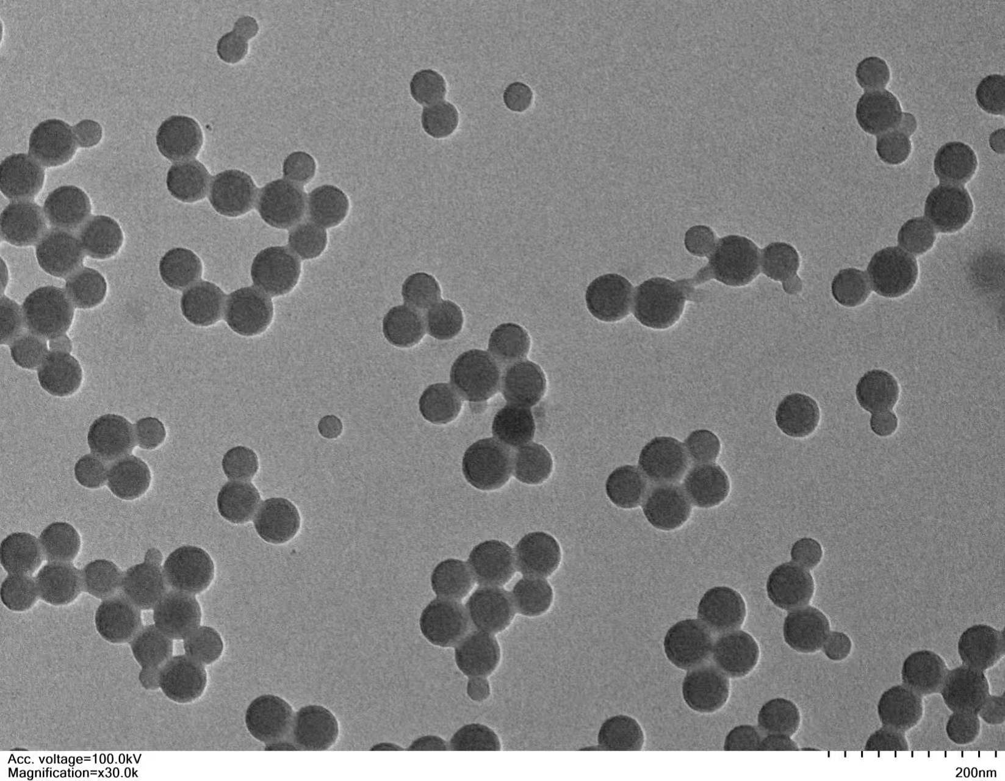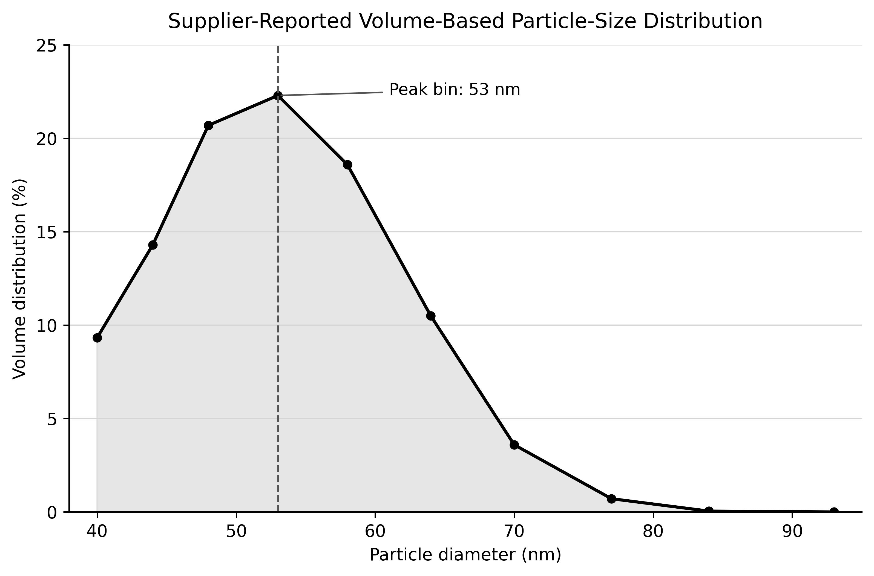
Figure S1. Supplier-provided SEM images and volume-based particle-size distribution data from supplier reports. The specific measurement method, dispersion medium, and batch-matching information for particle-size distribution were not provided by the supplier.
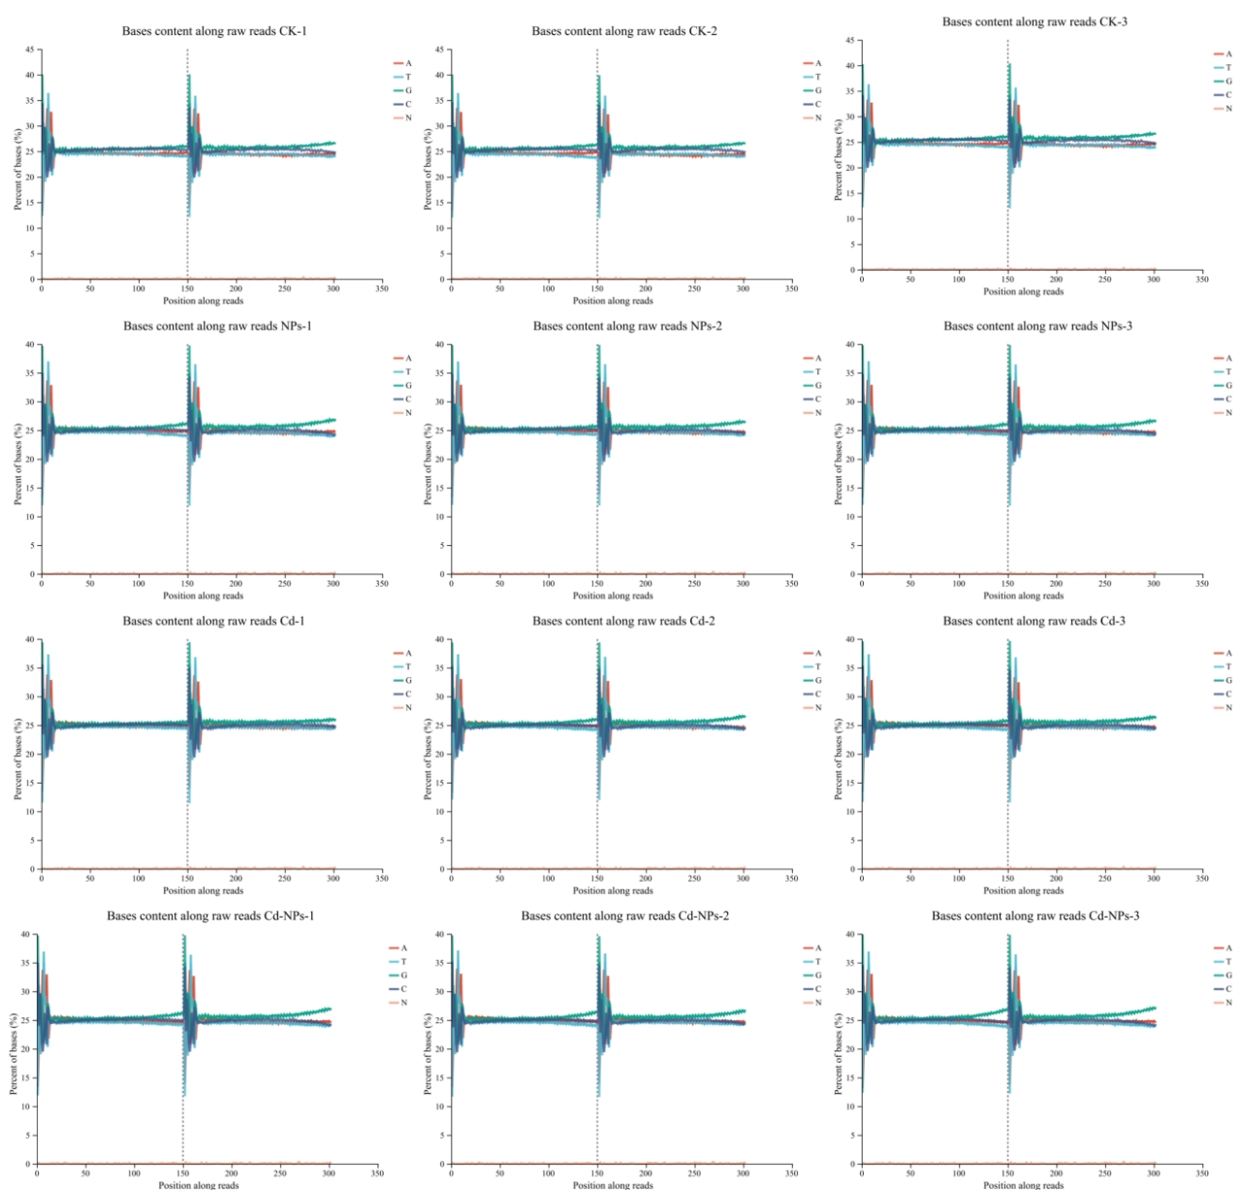

Figure S2. Base composition distribution of sequencing reads. CK, control; NPs, nanoplastics; Cd, cadmium; Cd-NPs, combined stress. The x-axis represents base positions along reads, and the y-axis shows the percentage of A, C, G, T, and N bases at each position; N denotes ambiguous bases. Different colors indicate different nucleotide types, reflecting base composition across samples.

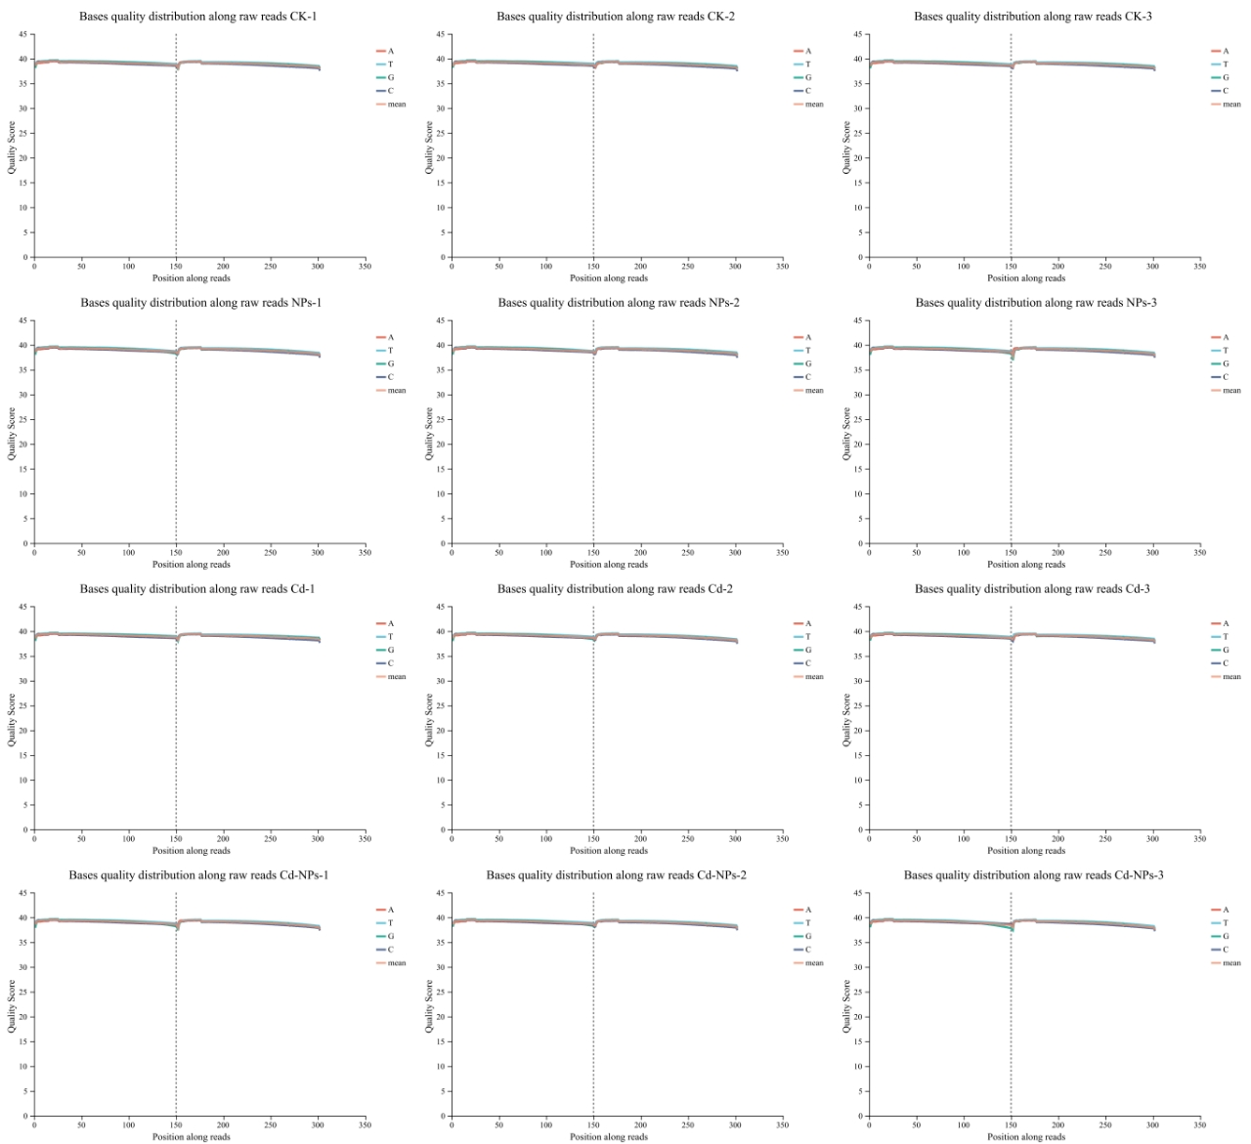
Figure S3. Base quality distribution of sequencing reads. CK, control; NPs, nanoplastics; Cd, cadmium; Cd–NPs, combined stress. The x-axis represents base positions along reads (1–151 for read 1; 152–302 for read 2), and the y-axis shows base quality scores, indicating overall sequencing quality across samples.

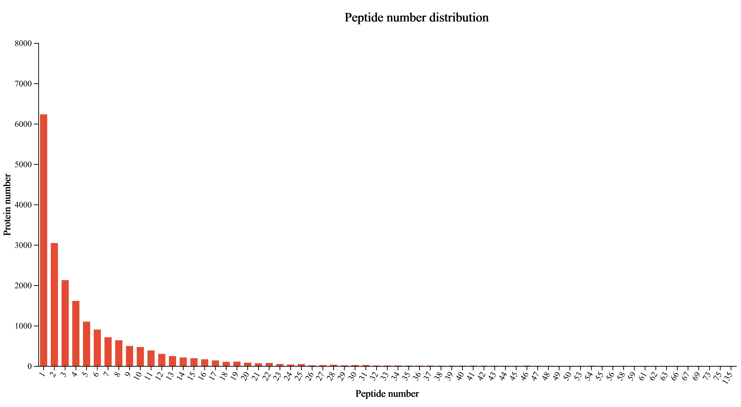

Figure S4. Distribution of peptide counts per protein. The x-axis represents the number of peptides identified per protein, and the y-axis indicates the corresponding number of proteins.

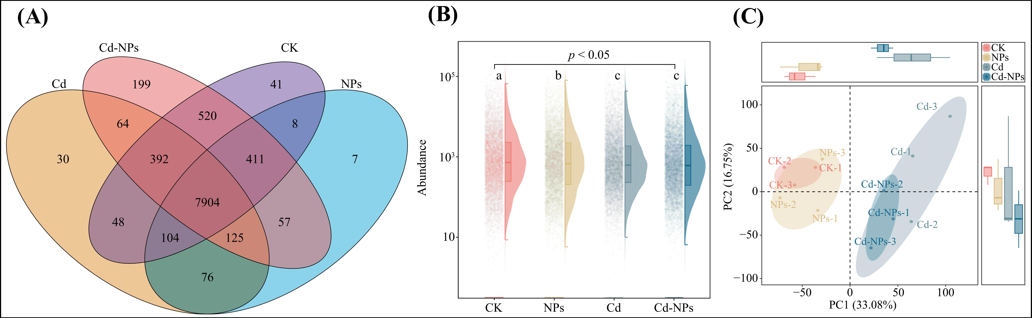
Figure S5. Overview of proteomic alterations in P. stratiotes under different treatments.
(A) Venn diagram showing the distribution of shared and unique proteins among different treatments. (B) Comparison of total protein abundance among different treatments. (C) PCA plot showing the clustering and separation of samples based on global protein abundance profiles.
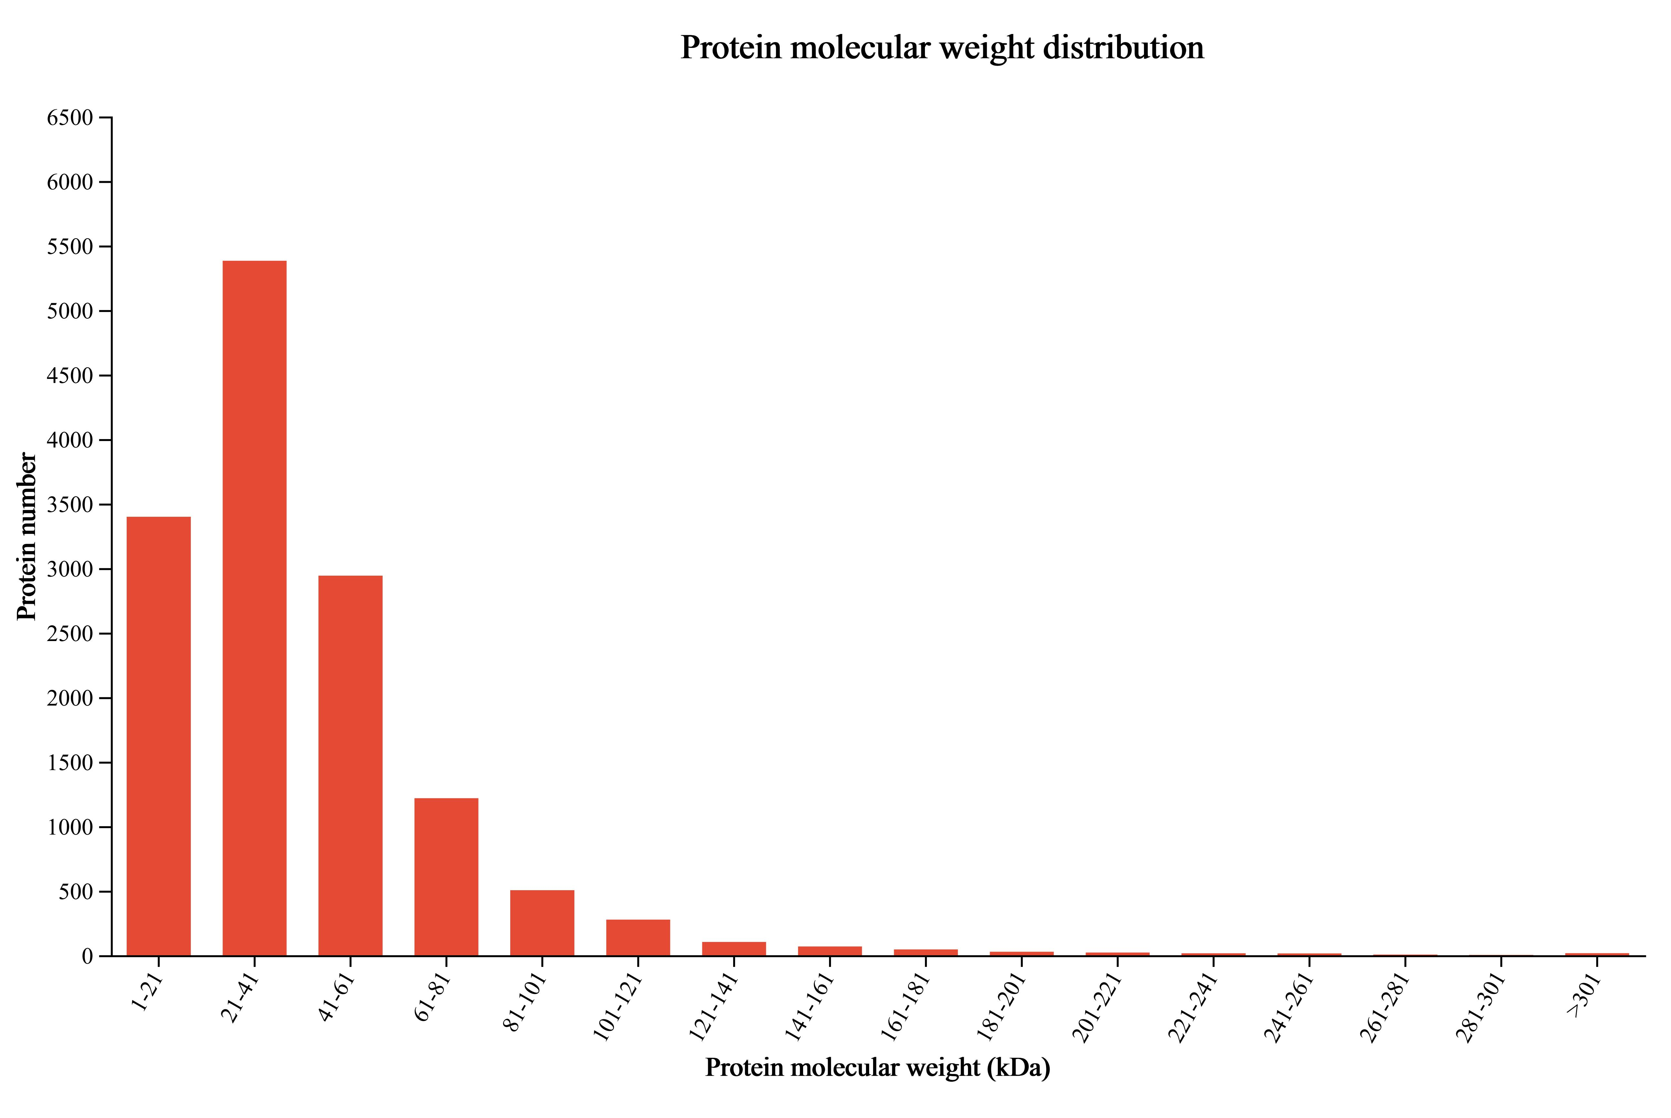

Figure S6. Molecular weight distribution of identified proteins. The x-axis represents protein molecular weight ranges, and the y-axis indicates the number of proteins in each range.

