ONLINE DATA SUPPLEMENT
Systolic blood pressure variability in patients with early severe sepsis or septic shock: a prospective cohort study

Yi Tang, MS³ (Yi.Tang@utah.edu), Jeff Sorenson, MStat (Jeff.Sorenson@imail.org), Michael Lanspa, MD^{1,2} (Michael.Lanspa@imail.org), Colin K. Grissom, MD^{1,2} (Colin.Grissom@imail.org), V.J. Mathews, PhD³ (Mathews@ece.utah.edu), Samuel M. Brown, MD MS^{1,2} (Samuel.Brown@imail.org)

¹Pulmonary and Critical Care, Intermountain Medical Center
5121 Cottonwood St, Murray, UT 84107
²Pulmonary and Critical Care, University of Utah School of Medicine
30 N 1900 E, Salt Lake City, UT 84132
³Electrical and Computer Engineering, University of Utah
50 Central Campus Dr #2110, Salt Lake City, UT 84112

SUPPLEMENTAL METHODS 1
Assessment of collinearity of admission APACHE II and PC₁ 2
Exploratory exact logistic regression analyses 2
Description of a Poincare plot 2
SUPPLEMENTAL RESULTS 3
eTable 1. Complexity metrics measured 3
eTable 2. Loadings of Complexity Metrics on Principal Component 1 6
Assessment of collinearity of admission APACHE II and PC₁ 7
eFigure 1: Scatterplot of APACHE II and PC₁ 8
eTable 3: Results of post hoc sensitivity analyses using exact logistic regression for vasopressor independence and 28-day all-cause mortality. 8

SUPPLEMENTAL METHODS

Assessment of collinearity of admission APACHE II and PC₁
For the purposes of regression modeling, we assessed the collinearity of APACHE II and PC₁. We did so by fitting relevant scatterplots of fitted regression lines (see eFigure 1). We calculated a variable inflation factor and compared the coefficients of linear and quadratic regression lines.

Exploratory exact logistic regression analyses
As a post hoc analysis, we used exact logistic regression to repeat our primary and secondary analyses. We used the elrm package, which employs Markov Chain Monte Carlo simulation to derive estimates. We report the results of these analyses in eTable 1.

Description of a Poincare plot
A Poincare plot (also known as a “return map”; see eFigure 1) describes the relationship between subsequent measurements in a series, alternatively its “self-similarity.”[1] By convention, the first standard deviation (SD1) of the Poincare plot represents the degree of dissimilarity of adjacent measurements, while the second standard deviation (SD2) represents the spread of values. In health, SD2 tends to be relatively high (indicating the effect of a normal sinus node arrhythmia), while in disease SD2 tends to be lower (indicating a stress system with low overall variation). SD1 is generally low and tends to be elevated in settings where the normal rhythm functions of the sinus node are disrupted in some way (e.g., by atrial or ventricular ectopic beats).
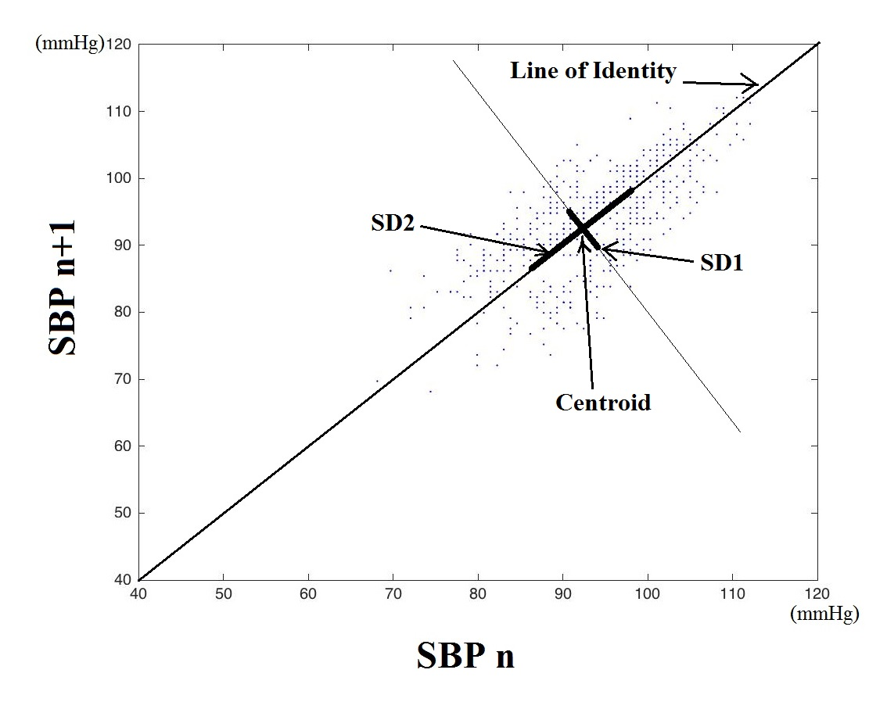

SUPPLEMENTAL RESULTS

eTable 1. Complexity metrics measured

Complexity measure | Median (IQI)
Mean | 98.3 (86.8 - 108.9)
Standard Deviation | 7.9 (6.6 - 11.6)
Coefficient of variation | 0.1 (0.1 - 0.1)
Poincare SD1 | 5.4 (3.6 - 7.8)
Poincare SD2 | 9.9 (8.3 - 14.4)
Square root of the mean squared differences of N successive NN intervals | 7.7 (5.1 - 11)
Sample entropy | 1.3 (1 - 1.5)
LFHF ratio Lomb Scargle | 0.7 (0.4 - 1.3)
LF Power Lomb Scargle | 0.1 (0.1 - 0.2)
HF Power Lomb Scargle | 0.2 (0.1 - 0.2)
Wavelet AUC | 10.2 (8.3 - 13)
Detrended Fluctuation Analysis: Alpha1 | 0.8 (0.7 - 1)
Detrended Fluctuation Analysis: Alpha2 | 0.8 (0.7 - 1)
Detrended Fluctuation Analysis: Alpha | 0.8 (0.7 - 1)
Largest Lyapunov exponent | 1.3 (1 - 1.6)
Skewness | 0.6 (-0.4 - 4.2)
Kurtosis | 15.8 (3.6 - 47.6)
Power Law Slope Frequency based | -0.1 (-0.2 - 0)
Power Law Y Intercept Frequency based | 9.5 (8.3 - 10.2)
Power Law Intercept Frequency based | 52.3 (0 - 142.1)
Power Law Goodness of Fit Frequency based | 0.8 (0.8 - 0.9)
Power Law Slope Lomb-Scargle | 0 (-0.1 - 0.1)
Power Law Y Intercept Lomb-Scargle | 5.8 (5.7 - 6)
Power Law Intercept Lomb-Scargle | 25.3 (-49.2 - 75.1)
Power Law Goodness of Fit Lomb-Scargle | 0 (0 - 0)
Power Law Slope Histogram based | -0.7 (-1.1 - -0.6)
Power Law Y Intercept Histogram based | -0.2 (-0.9 - 0.5)
Power Law Intercept Histogram based | -0.2 (-1.6 - 0.5)
Power Law Goodness of Fit Histogram based | 0.6 (0.4 - 0.7)
Detrended Fluctuation Analysis: area under the curve | 1.4 (1.2 - 1.5)
Multiscale Entropy | 1.2 (0.9 - 1.6)
LFHF ratio | 3.4 (1.1 - 5.2)
VLF Power | 4.8e+07 (6.4e+06 - 2.6e+08)
LF Power | 7.9e+07 (1.0e+07 - 4.4e+08)
HF Power | 3.3e+07 (1.1e+07 - 1.2e+08)
VLF Power Lomb-Scargle | 0.3 (0.1 - 0.4)
Activity | 9.8e+03 (7.6e+03 - 1.2e+04)
Mobility | 0.1 (0 - 0.1)
Complexity | 19.6 (15.4 - 27)
Embedding scaling exponent | 1 (1 - 1)
Recurrence quantification analysis: percentage of recurrences | 2.8 (1.8 - 7.9)
Recurrence quantification analysis: percentage of determinism | 22.1 (10 - 34.9)
Recurrence quantification analysis: maximum diagonal line | 0 (0 - 0.1)
Recurrence quantification analysis: average diagonal line | 0 (0 - 0)
Recurrence quantification analysis: Shannon entropy of the diagonals | 1.6 (1.2 - 2)
Recurrence quantification analysis: determinism/recurrences | 4.8 (2.4 - 7.2)
Recurrence quantification analysis: percentage of laminarity | 0.7 (0 - 7.6)
Recurrence quantification analysis: maximum vertical line | 0 (0 - 0)
Recurrence quantification analysis: trapping time | 0 (0 - 0)
Recurrence quantification analysis: Shannon entropy of the vertical lines | 0 (0 - 1.4)
Shannon entropy | 4.7 (4.4 - 5.3)
Plotkin and Swamy energy operator average energy | 19.4 (1.9 - 28.7)
Teager energy operator average energy | 37.7 (17 - 79.2)
Symbolic dynamics: percentage of 0 variations sequences, uniform case | 0.6 (0.3 - 0.8)
Symbolic dynamics: percentage of 1 variations sequences, uniform case | 0.3 (0.2 - 0.4)
Symbolic dynamics: percentage of 2 variations sequences, uniform case | 0.1 (0 - 0.2)
Symbolic dynamics: percentage of 0 variations sequences, non-uniform case | 0.4 (0.3 - 0.5)
Symbolic dynamics: percentage of 1 variations sequences, non-uniform case | 0.4 (0.4 - 0.5)
Symbolic dynamics: percentage of 2 variations sequences, non-uniform case | 0.2 (0.1 - 0.2)
Symbolic dynamics: forbidden words, uniform case | 192 (171.5 - 201)
Symbolic dynamics: forbidden words, non-uniform case | 31 (22 - 38)
Symbolic dynamics: Shannon entropy, uniform case | 2.7 (1.8 - 4.3)
Symbolic dynamics: Shannon entropy, non-uniform case | 4 (3.5 - 4.5)
Symbolic dynamics: modified conditional entropy, uniform case | 1 (0.8 - 1.2)
Symbolic dynamics: modified conditional entropy, non-uniform case | 1.3 (1.2 - 1.5)
Form factor | 1.6 (1.4 - 1.9)
Fuzzy entropy | 2.8 (2.3 - 3.1)
Grid transformation feature: grid count | 2.3 (1.5 - 3)
Rescaled detrended range analysis | 0.9 (0.8 - 1)
Higuchi scaling exponent | 1.9 (1.8 - 2)
Allan factor distance from a Poisson distribution | -0.3 (-0.3 - -0.3)
Fano factor distance from a Poisson distribution | -0.4 (-0.5 - -0.4)
Index of variability distance from a Poisson distribution | -0.3 (-0.6 - -0.1)
Scaled windowed variance | 0.2 (0.1 - 0.3)
Kullback-Leibler permutation entropy | 0 (0 - 0)
Multiscale time irreversibility asymmetry index | 0 (-0.1 - 0)
Lee parameter | 1.2 (1.1 - 1.3)
Poincaré plot cardiac sympathetic index | 1.9 (1.5 - 2.3)
Poincaré plot cardiac vagal index | 2.9 (2.7 - 3.2)
Mean of the differences | 0 (0 - 0)
Standard deviation of the differences | 7.7 (5.1 - 11)
Interquartile range | 7.8 (5.5 - 9.8)
Predictive feature: error from an Autoregressive model | 5.7 (3.7 - 8.3)
Multifractal spectrum cumulant of the first order | 0.5 (0.4 - 0.6)
Multifractal spectrum cumulant of the second order | -0.1 (-0.2 - 0)
Multifractal spectrum cumulant of the third order | 0 (0 - 0.1)
Kolmogorov-Sinai entropy | 0 (0 - 0.1)
Scale dependent Lyapunov exponent slope | -7.5 (-8.5 - -6.7)
Scale dependent Lyapunov exponent mean value | 5.6 (4.3 - 6.9)
Dynamical moment of the second order | 1.4 (-1.4 - 7.7)
Dynamical moment of the third order along the principal bisector | 9.2 (-28.5 - 78.9)
Dynamical moment of the third order along the secondary bisector | 159 (-117.2 - 4364.7)
Dynamical moment of the third order along the x axes | 254.9 (-37.9 - 2866.8)
Dynamical moment of the third order along the y axes | 15.2 (-99.7 - 2704.8)
Diffusion entropy | 0.1 (0 - 0.2)
IQI: inter-quartile interval

eTable 2. Loadings of Complexity Metrics on Principal Component 1
Complexity Metric | Loading on PC1*
Predictive feature: error from an Autoregressive model | 0.945
Poincaré SD1 | 0.930
Standard deviation of the differences | 0.930
Square root of the mean squared differences of N successive NN intervals | 0.930
Standard Deviation | 0.927
Mobility | 0.922
Teager energy operator average energy | 0.916
Poincaré plot cardiac vagal index | 0.907
Wavelet area under the curve | 0.897
Symbolic dynamics: forbidden words, non-uniform case | -0.895
Coefficient of variation | 0.892
Lee parameter | 0.883
Fuzzy entropy | 0.873
Poincaré SD2 | 0.863
Symbolic dynamics: Shannon entropy, non-uniform case | 0.847
Correlation dimension | 0.840
Detrended fluctuation analysis: area under the curve | 0.801
Symbolic dynamics: modified conditional entropy, non-uniform case | 0.801
HF Power | 0.781
HF Power Lomb-Scargle | 0.763
Detrended fluctuation analysis: Alpha 2 | -0.723
Symbolic dynamics: percentage of 2 variations sequences, non-uniform case | 0.721
Interquartile range | 0.703
Complexity | -0.673
VLF Power Lomb-Scargle | -0.666
Symbolic dynamics: percentage of 0 variations sequences, non-uniform case | -0.658
Correlation Dimension: Local Exponents | 0.654
Embedding scaling exponent | -0.653
Detrended fluctuation analysis: overall alpha | -0.630
Allan factor distance from a Poisson distribution | 0.610
Rescaled detrended range analysis | -0.601
Kolmogorov-Sinai entropy | 0.587
Power Law Y Intercept Frequency based | 0.569
Higuchi scaling exponent | 0.525
*Restricted to variables with loadings with an absolute value > 0.5
PC1: first principal component from principal components analysis

Assessment of collinearity of admission APACHE II and PC₁
The variance inflation factor (VIF) was approximately one, and the coefficients of the linear and quadratic regressions were not significantly different (eFigure 1). We therefore concluded that APACHE II and PC₁ were collinear.

eFigure 1: Scatterplot of APACHE II and PC₁
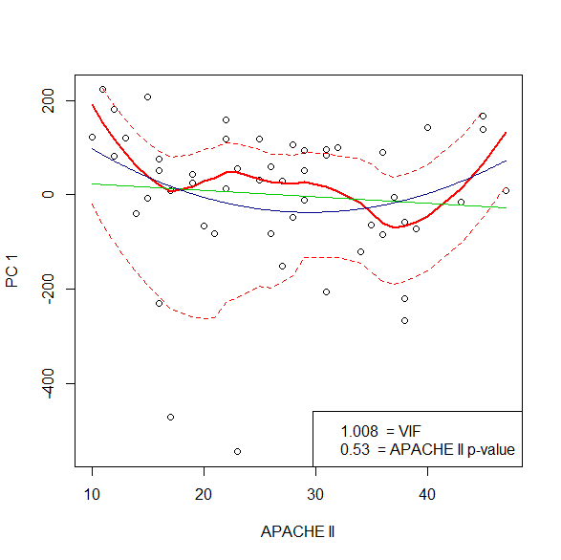

The green curve represents the bivariate regression equation (p_{apache} = 0.53); the blue curve represents the quadratic regression equation (p_{apache} = 0.08, p_{apache−squared} = 0.09), and the red curve is the LOESS smoothing curve.

eTable 3: Results of post hoc sensitivity analyses using exact logistic regression for vasopressor independence and 28-day all-cause mortality.
Outcome | Model | OR_{PC1} | 95% CI_{PC1}
Vasopressor independence | Primary | 1.14 | (0.89 to 1.66)
Vasopressor independence | First ancillary | 1.02 | (0.93 to 1.13)
Vasopressor independence | Second ancillary | 1.02 | (0.91 to 1.14)
Vasopressor independence | Third ancillary | 0.99 | (0.89 to 1.11)
28-day mortality | Primary | 1.21 | (0.85 to 4.62)
28-day mortality | First ancillary | 1.26 | (1.05 to 1.79)
28-day mortality | Second ancillary | 0.83 | (0.42 to 1.30)
28-day mortality | Third ancillary | 1.30 | (1.01 to 1.97)
First ancillary analysis: univariate analysis of PC₁ vs. outcome; second ancillary analysis: bivariate analysis of PC₁ and APACHE II vs. outcome; third ancillary analysis: bivariate analysis of PC₁ and vasopressor dose (in norepinephrine equivalent doses).
Analyses in blue font differed (in terms of whether the confidence interval included unity) from the prespecified analyses that employed Firth logistic regression.

References

1. Huikuri HV, Seppanen T, Koistinen MJ, Airaksinen J, Ikaheimo MJ, Castellanos A, Myerburg RJ: Abnormalities in beat-to-beat dynamics of heart rate before the spontaneous onset of life-threatening ventricular tachyarrhythmias in patients with prior myocardial infarction. Circulation 1996, 93:1836-1844.

