Supplemental digital content to
“Intraoperative ventilator settings and their association with postoperative pulmonary complications in neurosurgical patients “

Contents

Page 3 Table S1. STROBE Statement checklist
Page 6 List of LAS VEGAS study Network Collaborators
Page 13 Table S2. a, b. Full list of participating centres
Page 17 Table S3. Hospital characteristics of participating centres
Page 18 Table S4. Definition of recruitment manoeuvres
Page 18 Table S5. Definition of postoperative pulmonary complications
Page 19 Table S6. Definition of intraoperative complications
Page 20 Table S7. Univariate and multivariate logistic regression
Page 23 Figure FC. Flow-chart of patient’s inclusion criteria
Page 24 Figure S1. Settings of different hourly intraoperative factors over time.
Page 26 Figure S2. Combinations of ventilator settings in patients undergoing brain or spine surgery.
Page 28 Figure S3. Combinations of ventilator settings in patients with ARISCAT<26 and ARISCAT ≥26.
Page 30 Figure S4. Kaplan Meier plots
Page 32 Figure S5, Interaction between type of neurosurgery and age continuous on PPC as outcome

Table S1. STROBE Statement checklist
 | Item No. | Recommendation | Page  No.
Title and abstract | 1 | (a) Indicate the study’s design with a commonly used term in the title or the abstract | 1
Title and abstract | 1 | (b) Provide in the abstract an informative and balanced summary of what was done and what was found | 3
Introduction
Background/rationale | 2 | Explain the scientific background and rationale for the investigation being reported | 4
Objectives | 3 | State specific objectives, including any pre–specified hypotheses | 4
Methods
Study design | 4 | Present key elements of study design early in the paper | 5
Setting | 5 | Describe the setting, locations, and relevant dates, including periods of recruitment, exposure, follow-up, and data collection | 5
Participants | 6 | (a) Cohort study—Give the eligibility criteria, and the sources and methods of selection of participants. Describe methods of follow-up | 5
Participants | 6 | (b) Cohort study—For matched studies, give matching criteria and number of exposed and unexposed | NA
Variables | 7 | Clearly define all outcomes, exposures, predictors, potential confounders, and effect modifiers. Give diagnostic criteria, if applicable | 5
Data sources/ measurement | 8* | For each variable of interest, give sources of data and details of methods of assessment (measurement). Describe comparability of assessment methods if there is more than one group | 6
Bias | 9 | Describe any efforts to address potential sources of bias | 6
Study size | 10 | Explain how the study size was arrived at | 6
Continued on next page
Quantitative variables | 11 | Explain how quantitative variables were handled in the analyses. If applicable, describe which groupings were chosen and why | 6
Statistical methods | 12 | (a) Describe all statistical methods, including those used to control for confounding | 7
Statistical methods | 12 | (b) Describe any methods used to examine subgroups and interactions | 7
Statistical methods | 12 | (c) Explain how missing data were addressed | 7
Statistical methods | 12 | (d) Cohort study—If applicable, explain how loss to follow-up was addressed | 7
Statistical methods | 12 | (e) Describe any sensitivity analyses | 7
Participants | 13* | (a) Report numbers of individuals at each stage of study—e.g. numbers potentially eligible, examined for eligibility, confirmed eligible, included in the study, completing follow-up, and analysed | 6
Participants | 13* | (b) Give reasons for non-participation at each stage | 6
Participants | 13* | (c) Consider use of a flow diagram | 6
Descriptive data | 14* | (a) Give characteristics of study participants (e.g. demographic, clinical, social) and information on exposures and potential confounders | 6
Descriptive data | 14* | (b) Indicate number of participants with missing data for each variable of interest | NA
Descriptive data | 14* | (c) Cohort study—Summarise follow-up time (e.g., average and total amount) | NA
Outcome data | 15* | Cohort study—Report numbers of outcome events or summary measures over time | 7
Main results | 16 | (a) Give unadjusted estimates and, if applicable, confounder-adjusted estimates and their precision (e.g., 95% confidence interval). Make clear which confounders were adjusted for and why they were included | 8-9
Main results | 16 | (b) Report category boundaries when continuous variables were categorized | 8-9
Main results | 16 | (c) If relevant, consider translating estimates of relative risk into absolute risk for a meaningful time period | 8-9
Continued on next page
Other analyses | 17 | Report other analyses done - e.g. analyses of subgroups and interactions, and sensitivity analyses | NA
Discussion
Key results | 18 | Summarise key results with reference to study objectives | 9,10
Limitations | 19 | Discuss limitations of the study, taking into account sources of potential bias or imprecision. Discuss both direction and magnitude of any potential bias | 15
Interpretation | 20 | Give a cautious overall interpretation of results considering objectives, limitations, multiplicity of analyses, results from similar studies, and other relevant evidence | 10-14
Generalizability | 21 | Discuss the generalizability (external validity) of the study results | 11-14
Other information
Funding | 22 | Give the source of funding and the role of the funders for the present study and, if applicable, for the original study on which the present article is based | 2

Table S2 a. List of LAS VEGAS study Network Collaborators
Austria
LKH Graz, Graz: Wolfgang Kroell, Helfried Metzler, Gerd Struber, Thomas Wegscheider
AKH Linz, Linz: Hans Gombotz
Medical University Vienna: Michael Hiesmayr, Werner Schmid, Bernhard Urbanek

Belgium
UCL - Cliniques Universitaires Saint Luc Brussels: David Kahn, Mona Momeni, Audrey Pospiech, Fernande Lois, Patrice Forget, Irina Grosu
Universitary Hospital Brussels (UZ Brussel): Jan Poelaert, Veerle van Mossevelde, Marie-Claire van Malderen
Het Ziekenhuis Oost Limburg (ZOL), Genk: Dimitri Dylst, Jeroen van Melkebeek, Maud Beran
Ghent University Hospital, Gent: Stefan de Hert, Luc De Baerdemaeker, Bjorn Heyse, Jurgen Van Limmen, Piet Wyffels, Tom Jacobs, Nathalie Roels, Ann De Bruyne
Maria Middelares, Gent: Stijn van de Velde
European Society of Anaesthesiology, Brussels: Brigitte Leva, Sandrine Damster, Benoit Plichon

Bosnia and Herzegovina
General Hospital “prim Dr Abdulah Nakas” Sarajevo: Marina Juros-Zovko, Dejana Djonoviċ- Omanoviċ

Croatia
General Hospital Cakovec, Cakovec: Selma Pernar
General Hospital Karlovac, Karlovac: Josip Zunic, Petar Miskovic, Antonio Zilic
University Clinical Hospital Osijek, Osijek: Slavica Kvolik, Dubravka Ivic, Darija Azenic-Venzera, Sonja Skiljic, Hrvoje Vinkovic, Ivana Oputric
University Hospital Rijeka, Rijeka: Kazimir Juricic, Vedran Frkovic
General Hospital Dr J Bencevic, Slavonski Brod: Jasminka Kopic, Ivan Mirkovic
University Hospital Center Split, Split: Nenad Karanovic, Mladen Carev, Natasa Dropulic
University Hospital Merkur, Zagreb: Jadranka Pavicic Saric, Gorjana Erceg, Matea Bogdanovic Dvorscak
University Hospital Sveti Duh, Zagreb: Branka Mazul-Sunko, Anna Marija Pavicic, Tanja Goranovic
University Hospital, Medical school, “Sestre milosrdnice” (Sister of Charity), Zagreb: Branka Maldini, Tomislav Radocaj, Zeljka Gavranovic, Inga Mladic-Batinica, Mirna Sehovic

Czech Republic
University Hospital Brno, Brno: Petr Stourac, Hana Harazim, Olga Smekalova, Martina Kosinova, Tomas Kolacek, Kamil Hudacek, Michal Drab
University Hospital Hradec Kralove, Hradec Kralove: Jan Brujevic, Katerina Vitkova, Katerina Jirmanova
University Hospital Ostrava, Ostrava: Ivana Volfova, Paula Dzurnakova, Katarina Liskova
Nemocnice Znojmo, Znojmo: Radovan Dudas, Radek Filipsky

Egypt
El Sahel Teaching hospital, Cairo: Samir el Kafrawy
Kasr Al-Ainy Medical School, Cairo University: Hisham Hosny Abdelwahab, Tarek Metwally, Ahmed Abdel-Razek
Beni Sueif University Hospital, Giza: Ahmed Mostafa El-Shaarawy, Wael Fathy Hasan, Ahmed Gouda Ahmed
Fayoum University Hospital, Giza: Hany Yassin, Mohamed Magdy, Mahdy Abdelhady
Suis medical Insurance Hospital, Suis: Mohamed Mahran

Estonia
North Estonia Medical Center, Tallinn: Eiko Herodes, Peeter Kivik, Juri Oganjan, Annika Aun
Tartu University Hospital, Tartu: Alar Sormus, Kaili Sarapuu, Merilin Mall, Juri Karjagin

France
University Hospital of Clermont-Ferrand, Clermont-Ferrand: Emmanuel Futier, Antoine Petit, Adeline Gerard
Institut Hospitalier Franco-Britannique, Levallois-Perret: Emmanuel Marret, Marc Solier
Saint Eloi University Hospital, Montpellier: Samir Jaber, Albert Prades

Germany
Fachkrankenhaus Coswig, Coswig: Jens Krassler, Simone Merzky
University Hospital Carl Gustav Carus, Dresden: Marcel Gama de Abreu, Christopher Uhlig,
Thomas Kiss, Anette Bundy, Thomas Bluth, Andreas Gueldner, Peter Spieth, Martin Scharffenberg, Denny Tran Thiem, Thea Koch
Duesseldorf University Hospital, Heinrich-Heine University: Tanja Treschan, Maximilian Schaefer,
Bea Bastin, Johann Geib, Martin Weiss, Peter Kienbaum, Benedikt Pannen
Diakoniekrankenhaus Friederikenstift, Hannover: Andre Gottschalk, Mirja Konrad, Diana Westerheide, Ben Schwertfeger
University of Leipzig, Leipzig: Hermann Wrigge, Philipp Simon, Andreas Reske, Christian Nestler

Greece
“Alexandra” general hospital of Athens, Athens: Dimitrios Valsamidis, Konstantinos Stroumpoulis
General air force hospital, Athens: Georgios Anthopoulos, Antonis Andreaou, Dimitris Karapanos
Aretaieion University Hospital, Athens: Kassiani Theodorak, Georgios Gkiokas, Marios-Konstantinos Ttasoulis
Attikon University Hospital, Athens: Tatiana Sidiropoulou, Foteini Zafeiropoulou, Panagiota Florou, Aggeliki Pandazi
Ahepa University Hospital Thessaloniki, Thessaloniki: Georgia Tsaousi, Christos Nouris, Chryssa Pourzitaki,

Israel
The Lady Davis Carmel Medical Center, Haifa: Dmitri Bystritski, Reuven Pizov, Arieh Eden

Italy
Ospedale San. Paolo Bari, Bari: Caterina Valeria Pesce, Annamaria Campanile, Antonella Marrella
University of Bari “Aldo Moro”, Bari: Salvatore Grasso, Michele De Michele
Institute for Cancer Research and treatment, Candiolo, Turin: Francesco Bona, Gianmarco Giacoletto, Elena Sardo
Azienda Ospedaliera per l’emergenza Cannizzaro, Catania: Luigi Giancarlo Vicari Sottosanti
Ospedale Melegnano, Cernuso, Milano: Maurizio Solca
Azienda Ospedaliera – Universitaria Sant’Anna, Ferrara: Carlo Alberto Volta, Savino Spadaro, Marco Verri, Riccardo Ragazzi, Roberto Zoppellari
Ospedali Riuniti Di Foggia - University of Foggia, Foggia: Gilda Cinnella, Pasquale Raimondo, Daniela La Bella, Lucia Mirabella, Davide D'antini
IRCCS AOU San Martino IST Hospital, University of Genoa, Genoa: Paolo Pelosi, Alexandre Molin, Iole Brunetti, Angelo Gratarola, Giulia Pellerano, Rosanna Sileo, Stefano Pezzato, Luca Montagnani
IRCCS San Raffaele Scientific Institute, Milano: Laura Pasin, Giovanni Landoni, Alberto Zangrillo, Luigi Beretta, Ambra Licia Di Parma, Valentina Tarzia, Roberto Dossi, Marta Eugenia Sassone
Istituto europeo di oncologia – ieo, Milano: Daniele Sances, Stefano Tredici, Gianluca Spano, Gianluca Castellani, Luigi Delunas, Sopio Peradze, Marco Venturino
Ospedale Niguarda Ca'Granda Milano, Milano: Ines Arpino, Sara Sher
Ospedale San Paolo - University of Milano, Milano: Concezione Tommasino, Francesca Rapido, Paola Morelli
University of Naples “Federico II” Naples: Maria Vargas, Giuseppe Servillo
Policlinico "P. Giaccone", Palermo: Andrea Cortegiani, Santi Maurizio Raineri, Francesca Montalto, Vincenzo Russotto, Antonino Giarratano
Azienda Ospedaliero-Universitaria, Parma: Marco Baciarello, Michela Generali, Giorgia Cerati
Santa Maria degli Angeli, Pordenone: Yigal Leykin
Ospedale Misericordia e Dolce - Usl4 Prato, Prato: Filippo Bressan, Vittoria Bartolini, Lucia Zamidei
University hospital of Sassari, Sassari: Luca Brazzi, Corrado Liperi, Gabriele Sales, Laura Pistidda
Insubria University, Varese: Paolo Severgnini, Elisa Brugnoni, Giuseppe Musella, Alessandro Bacuzzi

Republic of Kosovo
Distric hospital Gjakova, Gjakove: Dalip Muhardri
University Clinical Center of Kosova, Prishtina: Agreta Gecaj-Gashi, Fatos Sada
Regional Hospital ”Prim.Dr. Daut Mustafa”, Prizren: Adem Bytyqi

Lithuania
Medical University Hospital, Hospital of Lithuanian University of Health Sciences, Kaunas: Aurika Karbonskiene, Ruta Aukstakalniene, Zivile Teberaite, Erika Salciute
Vilnius University Hospital - Institute of Oncology, Vilnius: Renatas Tikuisis, Povilas Miliauskas
Vilnius University Hospital - Santariskiu Clinics, Vilnius: Sipylaite Jurate, Egle Kontrimaviciute, Gabija Tomkute

Malta
Mater Dei Hospital, Msida: John Xuereb, Maureen Bezzina, Francis Joseph Borg

Netherlands
Academic Medical Centre, University of Amsterdam: Sabrine Hemmes, Marcus Schultz, Markus Hollmann, Irene Wiersma, Jan Binnekade, Lieuwe Bos
VU University Medical Center, Amsterdam: Christa Boer, Anne Duvekot
MC Haaglanden, Den Haag: Bas in ‘t Veld, Alice Werger, Paul Dennesen, Charlotte Severijns
Westfriesgasthuis, Hoorn: Jasper De Jong, Jens Hering, Rienk van Beek

Norway
Haukeland University Hospital, Bergen: Stefan Ivars, Ib Jammer
Førde Central Hospital /Førde Sentral Sykehus, Førde: Alena Breidablik
Martina Hansens Hospital, Gjettum: Katharina Skirstad Hodt, Frode Fjellanger, Manuel Vico Avalos
Bærum Hospital, Vestre Viken, Rud: Jannicke Mellin-Olsen, Elisabeth Andersson
Stavanger University Hospital, Stavanger: Amir Shafi-Kabiri

Panama
Hospital Santo Tomás, Panama: Ruby Molina, Stanley Wutai, Erick Morais

Portugal
Hospital do Espírito Santo - Évora, E.P.E, Évora.: Glória Tareco, Daniel Ferreira, Joana Amaral
Centro Hospitalar de Lisboa Central, E.P.E, Lisboa.: Maria de Lurdes Goncalves Castro, Susana Cadilha, Sofia Appleton
Centro Hospitalar de Lisboa Ocidental, E.P.E. Hospital de S. Francisco Xavier, Lisboa: Suzana Parente, Mariana Correia, Diogo Martins
Santarem Hospital, Santarem: Angela Monteirosa, Ana Ricardo, Sara Rodrigues

Romania
Spital Orasenesc, Bolintin Vale: Lucian Horhota
Clinical Emergency Hospital of Bucharest, Bucharest: Ioana Marina Grintescu, Liliana Mirea, Ioana Cristina Grintescu
Elias University Emergency Hospital, Bucharest: Dan Corneci, Silvius Negoita, Madalina Dutu, Ioana Popescu Garotescu
Emergency Institute of Cardiovascular Diseases Inst. ''Prof. C. C. Iliescu'', Bucharest: Daniela Filipescu, Alexandru Bogdan Prodan
Fundeni Clinical institute - Anaesthesia and Intensive Care, Bucharest: Gabriela Droc, Ruxandra Fota, Mihai Popescu
Fundeni Clinical institute - Intensive Care Unit, Bucharest: Dana Tomescu, Ana Maria Petcu, Marian Irinel Tudoroiu
Hospital Profesor D Gerota, Bucharest: Alida Moise, Catalin-Traian Guran
Constanta County Emergency Hospital, Constanta: Iorel Gherghina, Dan Costea, Iulia Cindea
University Emergency County Hospital Targu Mures, Targu Mures: Sanda-Maria Copotoiu, Ruxandra Copotoiu, Victoria Barsan, Zsolt Tolcser, Magda Riciu, Gheorghe Moldovan Septimiu, Mihaly Veres

Russia
Krasnoyarsk State Medical University, Krasnoyarsk: Alexey Gritsan, Tatyana Kapkan, Galina Gritsan, Oleg Korolkov
Burdenko Neurosurgery Institute, Moscow: Alexander Kulikov, Andrey Lubnin
Moscow Regional Research Clinical Institute, Moscow: Alexey Ovezov, Pavel Prokoshev, Alexander Lugovoy, Natalia Anipchenko
Municipal Clinical Hospital 7, Moscow: Andrey Babayants, Irina Komissarova, Karginova Zalina
Reanimatology Research Institute n.a. Negovskij RAMS, Moscow: Valery Likhvantsev, Sergei Fedorov

Serbia
Clinical Center of Vojvodina, Emergency Center, Novisad: Aleksandra Lazukic, Jasmina Pejakovic, Dunja Mihajlovic

Slovakia
National Cancer Institute, Bratislava: Zuzana Kusnierikova, Maria Zelinkova
F.D. Roosevelt teaching Hospital, Banská Bystrica: Katarina Bruncakova, Lenka Polakovicova
Faculty Hospital Nové Zámky, Nové Zámky: Villiam Sobona

Slovenia
Institute of Oncology Ljubljana, Ljubljana: Barbka Novak-Supe, Ana Pekle-Golez, Miroljub Jovanov, Branka Strazisar
University Medical Centre Ljubljana, Ljubljana: Jasmina Markovic-Bozic, Vesna Novak-Jankovic, Minca Voje, Andriy Grynyuk, Ivan Kostadinov, Alenka Spindler-Vesel

Spain
Hospital Sant Pau, Barcelona: Victoria Moral, Mari Carmen Unzueta, Carlos Puigbo, Josep Fava
Hospital Universitari Germans Trias I Pujol, Barcelona: Jaume Canet, Enrique Moret, Mónica Rodriguez Nunez, Mar Sendra, Andrea Brunelli, Frederic Rodenas
University of Navarra, Pamplona: Pablo Monedero, Francisco Hidalgo Martinez, Maria Jose Yepes Temino, Antonio Martínez Simon, Ana de Abajo Larriba
Corporacion Sanitaria Parc Tauli, Sabadell: Alberto Lisi, Gisela Perez, Raquel Martinez
Consorcio Hospital General Universitario de Valencia, Valencia: Manuel Granell, Jose Tatay Vivo, Cristina Saiz Ruiz, Jose Antonio de Andrés Ibañez
Hospital Clinico Valencia, Valencia: Ernesto Pastor, Marina Soro, Carlos Ferrando, Mario Defez
Hospital Universitario Rio Hortega, Valladolid: Cesar Aldecoa Alvares-Santullano, Rocio Perez, Jesus Rico

Sweden
Central Hospital in Kristianstad: Monir Jawad, Yousif Saeed, Lars Gillberg

Turkey
Ufuk University Hospital Ankara, Ankara: Zuleyha Kazak Bengisun, Baturay Kansu Kazbek
Akdeniz University Hospital, Antalya: Nesil Coskunfirat, Neval Boztug, Suat Sanli, Murat Yilmaz, Necmiye Hadimioglu
Istanbul University, Istanbul medical faculty, Istanbul: Nuzhet Mert Senturk, Emre Camci, Semra Kucukgoncu, Zerrin Sungur, Nukhet Sivrikoz
Acibadem University, Istanbul: Serpil Ustalar Ozgen, Fevzi Toraman
Maltepe University, Istanbul: Onur Selvi, Ozgur Senturk, Mine Yildiz
Dokuz Eylül Universitesi Tip Fakültesi, Izmir: Bahar Kuvaki, Ferim Gunenc, Semih Kucukguclu, Şule Ozbilgin
Şifa University Hospital, İzmir: Jale Maral, Seyda Canli
Selcuk University faculty of medicine, Konya: Oguzhan Arun, Ali Saltali, Eyup Aydogan
Fatih Sultan Mehmet Eğitim Ve Araştirma Hastanesi, Istanbul: Fatma Nur Akgun, Ceren Sanlikarip, Fatma Mine Karaman

Ukraine
Institute Of Surgery And Transplantology, Kiev: Andriy Mazur
Zaporizhzhia State Medical University, Zaporizhzhia: Sergiy Vorotyntsev

United Kingdom
SWARM Research Collaborative: for full list of SWARM contributors please see www.ukswarm.com
Northern Devon Healthcare NHS Trust, Barnstaple: Guy Rousseau, Colin Barrett, Lucia Stancombe
Golden Jubilee National Hospital, Clydebank, Scotland: Ben Shelley, Helen Scholes
Darlington Memorial Hospital, County Durham and Darlington Foundation NHS Trust, Darlington: James Limb, Amir Rafi, Lisa Wayman, Jill Deane
Royal Derby Hospital, Derby: David Rogerson, John Williams, Susan Yates, Elaine Rogers
Dorset County Hospital, Dorchester: Mark Pulletz, Sarah Moreton, Stephanie Jones
The Princess Alexandra NHS Hospital Trust, Essex: Suresh Venkatesh, Maudrian Burton, Lucy Brown, Cait Goodall
Royal Devon and Exeter NHS Foundation Trust, Exeter: Matthew Rucklidge, Debbie Fuller, Maria Nadolski, Sandeep Kusre
Hospital James Paget University Hospital NHS Foundation Trust, Great Yarmouth: Michael Lundberg, Lynn Everett, Helen Nutt
Royal Surrey County Hospital NHS Foundation Trust, Guildford: Maka Zuleika, Peter Carvalho, Deborah Clements, Ben Creagh-Brown
Kettering General Hospital NHS Foundation Trust, Kettering: Philip Watt, Parizade Raymode
Barts Health NHS Trust, Royal London Hospital, London: Rupert Pearse, Otto Mohr, Ashok Raj, Thais Creary
Newcastle Upon Tyne Hospitals NHS Trust The Freeman Hospital High Heaton, Newcastle upon Tyne: Ahmed Chishti, Andrea Bell, Charley Higham, Alistair Cain, Sarah Gibb, Stephen Mowat
Derriford Hospital Plymouth Hospitals NHS Trust, Plymouth: Danielle Franklin, Claire West, Gary Minto, Nicholas Boyd
Royal Hallamshire Hospital, Sheffield: Gary Mills, Emily Calton, Rachel Walker, Felicity Mackenzie, Branwen Ellison, Helen Roberts
Mid Staffordshire NHS, Stafford: Moses Chikungwa, Clare Jackson
Musgrove Park Hospital, Taunton: Andrew Donovan, Jayne Foot, Elizabeth Homan
South Devon Healthcare NHS Foundation Trust /Torbay Hospital, Torquay, Torbay: Jane Montgomery, David Portch, Pauline Mercer, Janet Palme
Royal Cornwall Hospital, Truro: Jonathan Paddle, Anna Fouracres, Amanda Datson, Alyson Andrew, Leanne Welch
Mid Yorkshire Hospitals NHS Trust; Pinderfields Hospital, Wakefield: Alastair Rose, Sandeep Varma, Karen Simeson
Sandwell and West Birmingham NHS Trust, West Bromich: Mrutyunjaya Rambhatla, Jaysimha Susarla, Sudhakar Marri, Krishnan Kodaganallur, Ashok Das, Shivarajan Algarsamy, Julie Colley
York Teaching Hospitals NHS Foundation Trust, York: Simon Davies, Margaret Szewczyk, Thomas Smith

United States
University of Colorado School of Medicine/University of Colorado Hospital, Aurora: Ana Fernandez- Bustamante, Elizabeth Luzier, Angela Almagro
Massachusetts General Hospital, Boston: Marcos Vidal Melo, Luiz Fernando, Demet Sulemanji
Mayo Clinic, Rochester: Juraj Sprung, Toby Weingarten, Daryl Kor, Federica Scavonetto, Yeo Tze

Table S2 b. Full list of participating centres
Country | City | Institution | # Patients
Austria | Graz | LKH Graz | 51
Austria | Linz | AKH Linz | 40
Austria | Vienna | Medical University Vienna | 34
Belgium | Brussels | UCL - Cliniques Universitaires Saint Luc Brussels | 119
Belgium | Brussels | Universitary Hospital Brussels (UZ Brussel) | 27
Belgium | Genk | Het ZOL (Ziekenhuis Oost Limburg) | 65
Belgium | Gent | Ghent University Hospital | 154
Belgium | Gent | Maria Middelares Gent | 10
Bosnia and Herzegovina | Sarajevo | General Hospital “prim Dr Abdulah Nakas” Sarajevo | 48
Croatia | Cakovec | General Hospital Čakovec | 40
Croatia | Karlovac | General Hospital Karlovac | 28
Croatia | Osijek | University Clinical Hospital Osijek | 125
Croatia | RIJEKA | University Hospital Rijeka | 53
Croatia | Slavonski Brod | General Hospital Dr J Bencevic | 46
Croatia | Split | University Hospital Center Split | 96
Croatia | Zagreb | University Hospital Merkur | 48
Croatia | Zagreb | University Hospital Sveti Duh | 59
Croatia | Zagreb | University Hospital, Medical school, “Sestre milosrdnice” (Sister of Charity) | 85
Czech Republic | Brno | University Hospital Brno | 149
Czech Republic | Hradec Kralove | University Hospital Hradec Kralove | 82
Czech Republic | Ostrava | University Hospital Ostrava | 102
Czech Republic | Znojmo | Nemocnice Znojmo, p.o. | 62
Egypt | Cairo | El Sahel Teaching hospital | 62
Egypt | Cairo | Kasr Al-Ainy Medical School, Cairo University | 38
Egypt | Giza | Beni Sueif University Hospital | 42
Egypt | Giza | Fayoum University Hospital | 49
Egypt | Suis | Suis medical Insurance Hospital | 48
Estonia | Tallinn | North Estonia Medical Center | 164
Estonia | Tartu | Tartu University Hospital | 80
France | Clermont-Ferrand | Estaing Hospital, University Hospital of Clermont-Ferrand | 30
France | Levallois-Perret | Institut Hospitalier Franco-Britannique | 21
France | Montpellier | Saint Eloi University Hospital, Montpellier | 140
Germany | Coswig | Fachkrankenhaus Coswig Gmbh, centre for pneumology and thoracic surgery | 10
Germany | Dresden | University Hospital Carl Gustav Carus | 219
Germany | Duesseldorf | Duesseldorf University Hospital, Heinrich-Heine University | 129
Germany | Hannover | Diakoniekrankenhaus Friederikenstift | 133
Germany | Leipzig | University of Leipzig | 71
Greece | Athens | “Alexandra” general hospital of Athens | 43
Greece | Athens | 251 General air force hospital | 41
Greece | Athens | Aretaieion University Hospital | 41
Greece | Athens | Attikon University Hospital | 54
Greece | Thessaloniki | Ahepa University Hospital Thessaloniki | 50
Israel | Haifa | The Lady Davis Carmel Medical Center | 40
Italy | Bari | Ospedale San. Paolo Bari | 35
Italy | Bari | University of Bari “Aldo Moro” | 81
Italy | Candiolo (Turin) | Institute for Cancer Research and treatment | 28
Italy | Catania | Azienda Ospedaliera per l’emergenza Cannizzaro | 39
Italy | Cernuso (Milano) | Ospedale Melegnano | 5
Italy | Ferrara | Azienda Ospedaliera – Universitaria Sant’Anna (Ferrara) | 88
Italy | Foggia | Ospedali Riuniti Di Foggia - University of Foggia | 85
Italy | Genoa | IRCCS San Martino AOU IST Hospital, University of Genoa | 173
Italy | Milano | IRCCS San Raffaele Scientific Institute | 156
Italy | Milano | Istituto europeo di oncologia - ieo | 131
Italy | Milano | Ospedale Niguarda Ca'Granda Milano | 19
Italy | Milano | Ospedale San Paolo - University of Milano | 46
Italy | Naples | University of Naples “Federico II” | 57
Italy | Palermo | Policlinico "P. Giaccone" | 92
Italy | Parma | Azienda Ospedaliero-Universitaria | 81
Italy | Pordenone | Santa Maria degli Angeli | 18
Italy | Prato | Ospedale Misericordia e Dolce - Usl4 Prato | 41
Italy | Sassari | University hospital of Sassari | 54
Italy | Varese | Insubria University | 125
Lithuania | Kaunas | Kaunas Medical University Hospital, Hospital of Lithuanian University of Health Sciences | 160
Lithuania | Vilnius | Vilnius University Hospital - Institute of Oncology | 108
Lithuania | Vilnius | Vilnius University Hospital - Santariskiu Clinics | 104
Malta | Msida | Mater Dei Hospital | 27
Netherlands | Amsterdam | Academic Medical Center, University of Amsterdam | 183
Netherlands | Amsterdam | VU University Medical Center | 104
Netherlands | Den Haag | MC Haaglanden | 94
Netherlands | Hoorn | Westfriesgasthuis | 104
Norway | Bergen | Haukeland University Hospital | 106
Norway | Førde | Førde Central Hospital /Førde Sentral Sykehus | 58
Norway | Gjettum | Martina Hansens Hospital | 57
Norway | Rud | Bærum Hospital, Vestre Viken | 57
Norway | Stavanger | Stavanger University Hospital | 70
Panama | Panama | Hospital Santo Tomás | 40
Portugal | Évora | Hospital do Espírito Santo - Évora, EPE. | 55
Portugal | Lisboa | Centro Hospitalar de Lisboa Central, EPE | 49
Portugal | Lisboa | Centro Hospitalar de Lisboa Ocidental, EPE | 41
Portugal | Santarem | Santarem Hospital | 44
Republic of Kosovo | Gjakovë | Distric hospital Gjakova | 9
Republic of Kosovo | Prishtina | University Clinical Center of Kosova | 92
Republic of Kosovo | Prizren | Regional Hospital ”Prim.Dr. Daut Mustafa” | 39
Romania | Bolintin Vale | Spital orasenesc Bolintin Vale | 8
Romania | Bucharest | Clinical Emergency Hospital of Bucharest | 58
Romania | Bucharest | Elias University Emergency Hospital | 53
Romania | Bucharest | Emergency Institute of Cardiovascular Diseases Inst. ''Prof. C. C. Iliescu'' | 6
Romania | Bucharest | Fundeni Clinical institute - Anaesthesia and Intensive Care | 43
Romania | Bucharest | Fundeni Clinical institute - Intensive Care Unit | 40
Romania | Bucharest | Hospital Profesor D Gerota | 21
Romania | Constanta | Constanta County Emergency Hospital | 73
Romania | Targu Mures | University Emergency County Hospital Targu Mures | 138
Russia | Krasnoyarsk | Krasnoyarsk State Medical University | 52
Russia | Moscow | Burdenko Neurosurgery Institute | 60
Russia | Moscow | Moscow Regional Research Clinical Institute | 59
Russia | Moscow | Municipal Clinical Hospital 7 | 49
Russia | Moscow | Reanimatology Research Institute n.a. Negovskij RAMS | 61
Serbia | Novisad | Clinical Center of Vojvodina, Emergency Center | 42
Slovakia | Bratislava | National Cancer Institute | 18
Slovakia | Banská Bystrica | F.D.Roosevelt teaching Hospital | 64
Slovakia | Nové Zámky | Faculty Hospital Nove Zamky | 47
Slovenia | Ljubljana | Institute of Oncology Ljubljana | 64
Slovenia | Ljubljana | University Medical Centre Ljubljana | 108
Spain | Barcelona | Hospital Sant Pau | 73
Spain | Barcelona | Hospital Universitari Germans Trias I Pujol | 103
Spain | Pamplona | University of Navarra | 90
Spain | Sabadell | Corporacion Sanitaria Parc Tauli | 66
Spain | Valencia | Consorcio Hospital General Universitario de Valencia | 61
Spain | Valencia | Hospital Clinico Valencia | 62
Spain | Valladolid | Hospital Universitario Rio Hortega | 82
Sweden | Kristianstad | Central Hospital in Kristianstad | 83
Turkey | Ankara | Ufuk University Hospital Ankara | 30
Turkey | Antalya | Akdeniz University Hospital | 165
Turkey | Istanbul | Istanbul university, Istanbul medical faculty | 81
Turkey | Istanbul | Acibadem University | 25
Turkey | Istanbul | Maltepe University | 37
Turkey | Izmir | Dokuz Eylül Universitesi Tip Fakültesi | 161
Turkey | Izmir | Şifa University Hospital / İzmir | 74
Turkey | Konya | Selcuk University faculty of medicine | 138
Turkey | Istanbul | Fatih Sultan Mehmet Eğitim Ve Araştirma Hastanesi | 53
Ukraine | Kiev | Institute Of Surgery And Transplantology | 17
Ukraine | Zaporizhzhia | Zaporizhzhia State Medical University | 18
United Kingdom | Barnstaple | Northern Devon Healthcare NHS Trust | 69
United Kingdom | Clydebank, Scotland | Golden Jubilee National Hospital | 67
United Kingdom | Darlington | Darlington Memorial Hospital, County Durham and Darlington Foundation NHS Trust | 54
United Kingdom | Derby | Royal Derby Hospital | 59
United Kingdom | Dorchester | Dorset County Hospital | 63
United Kingdom | Essex | The Princess Alexandra NHS Hospital Trust | 71
United Kingdom | Exeter | Royal Devon and Exeter NHS Foundation Trust | 123
United Kingdom | Great Yarmouth | Hospital James Paget University Hospital NHS Foundation Trust | 43
United Kingdom | Guildford | Royal Surrey County Hospital NHS Foundation Trust | 70
United Kingdom | Kettering | Kettering General Hospital NHS Foundation Trust | 40
United Kingdom | London | Barts Health NHS Trust, Royal London Hospital | 104
United Kingdom | Newcastle upon Tyne | Newcastle Upon Tyne Hospitals NHS Trust The Freeman Hospital High Heaton | 125
United Kingdom | Plymouth | Derriford Hospital Plymouth Hospitals NHS Trust | 179
United Kingdom | Sheffield | Royal Hallamshire Hospital | 103
United Kingdom | Stafford | Mid Staffordshire NHS | 28
United Kingdom | Taunton | Musgrove Park Hospital | 50
United Kingdom | Torquay, Torbay | South Devon Healthcare NHS Foundation Trust /Torbay Hospital, | 83
United Kingdom | Truro | Royal Cornwall Hospital | 81
United Kingdom | Wakefield | Mid Yorkshire Hospitals NHS Trust; Pinderfields Hospital | 65
United Kingdom | West Bromich | Sandwell and West Birmingham NHS Trust | 127
United Kingdom | York | York Teaching Hospitals NHS Foundation Trust | 81
United States | Aurora, Colorado | University of Colorado School of Medicine/University of Colorado Hospital | 56
United States | Boston | Massachusetts General Hospital, Boston | 120
United States | Rochester | Mayo Clinic | 200

Table S3. Hospital characteristics of participating centres
 |  | Centres responded (N = 145)
Community hospital |  | 33
Teaching hospital |  | 108
Number of hospital beds |  | 600 [400 – 960]
Number of ICU beds |  | 20 [11 – 35]
Number of operating theatres |  | 15 [9 -22]
Staff (anaesthesiologists) |  | 25 [12 – 40]
Invasive mechanical ventilation for surgery per week |  | 103 [60 – 200]
Surgical procedures
 | Abdominal surgery | 135 (93%)
 | Bariatric surgery | 66 (46%)
 | Cardiothoracic surgery | 71 (49%)
 | Endocrine surgery | 88 (61%)
 | Eye surgery | 97 (67%)
 | General surgery | 132 (91%)
 | Gynaecological surgery | 126 (87%)
 | Interventional neuroradiology | 56 (39%)
 | Neurosurgery | 82 (57%)
 | Oral and maxillofacial surgery | 96 (62%)
 | Orthopaedic surgery | 121 (83%)
 | Plastic surgery | 91 (63%)
 | Surgical oncology | 107 (74%)
 | Trauma surgery | 111 (77%)
 | Urology | 121 (83%)
 | Vascular surgery | 109 (75%)
Data are presented as median [QR] or N (%). One participating centre did not respond; ICU: intensive care unit

Table S4. Definition of recruitment manoeuvres
Type of recruitment manoeuvre | Definition
Bag squeezing | Sustained manual hyperinflation using balloon/bag
Ventilator | Transient stepwise increase in positive end expiratory pressure (PEEP) at constant tidal volume or transient stepwise increase in tidal volume at constant PEEP or inspiratory holds (continuous positive airway pressure (CPAP) applied for a fixed time) or any combination of the previous three
Rescue recruitment manoeuvre | Bag-squeezing or ventilator recruitment manoeuvre, and “unplanned recruitment manoeuvre” reported as intraoperative complication

Table S5. Definition of post-operative pulmonary complications (PPCs). Severe PPCs were defined as complications 2-5
Single PPC | Definition
1.Unplanned need for oxygen therapy | Supplemental O₂ therapy administered to correct hypoxemia, defined as SpO2 < 90% in room air or PaO₂ < 60 mmHg. This excludes oxygen administration given as a part of standard care, such as routine oxygen administration at the arrival in the PACU
2.Respiratory failure | SpO₂ < 90% in room air or PaO₂ < 60 mmHg with oxygen therapy, or need for non-invasive mechanical ventilation
3.Mechanical ventilation | Need for new invasive ventilation after surgery, or unexpected prolonged invasive ventilation after discharge from the operating room
4.Acute Distress Respiratory Syndrome | According to the Berlin definition
Pneumonia | Lung infiltrates at the chest X-ray or Computed Tomography, plus at least two among the following three criteria: fever > 38°C (100.4 °F), leucocytosis or leukopenia (WBC count > 12000 or <4000 cells/mm³), purulent secretions
5.Pneumothorax | Air in the pleural space without blood presence, as confirmed by chest X-ray

Table S6. Definition of intraoperative complications
Desaturation | Oxygen saturation, SpO₂ < 92%
Need for rescue recruitment manoeuvre | Ventilation strategies aimed at restoring aeration of the lungs
Need for ventilatory pressure reduction | Ventilation strategies aimed at lowering peak and/or plateau pressure
New onset of expiratory flow limitation | End-expiration expiratory flow higher than zero at the visual analysis of the flow curve
Hypotension | Systolic arterial pressure < 90 mmHg for at least 3 minutes
Need for vasoactive drugs | Use of vasoactive drugs to correct hypotension as previously defined
Arrhythmia | Defined as any new onset of atrial fibrillation, sustained ventricular tachycardia, supraventricular tachycardia, or ventricular fibrillation

Univariate models
Variables | OR | 95% CIs |  | P-value
Variables | OR | lower bound | upper bound | P-value
Age, per 10 years | 1.345 | 1.174 | 1.539 | 0.000
Gender | 1.238 | 0.780 | 1.964 | 0.364
BMI, per 5 kg/height² | 1.147 | 0.943 | 1.395 | 0.169
ASA, per 1 unit | 1.818 | 1.302 | 2.539 | 0.000
Smoker | 0.979 | 0.610 | 1.570 | 0.929
COPD | 1.846 | 0.784 | 4.348 | 0.161
Duration of anaesthesia, per 120 min | 1.452 | 1.196 | 1.762 | 0.000
Respiratory infection <30 days | 1.032 | 0.338 | 3.153 | 0.955
Total fluids, per 1000 ml | 1.264 | 1.088 | 1.469 | 0.002
Intraoperative complications
Desaturation | 4.043 | 1.303 | 12.550 | 0.016
Hypotension | 1.371 | 0.904 | 2.080 | 0.037
Use of vasoactive drugs | 1.982 | 0.922 | 4.261 | 0.080
Rescue Recruitment Manoeuvres Ventilator | 2.337 | 0.661 | 8.262 | 0.188
Ventilatory parameters
Driving pressure, per 5 cmH₂O | 1.014 | 0.713 | 1.441 | 0.940
PEEP, per 1 cmH₂O | 1.067 | 0.849 | 1.340 | 0.580
Tidal Volume mL/kg PBW | 0.959 | 0.905 | 1.016 | 0.159
Peak Pressure | 1.139 | 0.821 | 1.580 | 0.437
FiO₂ | 1.008 | 0.994 | 1.023 | 0.257
Flow limitation | 2.991 | 0.377 | 23.709 | 0.300
Routine Recruitment Manoeuvres Ventilator | 1.383 | 0.573 | 3.338 | 0.471
Type of neurosurgery | 1.500 | 0.871 | 2.585 | 0.144
ARISCAT risk score, per 1 unit | 1.037 | 1.020 | 1.053 | 0.000
ARISCAT risk score ≥ 26 | 2.661 | 1.674 | 4.230 | 0.000
Multivariate model
Predictors | OR | 95% CIs |  | P-value
Predictors | OR | lower bound | upper bound | P-value
Duration of anaesthesia, per 120 min | 1.295 | 1.067 | 1.572 | 0.009
Desaturation | 3.115 | 0.933 | 10.407 | 0.065
Hypotension | 3.014 | 0.912 | 10.313 | 0.085
ARISCAT risk score ≥ 26 | 1.675 | 0.978 | 2.869 | 0.060
Type of Neurosurgical procedure | 2.759 | 1.216 | 6.260 | 0.115
Age | 0.244 | 0.000 | 1197.249 | 0.745
Age according to type of Neurosurgical procedure | 0.000 | 0.000 | 0.189 | 0.031
Table S7. Univariate and multivariate logistic regression for the correlation of general intraoperative complications and ventilator parameters and the development of post pulmonary complications. Abbreviations: BMI, Body mass index; ASA, American Society of Anesthesiologists; COPD, chronic obstructive pulmonary disease; PEEP, positive end expiratory pressure; PBW, predicted body weight; FiO₂, Fraction of inspired oxygen; OR, odds ratio; CI, confidence interval.

ESM. Flowchart
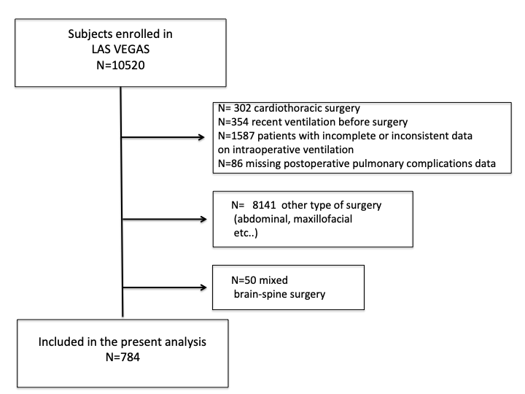
Figure S1. Settings of different hourly intraoperative factors over time. A, Positive End Expiratory Pressure (PEEP); B, inspired Fraction of Oxygen (FiO₂); C, Oxygen saturation (SpO₂); D, mean arterial pressure (MAP); E, Peak pressure (Ppeak); F, Tidal Volume (V_{T}); G, carbon dioxide (CO₂); H, respiratory rate (RR). T₀ represents the induction of general anaesthesia. Continuous line represents the spine group and dashed line represents the brain group.

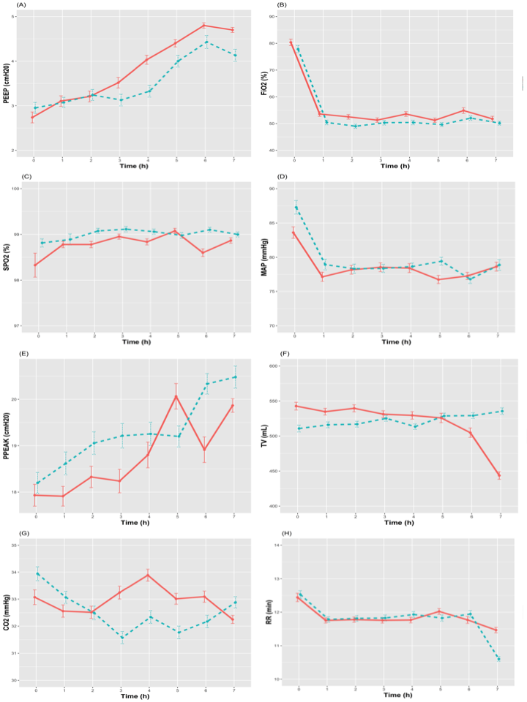
Figure S2. Combinations of ventilator settings in patients undergoing brain or spine surgery. Scatterplots showing distribution of tidal volume with positive end expiratory pressure combinations (upper left panel); tidal volume with Peak pressure (upper right panel); tidal volume with Driving pressure (lower left panel); tidal volume and respiratory rate (lower right panel). Scatter and the fitted line for each of the bivariate plots are shown in blue
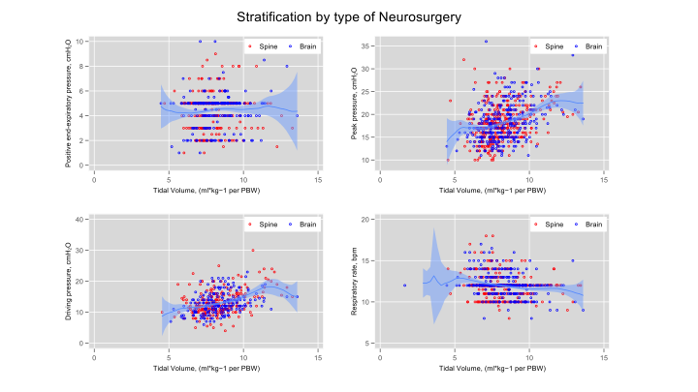
Figure S3.Combinations of ventilator settings in patients with ARISCAT<26 and ARISCAT ≥26. Scatterplots showing distribution of tidal volume with positive end expiratory pressure combinations (upper left panel); tidal volume with Peak pressure (upper right panel); tidal volume with Driving pressure (lower left panel); tidal volume and respiratory rate (lower right panel). Scatter and the fitted line for each of the bivariate plots are shown in blue
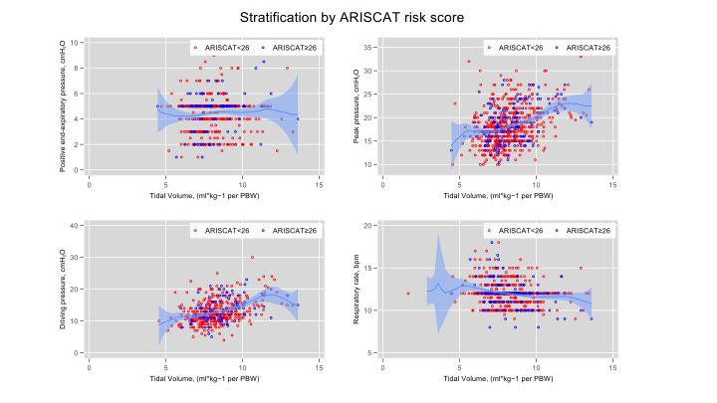

Figure S4. Kaplan-Meier plot for probability of hospital discharge and the occurrence of PPC over time for neurosurgical patients, stratified according to the type of surgery, and ARISCAT score. Test of equality Log Rank (Mantel-Cox) shows no statistical difference on length of stay and PPC occurrence between the type of surgery, but significant difference between patients with ARISCAT < 26 and ≥ 26.
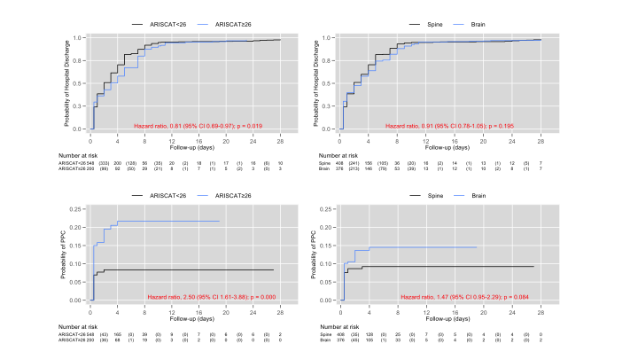

Figure S5. Interaction between type of neurosurgery and age continuous on PPC as outcome. This figure shows the delta log-odds - Brain minus spine surgery - per 1-unit change in age. Analysis adjusted by duration of anesthesia, desaturation, and ARISCAT risk score. By looking at the portion of the lower CI bound above the 0-line, we can conclude that the effect of age on PPC only becomes significant at age above 62. No effect between the two types of surgery was demonstrated below age 62.

