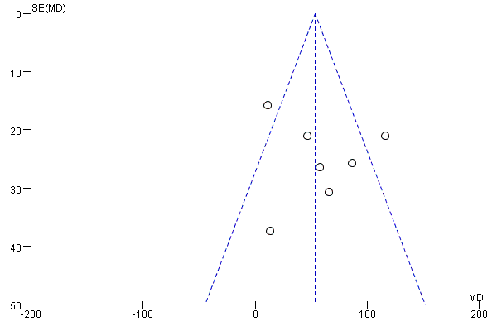
S1: Funnel plot of PaO₂

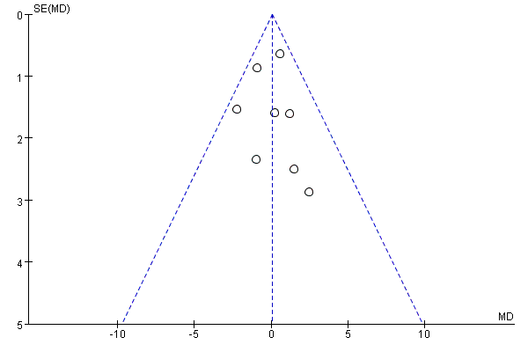
S2: Funnel plot of CO₂ accumulation.

