Supplemental material
APPENDIX 1: Supplemental Methods
We used the Dutch version “Questionnaire hypoesthesia”

- Do you currently have of have you had a numbness, dull feeling or tingling around the adrenal gland removal surgery area?

- Yes
- No
- Please indicate (with a cross mark) on the drawing below where you have or have had a numb feeling?

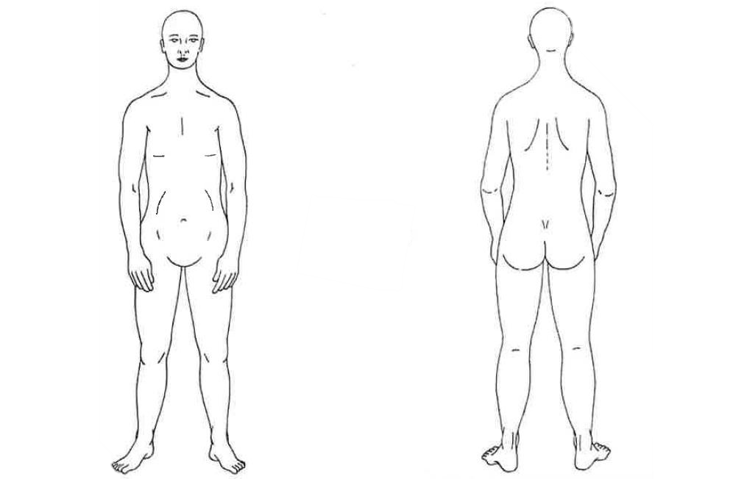

Below you will find a number of questions about the numbness that bothers you. If you feel a numb feeling in several places, complete the questions for the feeling that is the worst and most disturbing to you.

- How long have you had this numbness feeling? …… year(s)
…… month(s)
…… week(s)
…… day(s)
- How did the numbness feeling originate? Suddenly / Gradually
- Is this numbness always in the same place(s)? Yes / No
- Do you also feel tingling is this area? Yes / No
- Is the numbness continuously present? Yes / No
- Have you had a numb feeling in the past which Yes / No
has spontaneously improved?
- If so, was this right after surgery? Yes / No
- How long has the numbness lasted in total? ………..
- Do you experience the numbness feeling as No / a little / quite / a lot
a nuisance in your daily activities?
- Does it hinder you in carrying out your normal No / a little / quite / a lot
activities?
- Does it hinder you from making normal movements? No / a little / quite / a lot
- Did you feel lethargic because of this feeling No / a little / quite / a lot
yesterday?

