Table S1. LUS grading system
 | Normal Aeration | Mild Loss of Aeration | Moderate Loss of Aeration | Severe Loss of Aeration
LUS patterns | N | B1 | B2 | C
LUS scores | 0 | 1 | 2 | 3
LUS manifestations | 0-2 B lines or A-lines | ≥3 well-defined B-lines | Multiple coalescent B-lines | Subpleural tissue-like pattern and air bronchogram in consolidation
Representative LUS images | 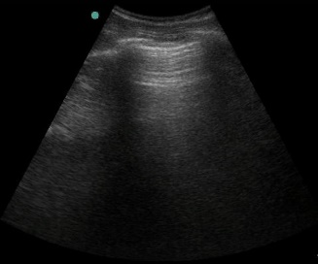 | 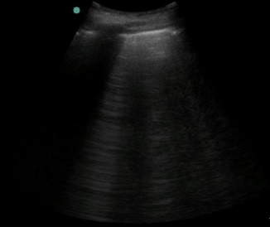 | 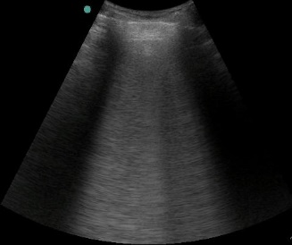 | 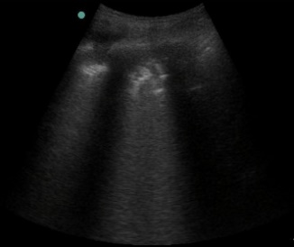
LUS, lung ultrasound.

