Glycemic control in critically ill patients with or without diabetes
Supplementary Information

Supplementary table 1. Measures of glycemic control 2
Supplementary table 2. Number of nondiabetes and diabetes patients on insulin, oral hypoglycemic agents, and diet 3
Supplementary table 3. Top ten admission diagnoses in patients admitted for medical or surgical diagnoses 4
Supplementary table 4. Odds ratios for the association of hospital mortality on glycemic measures derived from generalised additive model 5
Supplementary table 5. Hazard ratios from the Cox proportional hazard model with glucose as time-varying covariate on ICU mortality 6
Supplementary table 6. Schoenfeld's global and individual test for the violation of proportional assumptions of Cox proportional hazard model 7

Supplementary figure 1. Patient flow chart 8
Supplementary figure 2. Graphical representation of the generalised additive model showing the time weighted average glucose associated with below-average risk of mortality for a) patients with no diabetes and b) patients with diabetes 9
Supplementary figure 3. Probability of hospital mortality and time weighted average glucose in medical and surgical patients 11
Supplementary figure 4. Probability of hospital mortality and minimum glucose in medical and surgical patients 12
Supplementary figure 5. Probability of hospital mortality and coefficient of variation in medical and surgical patients 13
Supplementary figure 6. Probability of hospital mortality and time weighted average glucose in trauma and nontrauma patients 14
Supplementary figure 7. Probability of hospital mortality and minimum glucose in trauma and nontrauma patients 15
Supplementary figure 8. Probability of hospital mortality and coefficient of variation in trauma and nontrauma patients 16
Supplementary figure 9. Probability of hospital mortality and time weighted average glucose in diabetes patients on insulin, oral hypoglycemic agents, or diet and patients with no diabetes 17
Supplementary figure 10. Probability of hospital mortality and minimum glucose in diabetes patients on insulin, oral hypoglycemic agents, or diet and patients with no diabetes 18
Supplementary figure 11. Probability of hospital mortality and coefficient of variation in diabetes patients on insulin, oral hypoglycemic agents, or diet and patients with no diabetes 19
Supplementary figure 12. Probability of hospital mortality and time weighted average glucose in all diabetes and nondiabetes patients (including length of stay < 2 days) 20
Supplementary figure 13. Probability of hospital mortality and minimum glucose in all diabetes and nondiabetes patients (including length of stay < 2 days) 21
Supplementary figure 14. Probability of hospital mortality and coefficient of variation in all diabetes and nondiabetes patients (including length of stay < 2 days) 22
Supplementary figure 15. Smoothed scaled Schoenfeld residual plot of glucose on ICU mortality 23

Supplementary table 1. Measures of glycemic control
Measures | Details
Time weighted average (TWA)  glucose | The area under the curve (AUC) was first calculated  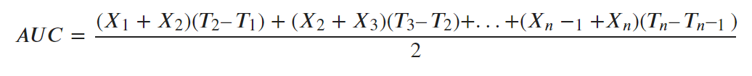  where X_{n} is the glucose value, X₁ is the first glucose value after ICU admission, X_{n} is the last value in the ICU admission, and T_{n} is the time the glucose value is taken  then the AUC was divided by the time (Tn-T1)  then:  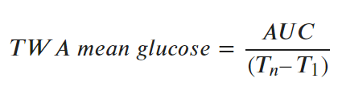
Coefficient of variation (CV) | 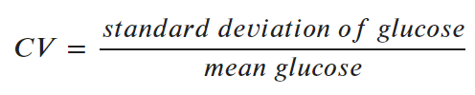

Supplementary table 2. Number of nondiabetes and diabetes patients on insulin, oral hypoglycemic agents, and diet
Patients | n
Insulin-dependent diabetes | 6454
Non-insulin-dependent diabetes on oral hypoglycemic agents | 6366
Non-insulin-dependent diabetes on diet | 1658
Diabetes (not known whether on insulin/ oral hypoglycemic agents/ diet) | 1174
Patients with no diabetes | 36455

Supplementary table 3. Top ten admission diagnoses in patients admitted for medical or surgical diagnoses
Medical |  | Surgical
Diagnosis | n | Diagnosis | n
Sepsis, pulmonary | 3498 | CABG alone, coronary artery bypass grafting | 1662
Congestive heart failure | 2031 | Aortic valve replacement (isolated) | 793
Cerebrovascular accident/stroke | 1972 | GI obstruction, surgery for (including lysis of adhesions) | 390
Cardiac arrest (with or without respiratory arrest) | 1946 | GI perforation/rupture, surgery for | 375
Sepsis, renal/UTI (including bladder) | 1861 | CABG with aortic valve replacement | 323
Infarction, acute myocardial | 1593 | Mitral valve replacement | 215
Pneumonia, bacterial | 1520 | Thoracotomy for lung cancer | 191
Emphysema/bronchitis | 1308 | Neoplasm-cranial, surgery for (excluding transphenoidal) | 174
Rhythm disturbance (atrial, supraventricular) | 1092 | Hematoma subdural, surgery for | 170
Arrest, respiratory (without cardiac arrest) | 1024 | Cancer-colon/rectal, surgery for (including abdominoperineal resections) | 158
CABG, coronary artery bypass graft; GI, gastrointestinal; UTI, urinary tract infection

Supplementary table 4. Odds ratios for the association of hospital mortality on glycemic measures derived from generalised additive model
 | Patients with no diabetes |  | Patients with diabetes
 | Crude OR (95% CI) | Adjusted OR (95% CI) | Crude OR (95% CI) | Adjusted OR (95% CI)
TWA glucose (mg/dL)
60 vs. 100 | 4.66 (2.78 – 7.80) | 4.34 (2.69 – 7.01) | 2.17 (1.17 – 4.03) | 1.91 (1.14 – 3.19)
80 vs. 100 | 1.78 (1.57 – 2.02) | 1.74 (1.57 – 1.92) | 1.45 (1.12 – 1.88) | 1.36 (1.12 – 1.66)
120 vs. 100 | 1.84 (1.80 – 1.89) | 1.66 (1.64 – 1.67) | 0.88 (0.83 – 0.94) | 0.91 (0.87 – 0.95)
140 vs. 100 | 3.85 (3.78 – 3.92) | 3.05 (3.03 – 3.08) | 1.21 (1.11 – 1.32) | 1.14 (1.08 – 1.20)
160 vs. 100 | 5.39 (5.37 – 5.41) | 3.84 (3.81 – 3.87) | 1.55 (1.41 – 1.70) | 1.37 (1.30 – 1.45)
180 vs. 100 | 6.03 (5.84 – 6.22) | 4.20 (4.07 – 4.33) | 1.67 (1.53 – 1.83) | 1.49 (1.41 – 1.57)
180 vs. 120 | 3.27 (3.09 – 3.46) | 2.53 (2.43 – 2.64) | 1.89 (1.84 – 1.94) | 1.65 (1.63 – 1.66)
180 vs. 150 | 1.26 (1.21 – 1.32) | 1.18 (1.22 – 1.14) | 1.17 (1.17 – 1.18) | 1.16 (1.16 – 1.17)
Minimum glucose (mg/dL)
70 vs. 80 | 1.37 (1.36 – 1.37) | 1.11 (1.11 – 1.12) | 1.08 (1.07 – 1.08) | 1.00 (1.00 – 1.00)
60 vs. 80 | 2.16 (2.12 – 2.21) | 1.47 (1.44 – 1.50) | 1.23 (1.22 – 1.24) | 1.07 (1.06 – 1.07)
50 vs. 80 | 3.39 (3.26 – 3.52) | 2.03 (1.96 – 2.10) | 1.48 (1.46 – 1.51) | 1.21 (1.19 – 1.22)
40 vs. 80 | 4.82 (4.49 – 5.18) | 2.72 (2.56 – 2.89) | 1.86 (1.78 – 1.94) | 1.45 (1.42 – 1.48)
30 vs. 80 | 6.43 (5.82 – 7.10) | 3.53 (3.24 – 3.85) | 2.42 (2.23 – 2.64) | 1.82 (1.73 – 1.91)
Coefficient of variation (%)
20 vs. 10 | 1.66 (1.61 – 1.70) | 1.11 (1.10 – 1.12) | 1.18 (1.14 – 1.22) | 0.91 (0.88 – 0.95)
30 vs. 10 | 2.63 (2.60 – 2.66) | 1.41 (1.41 – 4.42) | 1.40 (1.33 – 1.46) | 0.93 (0.89 – 0.96)
40 vs. 10 | 4.14 (4.07 – 4.22) | 1.92 (1.89 – 1.96) | 1.65 (1.60 – 1.70) | 0.98 (0.94 – 1.01)
50 vs. 10 | 5.78 (5.43 – 6.16) | 2.50 (2.37 – 2.65) | 1.95 (1.95 – 1.95) | 1.05 (1.04 – 1.06)
CI, confidence interval; OR, Odds ratio; TWA, time weighted average

Supplementary table 5. Hazard ratios from the Cox proportional hazard model with glucose as time-varying covariate on ICU mortality
Covariate | Coefficient(b_{i}) | HR [exp(b_{i})] (95% CI) | p-value
Glucose | 0.003 | 1.003 (1.002 – 1.004) | <0.001
Diabetes | -0.143 | 0.867 (0.799 – 0.940) | <0.001
Age (years) | 0.012 | 1.012 (1.009 – 1.014) | <0.001
APACHE IV | 0.017 | 1.017 (1.016 – 1.019) | <0.001
Admission diagnosis
Operative | -0.694 | 0.500 (0.446 – 0.560) | <0.001
BMI (kg/m²)
< 18.5 | Reference | - | -
18.5-<25 | -0.172 | 0.842 (0.744 – 0.952) | 0.006
25-<30 | -0.312 | 0.732 (0.645 – 0.831) | <0.001
30-<35 | -0.298 | 0.743 (0.650 – 0.849) | <0.001
35-<40 | -0.185 | 0.831 (0.717 – 0.963) | 0.014
≥40 | -0.329 | 0.719 (0.624 – 0.829) | <0.001
Mechanical ventilation | 0.163 | 1.177 (1.091 – 1.271) | <0.001
On inotropes or vasopressors | 0.501 | 1.650 (1.532 – 1.778) | <0.001
APACHE, Acute Physiology and Chronic Health Evaluation; BMI, Body mass index; CI, confidence interval; HR, Hazard ratios;

Supplementary table 6. Schoenfeld's global and individual test for the violation of proportional assumptions of Cox proportional hazard model
Covariate | p-value
Glucose | 0.007
Diabetes | 0.045
Age | <0.001
APACHE IV | <0.001
Admission diagnosis | <0.001
BMI | 0.752
Mechanical ventilation | <0.001
On inotropes or vasopressors | <0.001
Global | <0.001

Supplementary figure 1. Patient flow chart
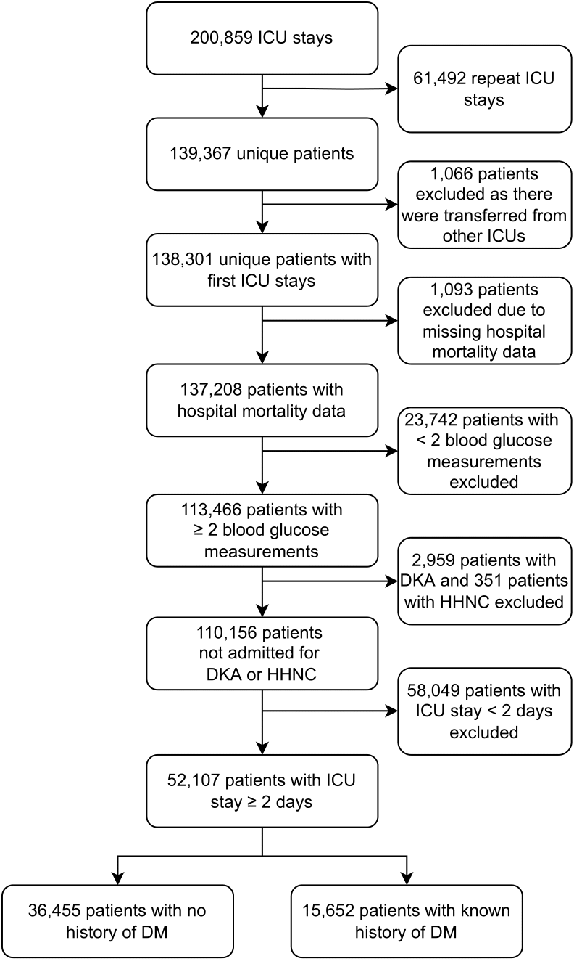
DM, diabetes mellitus; DKA, diabetic ketoacidosis; HHNC, diabetic hyperglycemic hyperosmolar nonketotic coma; ICU, intensive care unit
Supplementary figure 2. Graphical representation of the generalised additive model showing the time weighted average glucose associated with below-average risk of mortality for a) patients with no diabetes and b) patients with diabetes
a)
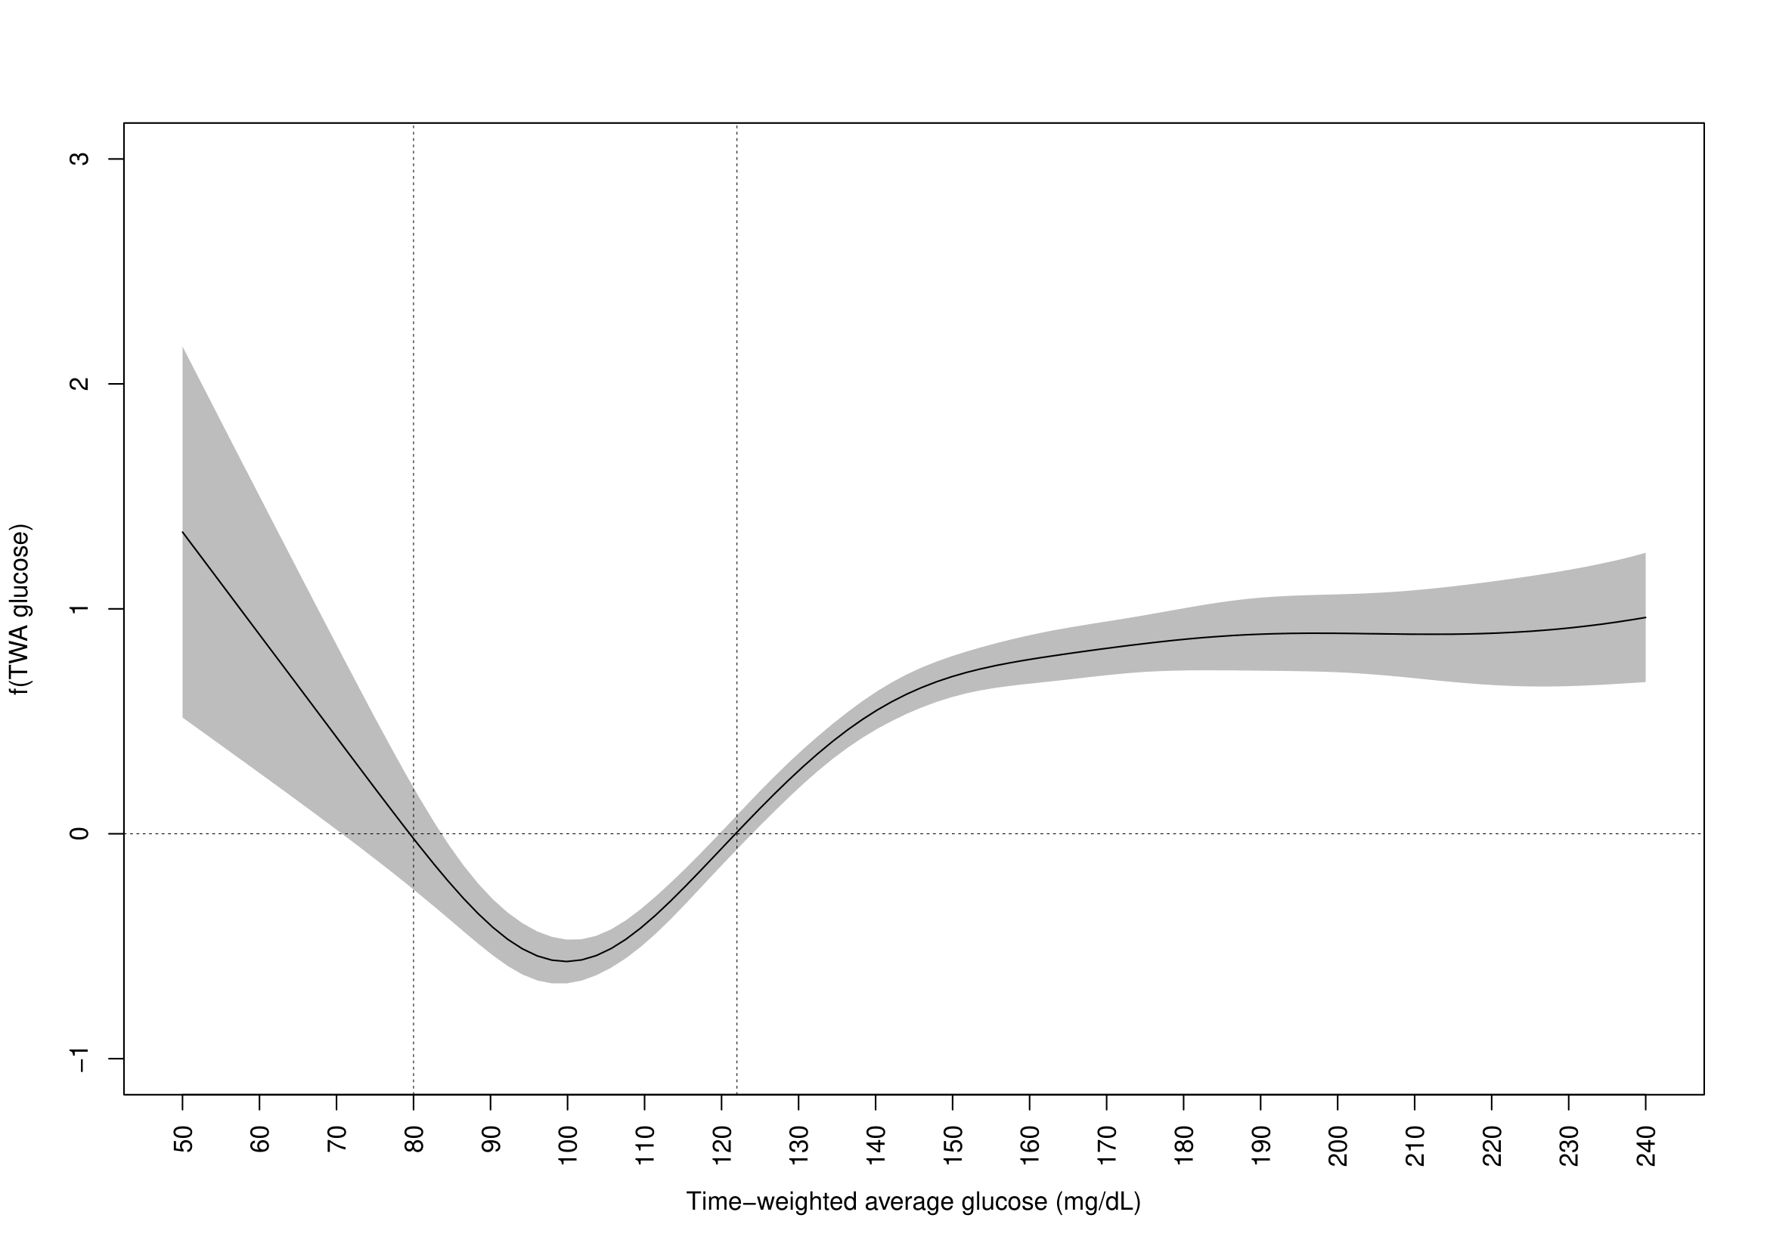
b)
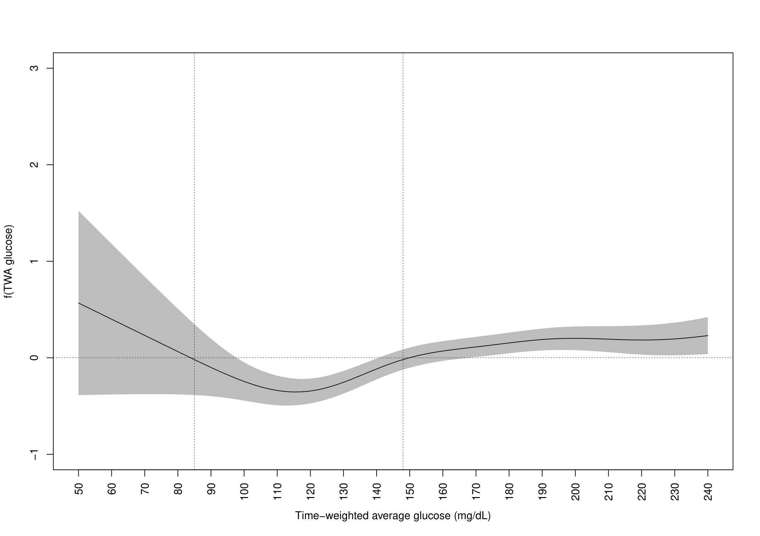
TWA, time weighted average
Association was adjusted for age, APACHE IV scores, body mass index, admission diagnosis, mechanical ventilation, and use of vasopressor or inotropic agents. Cutoffs were obtained where f(TWA glucose)=0 (which represented the average risk). A TWA glucose level ranging approximately from 80-120mg/dL and 90-150mg/dL represented a below-average risk of hospital mortality for patients with no diabetes and patients with diabetes respectively.

Supplementary figure 3. Probability of hospital mortality and time weighted average glucose in medical and surgical patients
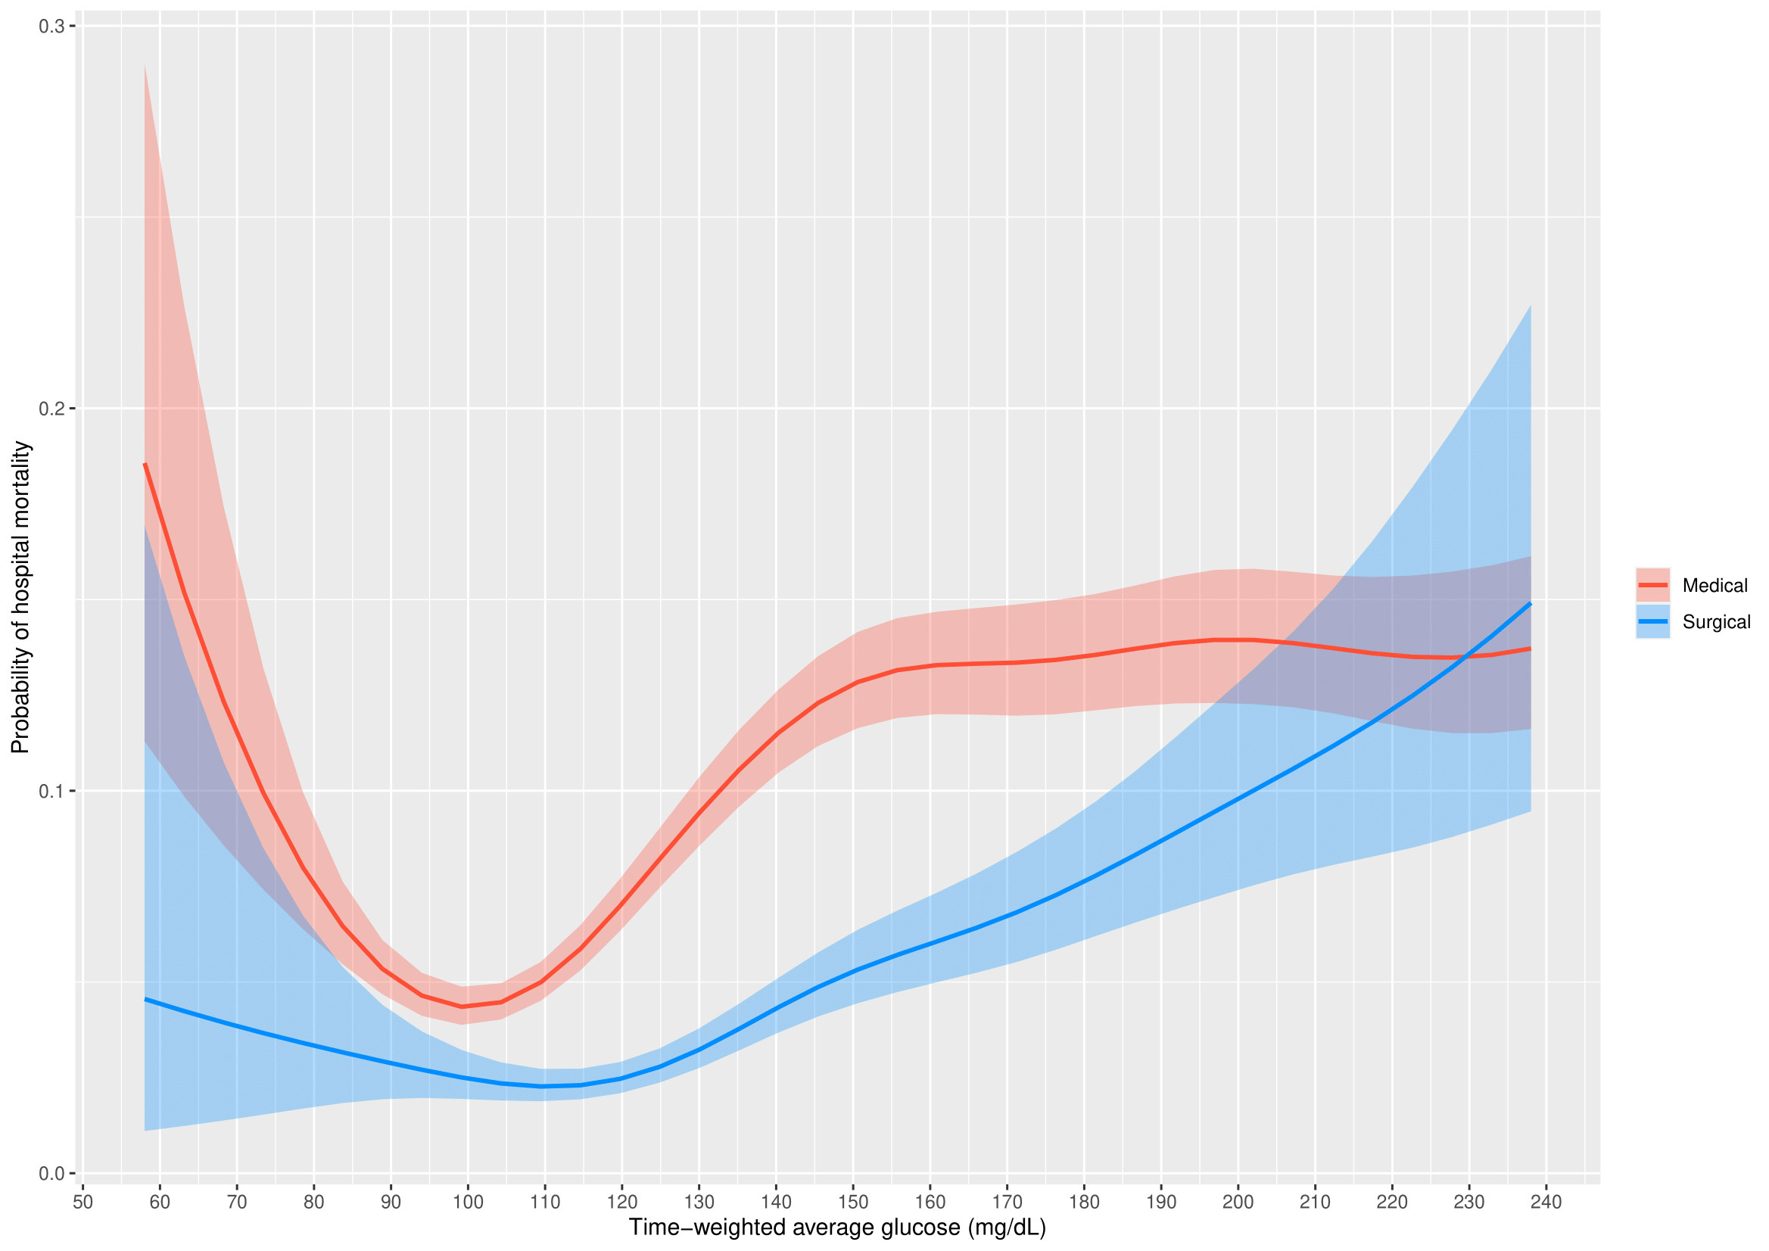
Analysis was adjusted for age, APACHE IV scores, body mass index, admission diagnosis, diabetes, mechanical ventilation, and use of vasopressor or inotropic agents.
Supplementary figure 4. Probability of hospital mortality and minimum glucose in medical and surgical patients
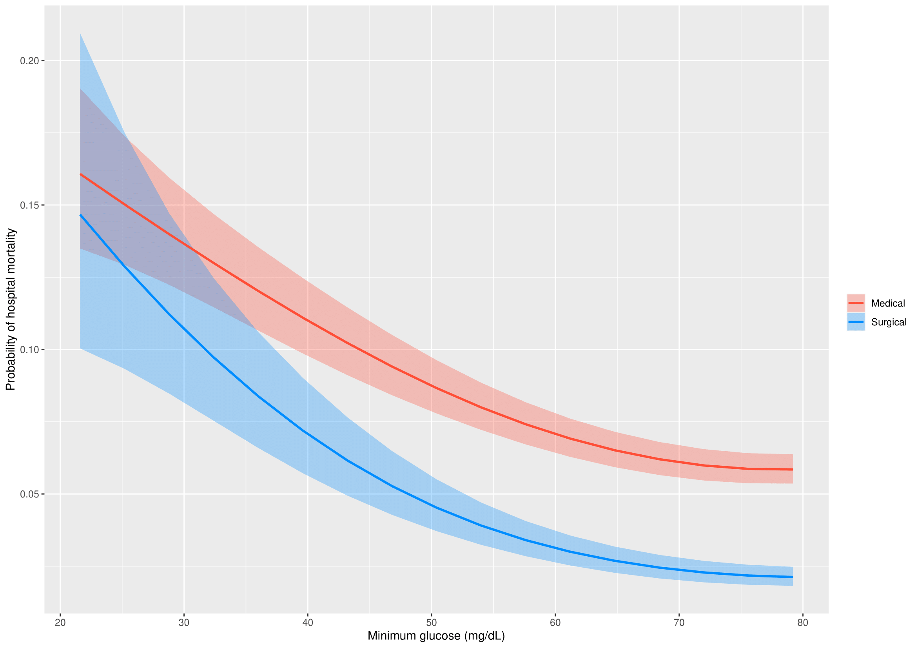
Analysis was adjusted for age, APACHE IV scores, body mass index, admission diagnosis, diabetes, mechanical ventilation, and use of vasopressor or inotropic agents.
Supplementary figure 5. Probability of hospital mortality and coefficient of variation in medical and surgical patients
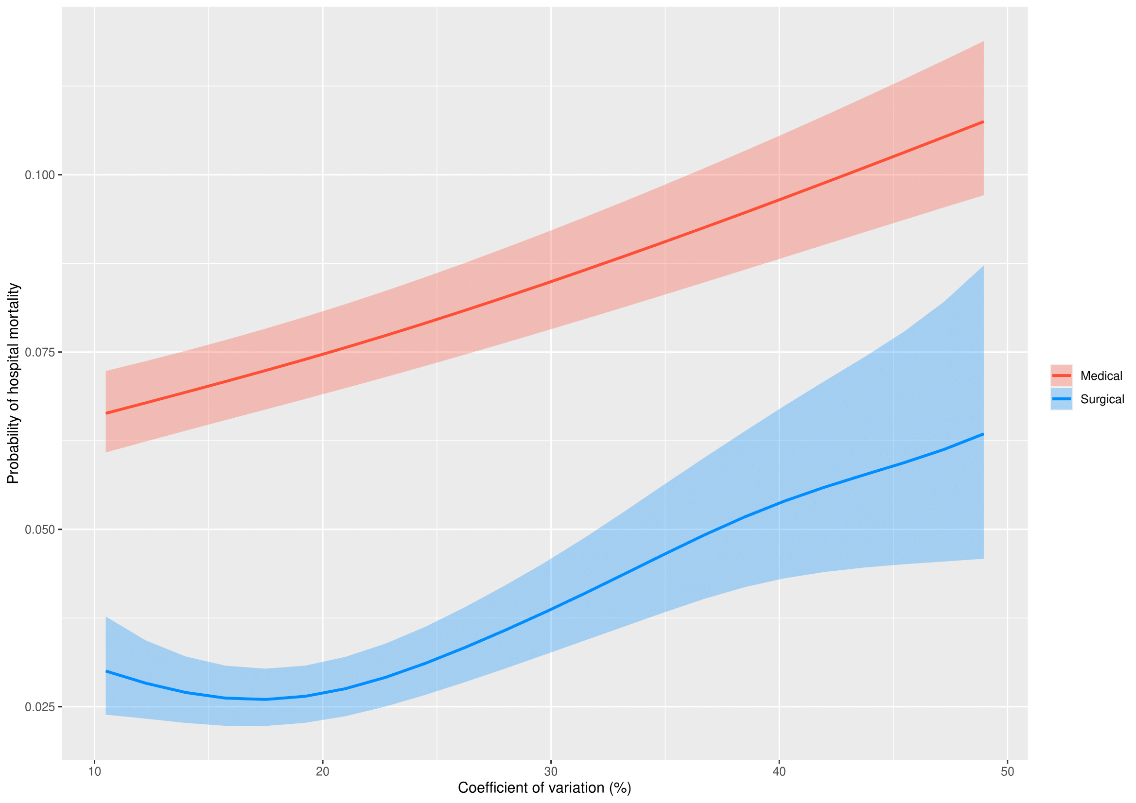
Analysis was adjusted for age, APACHE IV scores, body mass index, admission diagnosis, diabetes, mechanical ventilation, and use of vasopressor or inotropic agents.
Supplementary figure 6. Probability of hospital mortality and time weighted average glucose in trauma and nontrauma patients
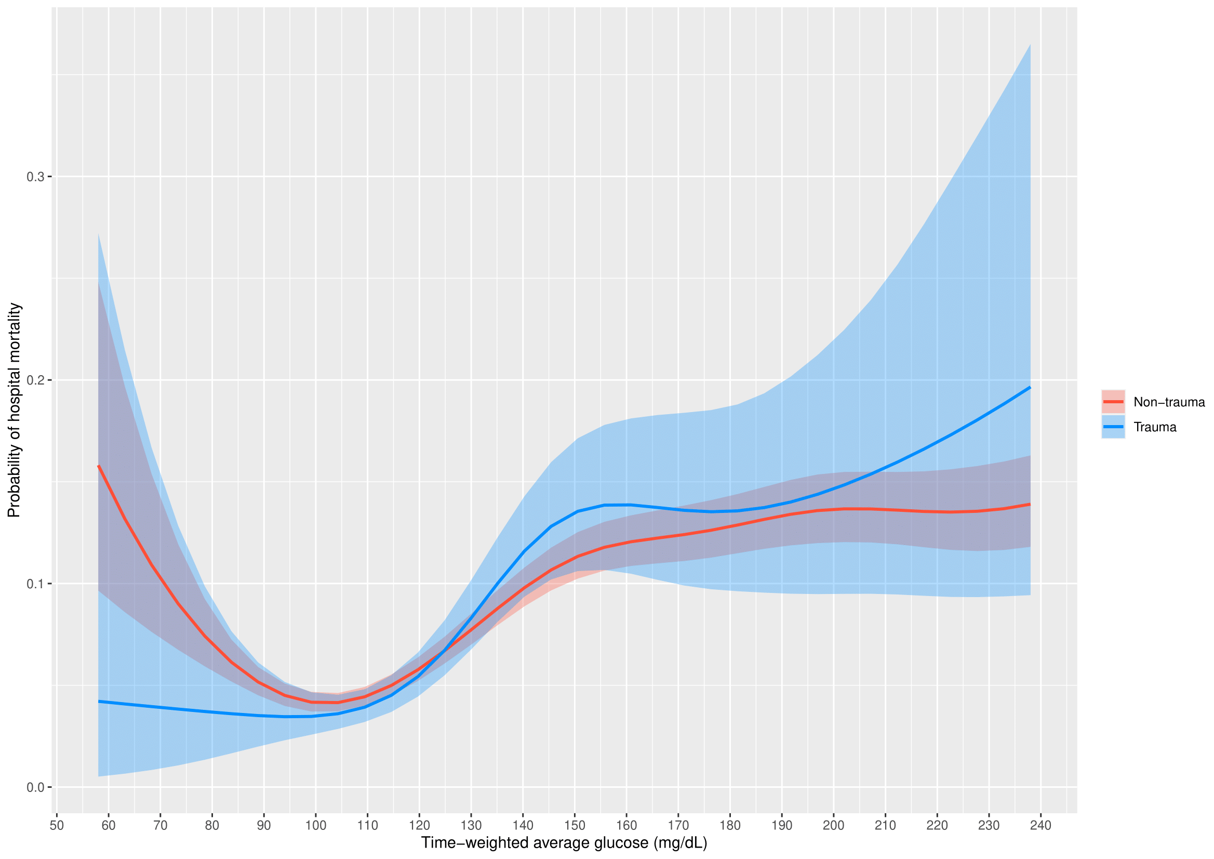
Analysis was adjusted for age, APACHE IV scores, body mass index, diabetes, mechanical ventilation, and use of vasopressor or inotropic agents.
Supplementary figure 7. Probability of hospital mortality and minimum glucose in trauma and nontrauma patients
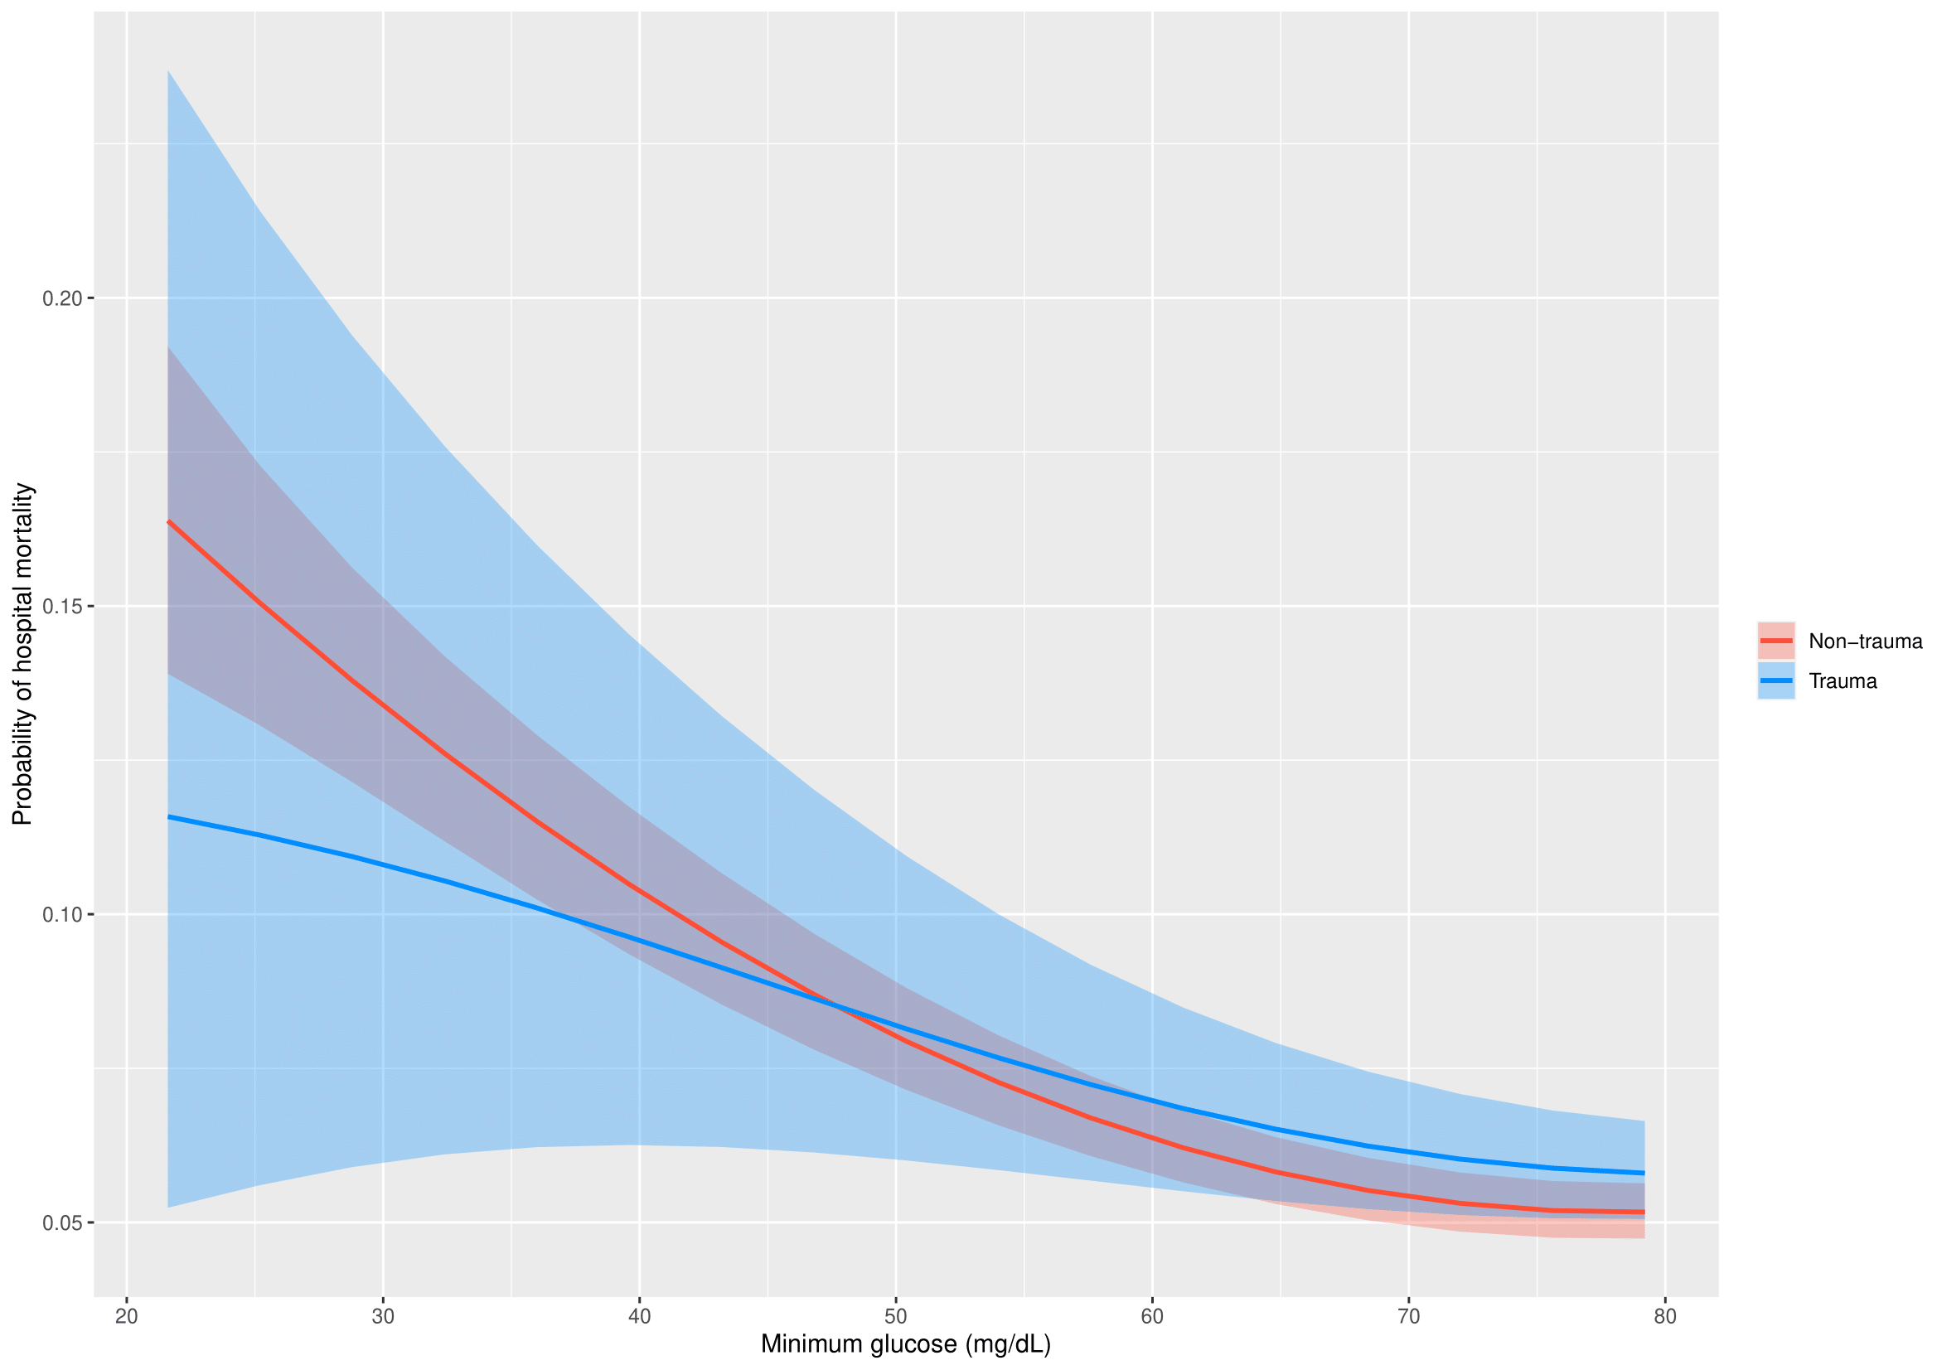
Analysis was adjusted for age, APACHE IV scores, body mass index, diabetes, mechanical ventilation, and use of vasopressor or inotropic agents.
Supplementary figure 8. Probability of hospital mortality and coefficient of variation in trauma and nontrauma patients
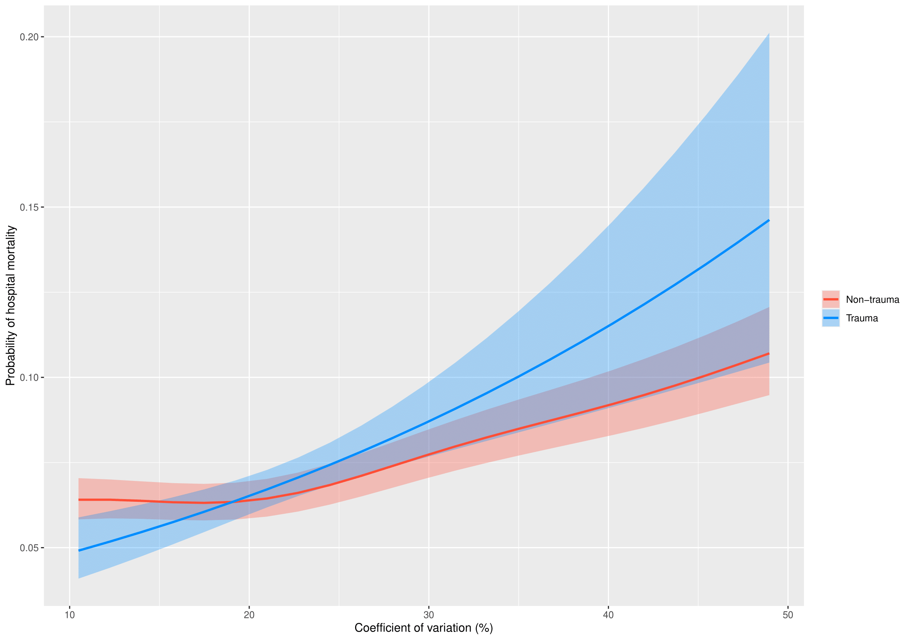
Analysis was adjusted for age, APACHE IV scores, body mass index, diabetes, mechanical ventilation, and use of vasopressor or inotropic agents.
Supplementary figure 9. Probability of hospital mortality and time weighted average glucose in diabetes patients on insulin, oral hypoglycemic agents, or diet and patients with no diabetes
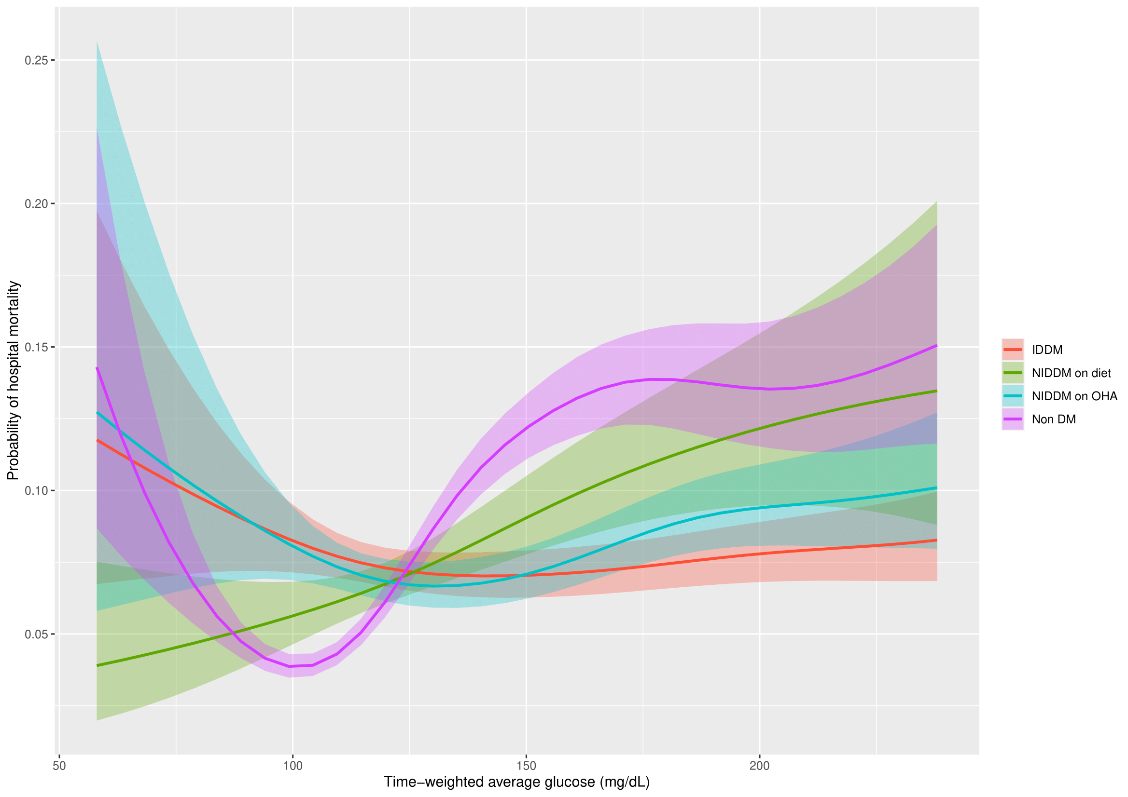
DM, diabetes mellitus; IDDM, insulin-dependent diabetes mellitus; NIDDM, non-insulin dependent diabetes mellitus; OHA, oral hypoglycemic agents;
Analysis was adjusted for age, APACHE IV scores, body mass index, admission diagnosis, mechanical ventilation, and use of vasopressor or inotropic agents.
Supplementary figure 10. Probability of hospital mortality and minimum glucose in diabetes patients on insulin, oral hypoglycemic agents, or diet and patients with no diabetes
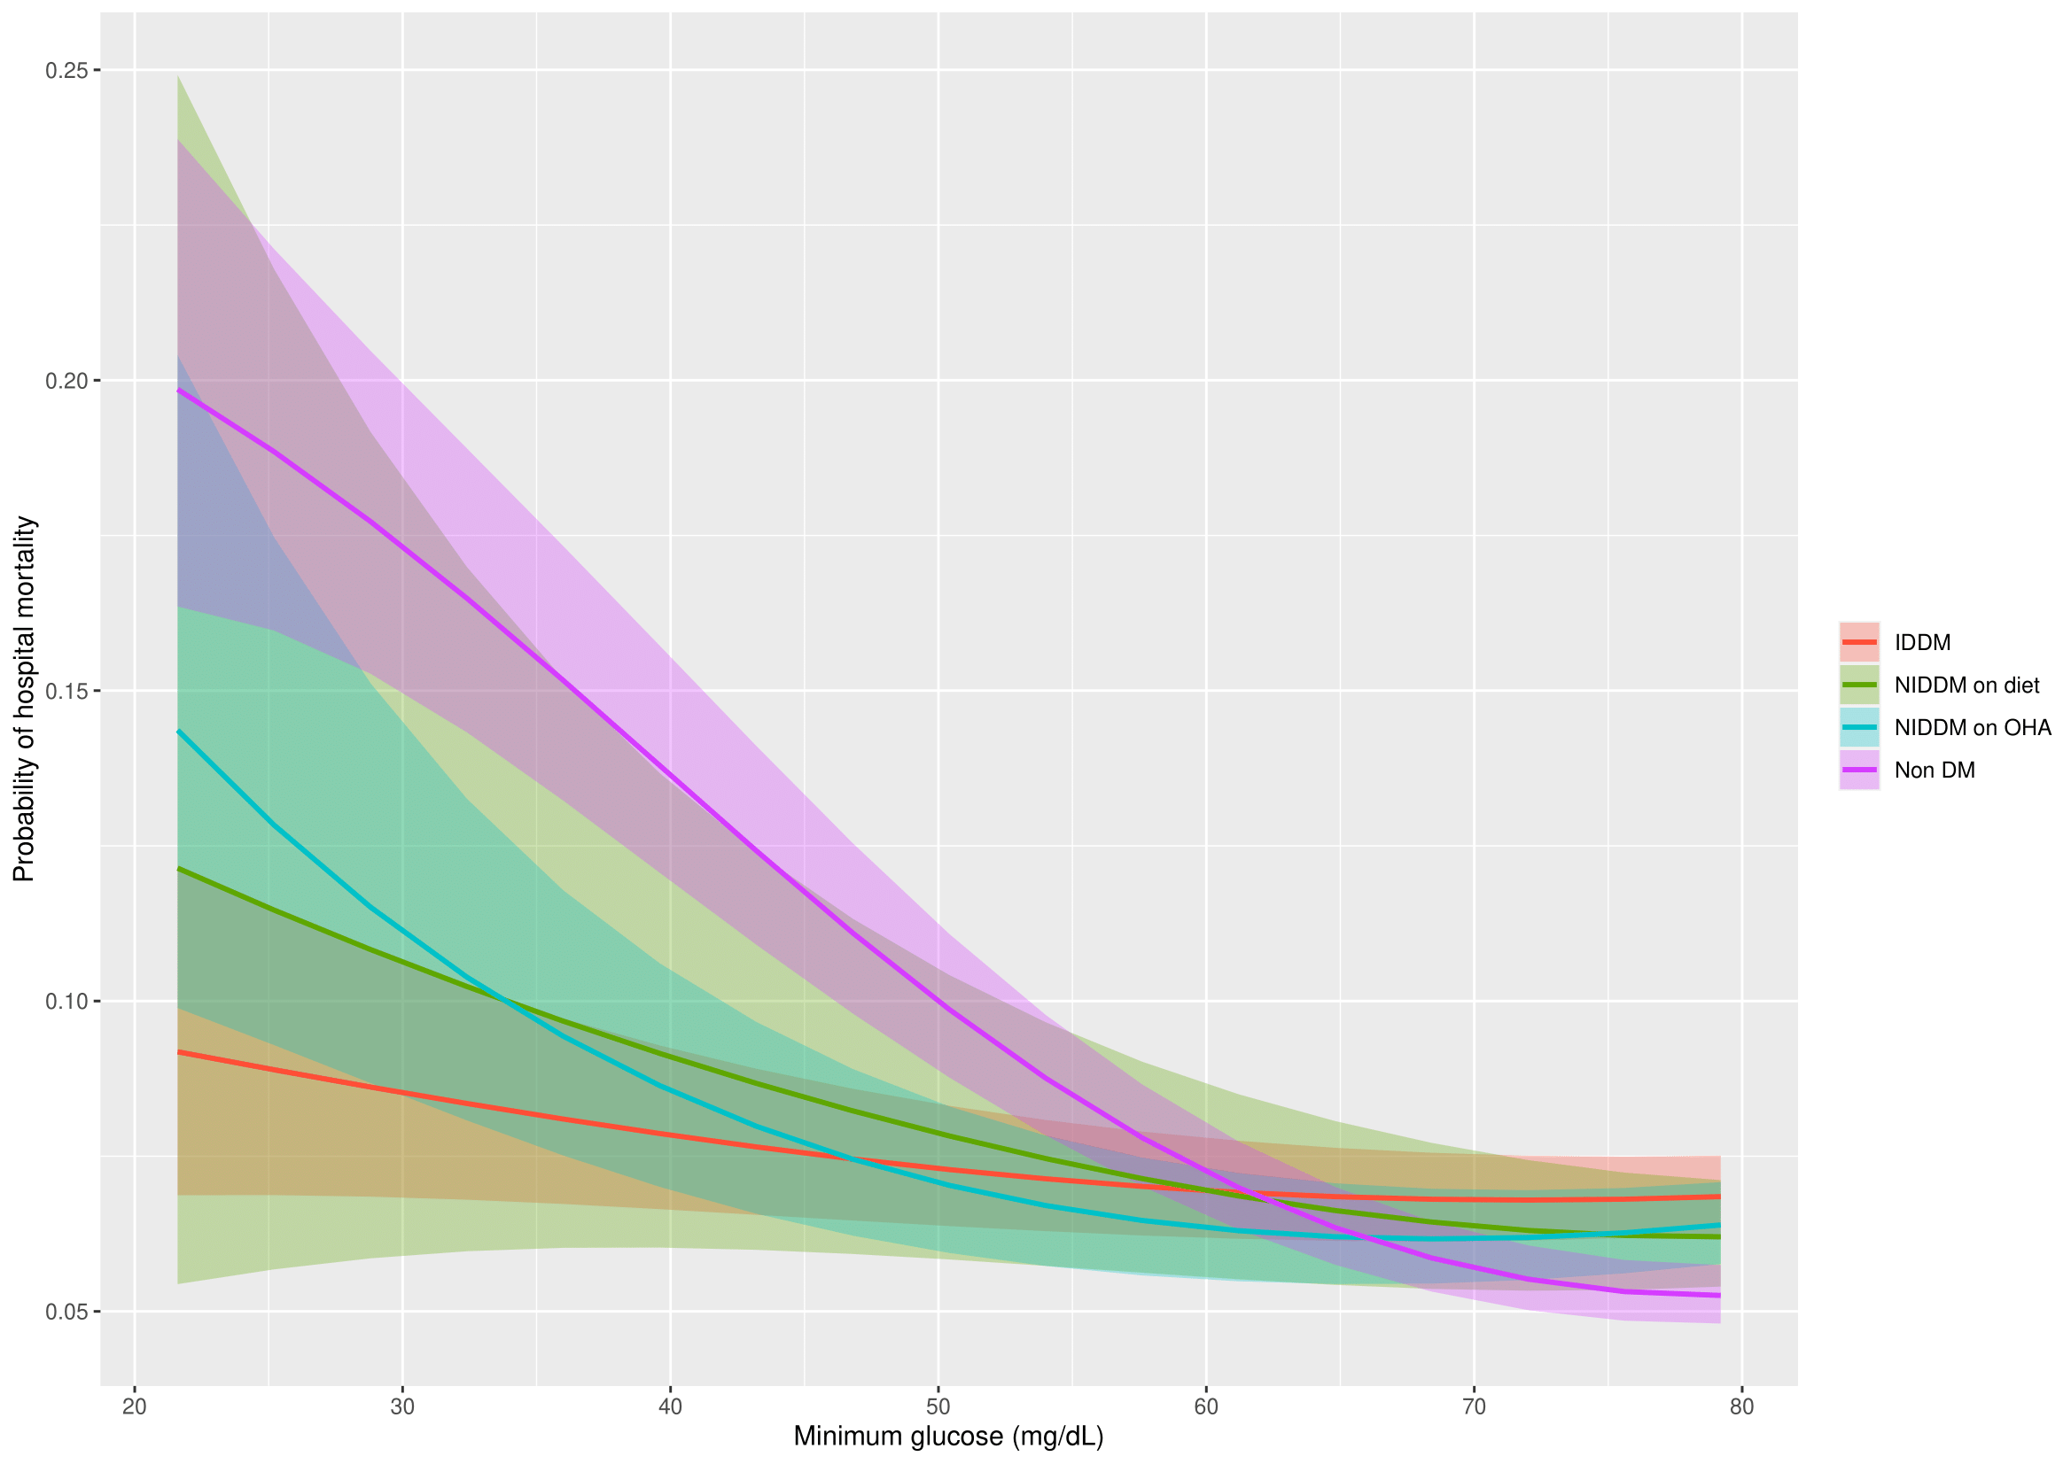
DM, diabetes mellitus; IDDM, insulin-dependent diabetes mellitus; NIDDM, non-insulin dependent diabetes mellitus; OHA, oral hypoglycemic agents;
Analysis was adjusted for age, APACHE IV scores, body mass index, admission diagnosis, mechanical ventilation, and use of vasopressor or inotropic agents.
Supplementary figure 11. Probability of hospital mortality and coefficient of variation in diabetes patients on insulin, oral hypoglycemic agents, or diet and patients with no diabetes
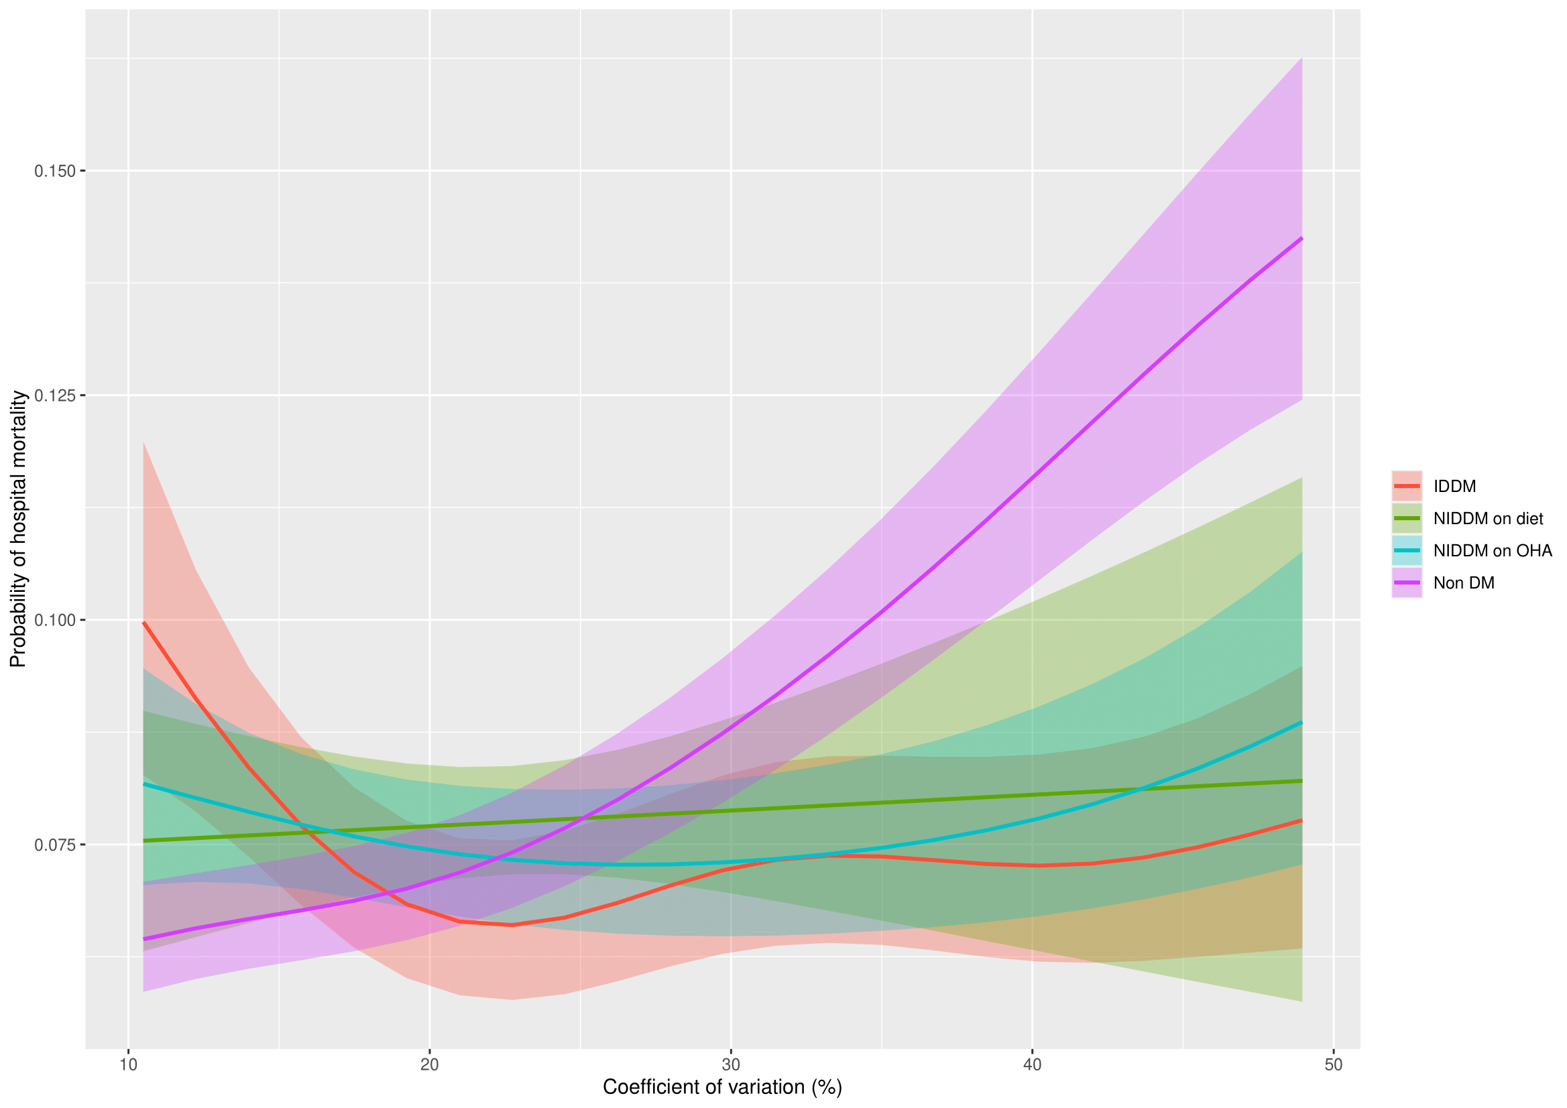
IDDM, insulin-dependent diabetes mellitus; NIDDM, non-insulin dependent diabetes mellitus; OHA, oral hypoglycemic agents; DM, diabetes mellitus
Analysis was adjusted for age, APACHE IV scores, body mass index, admission diagnosis, mechanical ventilation, and use of vasopressor or inotropic agents.

Supplementary figure 12. Probability of hospital mortality and time weighted average glucose in all diabetes and nondiabetes patients (including length of stay < 2 days)
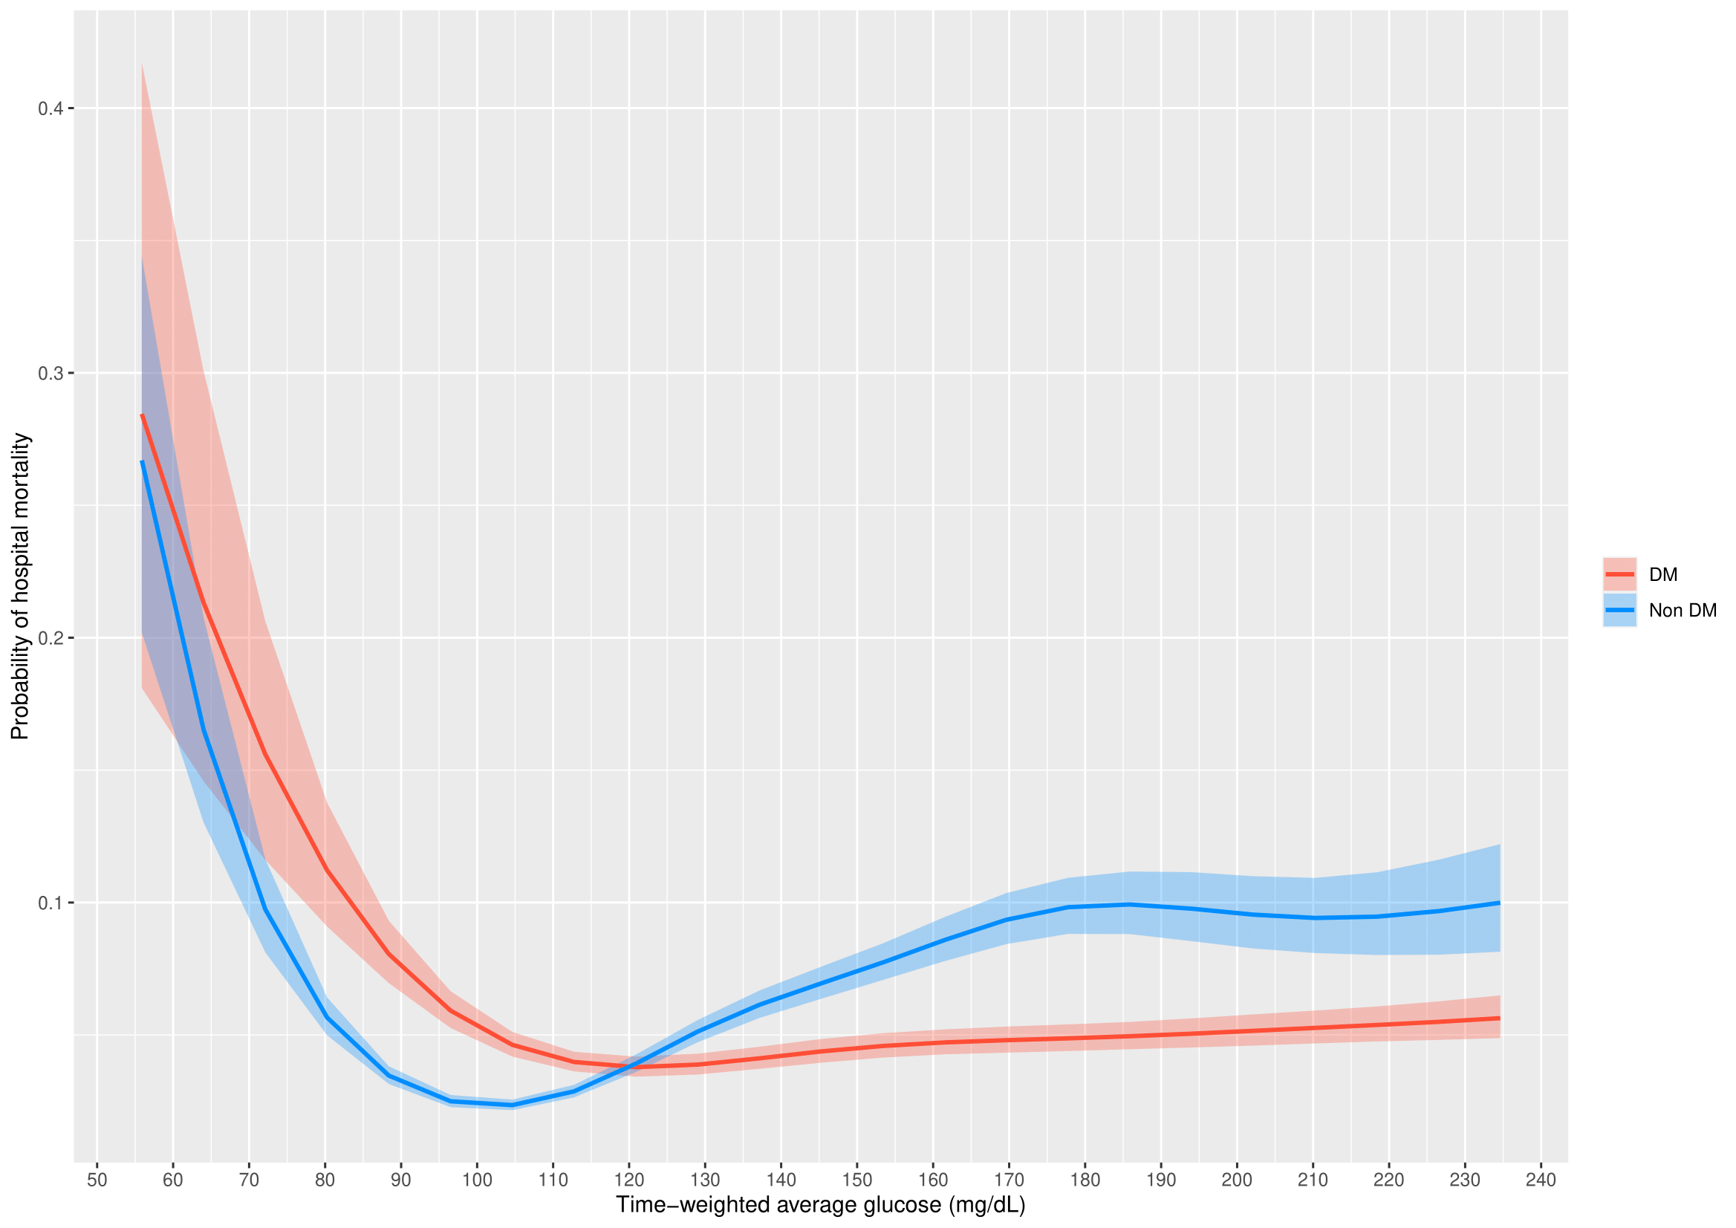
Analysis was adjusted for age, APACHE IV scores, body mass index, admission diagnosis, diabetes, mechanical ventilation, and use of vasopressor or inotropic agents.

Supplementary figure 13. Probability of hospital mortality and minimum glucose in all diabetes and nondiabetes patients (including length of stay < 2 days)
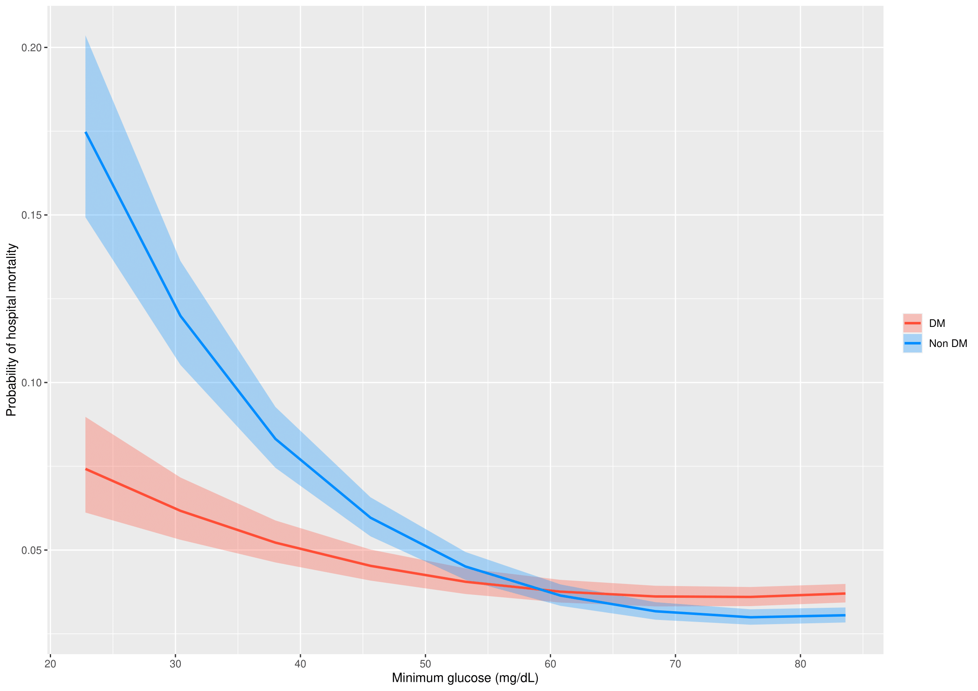
Analysis was adjusted for age, APACHE IV scores, body mass index, admission diagnosis, diabetes, mechanical ventilation, and use of vasopressor or inotropic agents.

Supplementary figure 14. Probability of hospital mortality and coefficient of variation in all diabetes and nondiabetes patients (including length of stay < 2 days)
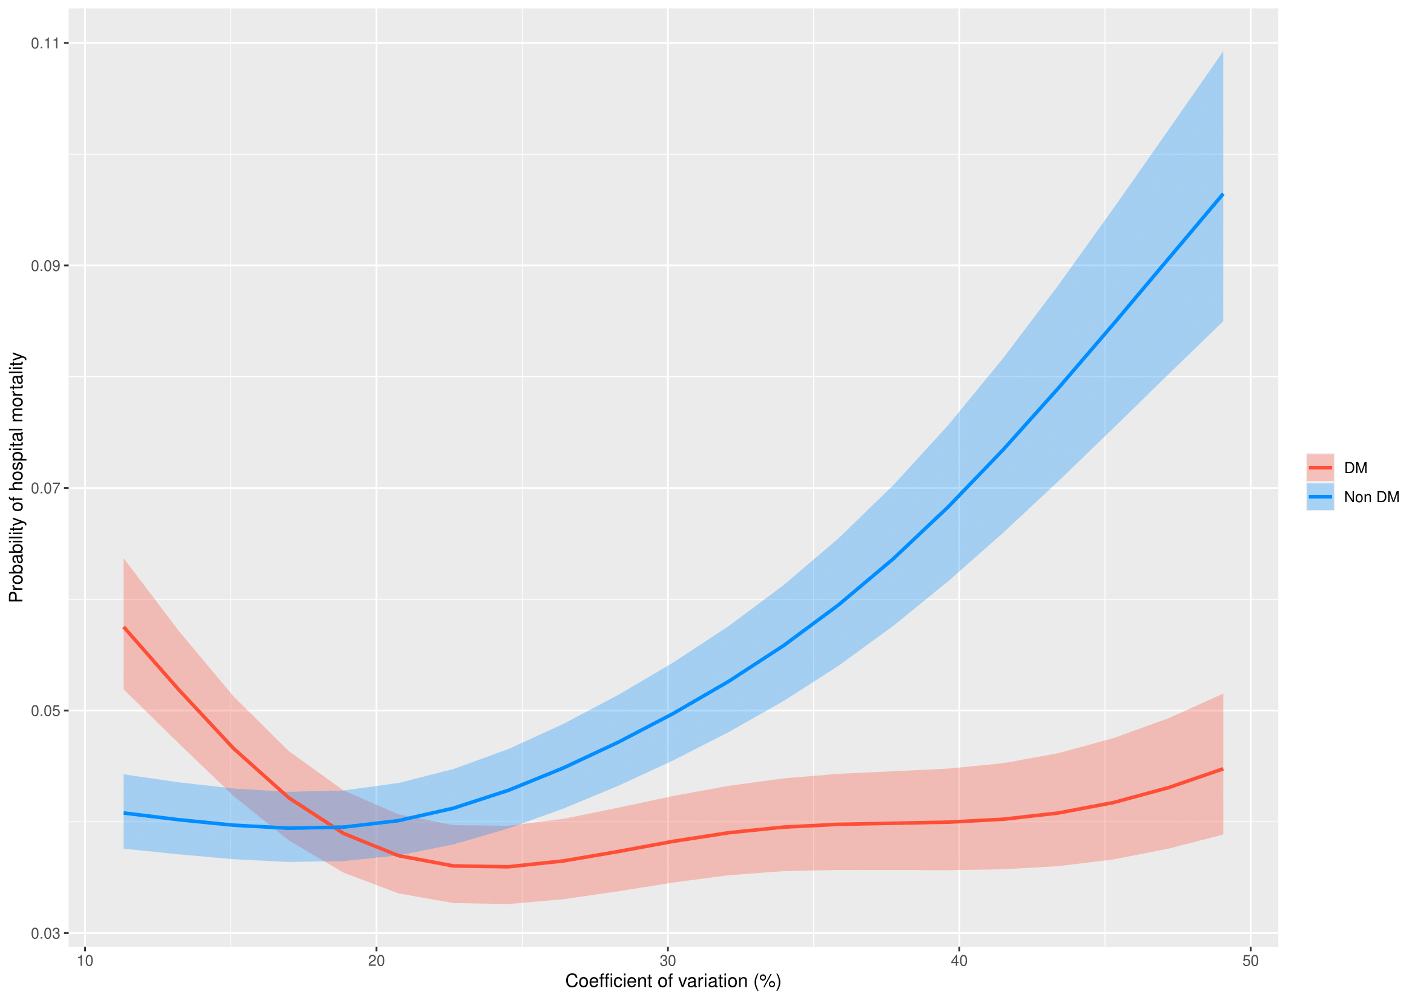
Analysis was adjusted for age, APACHE IV scores, body mass index, admission diagnosis, diabetes, mechanical ventilation, and use of vasopressor or inotropic agents.

Supplementary figure 15. Smoothed scaled Schoenfeld residual plot of glucose on ICU mortality
