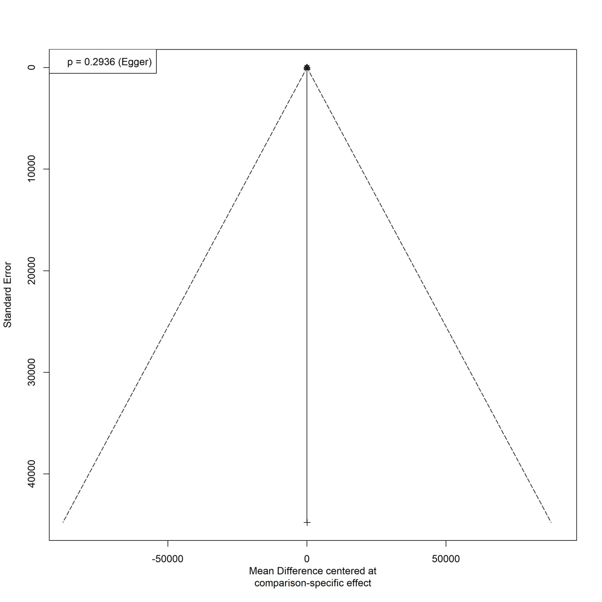
Supplementary material 2. Funnel plots for the postoperative opioid consumption at 24 hours.

