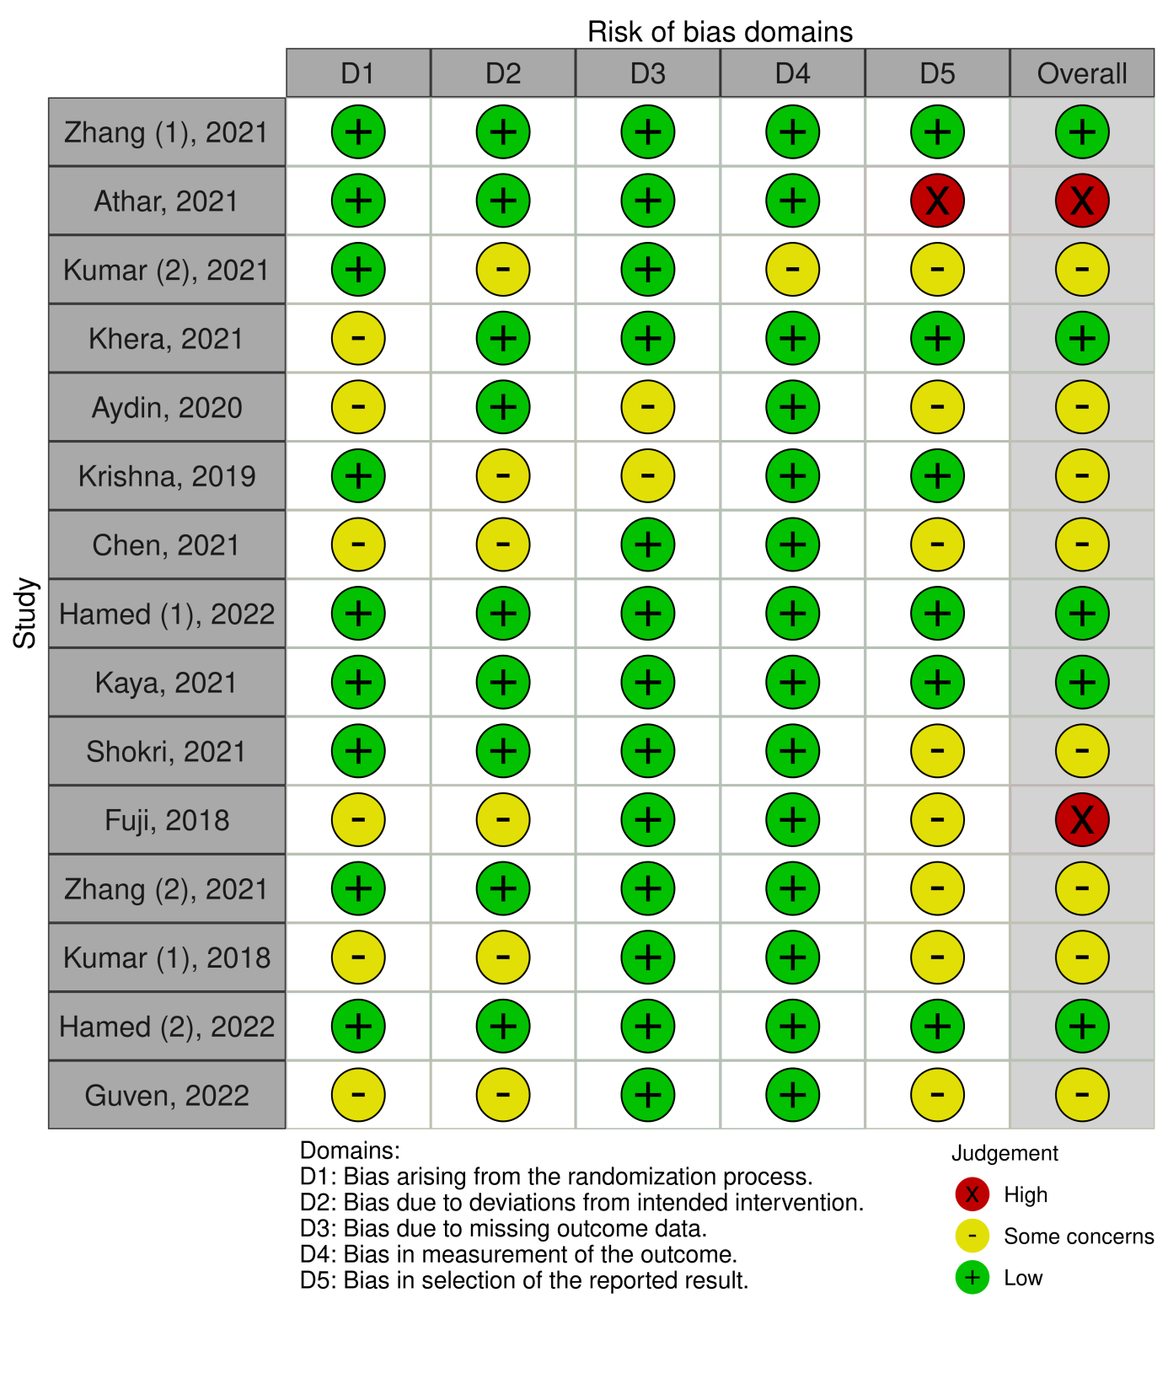
Supplementary material 3. Risk of bias assessment.

