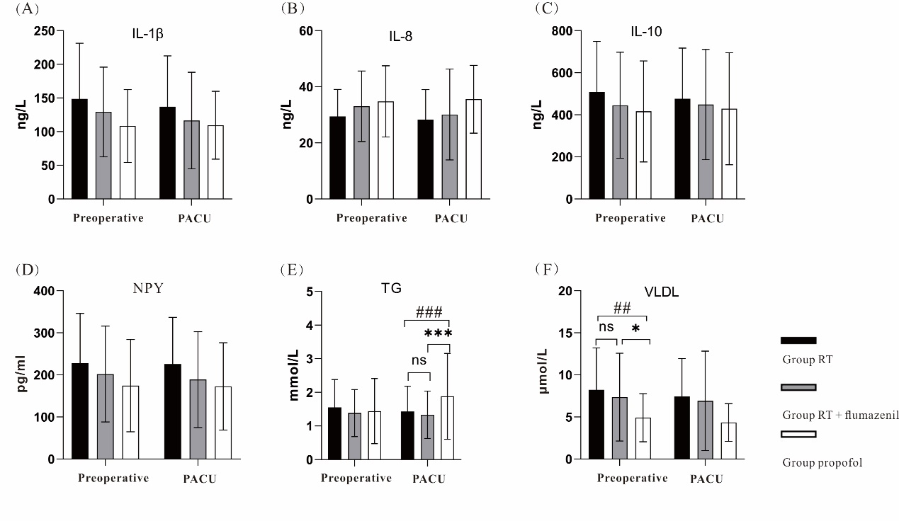
Supplementary Fig. 1 The inflammatory factors and lipid profiles measured in blood samples before anesthesia induction and at PACU discharge. (A) Serum IL-1β levels; (B) serum IL-8 levels; (C) serum IL-10 levels; (D) serum NPY levels; (E) serum TG levels; (F) serum VLDL levels. Data are shown as mean ± SD. SD, standard deviation, IL, interleukin; NPY, neuropeptide Y; TG, triglyceride; VLDL, very low density lipoprotein; PACU, postanesthesia care unit; RT, remimazolam tosilate.
*P < 0.05, ***P < 0.001, RT + flumazenil versus propofol group; ##P < 0.01, ###P < 0.001, RT versus propofol group; ns: no statistic difference.

