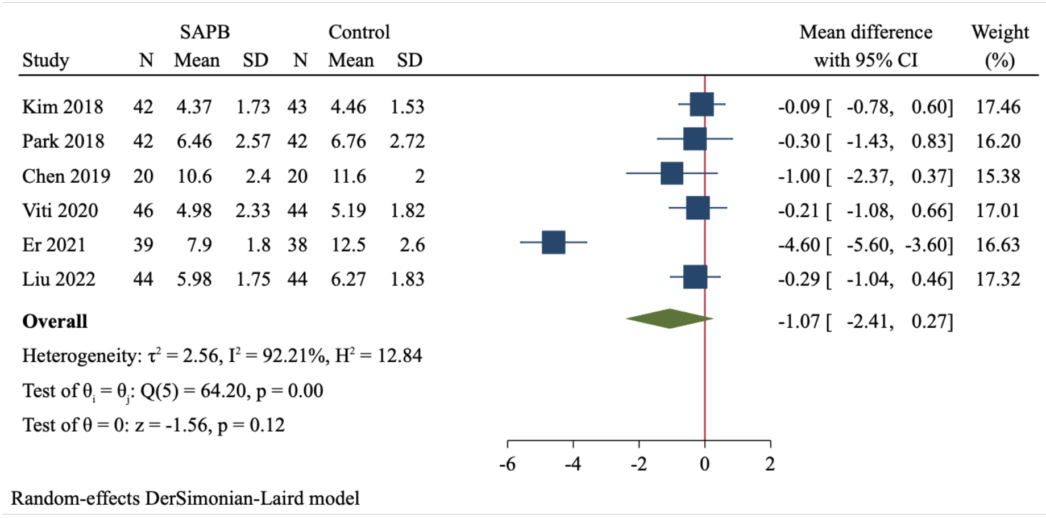
Fig. S1 Forest plot of meta-analysis for length of hospital stay

