Supplementary Table I: Database Search Strategies

1.1. PubMed, Searched on 31/03/2013
S.No. | Search String | Hits
1 | "Laryngoscopy"[MeSH Terms] OR "intubation, intratracheal"[MeSH Terms] OR "Rapid Sequence Induction and Intubation"[MeSH Terms] | 52,081
2 | "laryngoscop*"[Title/Abstract] OR "endotracheal intubat*"[Title/Abstract] OR "intratracheal intubat*"[Title/Abstract] OR "intra tracheal intubat*"[Title/Abstract] OR "tracheal intubat*"[Title/Abstract] | 33,338
3 | #1 OR #2 | 69,590
4 | "Dexmedetomidine"[MeSH Terms] | 5,225
5 | (MPV-1440 OR "MPV 1440" OR MPV1440 OR dex OR dexmed* OR dexdomitor OR dexdor OR cepedex OR precedex OR primadex OR sedadex OR sileo OR dextomid OR dexem OR dexmeto) [All Fields] | 19,548
6 | #4 or #5 | 19,548
7 | #3 AND #6 | 456
8 | Search: "Randomized Controlled Trial"[Publication Type] OR "Randomized Controlled Trials as Topic"[MeSH Terms] OR "Controlled Clinical Trial"[Publication Type] OR "Clinical Trial"[Publication Type] OR "Clinical Trials as Topic"[MeSH Terms] | 1,266,924
9 | "randomized"[Title/Abstract] OR "placebo"[Title/Abstract] OR control[Title/Abstract] OR "random*"[Title/Abstract] OR "trial"[Title/Abstract] | 4,458,011
10 | #8 OR #9 | 4,918,932
11 | #7 AND #10 | 281
12 | Filter: English | 264
13 | Filter: Human | 143

1.2. Embase (OvidSP) 1947 to March 30 2023, searched on 31/03/2023
# | Search String | Hits
1 | exp laryngoscopy/ | 29,503
2 | exp endotracheal intubation/ | 64,298
3 | laryngoscop*.mp. | 40,596
4 | (intubat* adj6 (tracheal or intratracheal or endotracheal)).mp. | 72,004
5 | 1 or 2 or 3 or 4 | 102,764
6 | exp dexmedetomidine/ | 17,913
7 | (MPV-1440 or MPV1440 or "MPV 1440" or dex or dexmed* or dexdomitor or dexdor or cepedex or precedex or primadex or sedadex or sileo or dextomid or dexem or dexmeto).mp. | 34,078
8 | 6 or 7 | 34,078
9 | 5 and 8 | 1,631
10 | exp randomized controlled trial/ | 781,854
11 | exp controlled clinical trial/ | 974,500
12 | exp clinical trial/ | 1,852,956
13 | (random* or placebo or control* or trial).tw. | 7,635,498
14 | ("randomized controlled trial" or "controlled clinical trial").tw. | 159,167
15 | 10 or 11 or 12 or 13 or 14 | 8,365,223
16 | 9 and 15 | 791
17 | limit 16 to (human and english language) | 632

1.3. Cochrane Library (all sections), searched via Wiley on 31/03/2013
S.No. | Search string | Hits
1 | MeSH descriptor: [Laryngoscopy] explode all trees | 1442
2 | MeSH descriptor: [Intubation, Intratracheal] explode all trees | 5076
3 | (laryngoscop*):ti,ab,kw | 5306
4 | ((tracheal or intratracheal or endotracheal) NEXT intubat*):ti,ab,kw | 10163
5 | #1 or #2 or #3 or #4 | 14725
6 | MeSH descriptor: [Dexmedetomidine] explode all trees | 2483
7 | MPV-1440 or MPV1440 or "MPV 1440" or dex or dexmed* or dexdomitor or dexdor or cepedex or precedex or primadex or sedadex or sileo or dextomid or dexem or dexmeto | 9369
8 | #6 or #7 | 9369
9 | #5 and #8 | 733
10 | MeSH descriptor: [Randomized Controlled Trial] explode all trees | 25744
11 | MeSH descriptor: [Clinical Trial] explode all trees | 45359
12 | (random* or placebo or control* or trial):ti,ab,kw | 1567841
13 | ("randomized controlled trial" or "controlled clinical trial"):ti,ab,kw | 648247
14 | #10 or #11 or #12 or #13 | 1567841
15 | #9 and #14 | 687

1.4. Web of Science, searched via Clarivate on 31/03/2023
S.No. | Search String | Hits
1 | TS=((laryngoscop* OR "endotracheal intubat*" OR "intratracheal intubat*" OR "intra tracheal intubat*" OR "tracheal intubat*")) | 32105
2 | TS=(mpv-1440 OR "mpv 1440" OR mpv1440 OR dex OR dexmed* OR dexdomitor OR dexdor OR cepedex OR precedex OR primadex OR sedadex OR sileo OR dextomid OR dexem OR dexmeto) | 28515
3 | TS=("randomized controlled trial" OR "controlled clinical trial" OR "clinical trial" OR random* OR placebo OR control OR trial*) | 9843165
4 | #1 AND #2 AND #3 | 291
5 | Limit to English language | 285

1.5. Scopus, searched via Elsevier on 31/03/2023
S.No. | Search String | Hits  (R1:MG)
1 | TITLE-ABS-KEY((laryngoscop* OR "endotracheal intubat*" OR "intratracheal intubat*" OR "intra tracheal intubat*" OR "tracheal intubat*")) | 95238
2 | TITLE-ABS-KEY(mpv-1440 OR "mpv 1440" OR mpv1440 OR dex OR dexmed* OR dexdomitor OR dexdor OR cepedex OR precedex OR primadex OR sedadex OR sileo OR dextomid OR dexem OR dexmeto) | 34541
3 | TITLE-ABS-KEY("randomized controlled trial" OR "controlled clinical trial" OR "clinical trial" OR random* OR placebo OR control OR trial*) | 13309055
4 | #1 AND #2 AND #3 | 773
5 | Limit to English language | 713

1.6. Google Scholar, searched on 31/03/2023

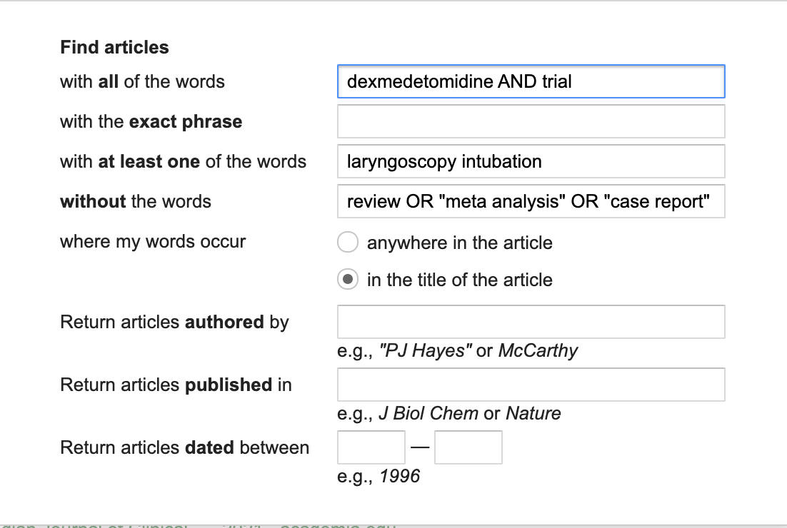

Supplementary file 2: Sensitivity analysis of Heart Rate

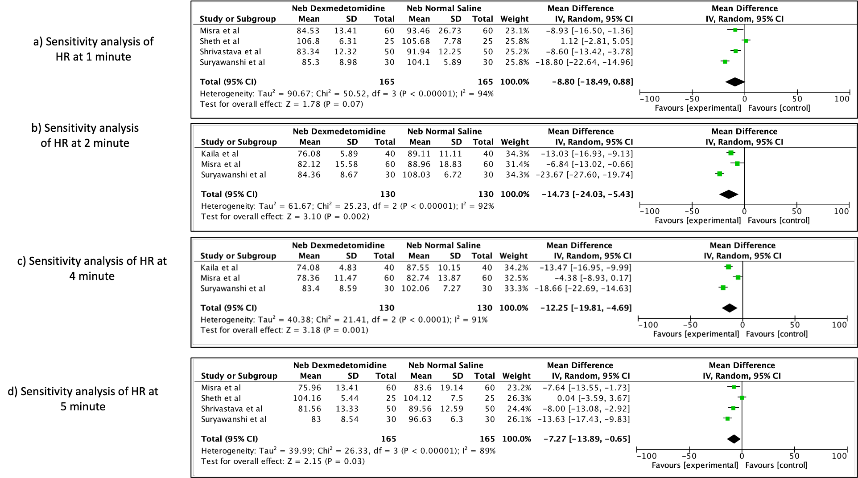

Supplementary file 3: Sensitivity analysis of Systolic Blood Pressure

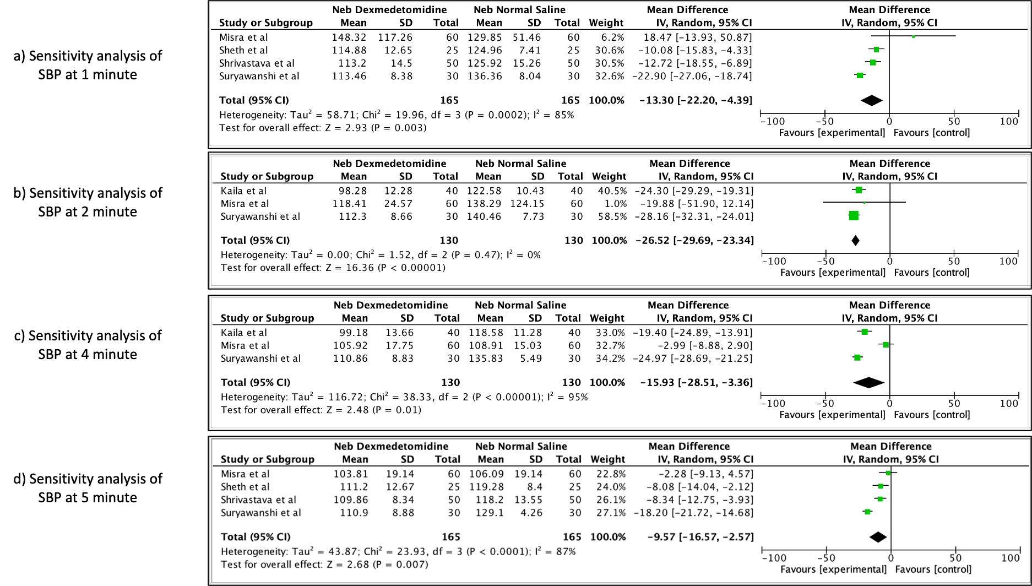

Supplementary file 4: Funnel Plot of HR at 1 minute

