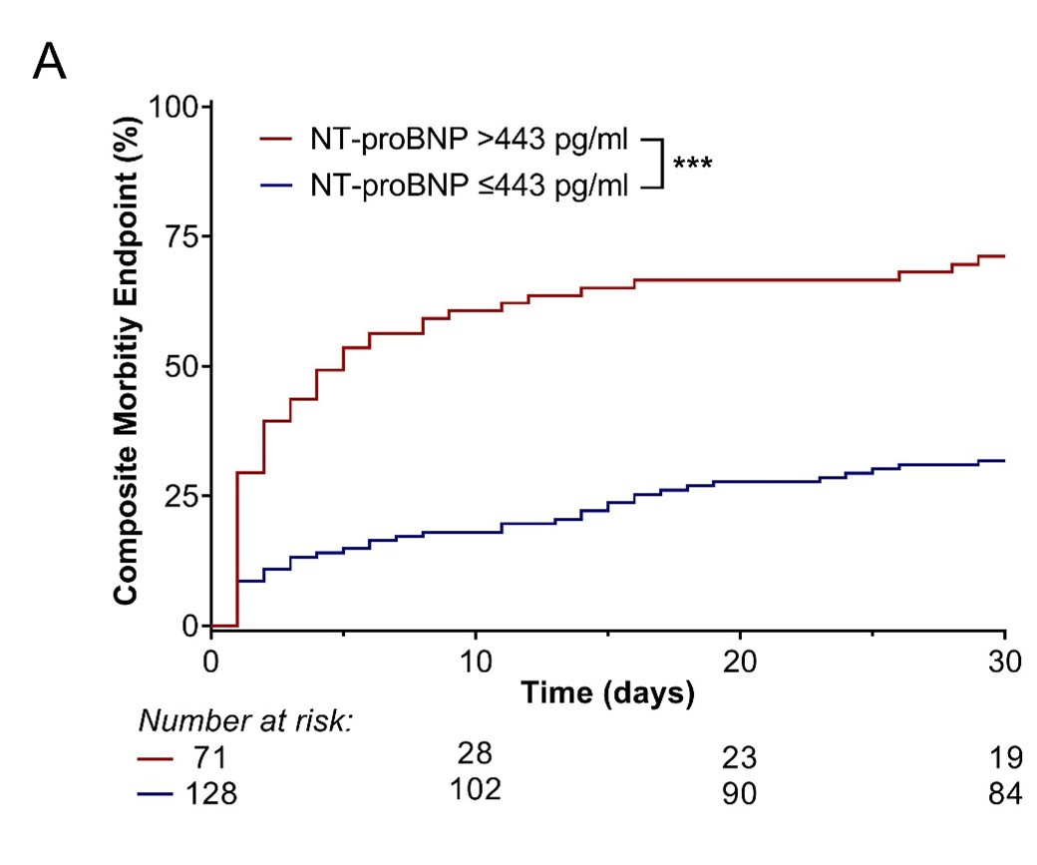
Supplementary Figure 1. A When the calculated NT-proBNP cut-off of 443 pg/ml was used to assess the risk of postoperative morbidity, composite morbidity endpoint rates were largely comparable with the cut-off of 450 pg/ml (NT-proBNP >443 pg/ml: 71.1% vs. NT-proBNP ≤443 pg/ml: 31.8%). ***p < 0.001.

