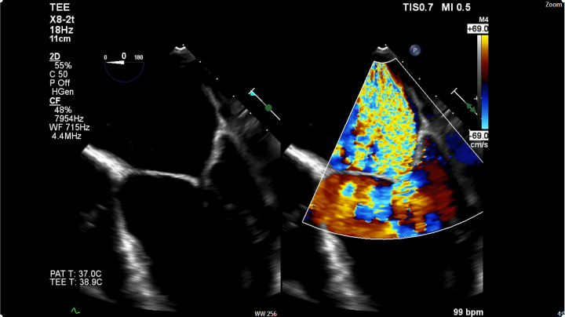
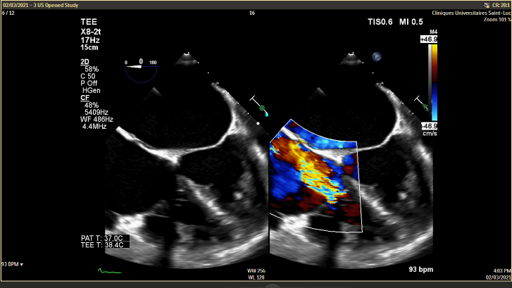
Annexes – Figure and Images
C.
B..
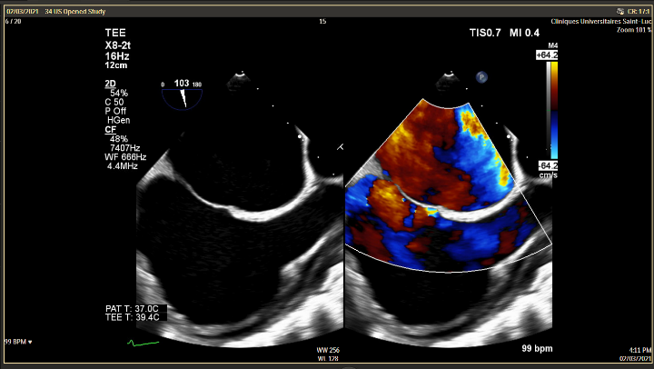
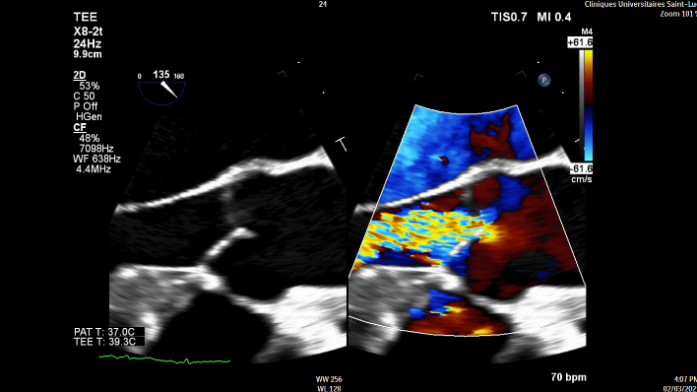
A.
D.
Image 1. Trans-esophageal echocardiographic images. Color Doppler on the different valves. A. Mitral insufficiency with severe mitral regurgitation reaching the atrial roof. B. tricuspid regurgitation. C. severe aortic regurgitation. D. A mid-esophageal bicaval view showing the PFO.

