Supplementary Material

Supplementary Figure-S1 The measure sites of pressure value.

Supplementary Figure-S2 The temperature measurement of the heater outlet.

Supplementary Figure-S3 The equipment of Martindale abrasion resistance test.

Supplementary Figure-S4 American Society for Testing and Materials grades.

Supplementary Figure-S5 The number of holes per unit area of FAW blanket.

Supplementary Figure-S6 Hole observation test (cell phone microscope hole observation, with or without fiber drift)

Supplementary Figure-S7 Trend graph of the heater outlet temperature over time in four groups.
Supplementary Figure S-8 The ASTM grade level of four groups after 5 cycles of friction.
Supplementary Figure S-9 Hole observation test results.
Supplementary Figure-S10 Comparison of MAP between the four groups. MAP= mean arterial pressure.
Supplementary Figure-S11 Comparison of HR between the four groups. HR= heart rate.
Supplementary Table-S1 Temperature of different parts of the manikin model.

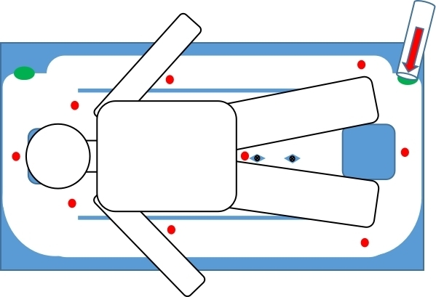

Supplementary Figure-S1 The measure sites of pressure value.

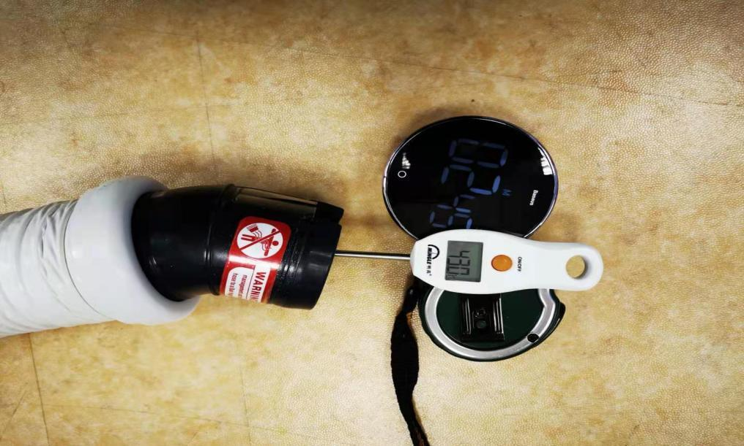

Supplementary Figure-S2 The temperature measurement of the heater outlet.

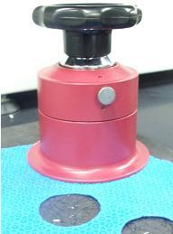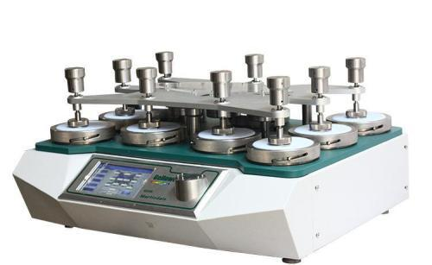

Supplementary Figure-S3 The equipment of Martindale abrasion resistance test.

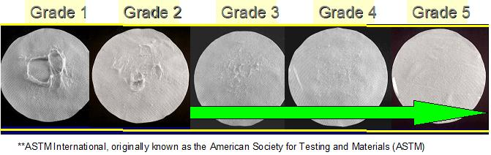

Supplementary Figure-S4 American Society for Testing and Materials grades.

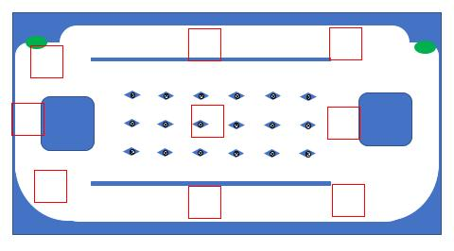

Supplementary Figure-S5 The number of holes per unit area of FAW blanket

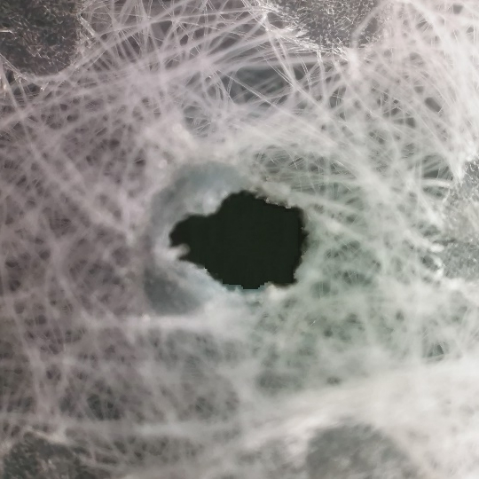

Supplementary Figure-S6 Hole observation test (cell phone microscope hole observation, with or without fiber drift)

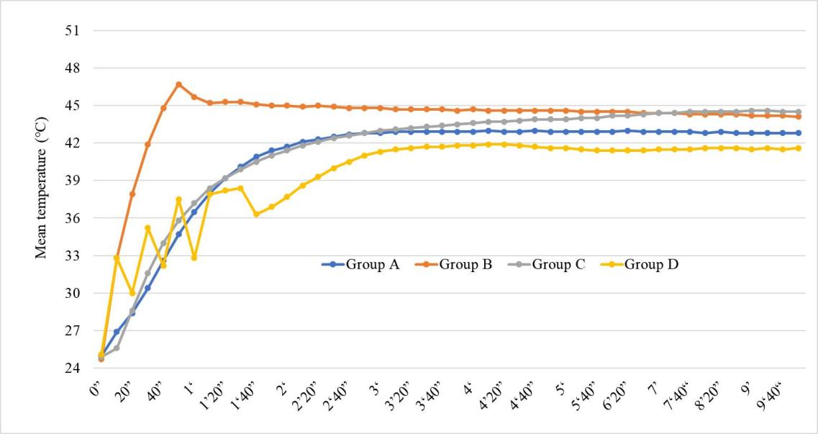

Supplementary Figure-S7 Trend graph of the heater outlet temperature over time in four groups.

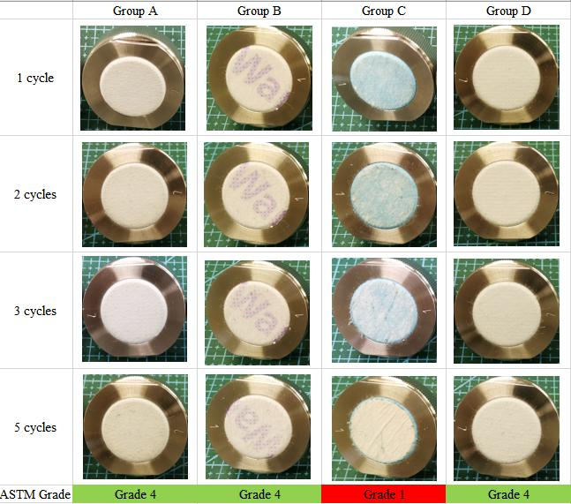

Supplementary Figure S-8 The ASTM grade level of four groups after 5 cycles of friction

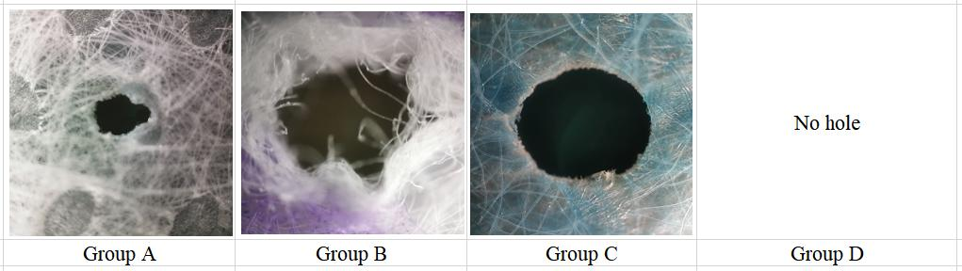

Supplementary Figure S-9 Hole observation test results

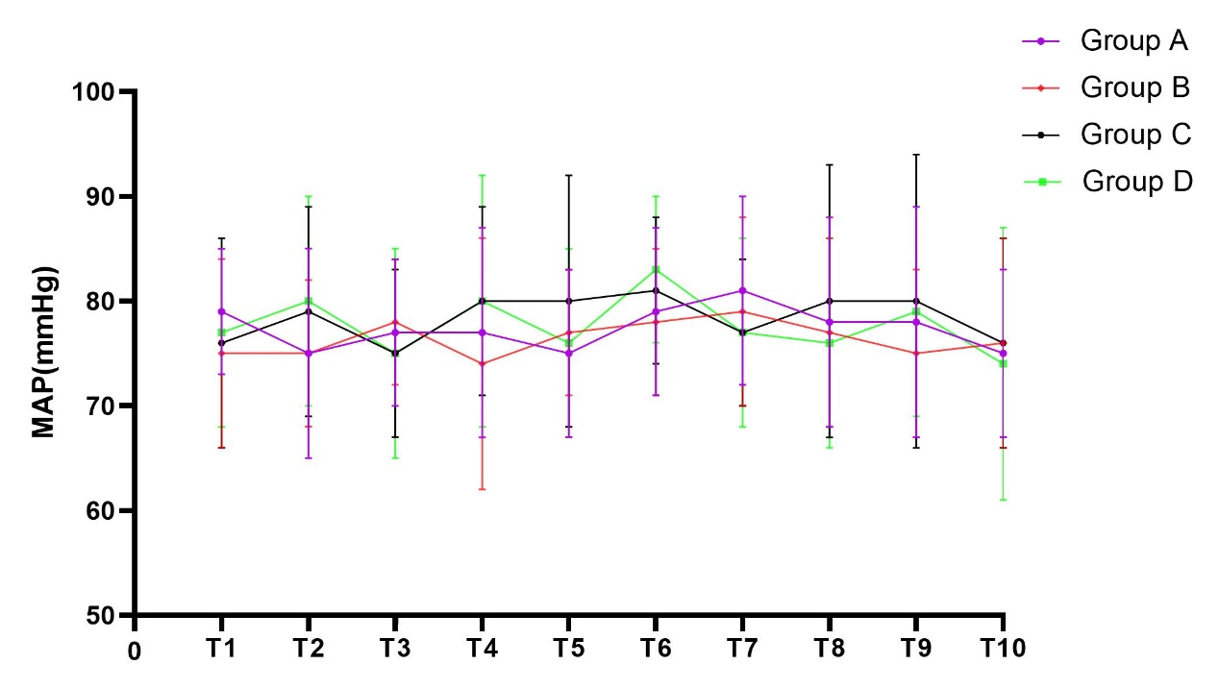Supplementary Figure-S10 Comparison of MAP between the four groups. MAP= mean arterial pressure.

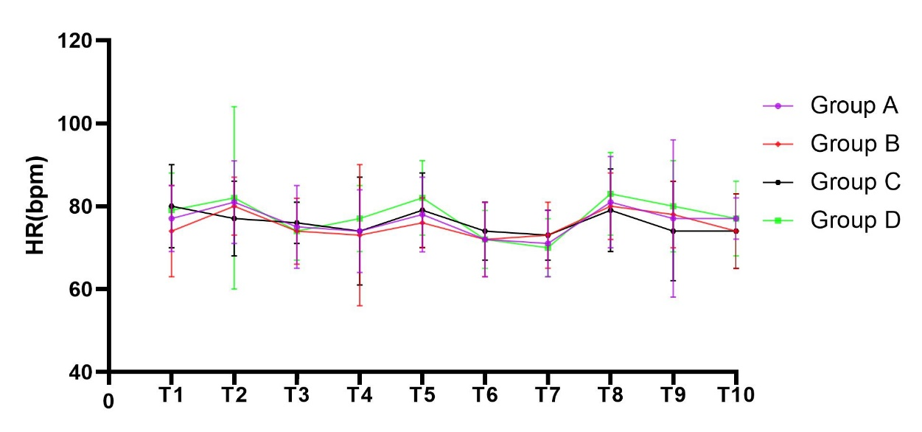

Supplementary Figure-S11 Comparison of HR between the four groups. HR= heart rate.

Supplementary Table-S1 Temperature of different parts of the manikin model

 | Group A | Group B | Group C | Group D | P-value
T1 | 35.98±3.27 | 32.48±3.44 | 29.84±3.11 | 33.44±2.93 | <0.001
T2 | 36.55±3.23 | 36.42±3.35 | 32.76±3.31 | 34.72±2.99 | <0.001
T3 | 36.84±3.33 | 38.62±3.17 | 33.45±3.26 | 36.94±2.69 | <0.001
T4 | 34.63±3.25 | 36.04±3.58 | 32.31±3.36 | 34.29±2.89 | <0.001
Average | 36.00±3.26 | 35.89±3.34 | 32.09±3.24 | 34.85±2.85 | <0.001

