Supplementary materials
Supplementary Table 1: Definition of postoperative pulmonary complications according to the European Perioperative Clinical Outcome definitions (EPCO).^{[21]}
Complication | Definition
Respiratory infection | Patient has received antibiotics for a suspected respiratory infection and met one or more of the following criteria: new or changed sputum,  new or changed lung opacities, fever, white blood cell count > 12×10⁹/L
Respiratory failure | Postoperative PaO₂ < 8 kPa (60mmHg) on room air, a PaO₂/Fi0₂ ratio <40 kPa (300mmHg) or arterial oxyhaemoglobin saturation measured with pulse oximetry < 90% and requiring oxygen therapy
Pleural effusion | Chest radiograph demonstrating blunting of the costophrenic angle, loss of sharp silhouette of the ipsilateral hemidiaphragm in upright position, evidence of displacement of adjacent anatomical structures or (in supine position) a hazy opacity in one hemithorax with preserved vascular shadows
Atelectasis | Lung opacification with a shift of the mediastinum, hilum or hemidiaphragm toward the affected area, and compensatory over-inflation in the adjacent non-atelectatic lung
Pneumothorax | Air in the pleural space with no vascular bed surrounding the visceral pleura
Bronchospasm | Newly detected expiratory wheezing treated with bronchodilators
Aspiration pneumonitis | Acute lung injury after the inhalation of regurgitated gastric contents

Supplementary Table 2: Postoperative pulmonary complications within seven days after surgery, length of hospital stay, ICU admission and 30-day mortality.
Variables | TEA group  (n=30) | Conventional group  (n=30) | P value
Secondary outcome
PPCs | 8(26.7%) | 12(40.0%) | 0.273
Respiratory failure | 0（0%） | 1（3.3%） | 0.313
Atelectasis | 5（16.7%） | 12（40.0%） | 0.045
Pleural effusion | 6（20%） | 9（30%） | 0.371
Respiratory infection | 6（20%） | 11（36.7%） | 0.152
Bronchospasm | 0（0%） | 0（0%） | NA
Aspiration pneumonitis | 0（0%） | 1（3.3%） | 0.313
Pneumothorax | 0（0%） | 0（0%） | NA
Length of hospital stay  ICU admission | 16.00[12.00-22.00]  3 (10%) | 15.00[11.75-19.25] | 0.382
Length of hospital stay  ICU admission | 16.00[12.00-22.00]  3 (10%) | 2 (6.7%) | 0.640
30-day mortality | 0 (0%) | 1 (3.3%) | 0.313
Data are expressed as number (percentage). TEA, thoracic epidural anesthesia; PPCs, postoperative pulmonary complications.

Supplementary Table 3: Characteristics of intraoperative Ventilator Parameters.
Variables | TEA group  (n=30) | Conventional group  (n=30) | P value
ΔP (cmH₂O)  T1  T2  T3 | 11.23±2.19  9.45±1.79  12.35±1.60 | 12.67±2.70  10.48±2.18  14.00±2.10 | 0.028  0.109  0.007
Individualized PEEP (cmH₂O)  T1  T2  T3 | 9[8-10]  6.5[5-7]  10[9-10] | 9[7-10]  7[6-8]  10[9.5-11] | 0.844  0.150  0.246
P_{plat} (cmH₂O)  T1  T2  T3 | 20±3.27  15.65±3.07  21.5[20-24] | 21.5±3.71  17.33±3.24  24[21-25] | 0.102  0.096  0.106
P_{peak} (cmH₂O)  T1  T2  T3 | 21.7±3.51  18.9±3.67  21.6±3.28 | 23.07±4.19  19.1±4.23  22.8±3.28 | 0.176  0.233  0.365
C_{RS} (ml/cmH₂O)  T1  T2  T3 | 43.37±5.31  47.90±5.61  41.70±5.59 | 40.37±6.02  44.43±5.25  37.38±5.70 | 0.045  0.047  0.019
T1, first titration; T2, when pneumoperitoneum is stopped for open specimen retrieval; T3, when pneumoperitoneum is re-established for intraperitoneal hemostasis. TEA, thoracic epidural anesthesia; ΔP,driving pressure; PEEP, positive end-expiratory pressure; Ppeak, peak airway pressure; Pplat, plateau pressure; C_{RS}, respiratory system compliance.

Supplementary Table 4: Characteristics of intraoperative arterial blood gas analysis.
Variables | TEA group  (n=30) | Conventional group  (n=30) | P value
pH | 7.36±0.55 | 7.37±0.58 | 0.447
PaO₂ | 322.67±67.083 | 283.33±75.249 | 0.037
PaCO₂ | 36.73±5.581 | 36.23±4.166 | 0.620
Arterial blood gas analysis was performed 30 min after the completion of the first individualized PEEP titration. TEA, thoracic epidural anesthesia.

Supplementary Table 5: Univariate and Multivariate Logistic Regression Analysis of Factors Associated with Postoperative Pulmonary Complications.
Variables | Crude OR (95% CI) | P value | Adjusted OR(95%CI) | P value
TEA application (yes) | 0.545 (0.183 to 1.623) | 0.276
ΔP (per 1cmH₂O) | 1.916 (1.006 to 1.086) | 0.000 | 2.190 (1.300 to 3.689) | 0.003
Age (per 1 year) | 1.045 (0.841 to 1.082) | 0.025 | 0.930 (0.858 to 1.009) | 0.081
Sex (female） | 0.603 (0.203 to 1.792) | 0.363
BMI (per unit) | 0.950 (0.811 to 1.112) | 0.519
Smoking status (no) | 3.273 (0.013 to 10.578) | 0.048 | 1.463 (0.245 to 8.758) | 0.677
Hemoglobin (per unit) | 1.001 (0.978 to 1.025) | 0.910
Serum bilirubin (per unit) | 1.015 (0.973 to 1.059) | 0.491
Serum creatinine (per unit) | 1.026 (0.986 to 1.067) | 0.202
Serum albumin (per unit) | 0.957 (0.853 to 1.074) | 0.458
Left ventricle ejection fraction, % (per unit) | 0.859 (0.780 to 0.945) | 0.002 | 0.913 (0.802 to 1.039) | 0.165
ALT (per unit) | 1.002 (0.993 to 1.010) | 0.713
AST (per unit) | 1.004 (0.995 to 1.012) | 0.433
Surgical method (laparoscopic） | 1.123 (0.351 to 3.594) | 0.844
Preoperative comorbidities (yes) | 4.333 (1.364 to 13.770) | 0.013 | 7.007 (0.918 to 54.505) | 0.060
Duration of surgery (per unit) | 1.002 (0.996 to 1.007) | 0.583
Total fluid volume (per unit) | 1.000 (0.999 to 1.001) | 0.985
Colloid (per unit) | 1.000 (0.999 to 1.001) | 0.935
Abbreviations: TEA, thoracic epidural anesthesia; ΔP, driving pressure; BMI, body mass index; ALT, alanine aminotransferase; AST, aspartate aminotransferase; CI, confidence interval; OR, odds ratio.

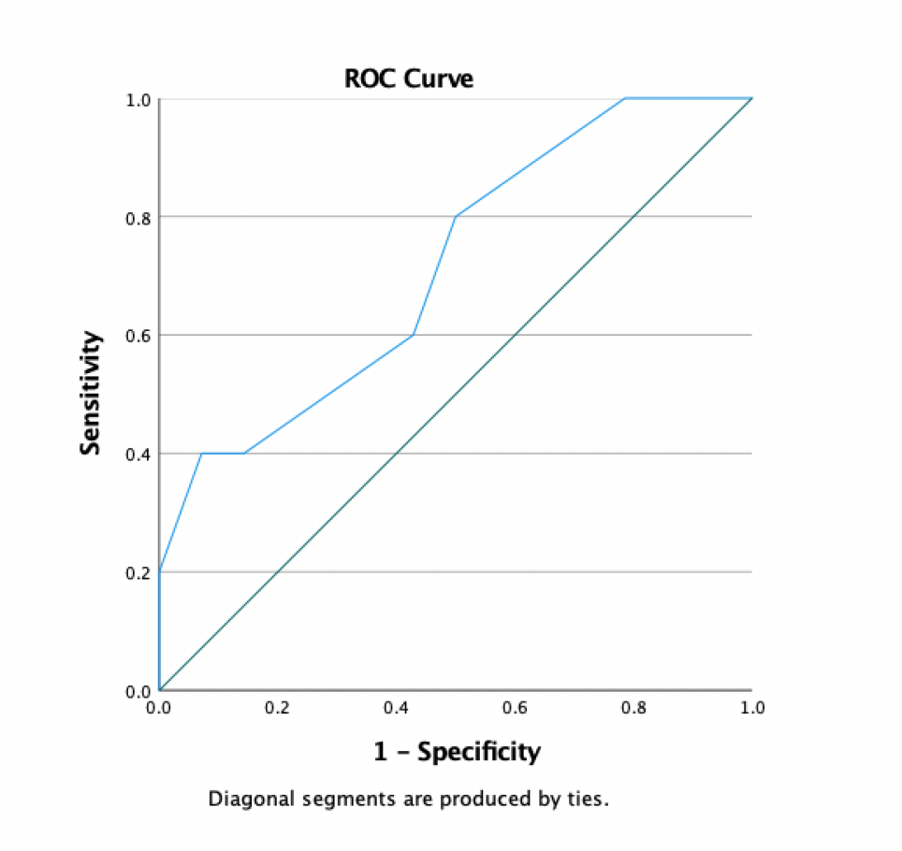、
Supplementary Figure 1: Receiver Operating Characteristic (ROC) curve for ΔP in predicting PPCs, with an area under the curve (AUC) of 0.83 and a ΔP cut-off value of 12.5 cmH₂O.

