SUPPLEMENTARY CONTENT
Kömürcü O, Genç C, Çiftçi Kurt B, Demir O, Akbaş A, Akyurt D, Selçuk Kuşderci H, Tulgar S, Süren M,
Preoperative evaluation: Impact on early perioperative hemodynamic and respiratory complications
Appendix: Definitions of Comorbidities, Outcomes, and Other Relevant Variables.
References
Tables
Figures
All variables.
This supplementary material has been provided by the authors to give readers additional information about their work
Appendix. Definitions of Comorbidities, Outcomes, and Other Relevant Variables.
1. Definitions of comorbidities, as determined by the presence in the preoperative interview or medical record of the following diagnoses:¹
A. Hypertension: hypertension, high blood pressure;
B. Coronary artery disease: myocardial infarct; heart attack; angina; history of interventional
angioplasty or Coronary Artery Bypass Graft surgery;
C. Chronic Obstructive Pulmonary Disease: COPD, chronic bronchitis, emphysema;
D. Asthma: asthma, reactive airway disease;
E. Sleep Apnea: sleep apnea, OSA, Apnea Hypopnea Index (AHI) 15 or AHI 5 with OSA
symptoms, presence of > 3 STOP BANG criteria (Snoring, Tiredness, Observed nocturnal
apnea; hypertension, BMI > 35, Age > 50 yo, thick Neck or circumference > 40cm / 16in,
Gender male);
F. Smoking history: smoking
G. Renal Failure: acute or chronic renal failure
2. Other relevant definitions:
A. Body Mass Index (BMI) was calculated as height(m) x weight(kg)-2.
B. Medications were collected as current if they had been used during the 30 days prior to
surgery.
C. Length of surgery: start (incision) time to end surgery end time
D. Length of Post Recovery Care Unit: The time between the patient's admission to the recovery room and the patient's transfer to the service room or intensive care unit.
3. Postoperative Outcomes
A. Respiratory and hemodynamic complications (intraoperative and within 24 hours from surgery end):^{2,3}
1. Respiratory Complications
- When postoperative pulse oximetry <90% and requiring oxygen therapy.
- Unplanned intubation with postoperative mechanical ventilation (POMV), defined as placement of a breathing tube that was not intended or planned, excluding instances of intubation during an unplanned return to the operating room. Also excluded those patients that were transferred intubated and ventilated to the intensive care unit (ICU) from the operating room.
- Bronchospasm, defined as presence in medical chart of bronchospasm and/or wheezing + bronchodilators (not bronchodilators alone).
2. Hemodynamic Complications
- Hypertension; systolic arterial pressure >160 mm Hg
- Hypotension; mean arterial pressure < 65 mmHg
- Cardiac arrhythmia:
  - Bradycardia: heart rate < 60 beats/minute
  - Tachycardia: heart rate > 100 beats/minute
  - Arrhythmia: Irregular heartbeat detected on ECG
- Acute Coronary syndrome; ECG changes and/or cardiac enzyme elevation accompanied by chest pain
B. Hospital time: Postoperative hospital time

References
1. Fernandez-Bustamante A, Frendl G, Sprung J, et al. Postoperative Pulmonary Complications, Early Mortality, and Hospital Stay Following Noncardiothoracic Surgery: A Multicenter Study by the Perioperative Research Network Investigators. JAMA Surg. Feb 1 2017;152(2):157-166. doi:10.1001/jamasurg.2016.4065
2. Chandler D, Mosieri C, Kallurkar A, et al. Perioperative strategies for the reduction of postoperative pulmonary complications. Best Practice & Research Clinical Anaesthesiology. 2020/06/01/ 2020;34(2):153-166. doi:https://doi.org/10.1016/j.bpa.2020.04.011
3. Stephenson C, Mohabbat A, Raslau D, Gilman E, Wight E, Kashiwagi D. Management of Common Postoperative Complications. Mayo Clinic Proceedings. 2020/11/01/ 2020;95(11):2540-2554. doi:https://doi.org/10.1016/j.mayocp.2020.03.008

E Table 1: All variables. Study group characteristics and bivariable analysis results.
Variables | All Patients | Group C | Group Non C | p
Demographics
Age median (IQR) | 58.5 (19) | 58 (18.7) | 54.5 (20.2) | < 0.01
Gender Male n (%) | 568 (50.9) | 298 (52.5) | 270 (47.5) | 0.01
Body Mass Index median (IQR) | 27.8 (5.4) | 28.5 (6.6) | 27.6 (4.4) | < 0.01
Comorbidities
Hypertension n (%) | 359 (32.1) | 196 (54.6) | 163 (45.4) | < 0.01
Diabetes n (%) | 190 (17) | 107 (56.3) | 83 (43.7) | 0.02
Coronary Artery Disease n (%) | 116 (10.4) | 65 (56) | 51 (44) | 0.09
Chronic Obstructive  Pulmonary Disease n (%) | 39 (3.5) | 13 (33.3) | 26 (66.7) | 0.04
Asthma n (%) | 53 (4.7) | 35 (66) | 18 (34) | 0.01
Obstructive Sleep Apnea n (%) | 8 (0.7) | 5 (62.5) | 3 (37.5) | 0.43
Chronic Renal Failure n (%) | 9 (0.8) | 6 (66.7) | 3 (33.3) | 0.28
Smoking n (%) | 346 (31) | 164 (47.4) | 182 (52.6) | 0.53
Preoperative Consultations |  |  |  | 0.45
Cardiology n (%) | 197 (17.6) | 116 (58.9) | 81 (41.1)
Chest Disease n (%) | 57 (5.1) | 32 (56.1) | 25 (43.9)
Internal medicine n (%) | 87 (7.8) | 42 (48.3) | 45 (51.7)
Neurology n (%) | 33 (3) | 18 (54.5) | 15 (45.5)
ASA |  |  |  | < 0.01
I | 184 (16.5) | 69 (67.5) | 115 (32.5)
II | 705 (63.1) | 340 (48.2) | 365 (51.8)
III | 228 (20.4) | 136 (59.6) | 92 (40.4)
Surgical Procedure |  |  |  | 0.34
General Surgery n (%) | 270 (24.2) | 134 (49.6) | 136 (50.4)
Urology n (%) | 254 (22.7) | 125 (49.2) | 128 (50.8)
Orthopedics n (%) | 284 (25.4) | 146 (51.4) | 138 (48.6)
Neuro Surgery n (%) | 95 (8.5) | 51 (53.7) | 44 (46.3)
Cardio Vascular Surgery n (%) | 11 (1) | 5 (45.5) | 6 (54.5)
Plastic And Reconstructive  Surgery n (%) | 58 (5.2) | 22 (37.9) | 36 (62.1)
Ear Nose and Throat Surgery n (%) | 126 (11.3) | 56 (44.4) | 70 (55.6)
Eye Surgery n (%) | 13 (1.2) | 3 (23.1) | 10 (76.9)
Obstetrics n (%) | 6 (0.5) | 3 (50) | 3 (50)
Surgery Duration (minute) median (IQR) | 110 (80) | 120 (82.5) | 90 (80) | 0.06
Intraoperative
Anesthesia |  |  |  | 0.36
General n (%) | 603 (54) | 301 (49.9) | 302 (50.1)
Regional n (%) | 514 (46) | 244 (47.4) | 270 (52.6)
Mechanical ventilation
VT (mL) median (IQR) | 500 (40) | 500 (34.5) | 500 (40) | < 0.01
PEEP (cmH₂O) median (IQR) | 5 (1) | 5 (1) | 5 (1) | < 0.01
Plato P median (cmH2O) (IQR) | 17 (7) | 18 (6) | 16.5 (7.2) | 0.05
ΔP median (cmH2O) (IQR) | 12 (5) | 13 (5) | 11 (7.2) | 0.01
Fluid balance (mL) median (IQR) | 1525 (1700) | 1600 (1825) | 1175 (1637) | 0.19
Blood product (IU)
ES n (%) | 10 (0.9) | 6 (60) | 4 (40) | 0.47
FFP n (%) | 2 (0.2) | 1 (50) | 1 (50) | 0.97
Plt n (%) | - | - | - | NA
SpO2 median (IQR) | 96 (5) | 95 (5) | 96 (4) | 0.64
Intraoperative complications
Hypotension n (%) | 235 (19.3) | 235 (19.3) | -
Hypertension n (%) | 143 (12.8) | 143 (12.8) | -
Bradycardia n (%) | 174 (15.6) | 174 (15.6) | -
Tachycardia n (%) | 15 (1.3) | 15 (1.3) | -
Arrhythmia n (%) | 28 (2.5) | 28 (2.5) | -
Hypoxia n (%) | 16 (1.4) | 16 (1.4) | -
Postoperative complications
Hypotension n (%) | 66 (5.9) | 66 (5.9) | -
Hypertension n (%) | 166 (14.9) | 166 (14.9) | -
Bradycardia n (%) | 122 (10.9) | 122 (10.9) | -
Tachycardia n (%) | 24 (2.1) | 24 (2.1) | -
Arrhythmia n (%) | 1 (0.1) | 1 (0.1) | -
Hypoxia n (%) | 119 (10.7) | 119 (10.7) | -
ICU transfer n (%) | 47 (4.2) | 47 (4.2) | -
PACU Duration (minute) median (IQR) | 30 (10) | 30 (13.7) | 30 (15) | 0.34
Hospital Duration (day) median (IQR) | 2 (3) | 2 (3) | 2 (2) | < 0.01

ASA= American Society of Anesthesia; ΔP= Driving Pressure; ES= Erythrocyte suspension; FFP= Fresh frozen plasma; PACU= Post anesthesia care unit; PEEP=Positive End-Expiratory Pressure; Plt= Platelet; PS= Pressure support; SpO2=Peripheral saturation of oxygen VT= Tidal Volüme
E Table 2: Effect of variables on perioperative respiratory complications

 | Beta | SE | OR (95% CI) | p
Age | 0.006 | 0.007 | 1.006 (0.992 - 1.020) | 0.406
Body Mass Index | 0.020 | 0.012 | 1.020 (0.997 - 1.045) | 0.094
Hypertension | 0.144 | 0.220 | 1.154 (0.749 - 1.778) | 0.515
Diabetes | 0.123 | 0.254 | 1.131 (0.782 - 2.777) | 0.629
Coronary Artery Disease | 0.388 | 0.323 | 1.973 (0.666 - 5.842) | 0.230
Chronic Obstructive Pulmonary Disease | 0.679 | 0.554 | 0.482 (0.244 - 0.946) | 0.220
Asthma | -0.732 | 0.345 | 0.466 (0.252 - 0.863) | 0.034
Obstructive Sleep Apnea | -0.665 | 0.867 | 0.514 (0.094 - 2.810) | 0.443
Chronic Renal Failure | -0.458 | 0.720 | 0.632 (0.128 - 3,132) | 0.574
Smoking | 0.223 | 0.212 | 1.249 (0.824 - 1.895) | 0.295
ASA Score | 0.412 | 0.190 | 1.509 (1.040 - 2.191) | 0.030
Preoperative Chest Diseases Consultations | -0.049 | 0.392 | 0.952 (0.442 - 2.053) | 0.901

ASA= American Society of Anesthesia

E Table 3: Effect of variables on perioperative hemodynamics complications
 | Beta | SE | OR (95% CI) | p
Age | 0.004 | 0.005 | 1.004 (0.995 - 1.014 | 0.364
Body Mass Index | -0.002 | 0.010 | 0.998 (0.979 - 1.017) | 0.817
Hypertension | -0.112 | 0.158 | 0.894 (0.656 - 1.218) | 0.478
Diabetes | -0.149 | 0.180 | 0.861 (0.606 - 1.225) | 0.407
Coronary Artery Disease | -0.131 | 0.237 | 0.877 (0.551 - 1.397) | 0.582
Chronic Obstructive Pulmonary Disease | 0.862 | 0.396 | 2.367 (1.089 - 5.146) | 0.030
Asthma | -0.293 | 0.297 | 0.746 (0.417 - 1.335) | 0.324
Obstructive Sleep Apnea | -0.236 | 0.758 | 0.789 (0.179 - 3.487) | 0.755
Chronic Renal Failure | -0.176 | 0.683 | 0.838 (0.220 - 3.197) | 0.796
Smoking | -0.088 | 0.146 | 0.916 (0.687 - 1.221) | 0.549
ASA Score | 0.128 | 0.139 | 1.137 (0.866 - 1.491) | 0.356
Preoperative Cardiology Consultations | -0.092 | 0.195 | 0.912 (0.622 - 1.337) | 0.637

ASA= American Society of Anesthesia
E Table 4: Effect of variables on perioperative complications

 | Beta | SE | OR (95% CI) | p
Age | 0.006 | 0.005 | 1.006 (0.998 - 1.016) | 0.174
Body Mass Index | 0.010 | 0.011 | 1.011 (0.989 - 1.032) | 0.333
Hypertension | -0.025 | 0.155 | 0.976 (0.720 – 1.321) | 0.873
Diabetes | -0.092 | 0.179 | 0.912 (0.643 – 1.295) | 0.607
Coronary Artery Disease | 0.068 | 0.225 | 1.071 (0.689 – 1.663) | 0.761
Chronic Obstructive Pulmonary Disease | 1.146 | 0.362 | 3.145 (1.545 – 6.399) | 0.002
Asthma | -0.763 | 0.314 | 0.466 (0.252 – 0.863) | 0.015
Obstructive Sleep Apnea | -0.705 | 0.786 | 0.494 (0.106 – 2.306) | 0.370
Chronic Renal Failure | -0.428 | 0.720 | 0.652 (0.159 – 2.672) | 0.552
Smoking | 0.042 | 0.142 | 1.043 (0.789 – 1.379) | 0.767
ASA Score | 0.317 | 0.142 | 1.373 (1.041 – 1.813) | 0.025
Preoperative Consultations | -0.129 | 0.157 | 0.879 (0.646 – 1.195) | 0.411

ASA= American Society of Anesthesia

E Figure 1: Flow diagram
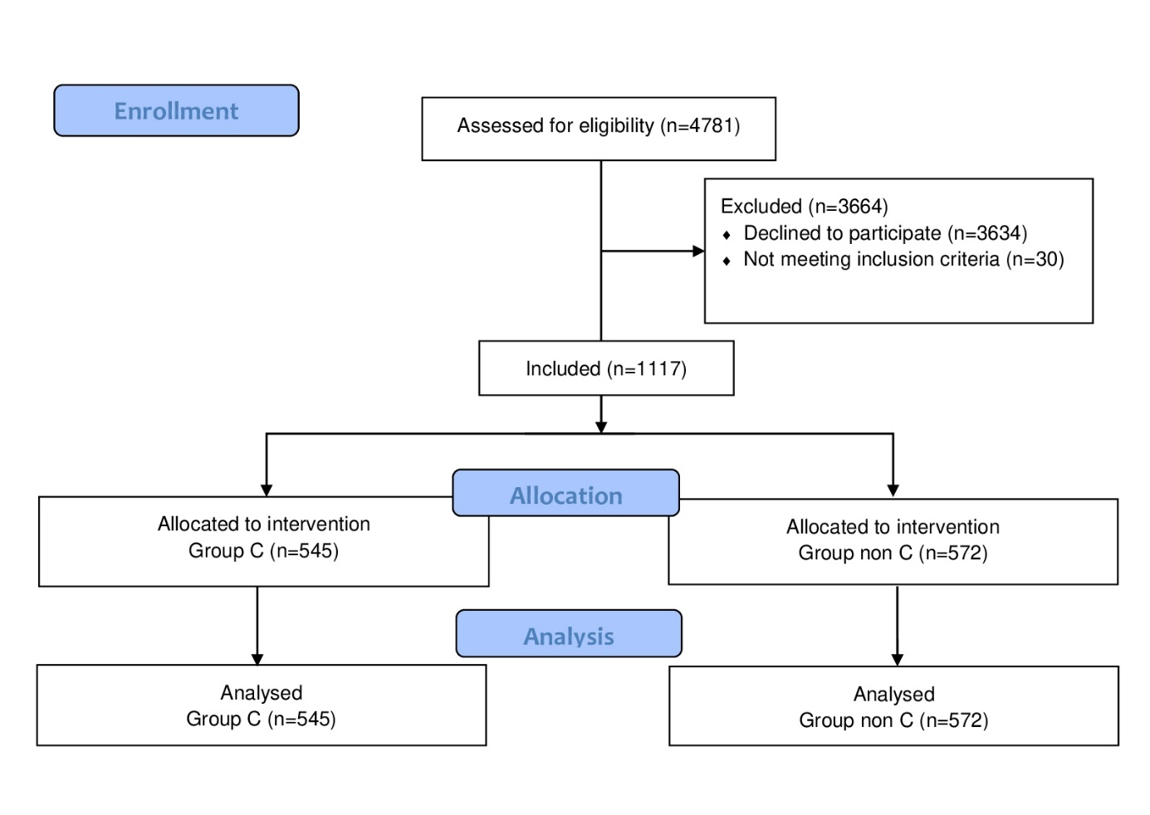Figure 2: Hospital time of the Group’s

