Supplemental table 1. Inclusion sites and number of inclusions
* Level of trauma-care (NL): ranges from 1 – 3, level 1 represents the highest level of trauma-care
** Location closed from 01-07-2019

Inclusion sites | City | Level of traumacare * | Inclusion period | Inclusions
Franciscus Hospital Location Gasthuis | Rotterdam | 2 | Sept. 2018 – Apr. 2020 | 689
Franciscus Hospital Location Vlietland | Schiedam | 3 | Sept. 2018 – Apr. 2020 | 226
Amsterdam University Medical Centre location AMC | Amsterdam | 1 | Aug. 2018 – Apr. 2020 | 30
Amsterdam University Medical Centre location VU | Amsterdam | 1 | Dec. 2018 – Nov 2019 | 71
Maasstad Hospital | Rotterdam | 2 | Jan. 2019 – Apr. 2020 | 157
Catharina hospital | Eindhoven | 2 | Dec. 2018 – Apr. 2020 | 147
Haaglanden Medical Centre - Westeinde | Den Haag | 1 | Jan. 2019 – Apr. 2019 | 15
Haaglanden Medical Centre – Bronovo ** | Den Haag | 2 | Jan. 2019 – Apr. 2019 | 2
Albert Schweitzer Hospital Dordwijk | Dordrecht | 2 | Nov. 2018 – Mar. 2019 | 7
Albert Schweitzer Hospital Zwijndrecht | Zwijndrecht | 3 | Nov. 2018 – Mar. 2019 | 13
Zuyderland Medical Centre - Sittard-Geleen | Sittard-Geleen | 3 | Feb. 2019 – Dec. 2019 | 45
Zuyderland Medical Centre - Heerlen | Heerlen | 2 | Feb. 2019 – Dec. 2019 | 65
Reinier de Graaf Hospital | Delft | 2 | Apr. 2019 – Aug. 2019 | 157
Leiden University Medical Centre | Leiden | 1 | Dec. 2019 – Apr. 2020 | 246
Erasmus Medical Centre | Rotterdam | 1 | Oct. 2019- Apr. 2020 | 90

Supplemental table 2. RAND 36-item Short Form Survey, question 7

How much bodily pain did you experienced during the past 4 weeks? | Score
None | 6
Very mild | 5
Mild | 4
Moderate | 3
Severe | 2
Very severe | 1

Supplemental table 3. RAND 36-item Short Form Survey, question 8.

During the past 4 weeks, how much did pain interfere with your normal work (including both work outside the home and housework)? | Score
Not at all | 5
A little bit | 4
Moderately | 3
Quite a bit | 2
Extremely | 1

Supplemental table 4. Questions and questionnaires of PRACTICE study.

Abbreviations:
NRS: numerating rating scale
SF-36: RAND 36-item Short Form Survey
EQ-5D-5L: Euroqol-5D-5L

Day | NRS of pain | Patient characteristics | EQ-5D-5L | SF-36
ED-visit (0) | √ | √
1 - 6 | √ | √
7 | √ |  | √
90 | √ |  | √ | √
180 | √ |  | √ | √

Supplemental Table 5. Specification of regression models used for multiple imputation using the mice package in R.
Number and percentage of missing values per variable are shown. Imputations were performed on the total number of n=1906 patients. Missings in outcome NRS at 90 days were imputed.

Abbreviations:
Logreg: logistic regression
Passive: passive imputation
Pmm: Predictive mean matching
Polr: proportional odds logistic regression
Polyreg: Bayesian polytomous regression

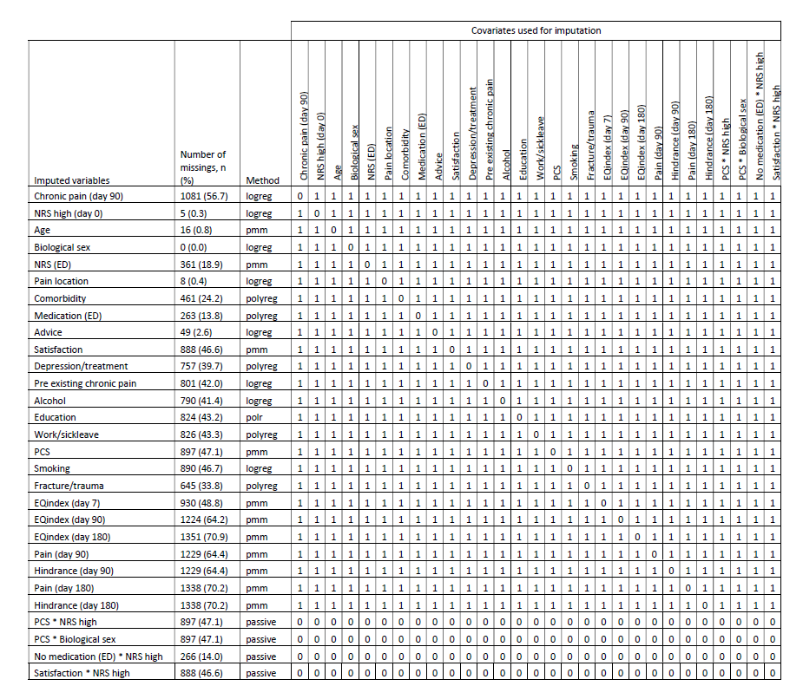

Supplemental table 6. Triage color and type of comorbidity.

 | Non-Responders  n = 1081 | Responders  n = 825 | P-value | NRS 0  n = 266 | NRS ≥ 1  n = 559  (chronic pain) | P-value
ED visit characteristics  Triage color MTS  (n, (%))  Blue  Green  Yellow  Orange  Red  Not registered | 11/1081 (1.0)  614/1081 (56.8)  333/1081 (30.8)  93/1081 (8.6)  0/1081 (0.0)  25/1081 (2.3) | 5/825 (0.6)  485/825 (58.8)  268/825 (32.5)  55/825 (6.7)  0/825 (0.0)  11/825 (1.3) | 0.329  0.384  0.434  0.118  N/A  0.120 | 0/266 (0.0)  166/266 (62.4)  76/266 (28.6)  20/266 (7.5)  0/266 (0.0)  3/266 (1.1) | 5/559 (0.9)  319/559 (57.1)  192/559 (34.4)  35/559 (6.3)  0/559 (0.0)  8/559 (1.4) | 0.122  0.145  0.098  0.498  N/A  1.000
Type of comorbidity (n (%))  COPD/Asthma  CVA/ACS  Diabetes  mellitus  Chronic kidney  failure  Chronic liver  failure  Oncologic  Other  None  Not registered | 57/864 (6.6)  32/864 (3.7)  52/864 (6.0)  9/864 (1.0)  0/864 (0.0)  27/864 (3.1)  307/864 (35.5)  386/864 (44.7)  76/864 (8.8) | 40/707 (5.7)  27/707 (3.8)  25/707 (3.5)  7/707 (1.0)  3/707 (0.4)  11/707 (1.6)  222/707 (31.4)  368/707 (52.1)  50/707 (7.1) | 0.441  0.905  0.023  0.919  0.091  0.044  0.085  0.004  0.211 | 13/228 (5.7)  14/228 (6.1)  5/228 (2.2)  3/228 (1.3)  1/228 (0.4)  3/228 (1.3)  58/228 (25.4)  128/228 (56.1)  16/228 (7.0) | 27/479 (5.6)  13/479 (2.7)  20/479 (4.2)  4/479 (0.8)  2/479 (0.4)  6/479 (1.7)  164/479 (34.2)  240/479 (50.1)  34/479 (7.1) | 0.972  0.026  0.182  0.687  1.000  1.000  0.018  0.133  0.969

