Online Data Supplement 1
Oxygenation
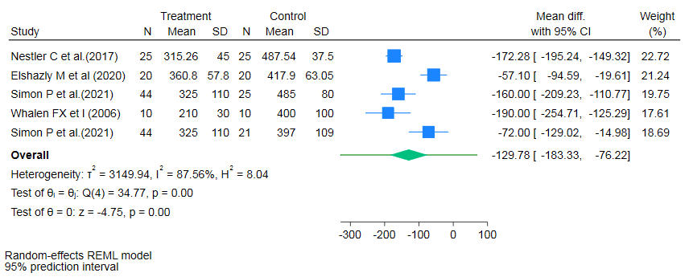
Figure S1. Forest plot for estimation of the predictive interval of true effect on PaO₂/FiO₂ for LPEEP vs HPEEP.
Data are presented as standardized mean difference and 95% confidence intervals and 95% predictive intervals. The diamond symbolises the summary estimate, which represents the combined effect size of all included studies. It provides an overall measure of the difference in PaO2/FiO2 outcomes between low PEEP and high PEEP.
Abbreviations: I²: the ratio of excess dispersion to total dispersion; SMD: standardized mean difference; CI: confidence interval; PaO2/FiO2: arterial oxygen partial pressure to fractional inspired oxygen ratio; LPEEP – low positive end-expiratory pressure; HPEEP – high positive end-expiratory pressure.

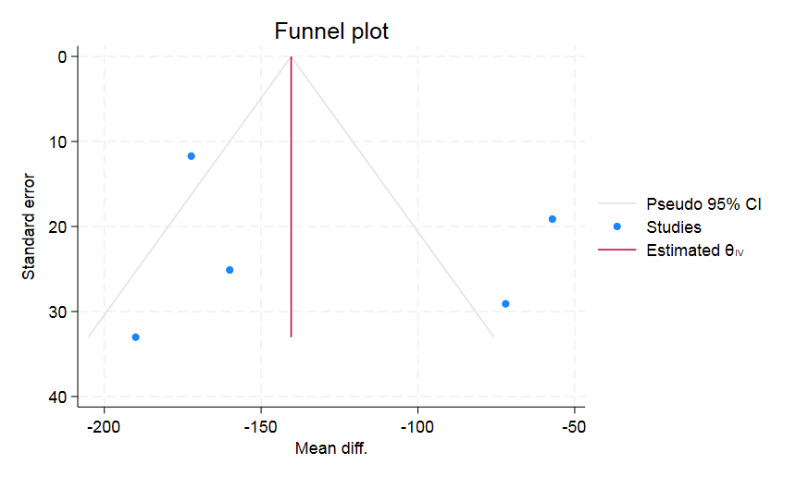

Figure S2. Funnel plot of publication bias in PaO2/FiO2 for LPEEP vs HPEEP
А funnel plot of effect size and standard error of effect size in PaO2/FiO2 for LPEEP vs HPEEP. The triangular lines on both sides of the summary estimate represent the precision measures, such as pseudo 95 % confidence intervals. The middle solid line indicates the overall effect of the meta-analysis. Each dot represents the individual study.
Abbreviations: PaO2/FiO2: arterial oxygen partial pressure to fractional inspired oxygen ratio; LPEEP – low positive end-expiratory pressure; HPEEP – high positive end-expiratory pressure.
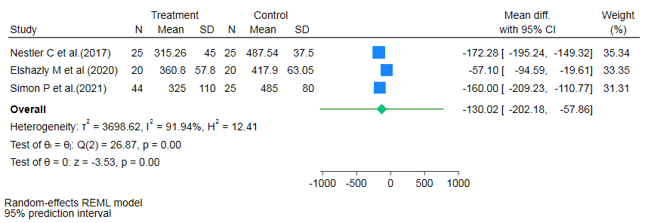
Figure S3. Forest plot for estimation of the predictive interval of true effect on PaO₂/FiO₂ for LPEEP vs iPEEP.
Data are presented as standardized mean difference and 95% confidence intervals and 95% predictive intervals. The diamond symbolises the summary estimate, which represents the combined effect size of all included studies. It provides an overall measure of the difference in PaO2/FiO2 outcomes between low PEEP and individualized PEEP.
Abbreviations: I²: the ratio of excess dispersion to total dispersion; SMD: standardized mean difference; CI: confidence interval; PaO2/FiO2: arterial oxygen partial pressure to fractional inspired oxygen ratio; LPEEP – low positive end-expiratory pressure; iPEEP – individualized positive end-expiratory pressure.
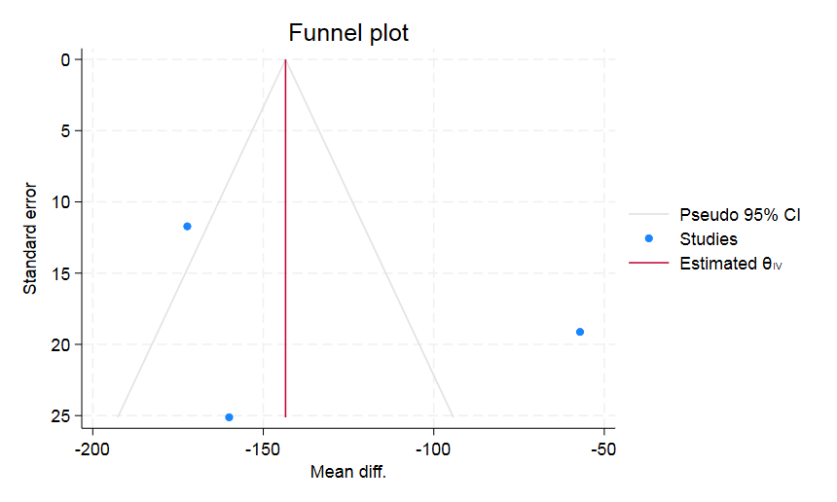
Figure S4. Funnel plot of publication bias in PaO2/FiO2 for LPEEP vs iPEEP
А funnel plot of effect size and standard error of effect size in PaO2/FiO2 for LPEEP vs iPEEP. The triangular lines on both sides of the summary estimate represent the precision measures, such as pseudo 95 % confidence intervals. The middle solid line indicates the overall effect of the meta-analysis. Each dot represents the individual study.
Abbreviations: PaO2/FiO2: arterial oxygen partial pressure to fractional inspired oxygen ratio; LPEEP – low positive end-expiratory pressure; iPEEP – individualized positive end-expiratory pressure.

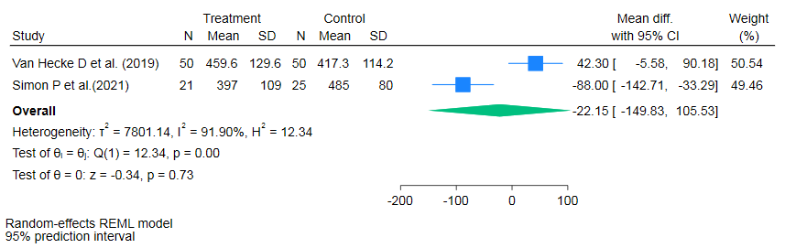
Figure S5. Forest plot for estimation of the predictive interval of true effect on PaO₂/FiO₂ for HPEEP vs iPEEP.
Data are presented as standardized mean difference and 95% confidence intervals and 95% predictive intervals. The diamond symbolises the summary estimate, which represents the combined effect size of all included studies. It provides an overall measure of the difference in PaO2/FiO2 outcomes between high PEEP and individualized PEEP.
Abbreviations: I²: the ratio of excess dispersion to total dispersion; SMD: standardized mean difference; CI: confidence interval; PaO2/FiO2: arterial oxygen partial pressure to fractional inspired oxygen ratio; HPEEP – high positive end-expiratory pressure; iPEEP – individualized positive end-expiratory pressure.
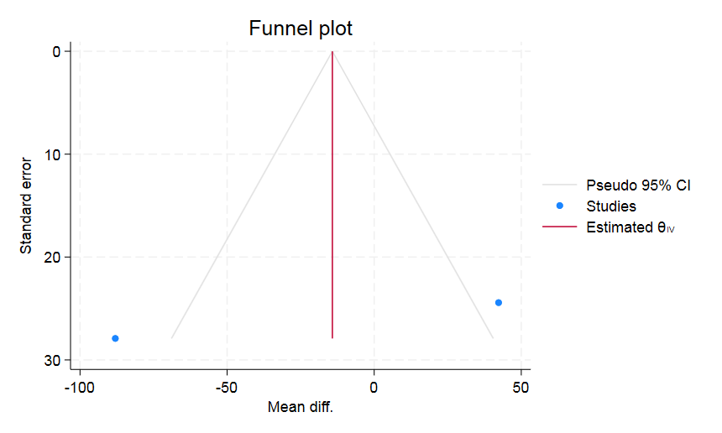

Figure S6. Funnel plot of publication bias in PaO2/FiO2 for HPEEP vs iPEEP
А funnel plot of effect size and standard error of effect size in PaO2/FiO2 for HPEEP vs iPEEP. The triangular lines on both sides of the summary estimate represent the precision measures, such as pseudo 95 % confidence intervals. The middle solid line indicates the overall effect of the meta-analysis. Each dot represents the individual study.
Abbreviations: PaO2/FiO2: arterial oxygen partial pressure to fractional inspired oxygen ratio; HPEEP – high positive end-expiratory pressure; iPEEP – individualized positive end-expiratory pressure.

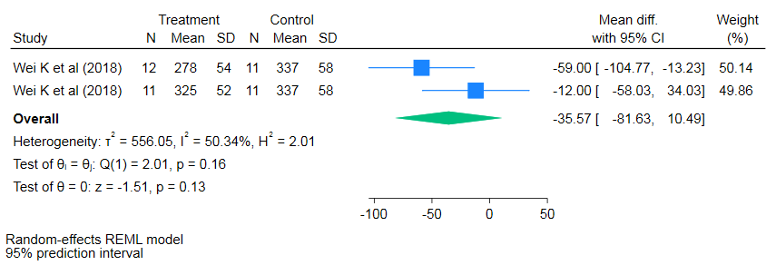
Figure S7. Forest plot for estimation of the predictive interval of true effect on PaO₂/FiO₂ for LPEEP vs MPEEP.
Data are presented as standardized mean difference and 95% confidence intervals and 95% predictive intervals. The diamond symbolises the summary estimate, which represents the combined effect size of all included studies. It provides an overall measure of the difference in PaO2/FiO2 outcomes between low PEEP and moderate PEEP.
Abbreviations: I²: the ratio of excess dispersion to total dispersion; SMD: standardized mean difference; CI: confidence interval; PaO2/FiO2: arterial oxygen partial pressure to fractional inspired oxygen ratio; LPEEP – low positive end-expiratory pressure; MPEEP – moderate positive end-expiratory pressure.
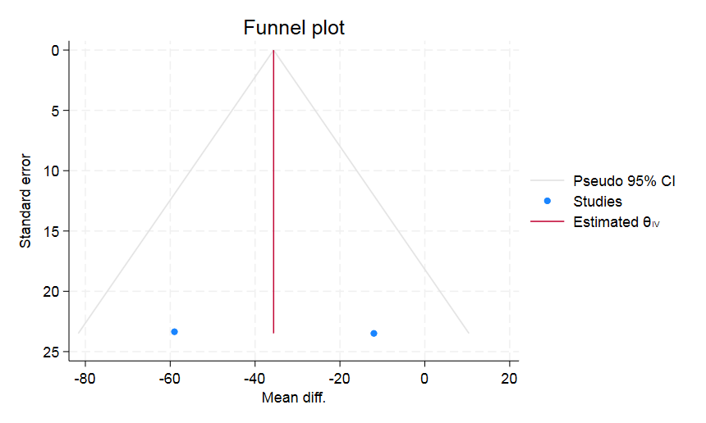

Figure S8. Funnel plot of publication bias in PaO2/FiO2 for LPEEP vs MPEEP
А funnel plot of effect size and standard error of effect size in PaO2/FiO2 for LPEEP vs MPEEP. The triangular lines on both sides of the summary estimate represent the precision measures, such as pseudo 95 % confidence intervals. The middle solid line indicates the overall effect of the meta-analysis. Each dot represents the individual study.
Abbreviations: PaO2/FiO2: arterial oxygen partial pressure to fractional inspired oxygen ratio; LPEEP – low positive end-expiratory pressure; MPEEP – moderate positive end-expiratory pressure.

Dynamic compliance
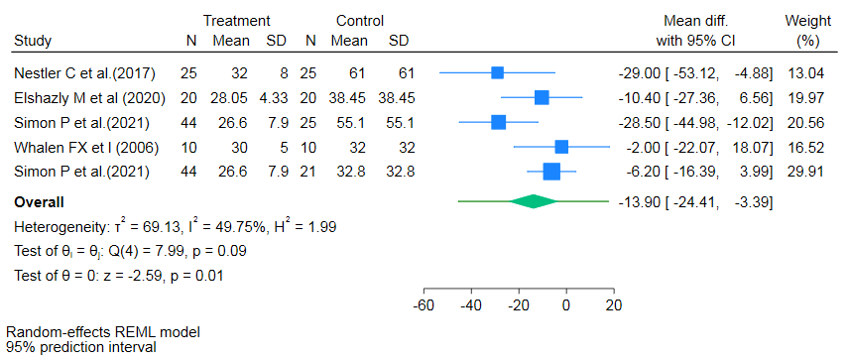
Figure S9. Forest plot for estimation of the predictive interval of true effect on Cdyn for LPEEP vs HPEEP.
Data are presented as standardized mean difference and 95% confidence intervals and 95% predictive intervals. The diamond symbolises the summary estimate, which represents the combined effect size of all included studies. It provides an overall measure of the difference in Cdyn outcomes between low PEEP and high PEEP.
Abbreviations: I²: the ratio of excess dispersion to total dispersion; SMD: standardized mean difference; CI: confidence interval; Cdyn: dynamic compliance; LPEEP – low positive end-expiratory pressure; HPEEP – high positive end-expiratory pressure.

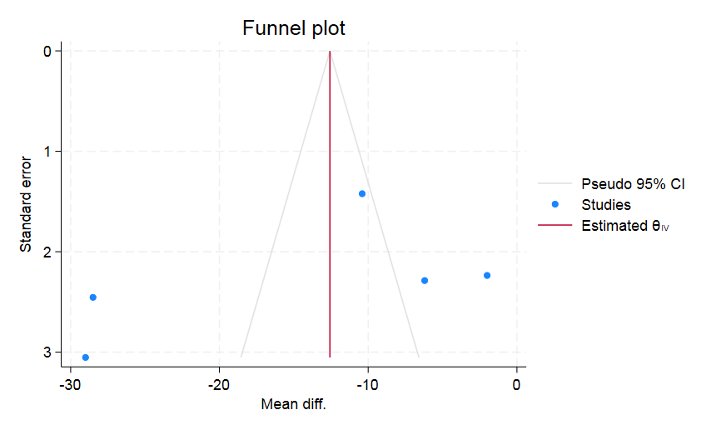
Figure S10. Funnel plot of publication bias in Cdyn for LPEEP vs HPEEP
А funnel plot of effect size and standard error of effect size in Cdyn for LPEEP vs HPEEP. The triangular lines on both sides of the summary estimate represent the precision measures, such as pseudo 95 % confidence intervals. The middle solid line indicates the overall effect of the meta-analysis. Each dot represents the individual study.
Abbreviations: Cdyn: dynamic compliance; LPEEP – low positive end-expiratory pressure; HPEEP – high positive end-expiratory pressure.

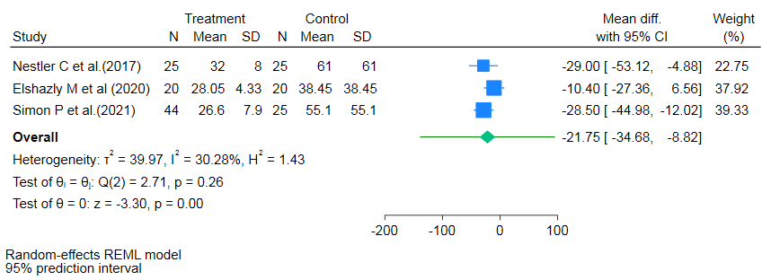

Figure S11. Forest plot for estimation of the predictive interval of true effect on Cdyn for LPEEP vs iPEEP.
Data are presented as standardized mean difference and 95% confidence intervals and 95% predictive intervals. The diamond symbolises the summary estimate, which represents the combined effect size of all included studies. It provides an overall measure of the difference in Cdyn outcomes between low PEEP and individualised PEEP.
Abbreviations: I²: the ratio of excess dispersion to total dispersion; SMD: standardized mean difference; CI: confidence interval; Cdyn: dynamic compliance; LPEEP – low positive end-expiratory pressure; iPEEP – individualised positive end-expiratory pressure.

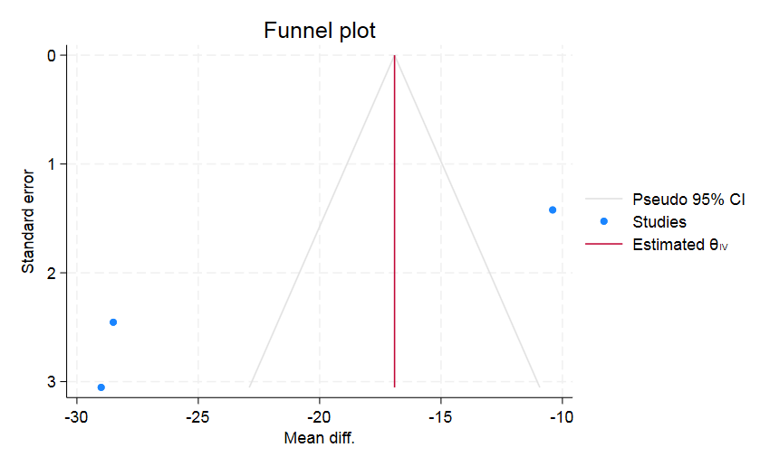
Figure S12. Funnel plot of publication bias in Cdyn for LPEEP vs iPEEP
А funnel plot of effect size and standard error of effect size in Cdyn for LPEEP vs iPEEP. The triangular lines on both sides of the summary estimate represent the precision measures, such as pseudo 95 % confidence intervals. The middle solid line indicates the overall effect of the meta-analysis. Each dot represents the individual study.
Abbreviations: Cdyn: dynamic compliance; LPEEP – low positive end-expiratory pressure; iPEEP – individualised positive end-expiratory pressure.

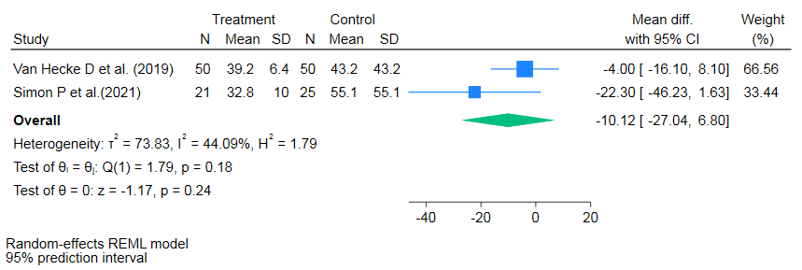

Figure S13. Forest plot for estimation of the predictive interval of true effect on Cdyn for HPEEP vs iPEEP.
Data are presented as standardized mean difference and 95% confidence intervals and 95% predictive intervals. The diamond symbolises the summary estimate, which represents the combined effect size of all included studies. It provides an overall measure of the difference in Cdyn outcomes between high PEEP and individualised PEEP.
Abbreviations: I²: the ratio of excess dispersion to total dispersion; SMD: standardized mean difference; CI: confidence interval; Cdyn: dynamic compliance; HPEEP – high positive end-expiratory pressure; iPEEP – individualised positive end-expiratory pressure.
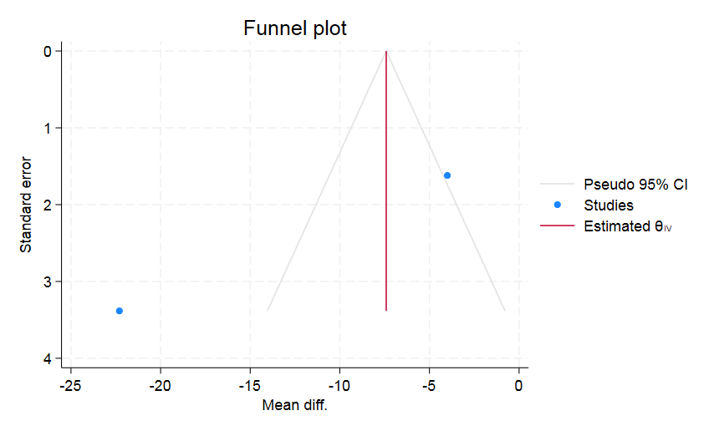

Figure S14. Funnel plot of publication bias in Cdyn for HPEEP vs iPEEP
А funnel plot of effect size and standard error of effect size in Cdyn for HPEEP vs iPEEP. The triangular lines on both sides of the summary estimate represent the precision measures, such as pseudo 95 % confidence intervals. The middle solid line indicates the overall effect of the meta-analysis. Each dot represents the individual study.
Abbreviations: Cdyn: dynamic compliance; HPEEP – high positive end-expiratory pressure; iPEEP – individualised positive end-expiratory pressure.

Driving pressure
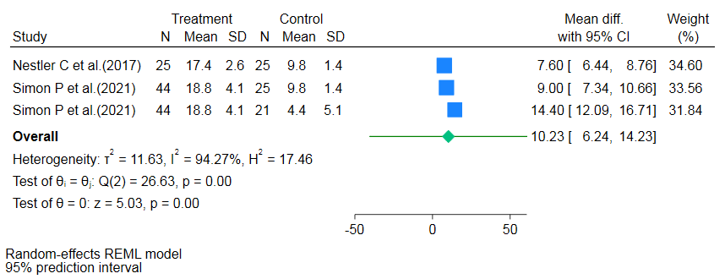
Figure S15. Forest plot for estimation of the predictive interval of true effect on driving pressure for LPEEP vs HPEEP.
Data are presented as standardized mean difference and 95% confidence intervals and 95% predictive intervals. The diamond symbolises the summary estimate, which represents the combined effect size of all included studies. It provides an overall measure of the difference in DP outcomes between low PEEP and high PEEP.
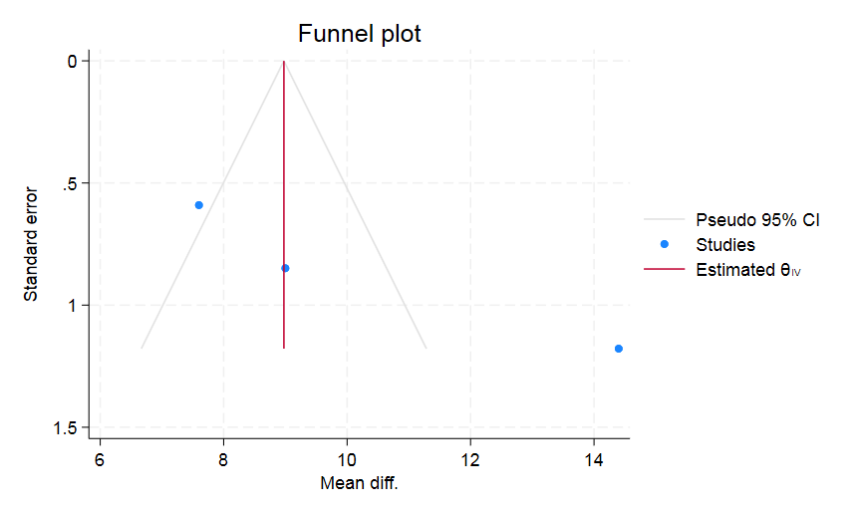
Abbreviations: I²: the ratio of excess dispersion to total dispersion; SMD: standardized mean difference; CI: confidence interval; Cdyn: dynamic compliance; DP: driving pressure; LPEEP – low positive end-expiratory pressure; HPEEP – high positive end-expiratory pressure.

Figure S16. Funnel plot of publication bias in driving pressure for LPEEP vs HPEEP
А funnel plot of effect size and standard error of effect size in DP for LPEEP vs HPEEP. The triangular lines on both sides of the summary estimate represent the precision measures, such as pseudo 95 % confidence intervals. The middle solid line indicates the overall effect of the meta-analysis. Each dot represents the individual study.
Abbreviations: Cdyn: dynamic compliance; DP: driving pressure; LPEEP – low positive end-expiratory pressure; HPEEP – high positive end-expiratory pressure.

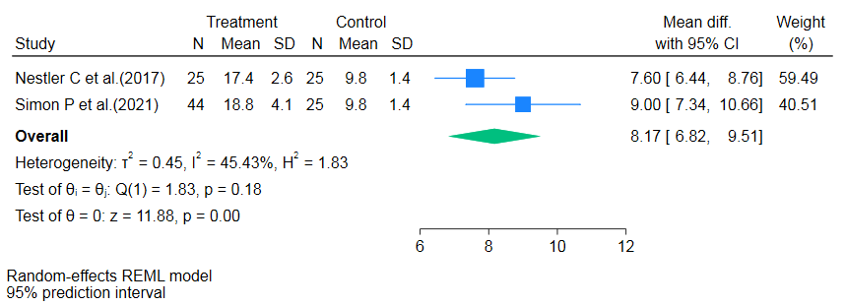
Figure S17. Forest plot for estimation of the predictive interval of true effect on driving pressure for LPEEP vs iPEEP.
Data are presented as standardized mean difference and 95% confidence intervals and 95% predictive intervals. The diamond symbolises the summary estimate, which represents the combined effect size of all included studies. It provides an overall measure of the difference in DP between low PEEP and individualised PEEP.
Abbreviations: I²: the ratio of excess dispersion to total dispersion; SMD: standardized mean difference; CI: confidence interval; Cdyn: dynamic compliance; DP: driving pressure; LPEEP – low positive end-expiratory pressure; iPEEP – individualised positive end-expiratory pressure.

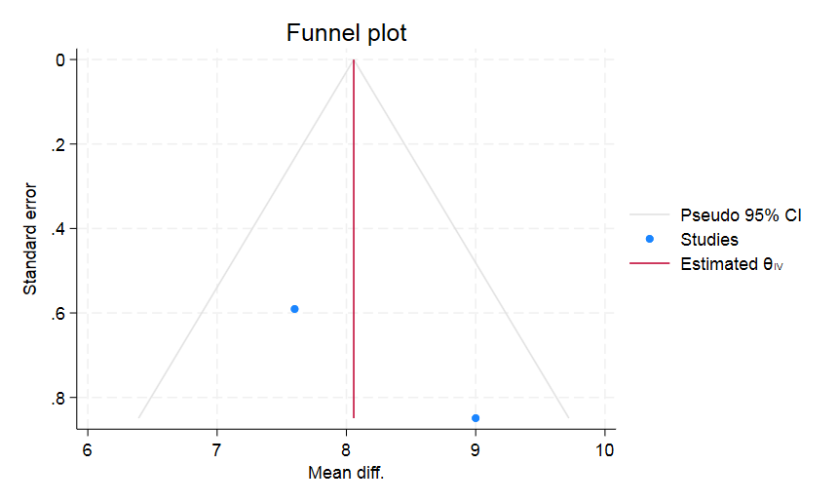

Figure S18. Funnel plot of publication bias in driving pressure for LPEEP vs iPEEP
А funnel plot of effect size and standard error of effect size in DP for LPEEP vs iPEEP. The triangular lines on both sides of the summary estimate represent the precision measures, such as pseudo 95 % confidence intervals. The middle solid line indicates the overall effect of the meta-analysis. Each dot represents the individual study.
Abbreviations: Cdyn: dynamic compliance; DP: driving pressure; LPEEP – low positive end-expiratory pressure; iPEEP – individualised positive end-expiratory pressure.

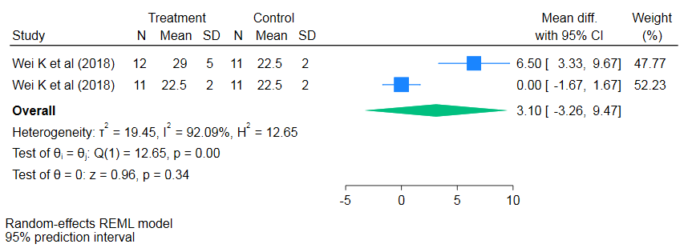
Figure S19. Forest plot for estimation of the predictive interval of true effect of driving pressure for LPEEP vs MPEEP.
Data are presented as standardized mean difference and 95% confidence intervals and 95% predictive intervals. The diamond symbolises the summary estimate, which represents the combined effect size of all included studies. It provides an overall measure of the difference in DP between low PEEP and moderate PEEP.
Abbreviations: I²: the ratio of excess dispersion to total dispersion; SMD: standardized mean difference; CI: confidence interval; Cdyn: dynamic compliance; DP: driving pressure; LPEEP – low positive end-expiratory pressure; MPEEP – moderate positive end-expiratory pressure.

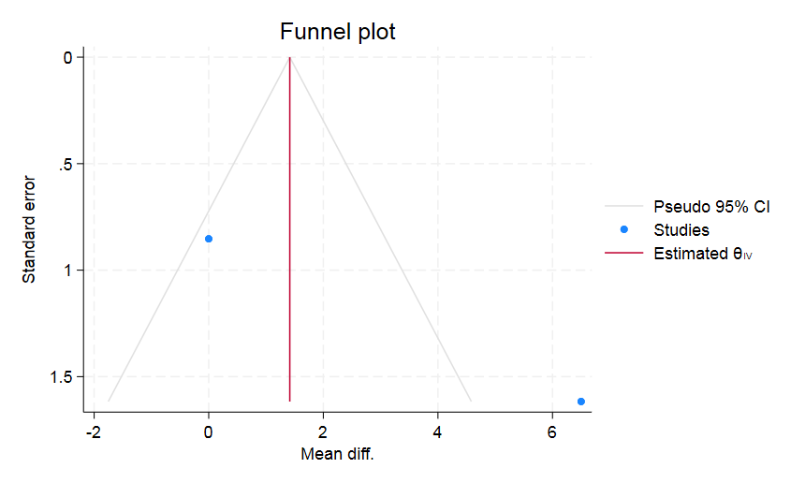
Figure S20. Funnel plot of publication bias of driving pressure for LPEEP vs MPEEP
А funnel plot of effect size and standard error of effect size in DP for LPEEP vs MPEEP. The triangular lines on both sides of the summary estimate represent the precision measures, such as pseudo 95 % confidence intervals. The middle solid line indicates the overall effect of the meta-analysis. Each dot represents the individual study.
Abbreviations: Cdyn: dynamic compliance; DP: driving pressure; LPEEP – low positive end-expiratory pressure; MPEEP – moderate positive end-expiratory pressure.

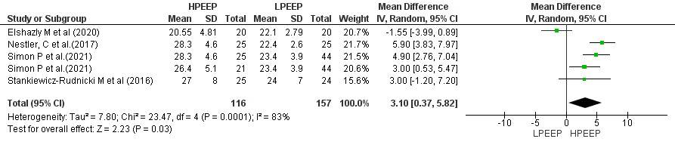
Figure S21. Forest plot for plateau pressure for LPEEP vs HPEEP.
Data are presented as mean differences and 95% confidence intervals. The vertical line represents no effect with the value of 0. The diamond represents the pooled mean effect estimate with 95% CI. It provides an overall measure of the difference in plateau pressure between different PEEP strategy groups.
Abbreviations: CI: confidence interval; SD: standard deviation; I²: the ratio of excess dispersion to total dispersion; Тau²: the variance of the true effect sizes; Chi²: observed weighted sum of squares; df: degrees of freedom; LPEEP: low positive end-expiratory pressure group; HPEEP: high positive end-expiratory pressure group.
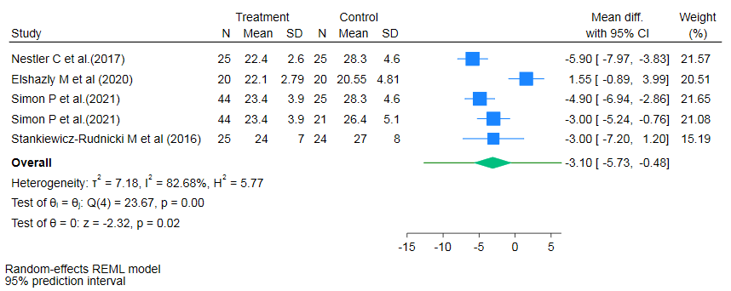
Figure S22. Forest plot for estimation of the predictive interval of true effect of plateau pressure for LPEEP vs HPEEP.
Data are presented as standardized mean difference and 95% confidence intervals and 95% predictive intervals. The diamond symbolises the summary estimate, which represents the combined effect size of all included studies. It provides an overall measure of the difference in plateau pressure between low PEEP and high PEEP.
Abbreviations: I²: the ratio of excess dispersion to total dispersion; SMD: standardized mean difference; CI: confidence interval; LPEEP – low positive end-expiratory pressure; HPEEP – high positive end-expiratory pressure.

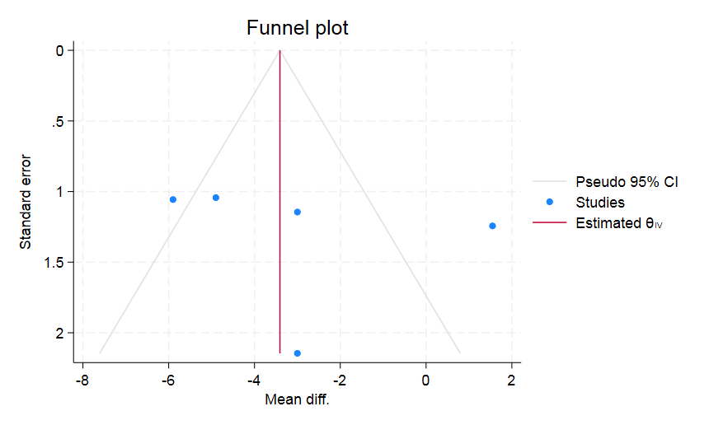
Figure S23. Funnel plot of publication bias in plateau pressure for LPEEP vs HPEEP
А funnel plot of effect size and standard error of effect size in plateau pressure for LPEEP vs HPEEP. The triangular lines on both sides of the summary estimate represent the precision measures, such as pseudo 95 % confidence intervals. The middle solid line indicates the overall effect of the meta-analysis. Each dot represents the individual study.
Abbreviations: LPEEP – low positive end-expiratory pressure; HPEEP – high positive end-expiratory pressure.

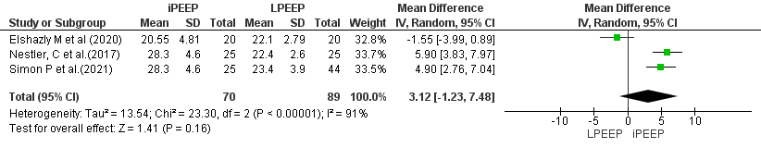
Figure S24. Forest plot for plateau pressure for LPEEP vs iPEEP.
Data are presented as mean differences and 95% confidence intervals. The vertical line represents no effect with the value of 0. The diamond represents the pooled mean effect estimate with 95% CI. It provides an overall measure of the difference in plateau pressure between different PEEP strategy groups.
Abbreviations: CI: confidence interval; SD: standard deviation; I²: the ratio of excess dispersion to total dispersion; Тau²: the variance of the true effect sizes; Chi²: observed weighted sum of squares; df: degrees of freedom; LPEEP: low positive end-expiratory pressure group; iPEEP: individualised positive end-expiratory pressure group.

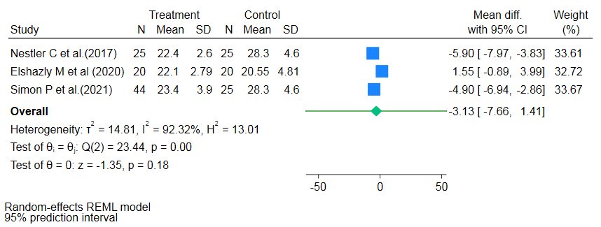
Figure S25. Forest plot for estimation of the predictive interval of true effect of plateau pressure for LPEEP vs iPEEP.
Data are presented as standardized mean difference and 95% confidence intervals and 95% predictive intervals. The diamond symbolises the summary estimate, which represents the combined effect size of all included studies. It provides an overall measure of the difference in plateau pressure between low PEEP and individualised PEEP.
Abbreviations: I²: the ratio of excess dispersion to total dispersion; SMD: standardized mean difference; CI: confidence interval; LPEEP – low positive end-expiratory pressure; iPEEP – individualised positive end-expiratory pressure.
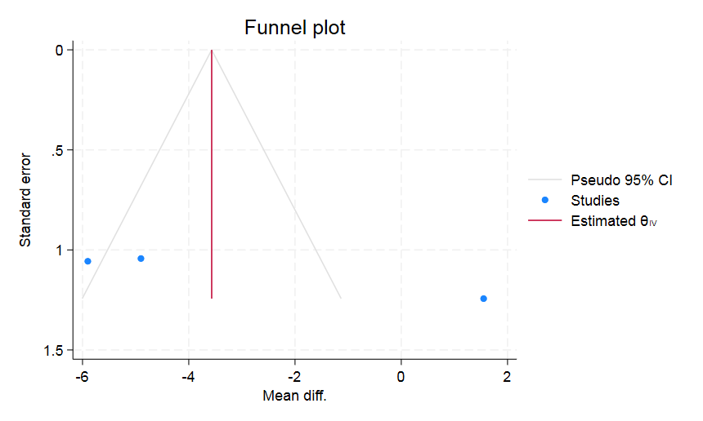

Figure S26. Funnel plot of publication bias in plateau pressure for LPEEP vs iPEEP
А funnel plot of effect size and standard error of effect size in plateau pressure for LPEEP vs iPEEP. The triangular lines on both sides of the summary estimate represent the precision measures, such as pseudo 95 % confidence intervals. The middle solid line indicates the overall effect of the meta-analysis. Each dot represents the individual study.
Abbreviations: LPEEP – low positive end-expiratory pressure; iPEEP – individualised positive end-expiratory pressure.

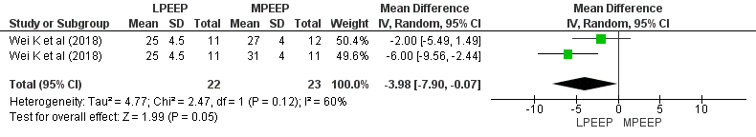
Figure S27. Forest plot for plateau pressure for LPEEP vs MPEEP.
Data are presented as mean differences and 95% confidence intervals. The vertical line represents no effect with the value of 0. The diamond represents the pooled mean effect estimate with 95% CI. It provides an overall measure of the difference in plateau pressure between different PEEP strategy groups.
Abbreviations: CI: confidence interval; SD: standard deviation; I²: the ratio of excess dispersion to total dispersion; Тau²: the variance of the true effect sizes; Chi²: observed weighted sum of squares; df: degrees of freedom; LPEEP: low positive end-expiratory pressure group; MPEEP: moderate positive end-expiratory pressure group.
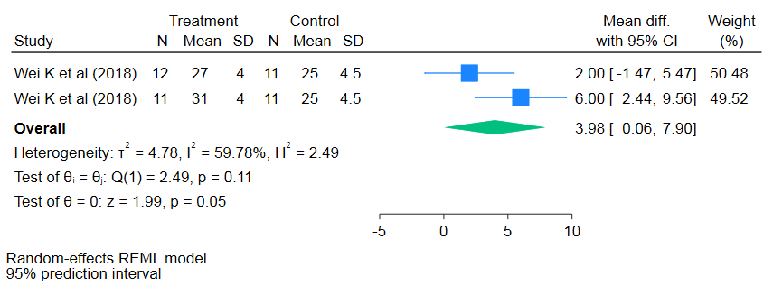
Figure S28. Forest plot for estimation of the predictive interval of true effect of plateau pressure for LPEEP vs MPEEP.
Data are presented as standardized mean difference and 95% confidence intervals and 95% predictive intervals. The diamond symbolises the summary estimate, which represents the combined effect size of all included studies. It provides an overall measure of the difference in plateau pressure between low PEEP and moderate PEEP.
Abbreviations: I²: the ratio of excess dispersion to total dispersion; SMD: standardized mean difference; CI: confidence interval; LPEEP – low positive end-expiratory pressure; MPEEP – moderate positive end-expiratory pressure.

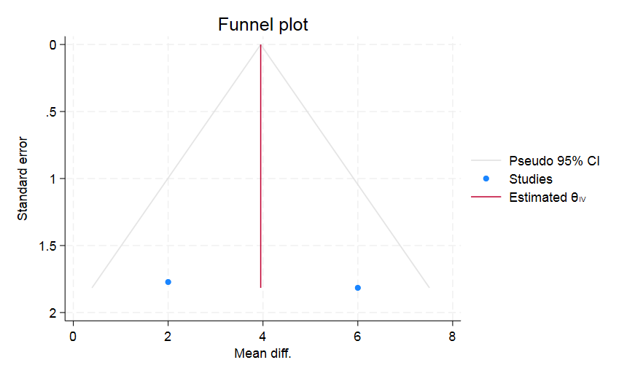
Figure S29. Funnel plot of publication bias in plateau pressure for LPEEP vs MPEEP
А funnel plot of effect size and standard error of effect size in plateau pressure for LPEEP vs MPEEP. The triangular lines on both sides of the summary estimate represent the precision measures, such as pseudo 95 % confidence intervals. The middle solid line indicates the overall effect of the meta-analysis. Each dot represents the individual study.
Abbreviations: LPEEP – low positive end-expiratory pressure; MPEEP – moderate positive end-expiratory pressure.

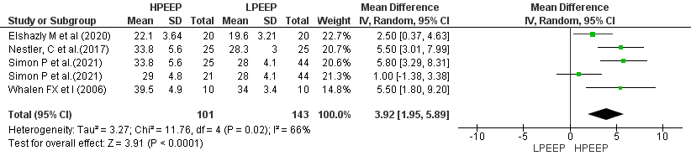

Figure S30. Forest plot for peak inspiratory pressure for LPEEP vs HPEEP.
Data are presented as mean differences and 95% confidence intervals. The vertical line represents no effect with the value of 0. The diamond represents the pooled mean effect estimate with 95% CI. It provides an overall measure of the difference in peak inspiratory pressure between different PEEP strategy groups.
Abbreviations: CI: confidence interval; SD: standard deviation; I²: the ratio of excess dispersion to total dispersion; Тau²: the variance of the true effect sizes; Chi²: observed weighted sum of squares; df: degrees of freedom; LPEEP: low positive end-expiratory pressure group; HPEEP: high positive end-expiratory pressure group.

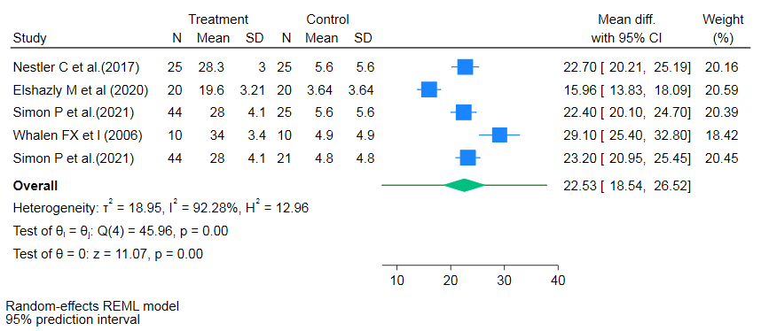

Figure S31. Forest plot for estimation of the predictive interval of true effect of peak inspiratory pressure for LPEEP vs HPEEP.
Data are presented as standardized mean difference and 95% confidence intervals and 95% predictive intervals. The diamond symbolises the summary estimate, which represents the combined effect size of all included studies. It provides an overall measure of the difference in plateau pressure between low PEEP and high PEEP.
Abbreviations: I²: the ratio of excess dispersion to total dispersion; SMD: standardized mean difference; CI: confidence interval; LPEEP – low positive end-expiratory pressure; HPEEP – high positive end-expiratory pressure.
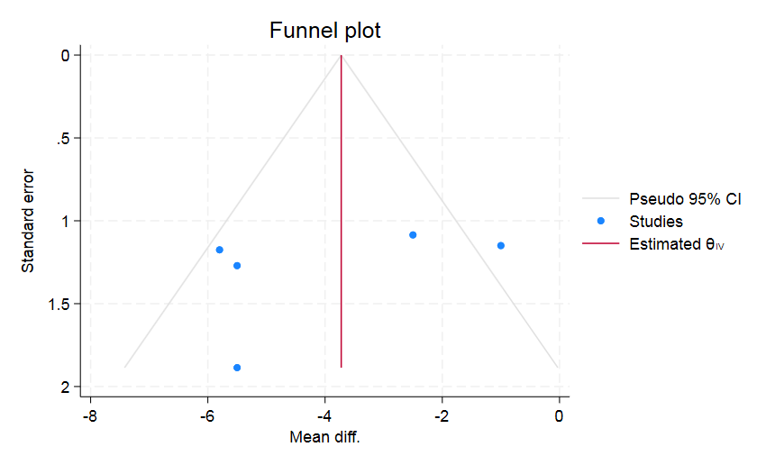
Figure S32. Funnel plot of publication bias in peak inspiratory pressure for LPEEP vs HPEEP
А funnel plot of effect size and standard error of effect size in plateau pressure for LPEEP vs HPEEP. The triangular lines on both sides of the summary estimate represent the precision measures, such as pseudo 95 % confidence intervals. The middle solid line indicates the overall effect of the meta-analysis. Each dot represents the individual study.
Abbreviations: LPEEP – low positive end-expiratory pressure; HPEEP – high positive end-expiratory pressure.

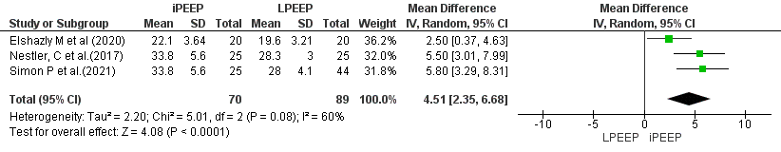
Figure S33. Forest plot for peak inspiratory pressure for LPEEP vs iPEEP.
Data are presented as mean differences and 95% confidence intervals. The vertical line represents no effect with the value of 0. The diamond represents the pooled mean effect estimate with 95% CI. It provides an overall measure of the difference in peak inspiratory pressure between different PEEP strategy groups.
Abbreviations: CI: confidence interval; SD: standard deviation; I²: the ratio of excess dispersion to total dispersion; Тau²: the variance of the true effect sizes; Chi²: observed weighted sum of squares; df: degrees of freedom; LPEEP: low positive end-expiratory pressure group; iPEEP: individualised positive end-expiratory pressure group.
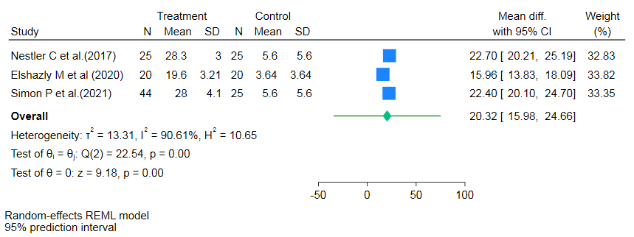
Figure S34. Forest plot for estimation of the predictive interval of true effect of peak inspiratory pressure for LPEEP vs iPEEP.
Data are presented as standardized mean difference and 95% confidence intervals and 95% predictive intervals. The diamond symbolises the summary estimate, which represents the combined effect size of all included studies. It provides an overall measure of the difference in plateau pressure between low PEEP and individualised PEEP.
Abbreviations: I²: the ratio of excess dispersion to total dispersion; SMD: standardized mean difference; CI: confidence interval; LPEEP – low positive end-expiratory pressure; iPEEP – individualised positive end-expiratory pressure.

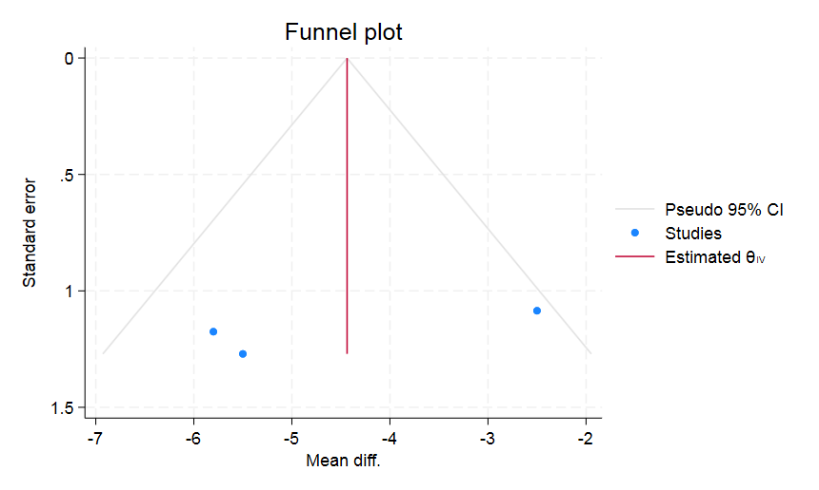
Figure S35. Funnel plot of publication bias in peak inspiratory pressure for LPEEP vs iPEEP
А funnel plot of effect size and standard error of effect size in plateau pressure for LPEEP vs iPEEP. The triangular lines on both sides of the summary estimate represent the precision measures, such as pseudo 95 % confidence intervals. The middle solid line indicates the overall effect of the meta-analysis. Each dot represents the individual study.
Abbreviations: LPEEP – low positive end-expiratory pressure; iPEEP – individualised positive end-expiratory pressure.

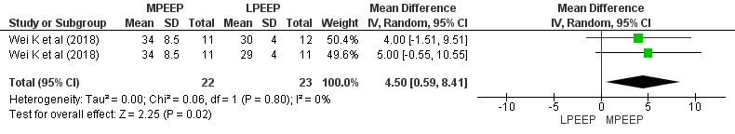
Figure S36. Forest plot for peak inspiratory pressure for LPEEP vs MPEEP.
Data are presented as mean differences and 95% confidence intervals. The vertical line represents no effect with the value of 0. The diamond represents the pooled mean effect estimate with 95% CI. It provides an overall measure of the difference in peak inspiratory pressure between different PEEP strategy groups.
Abbreviations: CI: confidence interval; SD: standard deviation; I²: the ratio of excess dispersion to total dispersion; Тau²: the variance of the true effect sizes; Chi²: observed weighted sum of squares; df: degrees of freedom; LPEEP: low positive end-expiratory pressure group; MPEEP: moderate positive end-expiratory pressure group

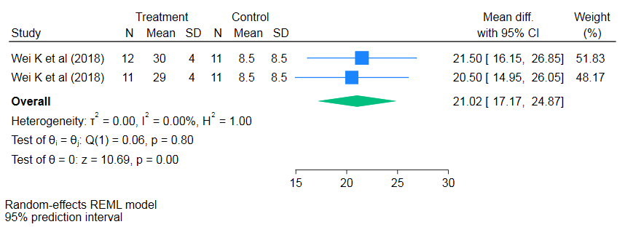
Figure S37. Forest plot for estimation of the predictive interval of true effect of peak inspiratory pressure for LPEEP vs MPEEP.
Data are presented as standardized mean difference and 95% confidence intervals and 95% predictive intervals. The diamond symbolises the summary estimate, which represents the combined effect size of all included studies. It provides an overall measure of the difference in plateau pressure between low PEEP and moderate PEEP.
Abbreviations: I²: the ratio of excess dispersion to total dispersion; SMD: standardized mean difference; CI: confidence interval; LPEEP – low positive end-expiratory pressure; MPEEP – moderate positive end-expiratory pressure.
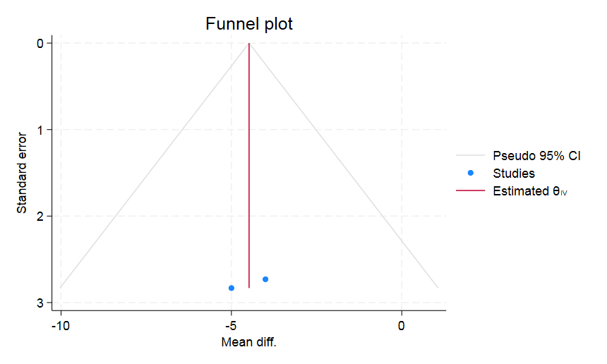

Figure S38. Funnel plot of publication bias in peak inspiratory pressure for LPEEP vs MPEEP
А funnel plot of effect size and standard error of effect size in plateau pressure for LPEEP vs MPEEP. The triangular lines on both sides of the summary estimate represent the precision measures, such as pseudo 95 % confidence intervals. The middle solid line indicates the overall effect of the meta-analysis. Each dot represents the individual study.
Abbreviations: LPEEP – low positive end-expiratory pressure; MPEEP – moderate positive end-expiratory pressure.

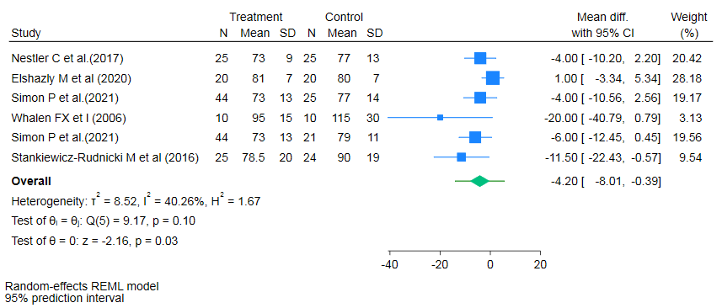

Figure S39. Forest plot for estimation of the predictive interval of true effect of mean arterial pressure for LPEEP vs HPEEP.
Data are presented as standardized mean difference and 95% confidence intervals and 95% predictive intervals. The diamond symbolises the summary estimate, which represents the combined effect size of all included studies. It provides an overall measure of the difference in plateau pressure between low PEEP and high PEEP.
Abbreviations: I²: the ratio of excess dispersion to total dispersion; SMD: standardized mean difference; CI: confidence interval; LPEEP – low positive end-expiratory pressure; HPEEP – high positive end-expiratory pressure.
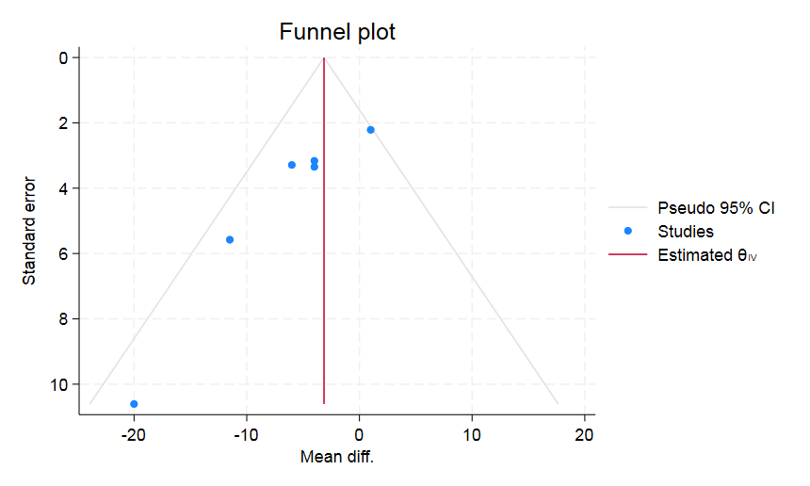

Figure S40. Funnel plot of publication bias in mean arterial pressure for LPEEP vs HPEEP
А funnel plot of effect size and standard error of effect size in plateau pressure for LPEEP vs HPEEP. The triangular lines on both sides of the summary estimate represent the precision measures, such as pseudo 95 % confidence intervals. The middle solid line indicates the overall effect of the meta-analysis. Each dot represents the individual study.
Abbreviations: LPEEP – low positive end-expiratory pressure; HPEEP – high positive end-expiratory pressure.

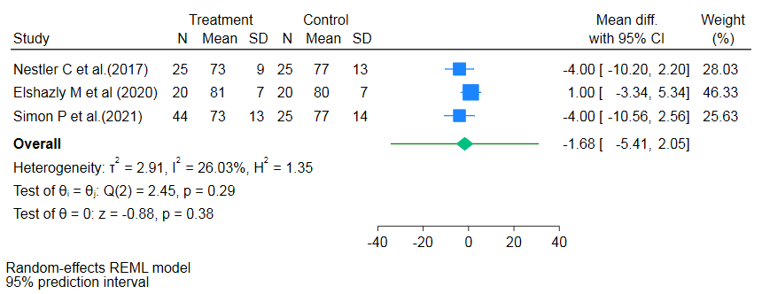
Figure S41. Forest plot for estimation of the predictive interval of true effect of mean arterial pressure for LPEEP vs iPEEP.
Data are presented as standardized mean difference and 95% confidence intervals and 95% predictive intervals. The diamond symbolises the summary estimate, which represents the combined effect size of all included studies. It provides an overall measure of the difference in plateau pressure between low PEEP and individualised PEEP.
Abbreviations: I²: the ratio of excess dispersion to total dispersion; SMD: standardized mean difference; CI: confidence interval; LPEEP – low positive end-expiratory pressure; iPEEP – individualised positive end-expiratory pressure.
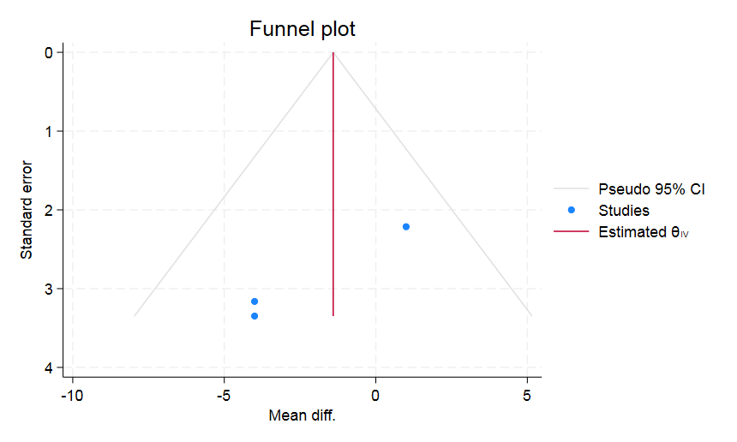

Figure S42. Funnel plot of publication bias in mean arterial pressure for LPEEP vs iPEEP
А funnel plot of effect size and standard error of effect size in plateau pressure for LPEEP vs iPEEP. The triangular lines on both sides of the summary estimate represent the precision measures, such as pseudo 95 % confidence intervals. The middle solid line indicates the overall effect of the meta-analysis. Each dot represents the individual study.
Abbreviations: LPEEP – low positive end-expiratory pressure; iPEEP – individualised positive end-expiratory pressure.

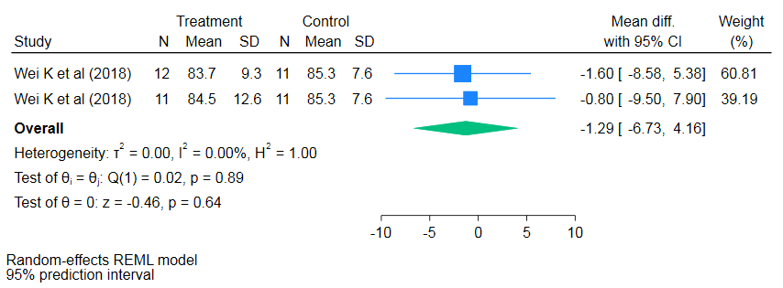
Figure S43. Forest plot for estimation of the predictive interval of true effect of mean arterial pressure for LPEEP vs MPEEP.
Data are presented as standardized mean difference and 95% confidence intervals and 95% predictive intervals. The diamond symbolises the summary estimate, which represents the combined effect size of all included studies. It provides an overall measure of the difference in plateau pressure between low PEEP and moderate PEEP.
Abbreviations: I²: the ratio of excess dispersion to total dispersion; SMD: standardized mean difference; CI: confidence interval; LPEEP – low positive end-expiratory pressure; MPEEP – moderate positive end-expiratory pressure.

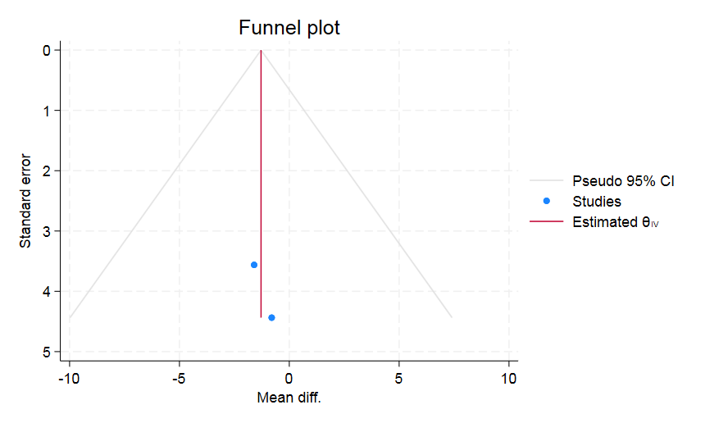

Figure S44. Funnel plot of publication bias in mean arterial pressure for LPEEP vs MPEEP
А funnel plot of effect size and standard error of effect size in plateau pressure for LPEEP vs MPEEP. The triangular lines on both sides of the summary estimate represent the precision measures, such as pseudo 95 % confidence intervals. The middle solid line indicates the overall effect of the meta-analysis. Each dot represents the individual study.
Abbreviations: LPEEP – low positive end-expiratory pressure; MPEEP – moderate positive end-expiratory pressure.

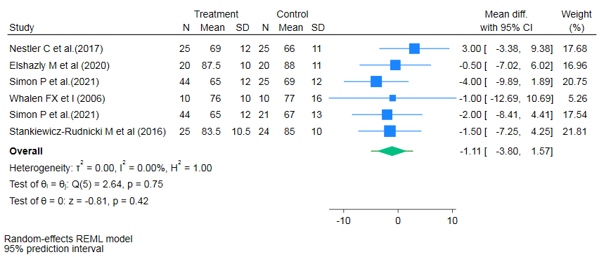

Figure S45. Forest plot for estimation of the predictive interval of true effect of the heart rate for LPEEP vs HPEEP.
Data are presented as standardized mean difference and 95% confidence intervals and 95% predictive intervals. The diamond symbolises the summary estimate, which represents the combined effect size of all included studies. It provides an overall measure of the difference in plateau pressure between low PEEP and high PEEP.
Abbreviations: I²: the ratio of excess dispersion to total dispersion; SMD: standardized mean difference; CI: confidence interval; LPEEP – low positive end-expiratory pressure; HPEEP – high positive end-expiratory pressure.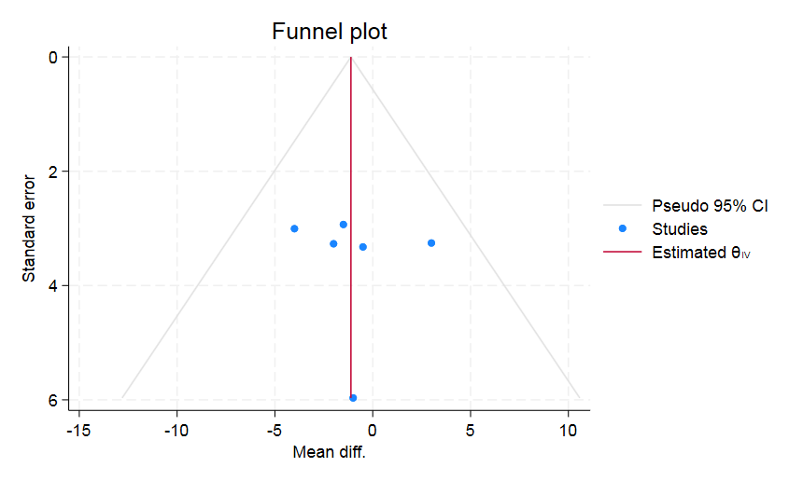

Figure S46. Funnel plot of publication bias of the heart rate for LPEEP vs HPEEP
А funnel plot of effect size and standard error of effect size in plateau pressure for LPEEP vs HPEEP. The triangular lines on both sides of the summary estimate represent the precision measures, such as pseudo 95 % confidence intervals. The middle solid line indicates the overall effect of the meta-analysis. Each dot represents the individual study.
Abbreviations: LPEEP – low positive end-expiratory pressure; HPEEP – high positive end-expiratory pressure.

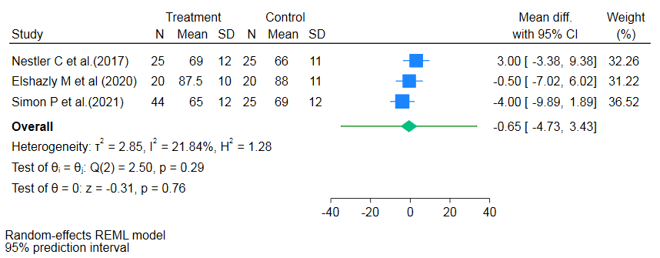

Figure S47. Forest plot for estimation of the predictive interval of true effect of the heart rate for LPEEP vs iPEEP.
Data are presented as standardized mean difference and 95% confidence intervals and 95% predictive intervals. The diamond symbolises the summary estimate, which represents the combined effect size of all included studies. It provides an overall measure of the difference in plateau pressure between low PEEP and individualised PEEP.
Abbreviations: I²: the ratio of excess dispersion to total dispersion; SMD: standardized mean difference; CI: confidence interval; LPEEP – low positive end-expiratory pressure; iPEEP – individualised positive end-expiratory pressure.

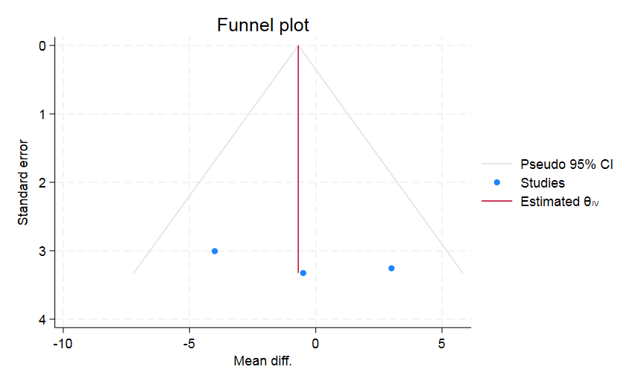
Figure S48. Funnel plot of publication bias of the heart rate for LPEEP vs iPEEP
А funnel plot of effect size and standard error of effect size in plateau pressure for LPEEP vs HPEEP. The triangular lines on both sides of the summary estimate represent the precision measures, such as pseudo 95 % confidence intervals. The middle solid line indicates the overall effect of the meta-analysis. Each dot represents the individual study.
Abbreviations: LPEEP – low positive end-expiratory pressure; iPEEP – individualised positive end-expiratory pressure.

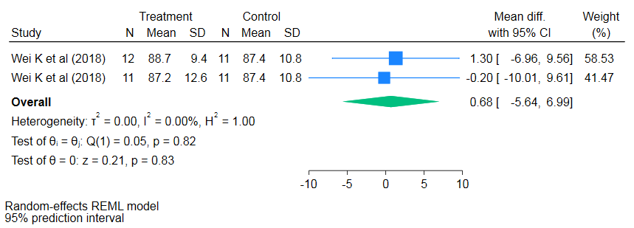

Figure S49. Forest plot for estimation of the predictive interval of true effect of the heart rate for LPEEP vs MPEEP.
Data are presented as standardized mean difference and 95% confidence intervals and 95% predictive intervals. The diamond symbolises the summary estimate, which represents the combined effect size of all included studies. It provides an overall measure of the difference in plateau pressure between low PEEP and moderate PEEP.
Abbreviations: I²: the ratio of excess dispersion to total dispersion; SMD: standardized mean difference; CI: confidence interval; LPEEP – low positive end-expiratory pressure; MPEEP – moderate positive end-expiratory pressure.

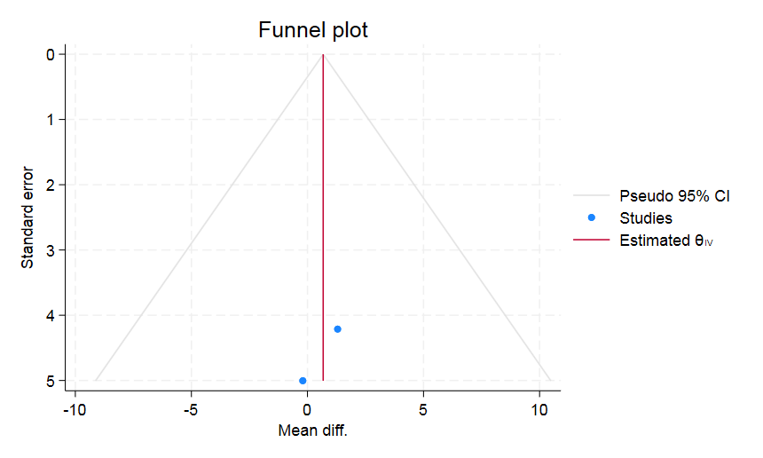

Figure S50. Funnel plot of publication bias of the heart rate for LPEEP vs MPEEP
А funnel plot of effect size and standard error of effect size in plateau pressure for LPEEP vs MPEEP. The triangular lines on both sides of the summary estimate represent the precision measures, such as pseudo 95 % confidence intervals. The middle solid line indicates the overall effect of the meta-analysis. Each dot represents the individual study.
Abbreviations: LPEEP – low positive end-expiratory pressure; MPEEP – moderate positive end-expiratory pressure.

