Data analysis of the secondary outcome of parental anxiety
A Bayesian network meta-analysis was conducted using Stata 14.0 and OpenBUGS software. Post-intervention measurements were selected for comparison. Continuous variables were analyzed employing SMD and 95% CrI, with statistical significance set at α=0.05. Global and local inconsistencies were assessed using inconsistency factors and node-splitting analyses, respectively[1, 2]. A p-value of >0.05 indicated that there were no significant inconsistencies between the direct and indirect comparisons; in these cases, the consistency model was adopted. Otherwise, the inconsistency model was used to aggregate effect sizes and their 95% CrI for the various interventions. The network meta-analysis utilized the Bayesian framework and Markov Chain Monte Carlo simulations in OpenBUGS. To mitigate initial value bias, we ran 100,000 iterations on three chains after 50,000 burn-in periods. The model was considered appropriate when the posterior mean residual deviance closely matched the number of unconstrained data points. The intervention hierarchy was assessed using the Surface Under the Cumulative Ranking (SUCRA). A SUCRA value approaching 1 indicated greater efficacy, whereas a value closer to 0 suggested lower efficacy[3].

Data analysis the tertiary outcome of induction compliance of children
A network meta-analysis was conducted using Stata 14.0 and a frequentist framework with a random-effects model. Post-intervention outcome measures were selected for comparison in all eligible studies. The mean difference (MD) and 95% confidence intervals (95% CI) were used as summary statistics in the network meta-analysis, with statistical significance set at α=0.05. Global and local inconsistencies were assessed using inconsistency factors and node-splitting analyses, respectively [1, 2].A p-value of >0.05 indicated no significant inconsistencies between the direct and indirect comparisons; in these cases, the consistency model was adopted. Otherwise, the inconsistency model was used to aggregate effect sizes and their 95% CI for the various interventions. The intervention hierarchy was assessed using the SUCRA. A SUCRA value approaching 1 indicated greater efficacy, whereas a value closer to 0 suggested lower efficacy[3].

Table1 Network league table of NMA for children’s anxiety during inhalation anesthesia induction
SUCRA=92%
IDI-PPIA group | SUCRA=73%
-0.47 (-1.64,0.71) | PDI-PPIA group | SUCRA=58%
-0.76 (-2.52,1.00) | -0.29 (-2.35,1.77) | IPG group | SUCRA=50%
-0.99 (-1.99,0.01) | -0.52 (-1.87,0.83) | -0.23 (-2.13,1.67) | IDI group | SUCRA=46%
-1.07 (-2.09,-0.05) | -0.60 (-1.88,0.67) | -0.31 (-2.21,1.59) | -0.08 (-1.06,0.90) | PDI grpup | SUCRA=30%
-1.35 (-1.98,-0.72) | -0.89 (-2.00,0.23) | -0.59 (-2.40,1.21) | -0.36 (-1.25,0.52) | -0.28 (-1.14,0.58) | PPIA group | SUCRA=1%
-2.21 (-3.03,-1.39) | -1.74 (-2.96,-0.53) | -1.45 (-3.23,0.33) | -1.22 (-2.02,-0.42) | -1.14 (-1.84,-0.43) | -0.86 (-1.48,-0.23) | Usual care group

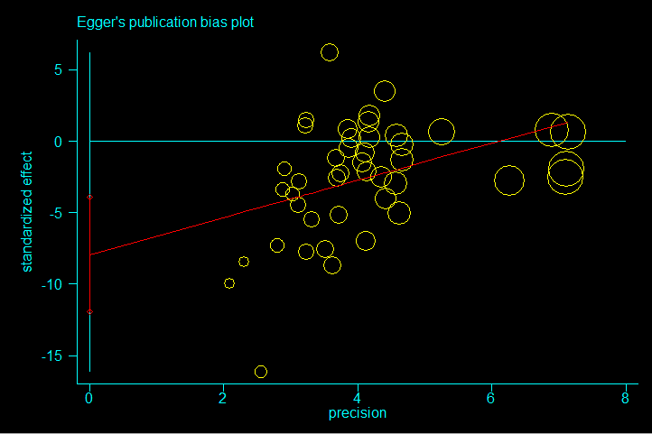
Fig. 1. Funnel Plot of Effect Size related to Publication Bias.

Table2 Network league table of NMA for anxiety, excluding studies with <30 participants in control/experimental groups.

SUCRA=91%
PDI-PPIA group | SUCRA=82%
-0.28 (-1.44,0.88) | IDI-PPIA group | SUCRA=50%
-0.93 (-2.24,0.38) | -0.65 (-1.69,0.39) | IDI group | SUCRA=45%
-1.03 (-2.28,0.22) | -0.75 (-1.81,0.31) | -0.09 (-1.05,0.87) | PDI group | SUCRA=31%
-1.24 (-2.30,-0.18) | -0.96 (-1.61,-0.31) | -0.31 (-1.21,0.59) | -0.22 (-1.10,0.66) | PPIA group | SUCRA=9%
-2.22 (-3.40,-1.04) | -1.94 (-2.82,-1.06) | -1.29 (-2.09,-0.49) | -1.19 (-1.90,-0.48) | -0.97 (-1.64,-0.30) | Usual care group

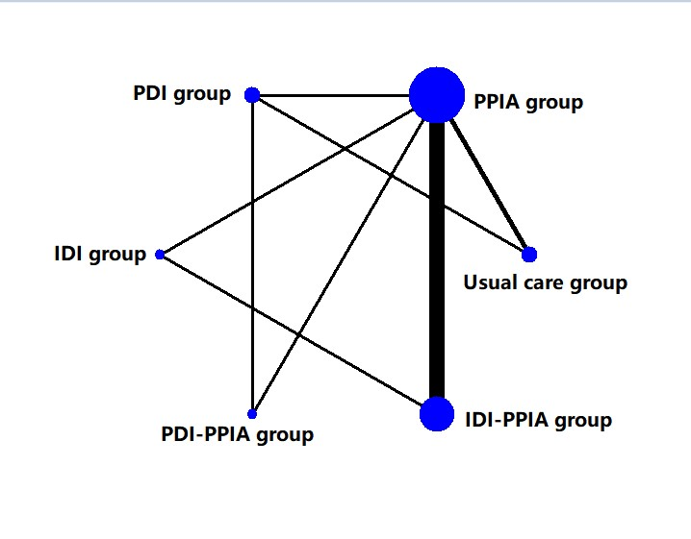
Fig. 2. Network map for the comparison of different interventions about decreasing the anxiety of parents

Table 3 Network league table of NMA for parental anxiety reduction with SMD and 95% CrI
SUCRA=76%
IDI-PPIA group | SUCRA=50%
-0.30 (-1.65,1.05) | IDI group | SUCRA=49%
-0.34 (-1.67,0.99) | -0.04 (-1.82,1.74) | PDI group | SUCRA=48%
-0.35 (-1.94,1.24) | -0.05 (-2.03,1.93) | -0.01 (-1.44,1.42) | PDI-PPIA group | SUCRA=46%
-0.34 (-0.97,0.29) | -0.04 (-1.39,1.31) | 8.44 (7.26,9.62) | 0.01 (-1.44,1.46) | PPIA group | SUCRA=31%
-0.57 (-1.71,0.57) | -0.27 (-1.92,1.38) | -0.23 (-1.41,0.95) | -0.22 (-1.81,1.37) | -0.23 (-1.19,0.73) | Usual care group

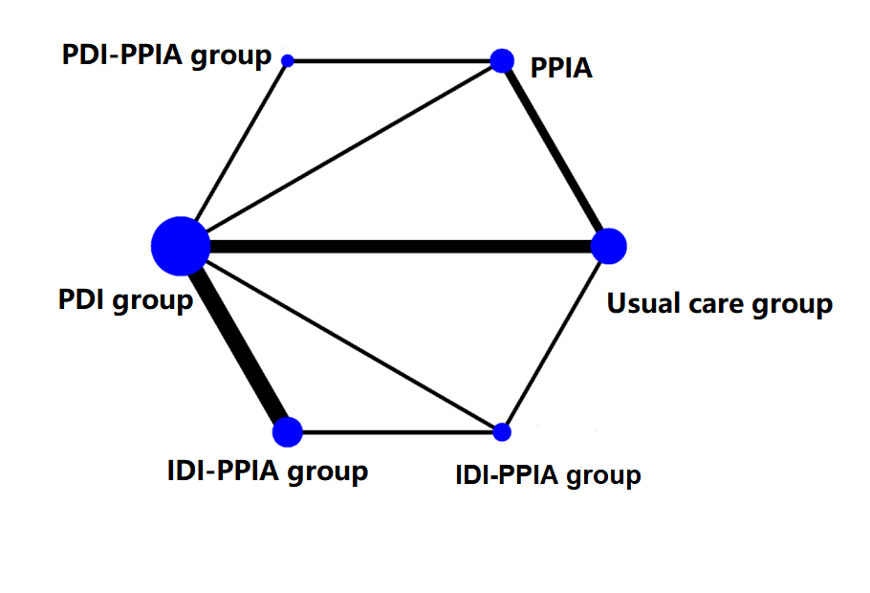
Fig.3. Network map for the comparison of different interventions about the induction compliance about children. PPIA, Parental presence during the induction of anesthesia; PDI, passive distraction intervention group; IDI, interactive distraction intervention group; IDI-PPIA, interactive distraction intervention with PPIA group; PDI-PPIA, passive distraction intervention with PPIA group.

Table.4. Network league table of NMA for children induction compliance with MD and 95% CI.
SUCRA=79%
PPIA group | SUCRA=68%
-0.17 (-1.30,0.97) | IDI group | SUCRA=61%
-0.25 (-1.19,0.69) | -0.08 (-1.56,1.39) | PDI-PPIA group | SUCRA=57%
-0.37 (-1.64,0.89) | -0.21 (-1.63,1.21) | -0.12 (-1.70,1.45) | IDI-PPIA group | SUCRA=34%
-0.71 (-1.56,0.13) | -0.55 (-1.61,0.51) | -0.46 (-1.73,0.80) | -0.34 (-1.28,0.60) | PDI group | SUCRA=1%
-1.42 (-2.09,-0.76) | -0.71 (-1.24,-0.19) | 0.01 (-1.41,1.42) | -1.26 (-2.18,-0.34) | -1.21 (-2.48,0.06) | Usual care group

1. S. Dias NJW, D. M. Caldwell, A. E. Ades: Checking consistency in mixed treatment comparison meta-analysis. Statistic in medicine 2009, 29:932-944.
2. White IR, Barrett JK, Jackson D, Higgins JP: Consistency and inconsistency in network meta-analysis: model estimation using multivariate meta-regression. Res Synth Methods 2012, 3(2):111-125.
3. Salanti G, Ades AE, Ioannidis JP: Graphical methods and numerical summaries for presenting results from multiple-treatment meta-analysis: an overview and tutorial. J Clin Epidemiol 2011, 64(2):163-171.

