Additional file 1
Supplementary information
Title: Comparison of Airway Opening Pressure Measurements: Low-Constant-Flow vs. Constant Low-slope Pressure Ramp Methods

Authors:
Ken Tonai¹, Atsuko Shono¹, Ryuichi Nakayama¹, and Shinshu Katayama¹

Affiliations
¹Division of Intensive Care, Department of Anesthesiology and Intensive Care Medicine, Jichi Medical University School of Medicine, Shimotsuke, Tochigi, Japan

Corresponding author:
Shinshu Katayama
3311-1 Yakushiji Shimotsuke, Tochigi 329-0498, Japan
E-mail address: shinsyu_k@jichi.ac.jp

EXTENDED METHODS
Figure S1. Measurement of pressure rise rate.
Figure S2. Measurement of pressure at the linearization point (P_{LP}) during mechanical ventilation.

EXTENDED RESULTS
Figure S3. Correlation between the rate of pressure rise and the difference in values of AOP_{flow} and AOP_{pres}.

Table S1. Patient characteristics based on the presence or absence of AOP_{flow.}

Extended methods
Pressure rise rate (P_{rise}) from start of inflation to AOP
In this study, the pressure rise rate was defined as the rate of pressure increase from the pressure at the beginning of inflation up to the airway opening pressure (AOP).

Figure S1. Pressure-time curve (a) and flow-time curve (b) in the low-constant flow and constant low-slope pressure ramp methods
Data are from the same patient as in Figure 1. The solid blue line represents the low-constant-flow method, and the solid orange line denotes the constant low-slope pressure ramp method.
Abbreviations: AOP, airway opening pressure; AOP_{flow}, AOP with low-constant-flow method; AOP_{pres}, AOP with constant low-slope pressure ramp method.

Pressure at Linearization Point (P_{LP})
We compared the pressure at which the pressure-volume (P-V) curve becomes linear in the low constant pressure ramp method, defined as "Pressure at Linearization Point (P_{LP})", with the airway opening pressure (AOP) in constant low-flow inflation (5 L/min): a volume-controlled mode with a tidal volume of 500mL, inspiratory time 6 s, respiratory rate 4–5/min, and PEEP of 0 cmH₂O. The P_{LP} was defined as the pressure at the intercept between the pressure axis and the tangent drawn on the P–V curve at a volume of 250 mL (half of the 500 mL tidal volume in the low-constant flow method), deviated by 4 mL from the P–V curve (Figure S2).

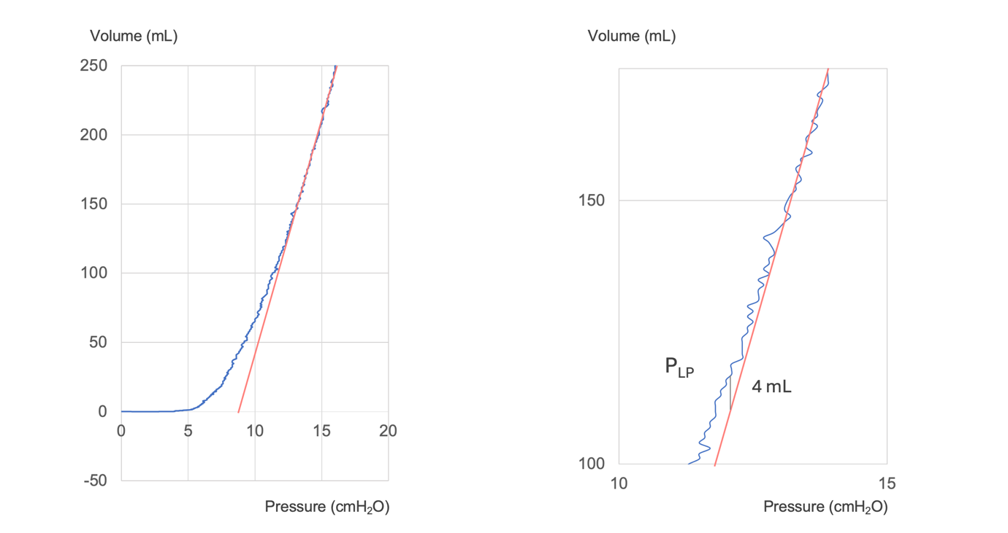
Figure S2: Pressure at linearization point (P_{LP}) in pressure-volume curve
Abbreviations: P_{LP}, Pressure at linearization point.

Extended results
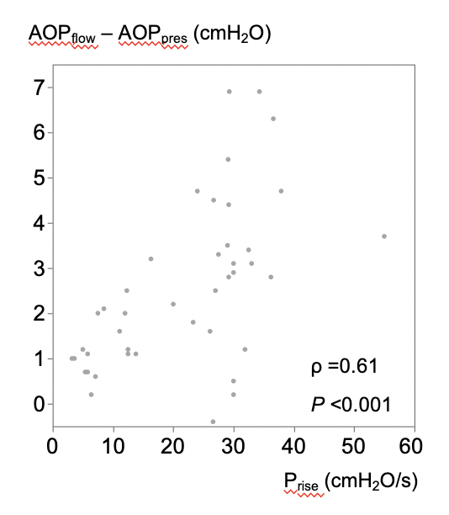
Figure S3. Correlation between the rate of pressure rise from the beginning of inflation up to AOP and the difference in values of AOP_{flow} and AOP_{pres}
Spearman’s rank correlation coefficient was 0.61 (P<0.001).

Abbreviations: AOP, airway opening pressure; AOP_{flow}, AOP with low-constant-flow method; AOP_{pres}, AOP with constant low-slope pressure ramp method; P_{rise}, Pressure rise rate from the beginning of inflation up to AOP.

Table S1: Patient characteristics based on the presence or absence of AOP_{flow}
Patient (n = 42) | Patients with  AOP_{flow} ≥ 5 cm H₂O  (n = 20) | Patients with  AOP_{flow <} 5 cm H₂O  (n =22) | P-value
Age (years) | 63 (54–74) | 65 (51–73) | 0.83
Male sex | 13 (65%) | 13 (59%) | 0.69
BMI (kg/m²) | 27.7 (24.9–31.0) | 25.9 (21.0–29.5) | 0.24
Medical history
COPD | 0 (0%) | 0 (0%) | -
Other chronic lung disease | 0 (0%) | 1 (4.5%) | 0.33
Reasons for mechanical ventilation
Pneumonia | 11 (55%) | 14 (64%) | 0.26
Extra-pulmonary sepsis | 7 (35%) | 3 (17%) | 0.10
Acute cardiac failure | 4 (20%) | 1 (4.5%) | 0.12
Other | 1 (5.0%) | 6 (27%) | 0.053
PaO₂/F_{I}O₂ ratio | 178 (137–223) | 187 (147–230) | 0.97
APACHE II score | 23 (19–31) | 23 (17–30) | 0.91
SOFA score (Measurement Day) | 12 (10–16) | 11 (9–14) | 0.31
Hospital mortality | 4 (20%) | 1 (4.5%) | 0.12
Ventilator-free days at day 28 (days) | 20 (17–23) | 18 (10–20) | 0.085
AOP_{flow}, airway opening pressure measured using the flow method; BMI, body mass index, COPD, chronic obstructive pulmonary disease; PaO₂/F_{I}O₂ ratio: ratio of arterial oxygen partial pressure (PaO₂) to fractional inspired oxygen (F_{I}O₂); APACHE II: Acute Physiology and Chronic Health Evaluation II; SOFA score: Sequential Organ Failure Assessment score

