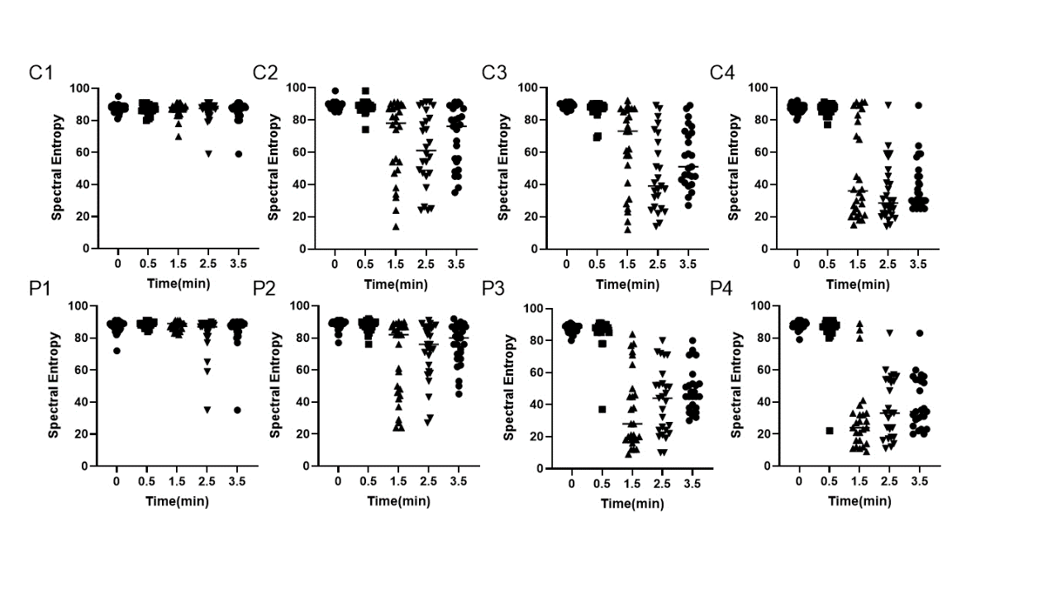 Figure A The scatter plots of Spectral Entropy.
Figure B The scatter plots of Mean Arterial Pressure.
Figure C The scatter plots of Systolic Blood Pressure.
Figure D The scatter plots of Respiratory Rate.
Figure E The scatter plots of Heart Rate.

