Table A Other endpoints and adverse events at different dosages within 2 min after administration of drugs
Group | C1 | C2 | C3 | C4
Dose: mg/kg | 0.2 | 0.3 | 0.4 | 0.5
Time of loss eyelash reflex, s | 85 | 73.89±31.08 | 58.40±40.06 | 55.54±26.88
Hypotension, n (%) | 6（20.7） | 7（24.1） | 8（27.6） | 8（27.6）
Respiratory depression, n (%) | 1(3.4) | 1(3.4) | 8(27.6) | 17(58.6)
bradycardia | 0 | 0 | 0 | 0
Injection Pain | 0 | 0 | 0 | 0
Group | P1 | P2 | P3 | P4
Dose: mg/kg | 1.0 | 1.5 | 2.0 | 2.5
Time of loss eyelash reflex, s | 123±7.07 | 57.63±22.44 | 51.48±29.99 | 44.28±20.82
Hypotension, n (%) | 5（18.5） | 9（31.0） | 9（31.0） | 14（48.3）
Respiratory depression, n (%) | 0 | 9(31.0) | 16(55.2) | 20(69.0)
bradycardia | 0 | 0 | 0 | 0
Injection Pain, n (%) | 8(29.6) | 10(34.5) | 10(34.5) | 5(17.2)
Notes: values are mean±SD or number of patients, N (%)
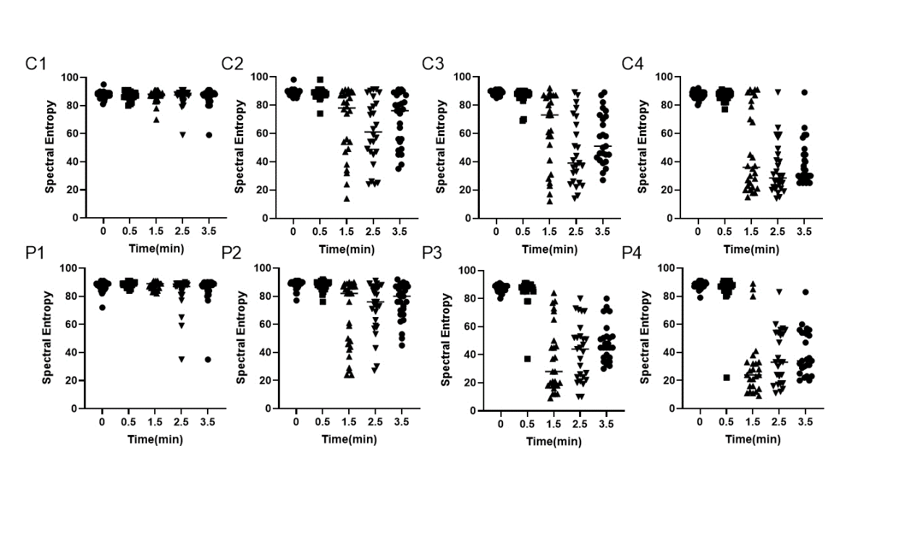Figure A The scatter plots of Spectral Entropy.
Figure B The scatter plots of Mean Arterial Pressure.
Figure C The scatter plots of Systolic Blood Pressure.
Figure D The scatter plots of Respiratory Rate.
Figure E The scatter plots of Heart Rate.

