Patient Preferences for Analgesia in Lung Surgery: Supplementals
Table S1: STROBE Statement—Checklist of items that should be included in reports of cohort studies
 | Item No | Recommendation | Page
Title and abstract | 1 | (a) Indicate the study’s design with a commonly used term in the title or the abstract | 1
Title and abstract | 1 | (b) Provide in the abstract an informative and balanced summary of what was done and what was found | 4
Introduction
Background/rationale | 2 | Explain the scientific background and rationale for the investigation being reported | 5
Objectives | 3 | State specific objectives, including any prespecified hypotheses | 5
Methods
Study design | 4 | Present key elements of study design early in the paper | 6
Setting | 5 | Describe the setting, locations, and relevant dates, including periods of recruitment, exposure, follow-up, and data collection | 6
Participants | 6 | (a) Give the eligibility criteria, and the sources and methods of selection of participants. Describe methods of follow-up | 6
Participants | 6 | (b) For matched studies, give matching criteria and number of exposed and unexposed | N/A
Variables | 7 | Clearly define all outcomes, exposures, predictors, potential confounders, and effect modifiers. Give diagnostic criteria, if applicable | 8
Data sources/ measurement | 8* | For each variable of interest, give sources of data and details of methods of assessment (measurement). Describe comparability of assessment methods if there is more than one group | 7,8
Bias | 9 | Describe any efforts to address potential sources of bias | 6
Study size | 10 | Explain how the study size was arrived at | N/A
Quantitative variables | 11 | Explain how quantitative variables were handled in the analyses. If applicable, describe which groupings were chosen and why | 8,9
Statistical methods | 12 | (a) Describe all statistical methods, including those used to control for confounding | 8,9
Statistical methods | 12 | (b) Describe any methods used to examine subgroups and interactions | N/A
Statistical methods | 12 | (c) Explain how missing data were addressed | N/A
Statistical methods | 12 | (d) If applicable, explain how loss to follow-up was addressed | N/A
Statistical methods | 12 | (e) Describe any sensitivity analyses | N/A
Results
Participants | 13* | (a) Report numbers of individuals at each stage of study—eg numbers potentially eligible, examined for eligibility, confirmed eligible, included in the study, completing follow-up, and analysed | 10
Participants | 13* | (b) Give reasons for non-participation at each stage | N/A
Participants | 13* | (c) Consider use of a flow diagram | N/A
Descriptive data | 14* | (a) Give characteristics of study participants (eg demographic, clinical, social) and information on exposures and potential confounders | 10
Descriptive data | 14* | (b) Indicate number of participants with missing data for each variable of interest | N/A
Descriptive data | 14* | (c) Summarise follow-up time (eg, average and total amount) | N/A
Outcome data | 15* | Report numbers of outcome events or summary measures over time | N/A
Main results | 16 | (a) Give unadjusted estimates and, if applicable, confounder-adjusted estimates and their precision (eg, 95% confidence interval). Make clear which confounders were adjusted for and why they were included | 10
Main results | 16 | (b) Report category boundaries when continuous variables were categorized | Table 1 and 3
Main results | 16 | (c) If relevant, consider translating estimates of relative risk into absolute risk for a meaningful time period | N/A
Other analyses | 17 | Report other analyses done—eg analyses of subgroups and interactions, and sensitivity analyses | N/A
Discussion
Key results | 18 | Summarise key results with reference to study objectives | 11,12
Limitations | 19 | Discuss limitations of the study, taking into account sources of potential bias or imprecision. Discuss both direction and magnitude of any potential bias | 12
Interpretation | 20 | Give a cautious overall interpretation of results considering objectives, limitations, multiplicity of analyses, results from similar studies, and other relevant evidence | 11,12
Generalisability | 21 | Discuss the generalisability (external validity) of the study results | 11,12
Other information
Funding | 22 | Give the source of funding and the role of the funders for the present study and, if applicable, for the original study on which the present article is based | 14
* Give information separately for exposed and unexposed groups.
S2: Ethical Committee review
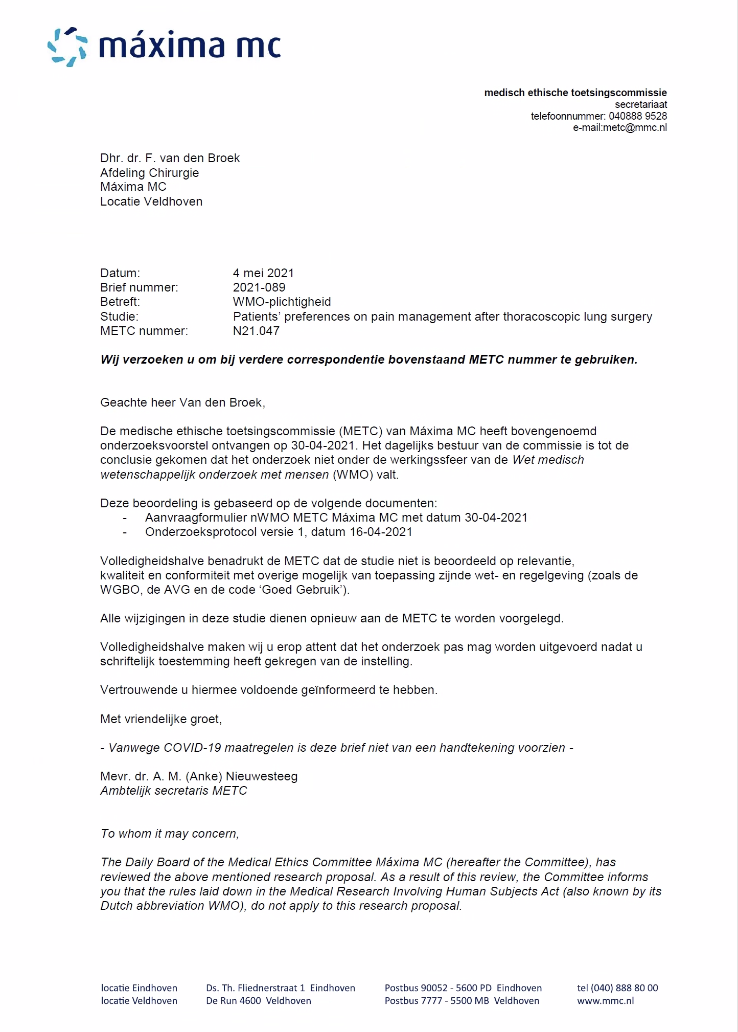

Table S3: List of outomes based on the literature and rated as important by medical specialists
Outcome | n (%)
Reduction of pain | 8 (100)
Pain score during coughing | 8 (100)
Side-effects of thoracic epidural analgesia:  Nausea and vomiting | 8 (100)
Cost-effectiveness of the analgesic technique | 8 (100)
Pain score at rest | 7 (85.7)
Pain score during mobilisation | 7 (85.7)
Postoperative morfine use | 7 (85.7)
Side-effects of the use of opioids:  Nausea and vomiting | 7 (85.7)
Side-effects of thoracic epidural analgesia:  Bladder retention | 7 (85.7)
Mobility | 7 (85.7)
Patient satisfaction | 7 (85.7)
Presence of a bladder catheter | 7 (85.7)
Easy breathing | 7 (85.7)
A good sleep | 7 (85.7)
Presence of thoracic drainage | 6 (71.4)
Going to the toilet without assistance and taking care of personal hygiene | 6 (71.4)
Side-effects of morphine | 6 (71.4)
Length of hospital stay | 4 (57.1)
Awake placement of the analgesic technique | 1 (14.3)

