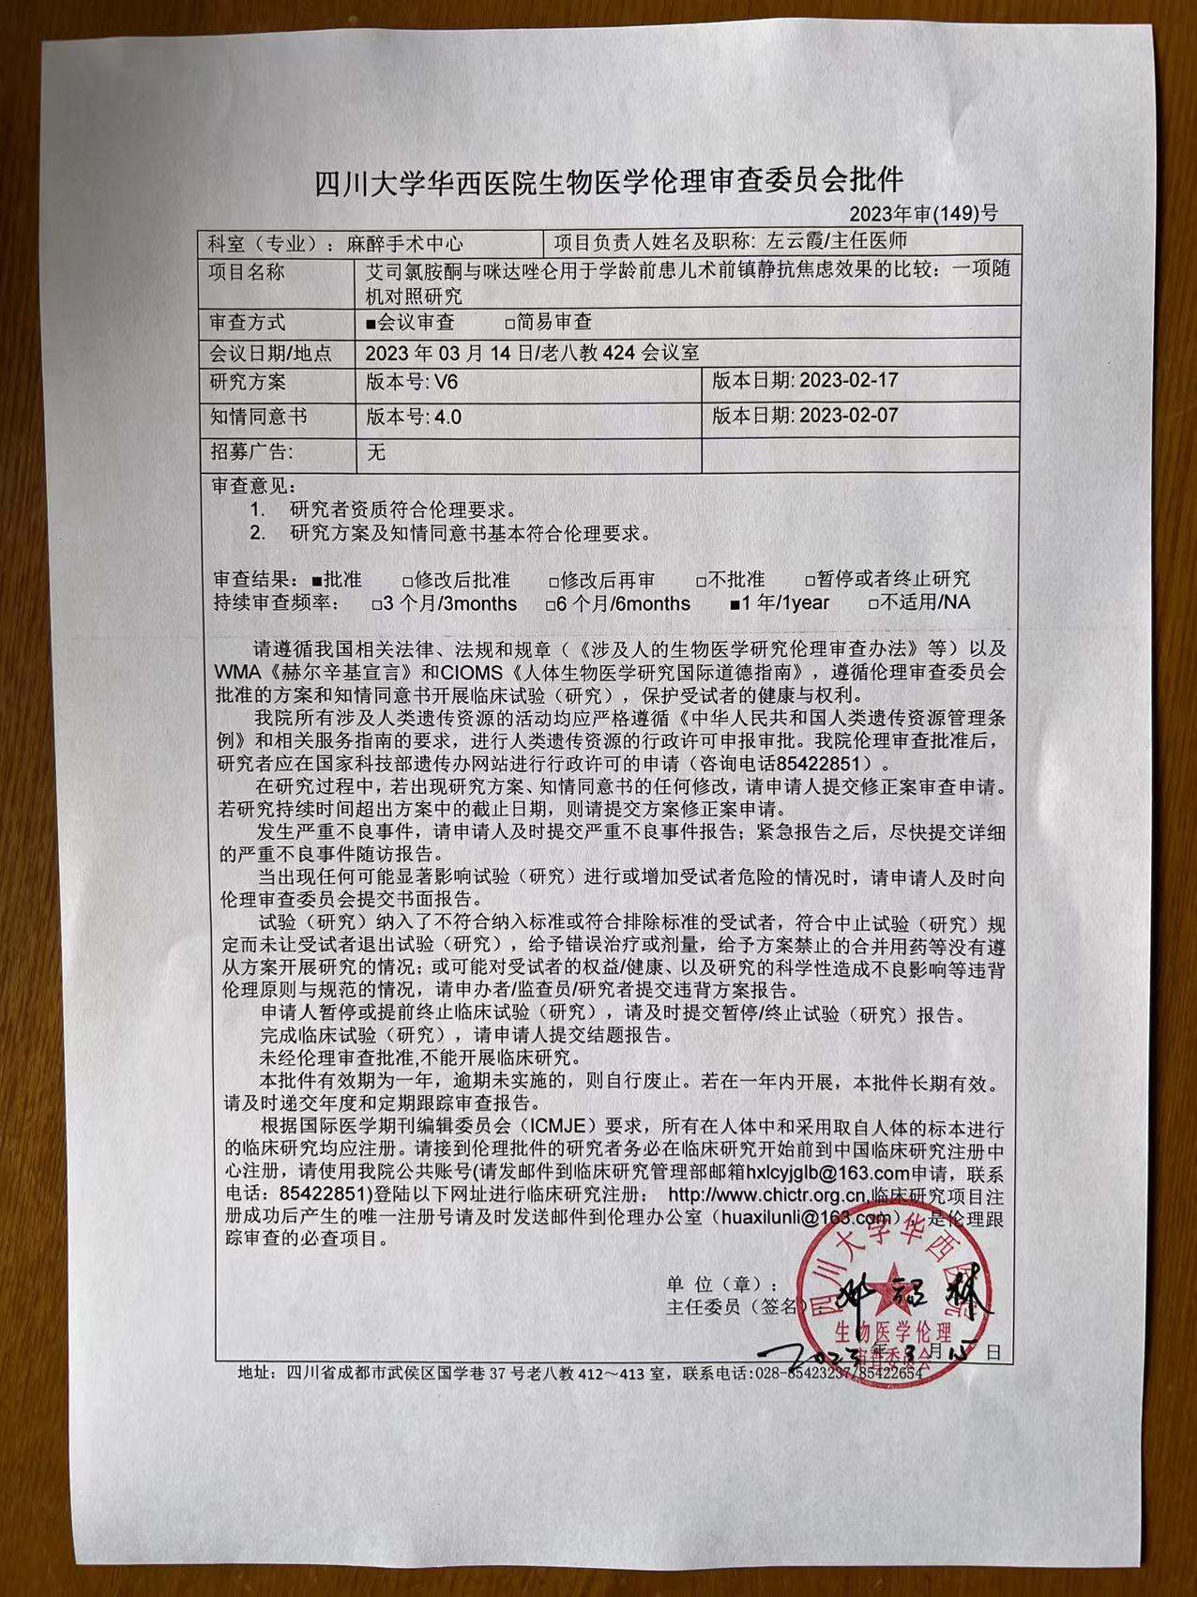

Approved by the Biomedical Ethics Review Committee of West China Hospital of Sichuan University
Approval number: 2023(149)

Name and title of primary investigator:
Zuo Yunxia/Chief physician

Department:
Anesthesiology

Title:
Comparison of S-ketamine and midazolam for intravenous preoperative sedative and anxiolytic effects in preschool children: study protocol for a randomized controlled clinical trial

Meeting date:
March 14, 2023 at Conference Room 424, Laobaku

Research Proposal:
V6. Date :2023-02-17

Informed Consent Form:
V4. Date :2023-02-07

Wanted AD:
None

Review Comments:
1. Researcher qualifications meet ethical requirements.
2. The research proposal and informed consent basically meet the ethical requirements

Review result:
Approval □Disapproved □Suspend or terminate the study □Approved after modification □Retrial after amendment.

Please conduct clinical trials (studies) in accordance with relevant Chinese laws, regulations and regulations (Measures for Ethical Review of Biomedical Research Involving Humans, etc.), WMA Declaration of Helsinki and CIOMS International Ethical Guidelines for Human Biomedical Research, and follow protocols approved by ethical review committees and informed consent forms. Protect the health and rights of participants. All activities involving human genetic resources in our hospital shall strictly comply with the requirements of the Regulations of the People's Republic of China on the Management of Human Genetic Resources and the relevant service guidelines, and shall be applied for administrative approval of human genetic resources. After the ethical review is approved by our hospital, the researcher should apply for the administrative license on the website of the Genetics Office of the Ministry of Science and Technology (Tel: 85422851).
During the study, if there are any changes to the study protocol or informed consent, the sponsor should submit an application for amendment review. If the study duration exceeds the deadline in the protocol, t should also submit an application for amendment to the protocol.
The sponsor is requested to submit a serious adverse event report in a timely manner. Please submit a detailed serious adverse event follow-up report as soon as possible after the emergency report.
When any situation arises that may significantly affect the conduct of the trial or increase risk to the participants, the sponsor is requested to submit a written report to the Ethics Review Committee in a timely manner.
The sponsor/supervisor/researcher is requested to submit a report of violation of protocol in the following situations: participants who do not meet the inclusion or meet the exclusion criteria are included in the trial; participants are discontinued but not withdrawn from the study; the wrong treatment or dose is given; drug combinations prohibited by the protocol are given and no study is conducted from the protocol; any other situation that may cause adverse impact on the participants' rights/health or violate the ethical principles and norms.
If the sponsor suspends or terminates the clinical trial in advance, please submit the suspension/termination report in time.
Once the clinical trial is finished, please submit the final report.
Clinical studies cannot be conducted without ethical review approval.
This approval shall be valid for one year. If it is not implemented within the time limit, it shall be automatically invalid. If this trial is carried out within one year, it will be valid for a long time. Please timely submit annual and regular follow-up review reports.
As required by the International Committee of Medical Journal Editors (ICMJE), all clinical studies conducted in humans and using specimens taken from humans should be registered. Researchers who receive the ethical approval must register with the Chinese Clinical Trial Registry before the start of clinical studies. Please use the public account of our hospital (please email hxlcyiglb@163.com to the Department of Clinical Research Management to apply for contact number :85422851) and log in the following website for clinical trial registration: http//wwchictr.org.cn The unique registration number generated after the successful registration of the clinical research project should be sent to the Ethics Office (huaxilunli@163.com) in time which is a required item of ethical follow-up review.

Address:
Room 412~413, Lao Ba Jiao, No. 37, Guoxue Lane, Wuhou District, Chengdu, Sichuan
Tele:
028-85433237/85422654

