Supplementary Material 1. Anatomical illustration of cervical fascial layers. (D) The area where the LA is injected in deep CPB. (I) The area where the LA is injected in the intermediate CPB. (S) The area where the LA is injected in the superficial CPB.
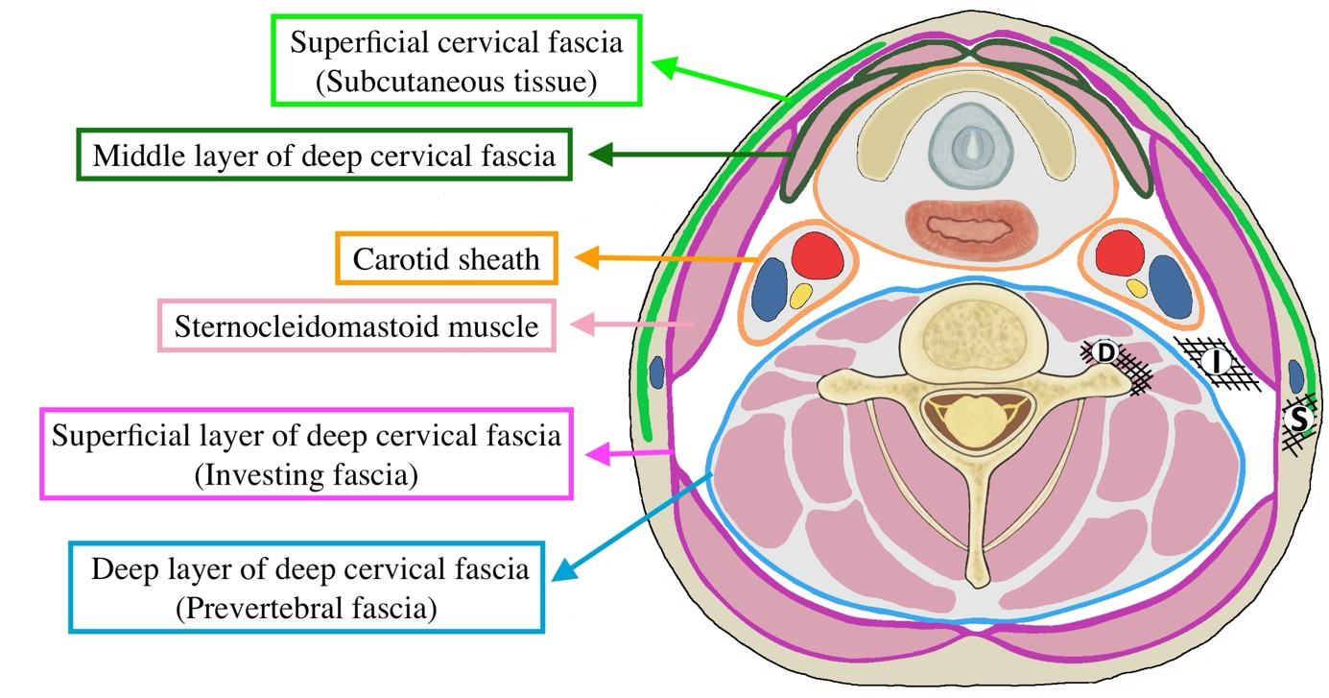
Abbreviations: CPB, cervical plexus block; LA, local anesthetic.

