Supplementary material 1. Ultrasound view of anatomy relevant for femoral nerve block performance

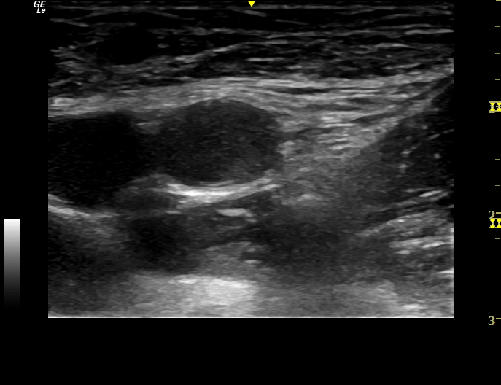
Iliac fascia
FN
Iliopsoas muscle
FV
FA

