Supplementary material 2. Ultrasound view of anatomy relevant for quadratus lumborum block perfomance
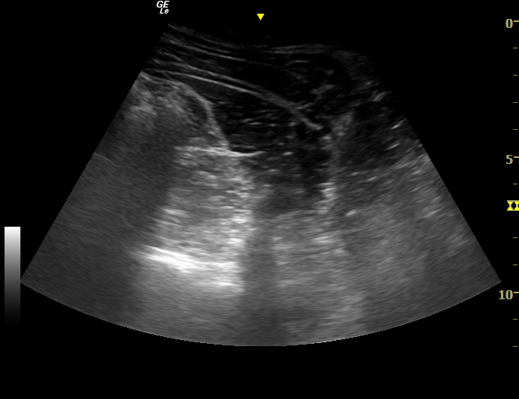
Erector spinae
Psoas
QLM

