Supplementary Figure 1A. Linear regression analysis of time to norepinephrine administration and lactate. The regression line (solid blue) with confidence interval (blue area) indicates a significant negative association (coefficient, -0.22; 95% confidence interval, -0.27 to -0.17)
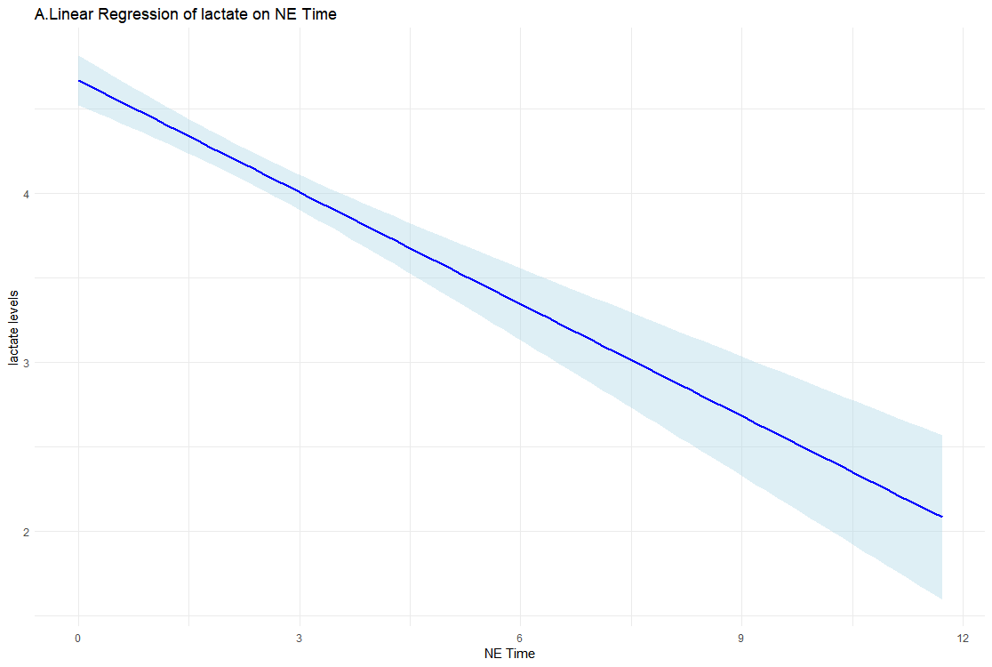
Supplementary Figure 1B. Linear regression analysis of time to norepinephrine administration and SOFA score. The regression line (solid blue) with confidence interval (blue area) indicates a significant negative association (coefficient, -0.37; 95% confidence interval, -0.42 to -0.32)
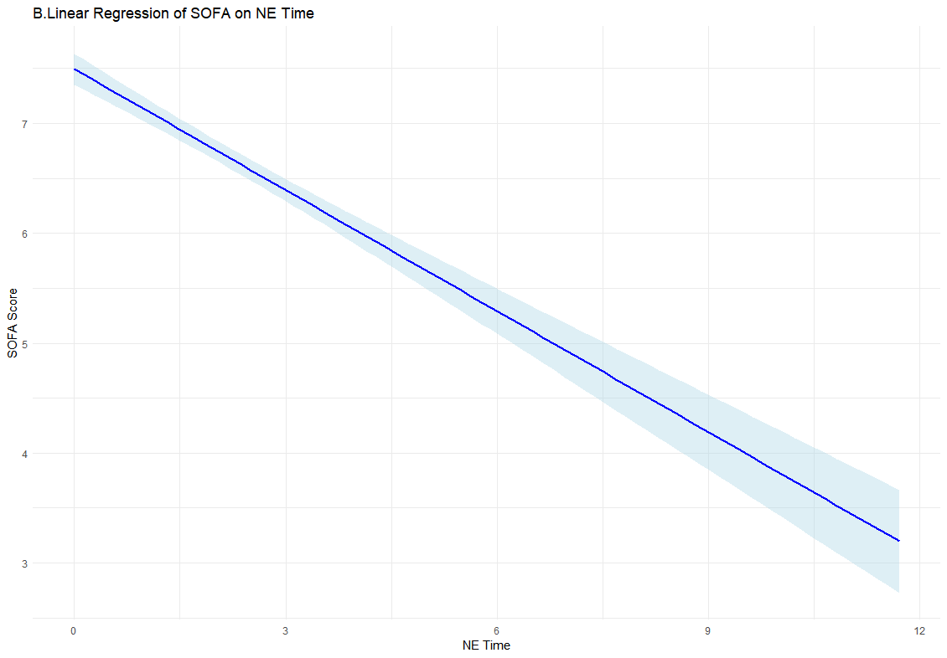
Supplementary Table 1. Comparisons according to the Sepsis-3 shock definition
Characteristic | Non-Sepsis-3  (N=1635) | Sepsis-3  (N=2821) | p
Age(yr) | 67.4 ± 12.8 | 68.6 ± 13.1 | <0.001
Male sex | 878 (53.7%) | 1713 (60.7%)
Vital sign at ED arrival
Systolic pressure (mmHg) | 77.3 ± 10.3 | 74.4 ± 12.0 | <0.001
Diastolic pressure (mmHg) | 48.3 ± 8.2 | 45.9 ± 9.1 | <0.001
Heart rate (/min) | 102.0 ± 23.7 | 108.5 ± 25.1 | <0.001
Respiratory rate (/min)* | 20.1 ± 3.8 | 22.2 ± 5.7 | <0.001
Body temperature* | 37.5 ± 1.2 | 37.3 ± 1.3 | <0.001
Suspected infection source
Respiratory infection | 449 (27.5%) | 825 (29.2%) | 0.217
Urinary tract infection | 464 (28.4%) | 679 (24.1%) | 0.002
Intraabdominal infection | 622 (38.0%) | 1250 (44.3%) | <0.001
Other or unknown | 270 (16.5%) | 491 (17.4%) | 0.471
Comorbidity
HTN | 650 (39.8%) | 1184 (42.0%) | 0.157
DM | 431 (26.4%) | 965 (34.2%) | <0.001
Cardiac disease | 258 (15.8%) | 382 (13.5%) | 0.045
Chronic lung disease | 120 (7.3%) | 187 (6.6%) | 0.400
Chronic renal disease | 170 (10.4%) | 281 (10.0%) | 0.679
Chronic liver disease | 122 (7.5%) | 355 (12.6%) | <0.001
Cerebrovascular disease | 200 (12.2%) | 328 (11.6%) | 0.579
Positive blood culture | 567 (34.7%) | 1434 (50.8%) | <0.001
Lactate(mmol/L) | 2.1 ± 1.5 | 5.4 ± 3.4 | <0.001
SOFA score upon enroll time | 5.4 ± 2.8 | 7.4 ± 3.2 | <0.001
DSI | 2.2 ± 0.6 | 2.5 ± 0.9 | <0.001
Mechanical ventilation | 214 (13.1%) | 988(35.0%) | <0.001
Renal replacement therapy | 122 (7.5%) | 631(22.4%) | <0.001
Antibiotics administered within 1hour | 259(15.8%) | 621(22.0%) | <0.001
2nd vasopressor use | 193 (11.8%) | 1135(40.2%) | <0.001
Time to norepinephrine from ED arrival (hour) | 2.6 ± 2.0 | 2.0 ± 1.9 | <0.001
28-Day mortality | 206 (12.6%) | 905 (32.1%) | <0.001
ED = Emergency Department, HTN = Hypertension, DM =Diabetes mellitus, SOFA = Sequential Organ Failure Assessment, DSI = Diastolic Shock Index, NE = norepinephrine.
*Except for one missing respiratory rate and one missing body temperature, no additional missing data were identified.

Supplementary Figure 2. The distribution of the timing of norepinephrine administration from emergency department arrival (A. non-sepsis-3 shock, B. sepsis-3 septic shock)

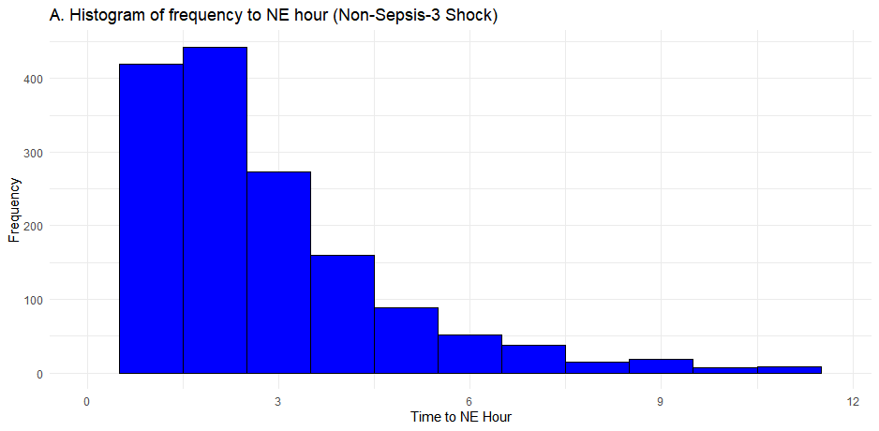
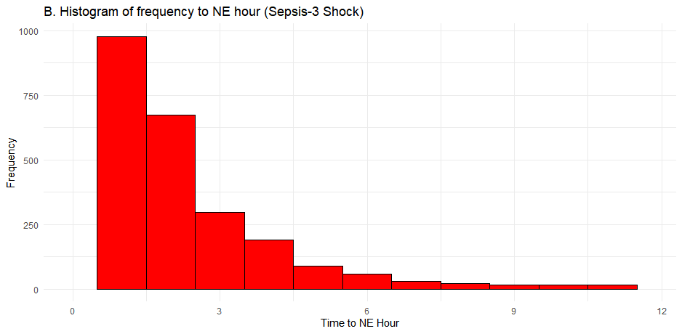

Supplementary Table 2. Comparisons according to the vasopressor requirement risk
 | Characteristic | Low-vasopressor risk  (N=2401) | High-vasopressor risk (N=2055) | p
 | Age(yr) | 68.4 ± 12.6 | 67.8 ± 13.5 | 0.180
 | Male sex | 1354 (56.4%) | 1237 (60.2%) | 0.011
 | Vital sign at ED arrival
 | Systolic pressure (mmHg) | 77.7 ± 10.1 | 72.9 ± 12.4 | <0.001
 | Diastolic pressure (mmHg) | 49.0 ± 8.2 | 44.2 ± 8.9 | <0.001
 | Heart rate (/min) | 95.6 ± 22.9 | 118.5 ± 21.0 | <0.001
 | Respiratory rate (/min)* | 20.3 ± 3.9 | 22.8 ± 6.0 | <0.001
 | Body temperature* | 37.2 ± 1.2 | 37.5 ± 1.3 | <0.001
 | Suspected infection source
 | Respiratory infection | 648 (27.0%) | 626 (30.5%) | 0.012
 | Urinary tract infection | 667 (27.8%) | 476 (23.2%) | <0.001
 | Intraabdominal infection | 996 (41.5%) | 876 (42.6%) | 0.458
 | Other or unknown | 380 (15.8%) | 381 (18.5%) | 0.018
 | Comorbidity
 | HTN | 1023 (42.6%) | 811 (39.5%) | 0.036
 | DM | 730 (30.4%) | 666 (32.4%) | 0.160
 | Cardiac disease | 397 (16.5%) | 243 (11.8%) | <0.001
 | Chronic lung disease | 162 (6.7%) | 145 (7.1%) | 0.729
 | Chronic renal disease | 273 (11.4%) | 178 (8.7%) | 0.003
 | Chronic liver disease | 248 (10.3%) | 229 (11.1%) | 0.408
 | Cerebrovascular disease | 297 (12.4%) | 231 (11.2%) | 0.264
 | Positive blood culture | 959 (39.9%) | 1042 (50.7%) | <0.001
 | Lactate(mmol/L) | 2.7 ± 2.5 | 5.9 ± 3.3 | <0.001
 | SOFA score upon enroll time | 6.1 ± 3.0 | 7.4 ± 3.3 | <0.001
 | DSI | 2.0 ± 0.6 | 2.8 ± 0.8 | <0.001
 | Septic shock (Sepsis-3) | 1026 (42.7%) | 1795 (87.3%) | <0.001
 | Mechanical ventilation | 484 (20.2%) | 718 (34.9%) | <0.001
 | Renal replacement therapy | 310 (12.9%) | 443 (21.6%) | <0.001
Antibiotics administered within 1hour |  | 392(16.3%) | 488(23.7%) | <0.001
 | 2nd vasopressor use | 487 (20.3%) | 841 (40.9%) | <0.001
 | Time to norepinephrine use from ED arrival (hour) | 2.4 ± 1.9 | 2.0 ± 1.8 | <0.001
 | 28-Day mortality | 434 (18.1%) | 677 (32.9%) | <0.001
ED = Emergency Department, HTN = Hypertension, DM =Diabetes mellitus, SOFA = Sequential Organ Failure Assessment, DSI = Diastolic Shock Index.
*Except for one missing respiratory rate and one missing body temperature, no additional missing data were identified.

Supplementary Figure 3. Spline curves showing adjusted odds ratios for 28-day mortality by norepinephrine initiation time
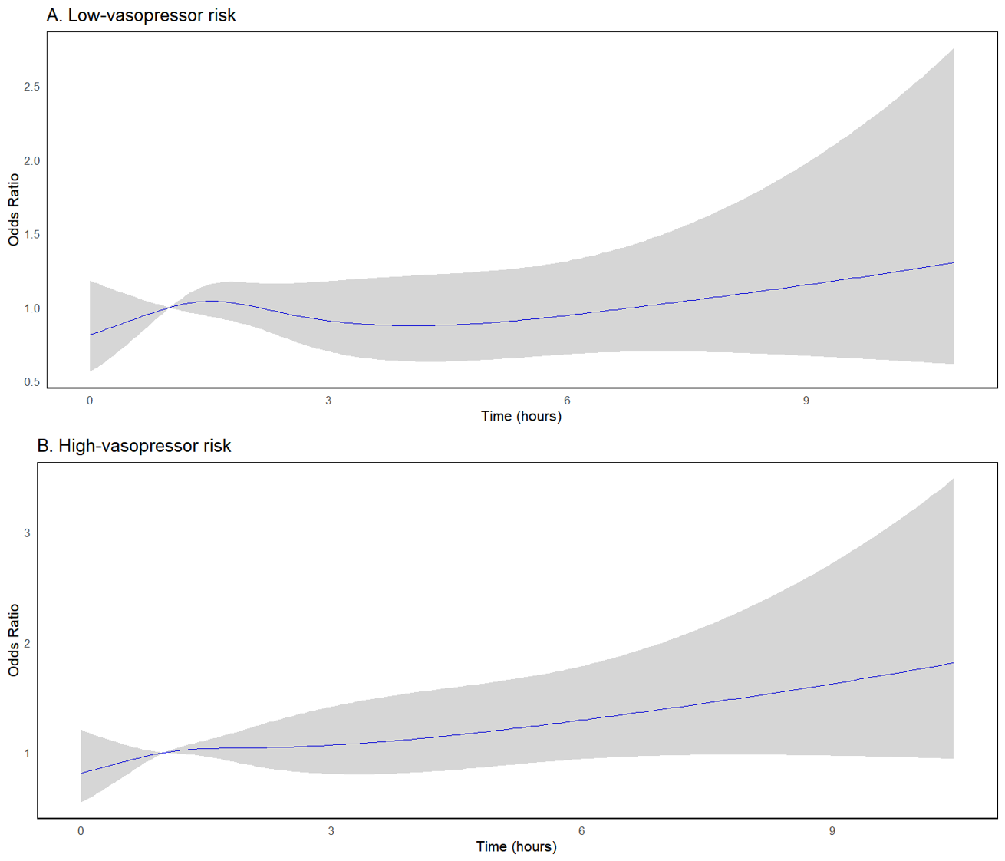

Supplementary Table 3. Multivariable logistic regression for the effect of the timing of norepinephrine administration from initial hypotension on 28-day mortality according to additional subgroups
Group | Adjusted odds ratio | 95% Confidence interval | p
Lactate ≥4 mmol/L | 1.07 | 1.01–1.13 | 0.025
Lactate <4 mmol/L | 1.01 | 0.95-1.07 | 0.735
Diastolic Shock Index ≥2.2 | 1.07 | 1.01-1.13 | 0.016
Diastolic Shock Index <2.2 | 1.00 | 0.94-1.06 | 0.904
SOFA = Sequential Organ Failure Assessment

